# Documentation for JIRA Configuration

JIRA Setup

Documentation for JIRA Configuration 1

1. Create New Project: 2

2. Select required Issue Types: 4

3. Custom Field Creation: 6

4. Field Configurations: 8

5. Assign Field configuration to the project: 11

6. Screens Configuration: 13

7. Workflow Configuration: 22

8. Kanban / Scrum Board Settings: 30

9. Sprint Creation and Planning: 34

10. Create Release / Version: 36

11. Automation: 38

12. Excel Automation for Metrics/ Reports: 48

Create a JQL 49

API Token Generation from JIRA: 50

Excel Configuration: 53

Metric Calculations: 60

13. Time In Status Configuration: 63

14. Power BI Configuration: 65

15. PowerBI Dashboard Refresh and Publish: 77

Manual Refresh: 77

Schedule Refresh: 80

## Create New Project:

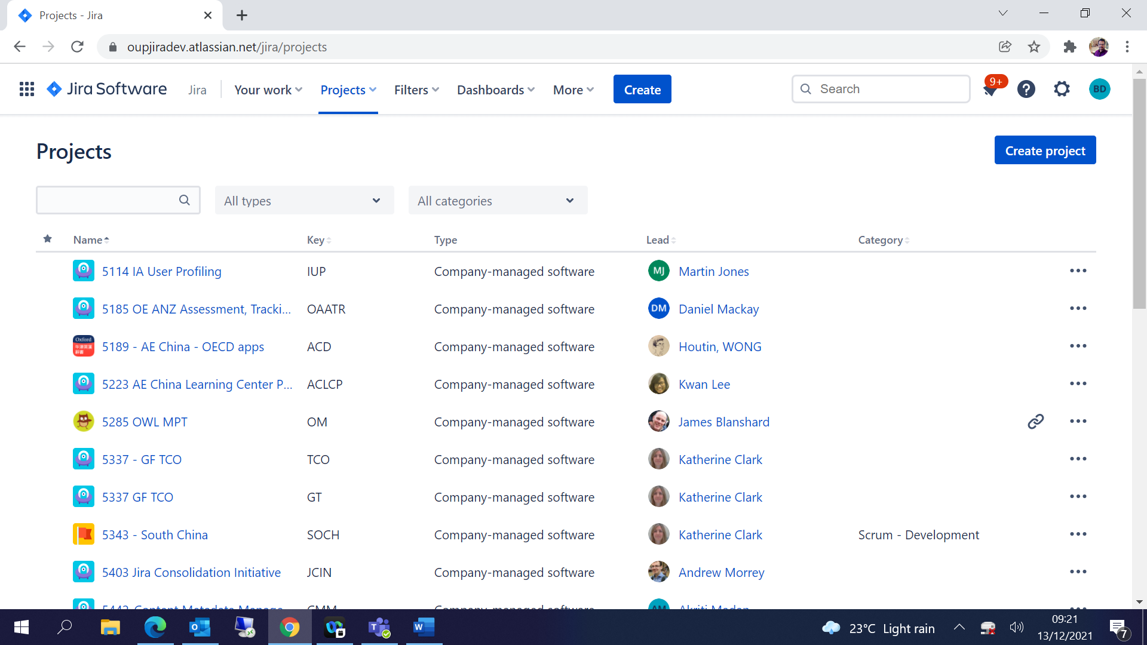

Choose template either Kanban / Scrum based on the requirement:

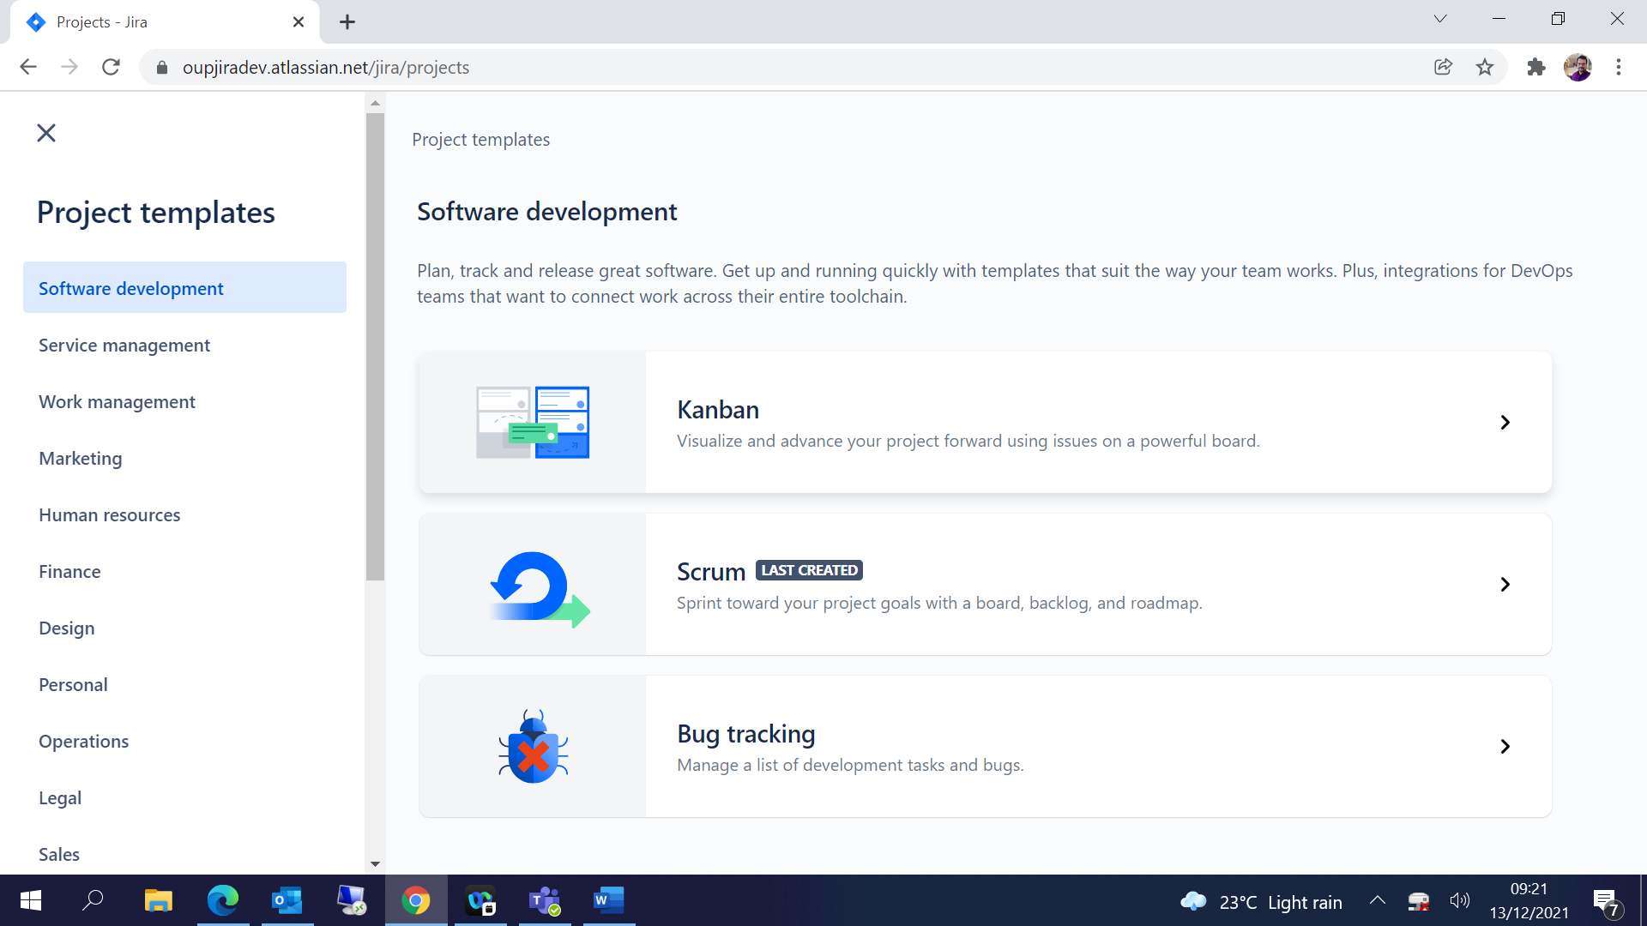

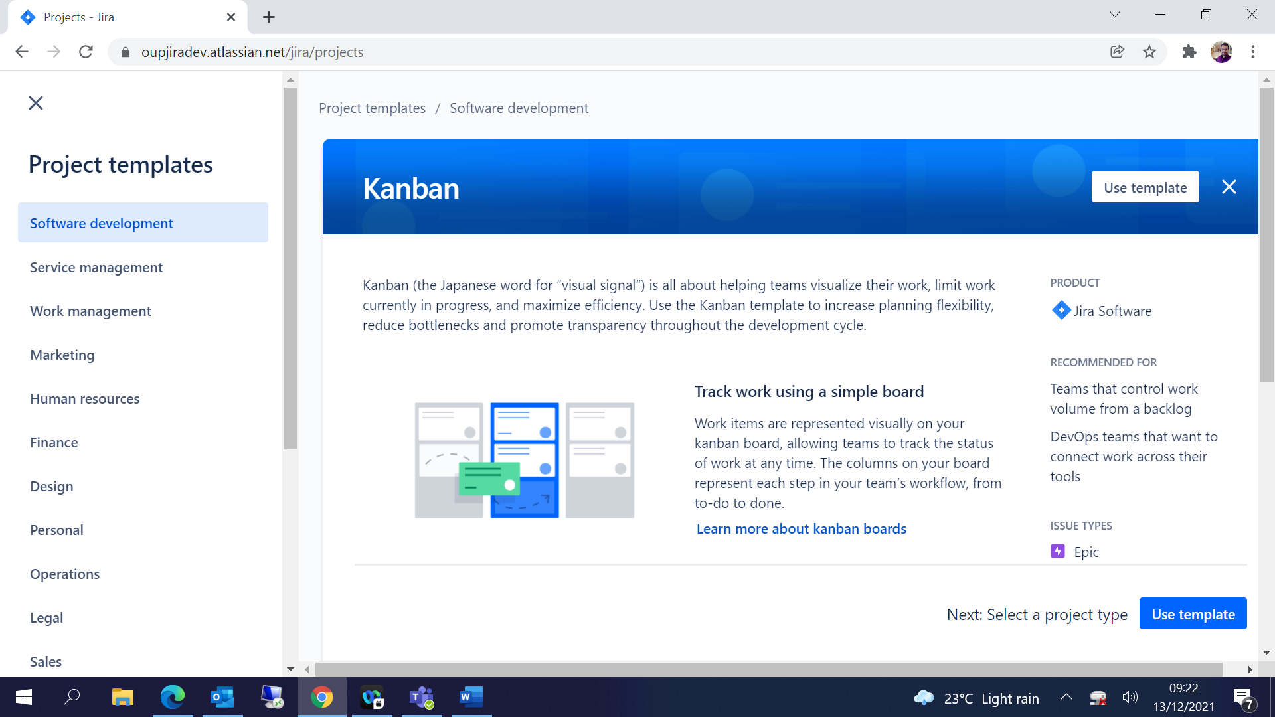

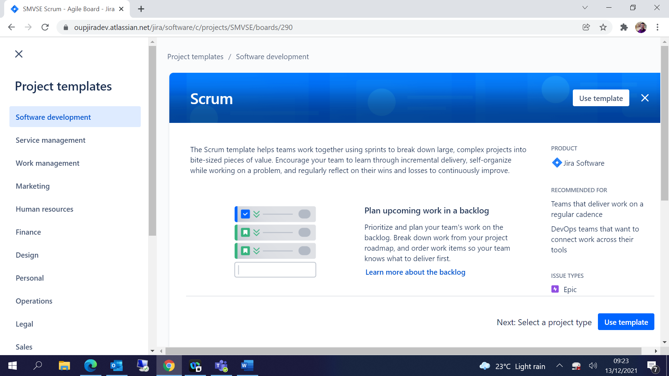

Select Company Managed as the project will be maintained by JIRA Admin:

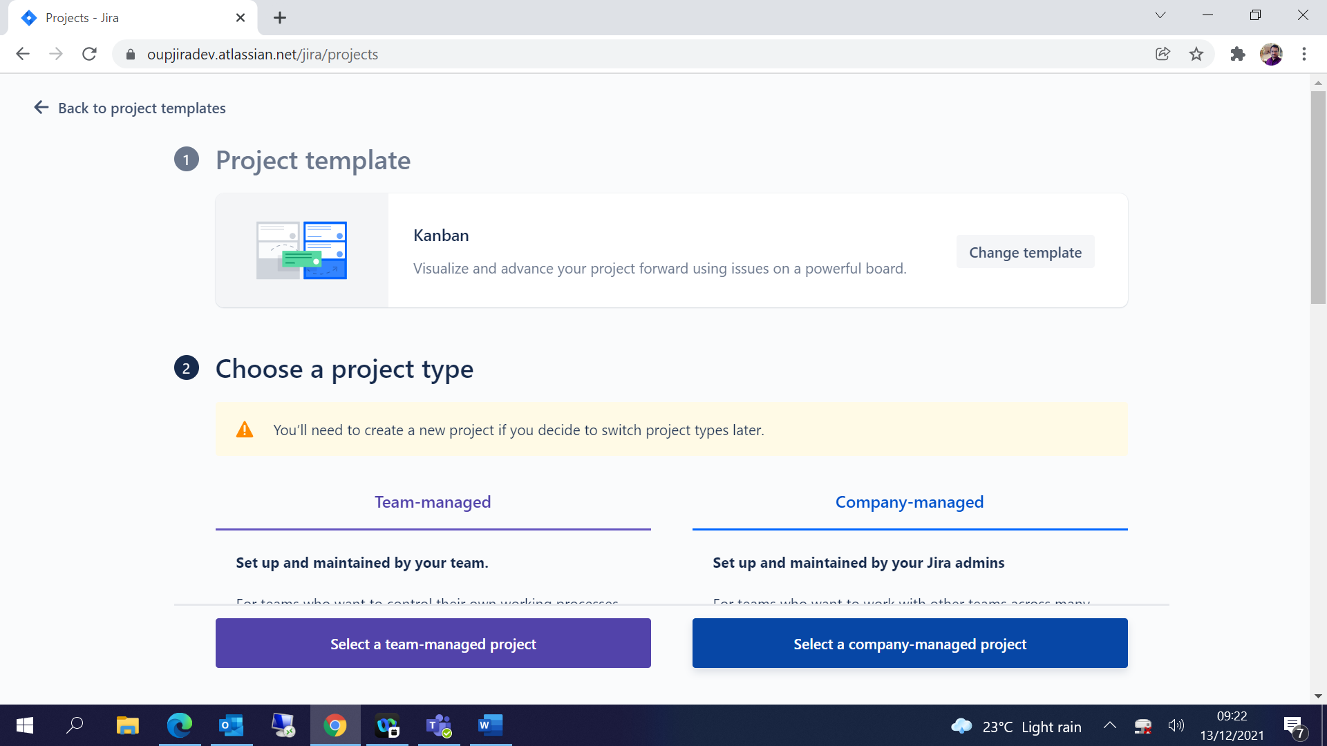

Give Project name, Key and click on Create Project:

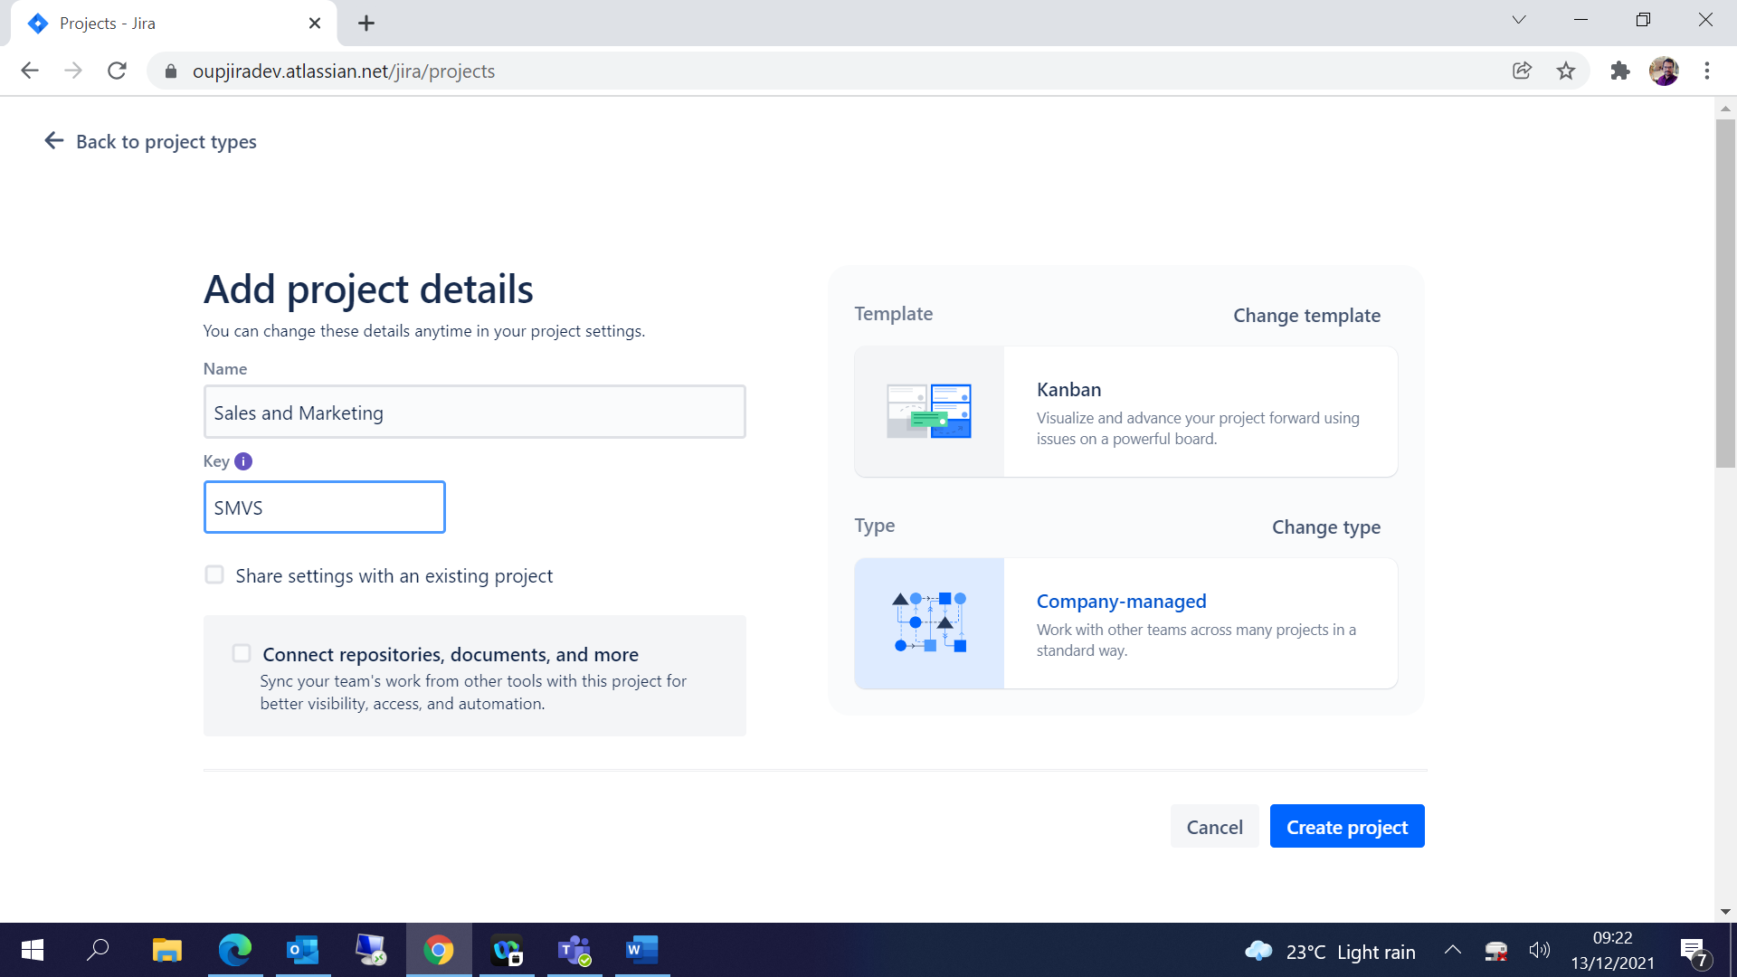

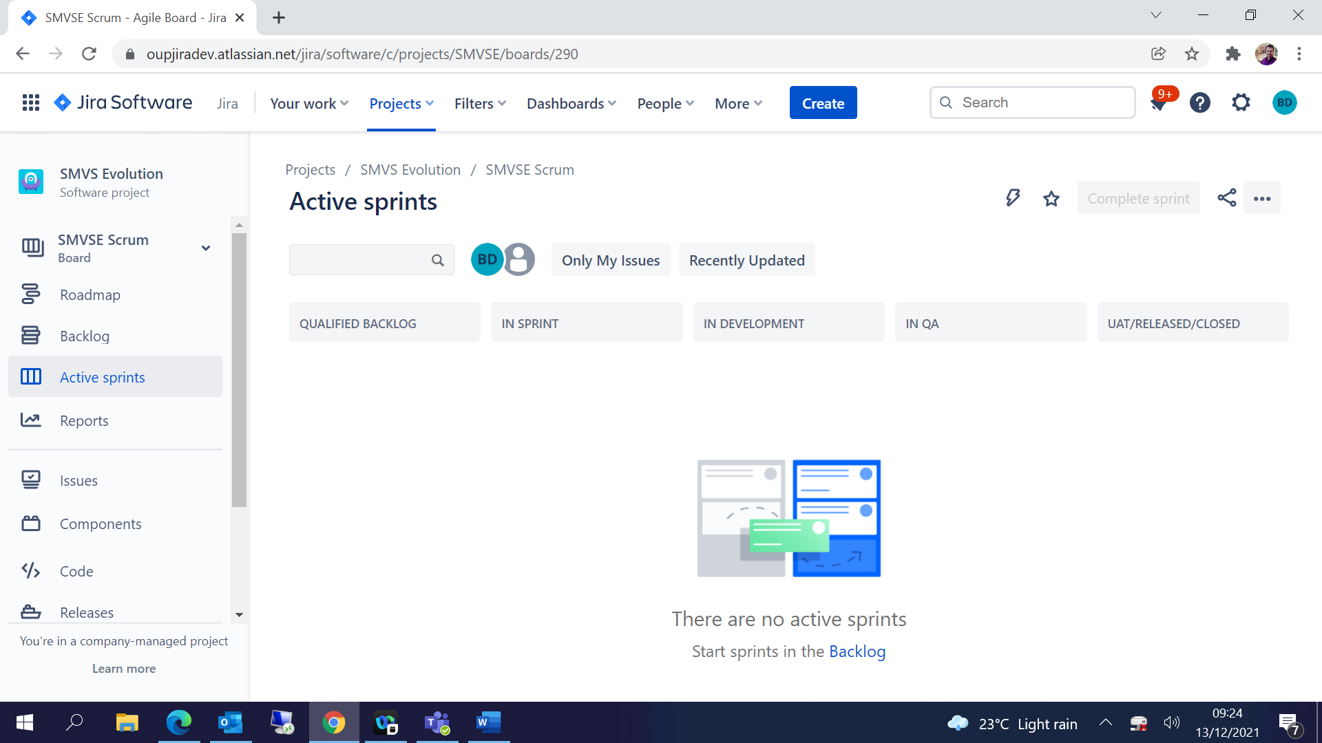

## Select required Issue Types:

Goto 🡪Project Settings

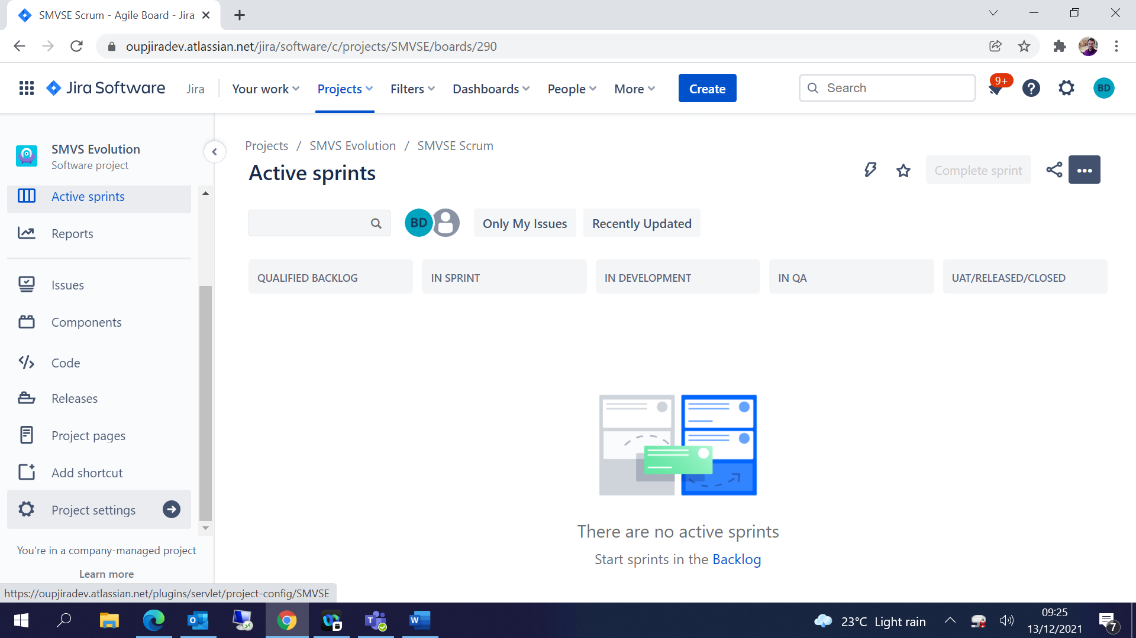

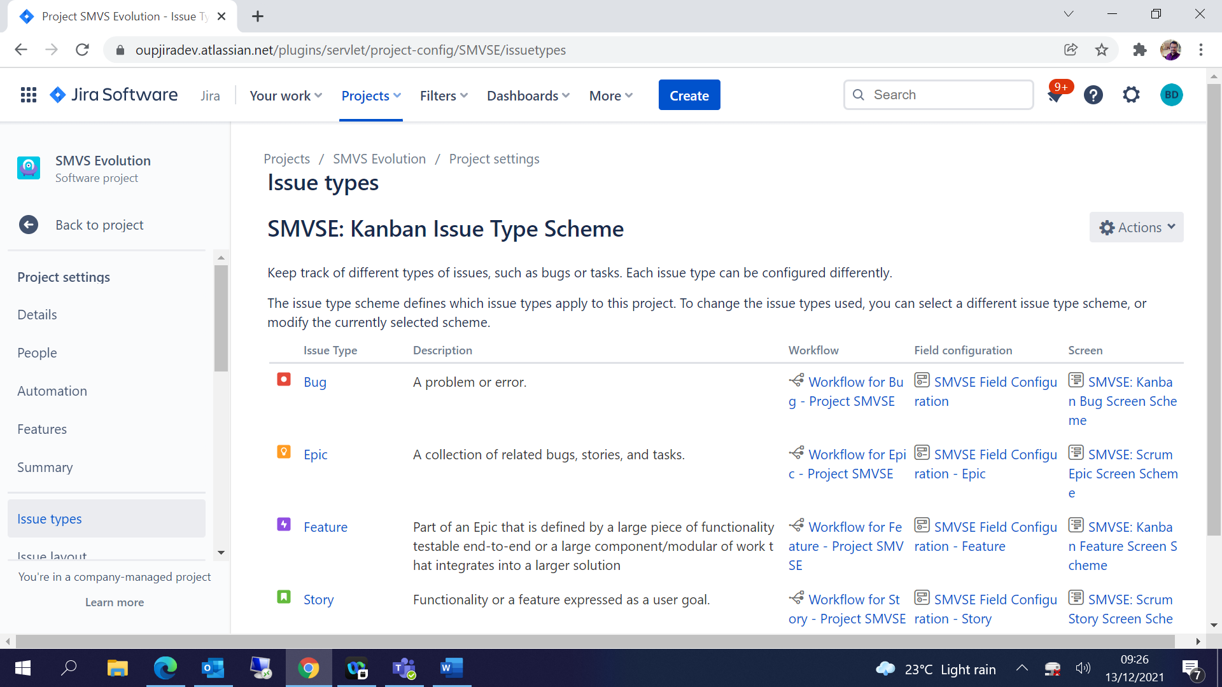

Click on Actions 🡪 Edit Issue Types:

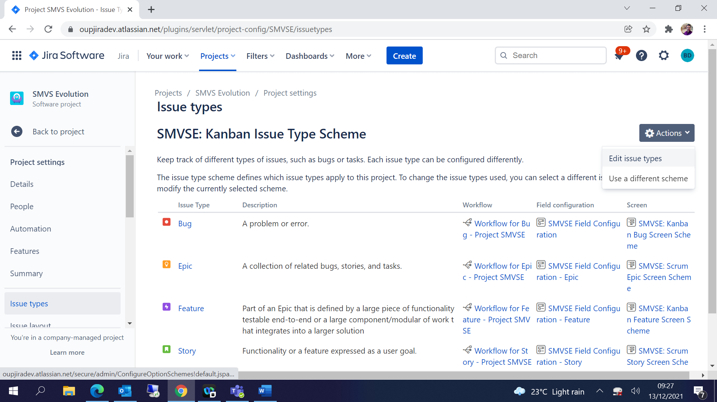

Add / Remove required Issue Types and Save:

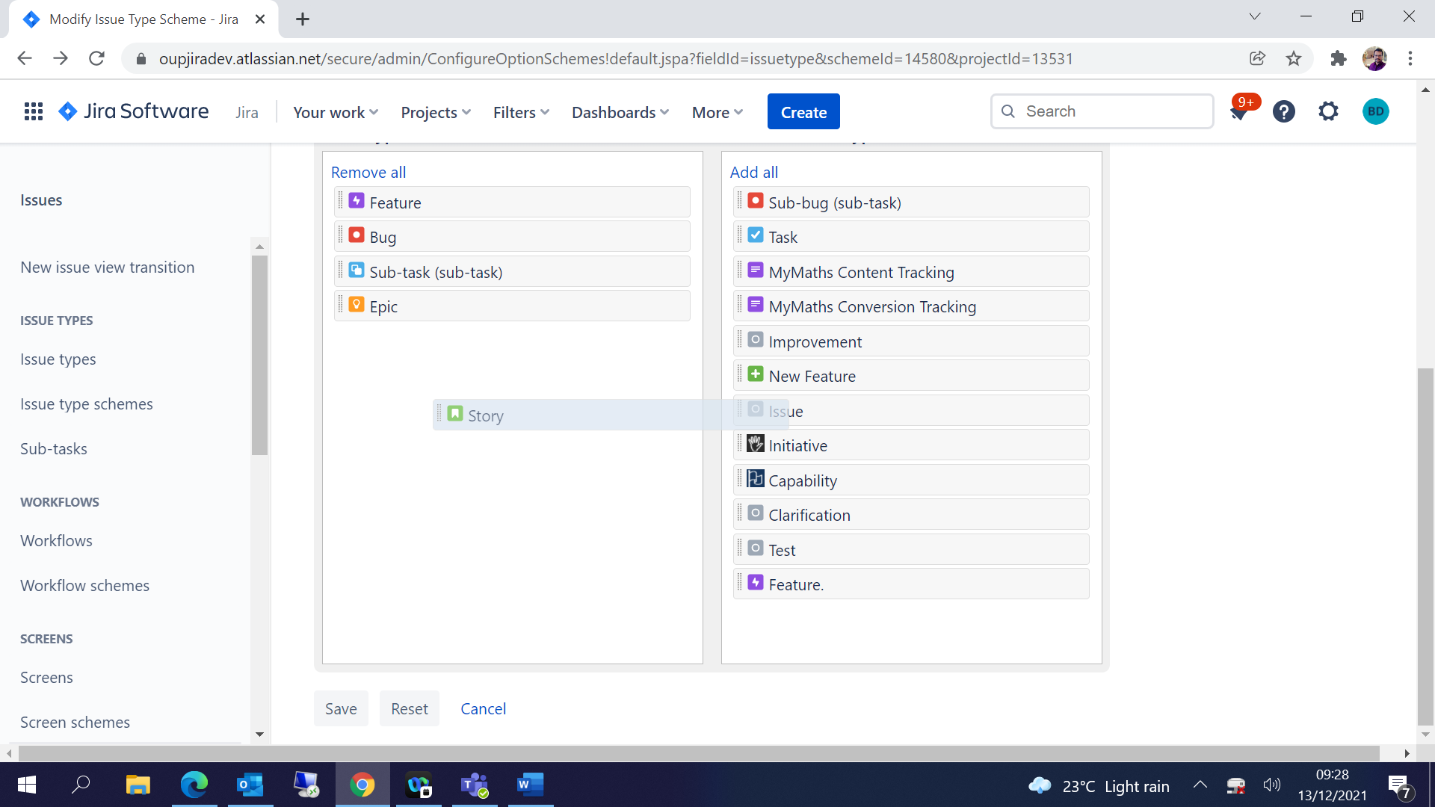

You can create your own Issue type schemes based on the requirements

Subtask configuration:

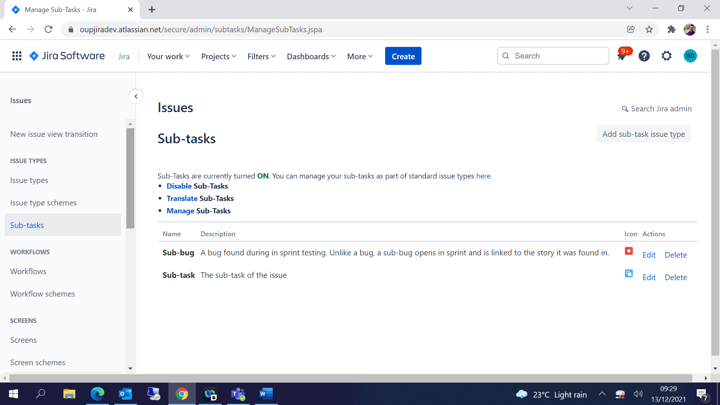

## Custom Field Creation:

Click on Setting Icon and select Issues-

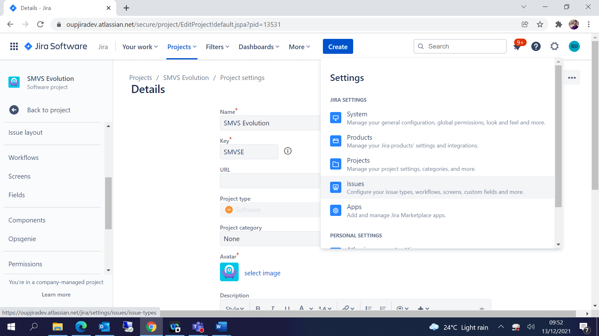

Select Custom Fields from Left pane-

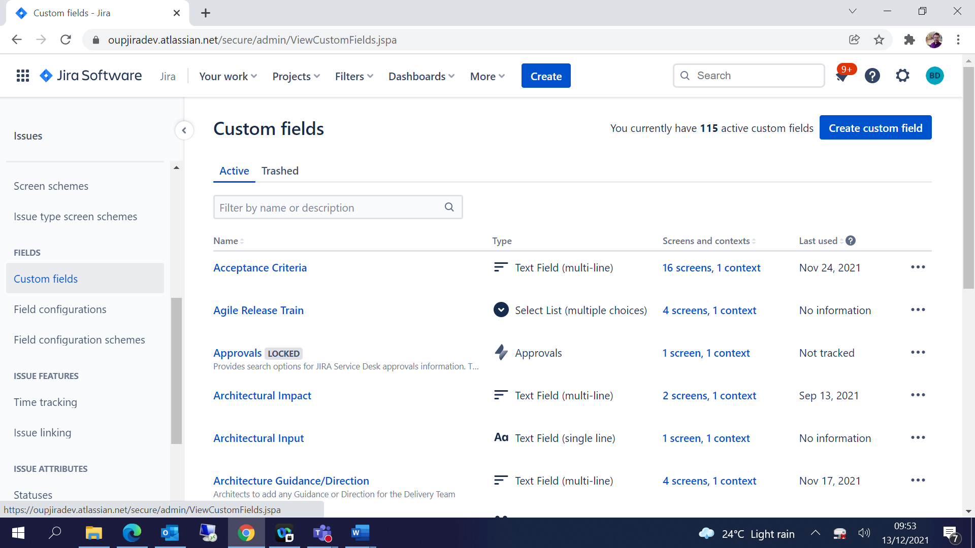

Create Custom Field 🡪 Choose Field Type and proceed accordingly:

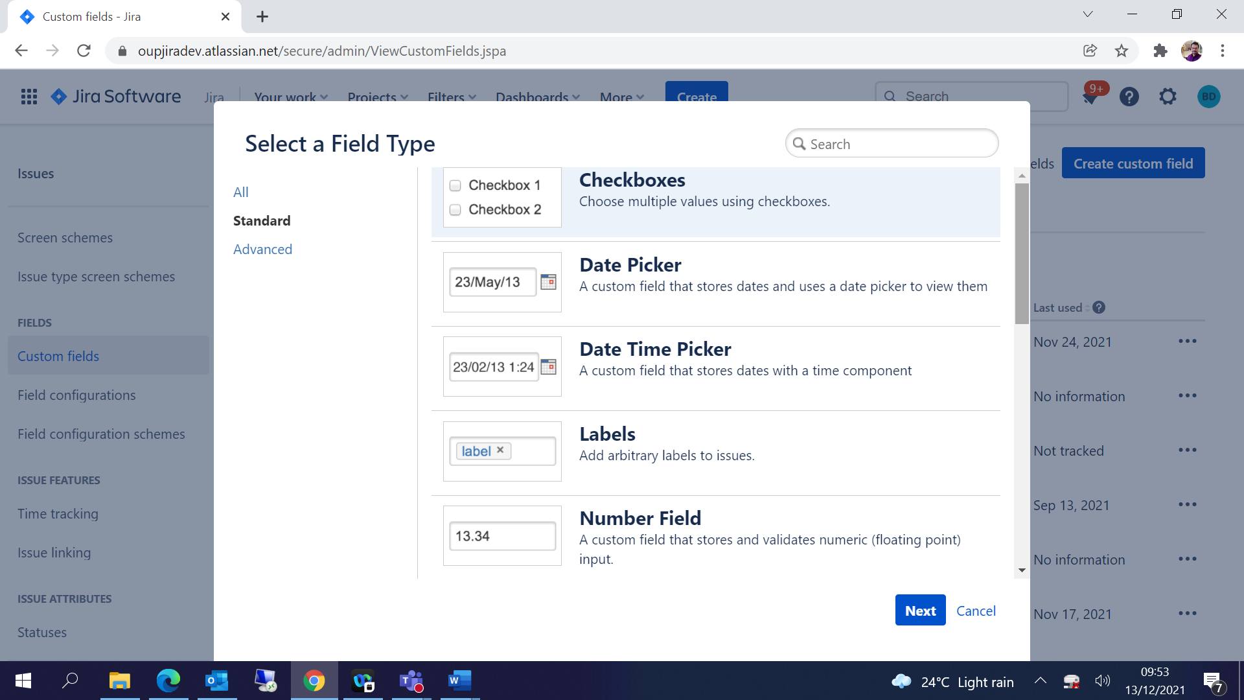

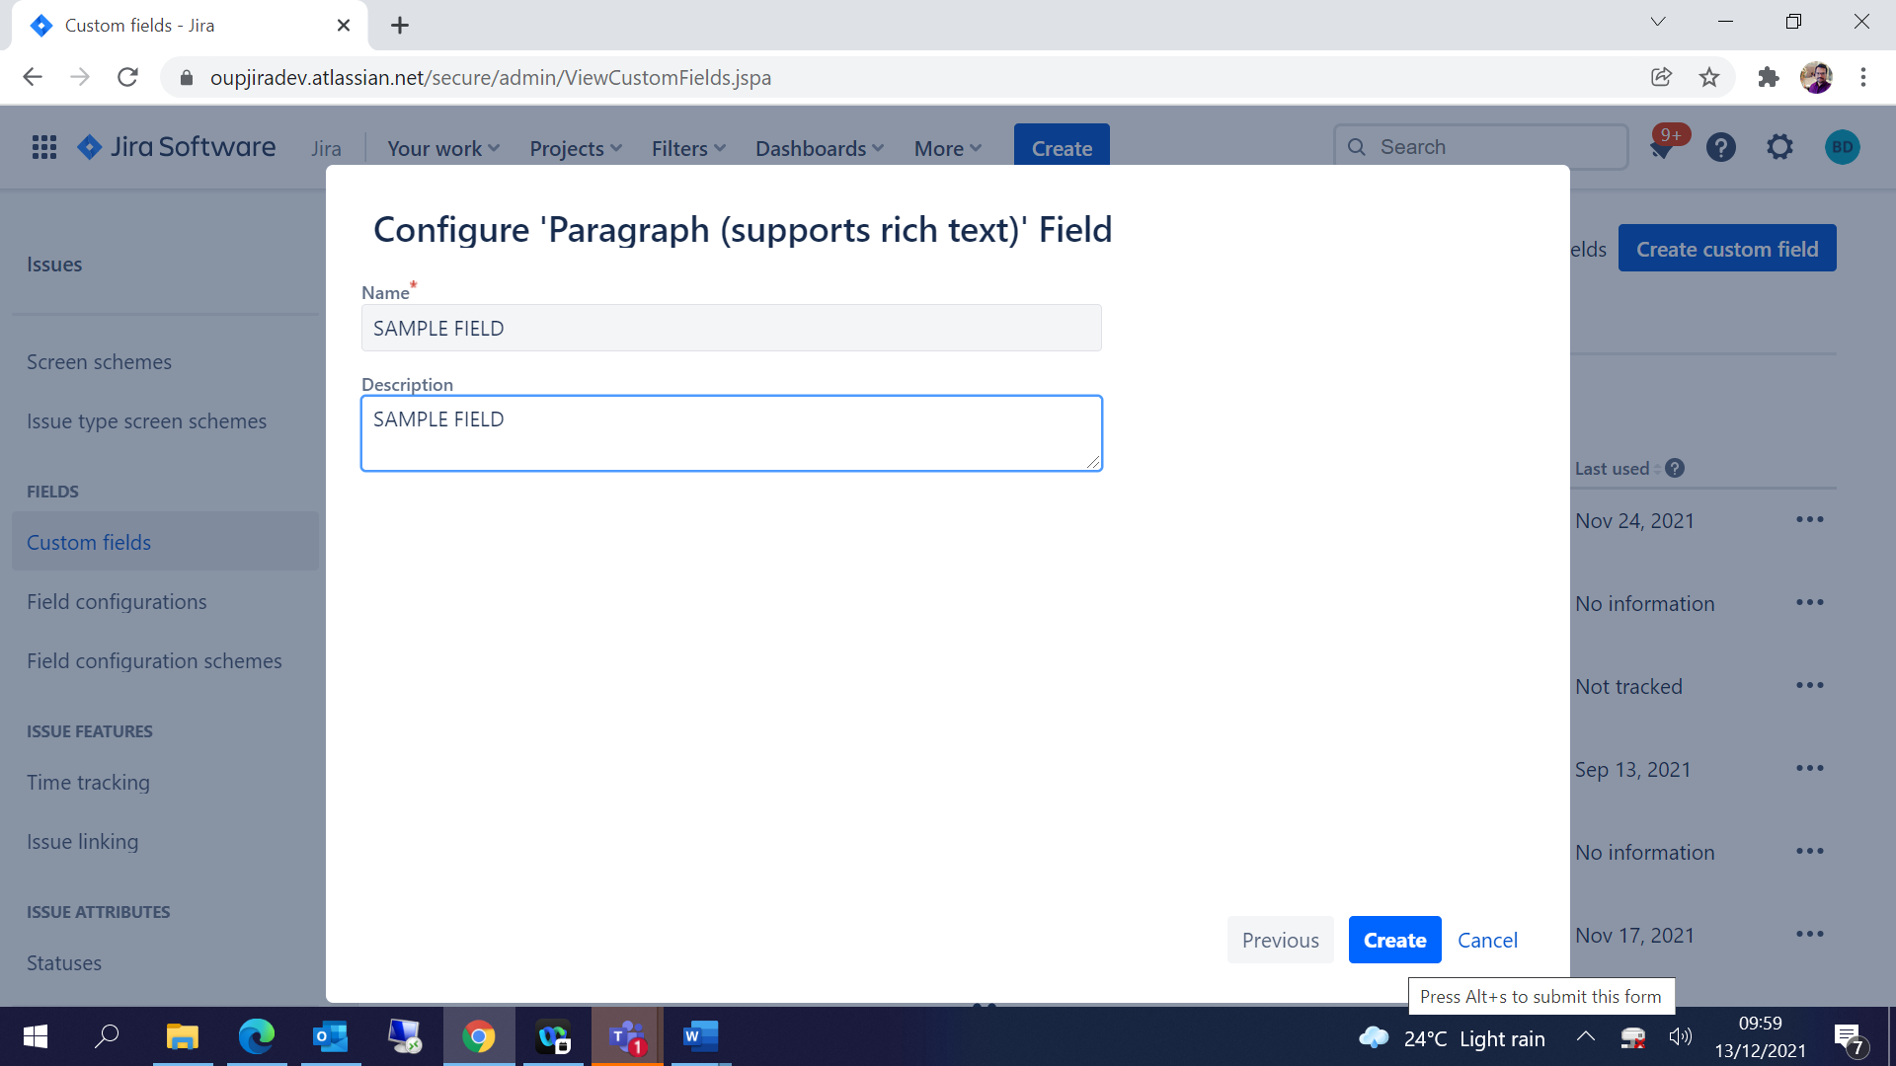

For Dropdown field:

Choose Select List (Single Choice)🡪add options accordingly-

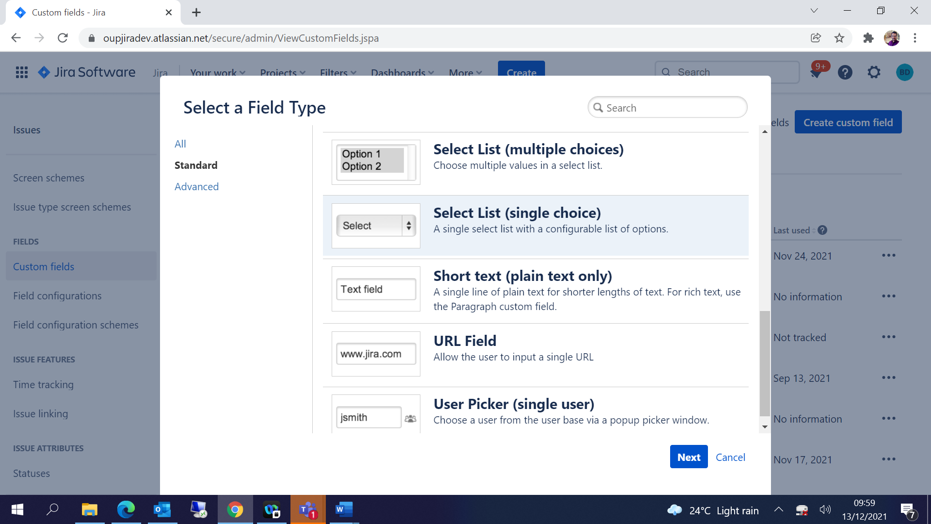

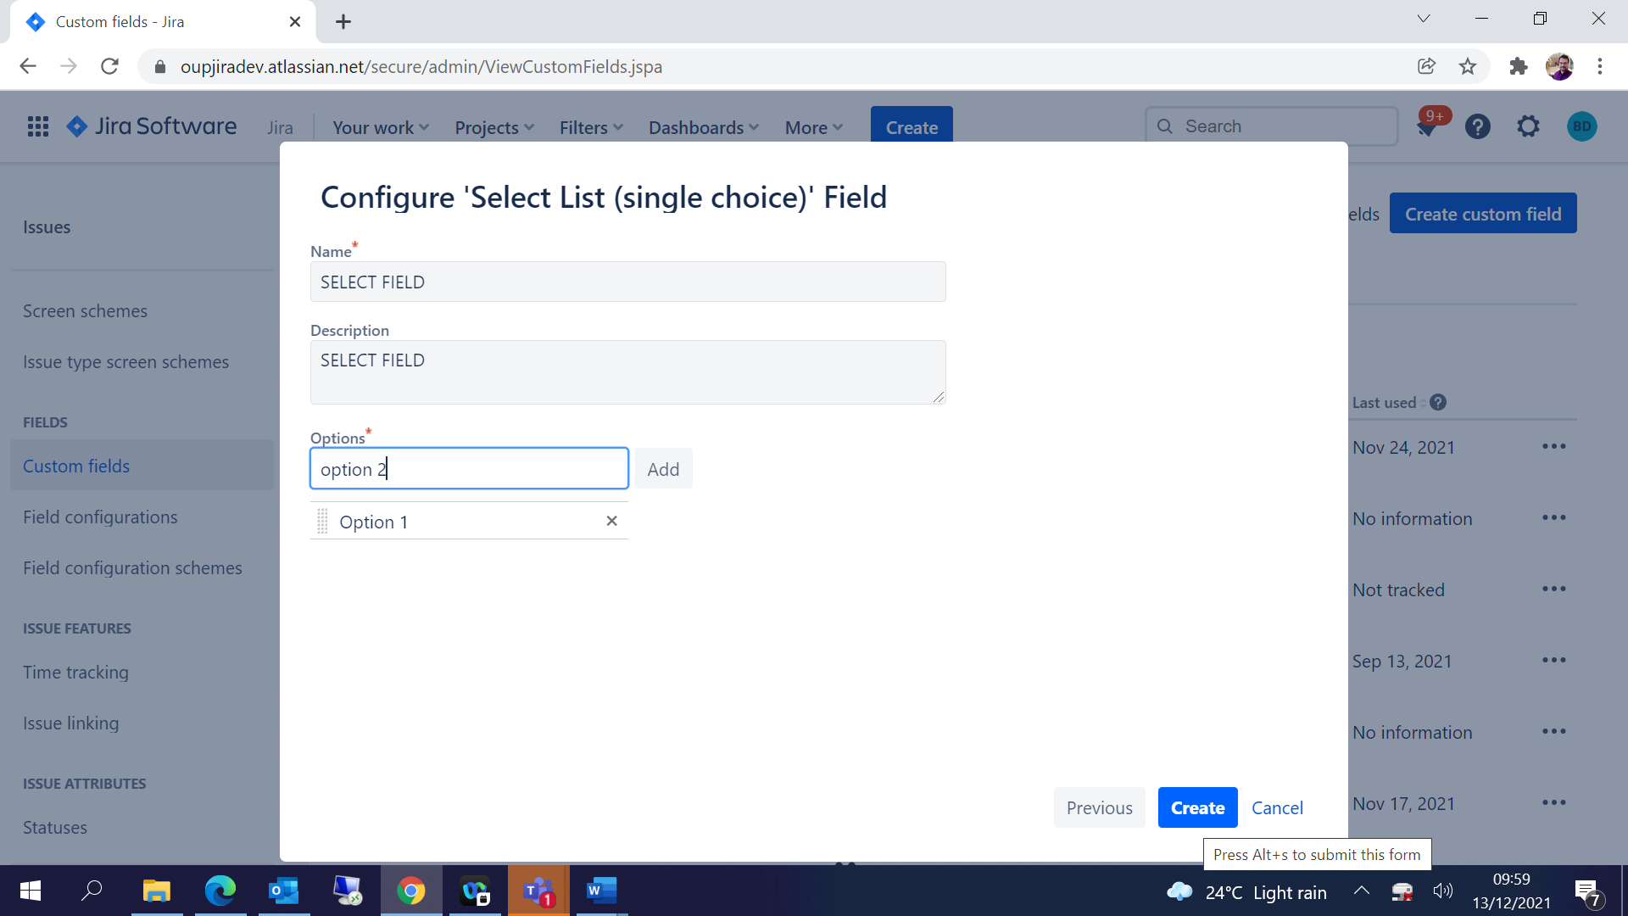

## Field Configurations:

JIRA Settings 🡪 Issues 🡪 Field Configurations🡪

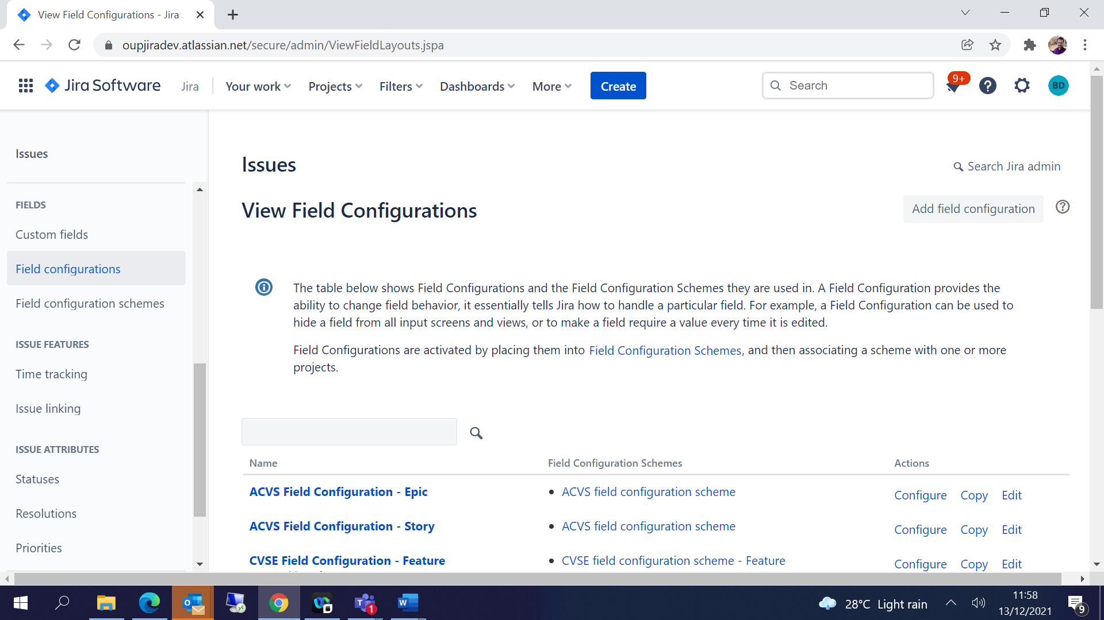

Copy the Default Field configurations and rename it as per the project -

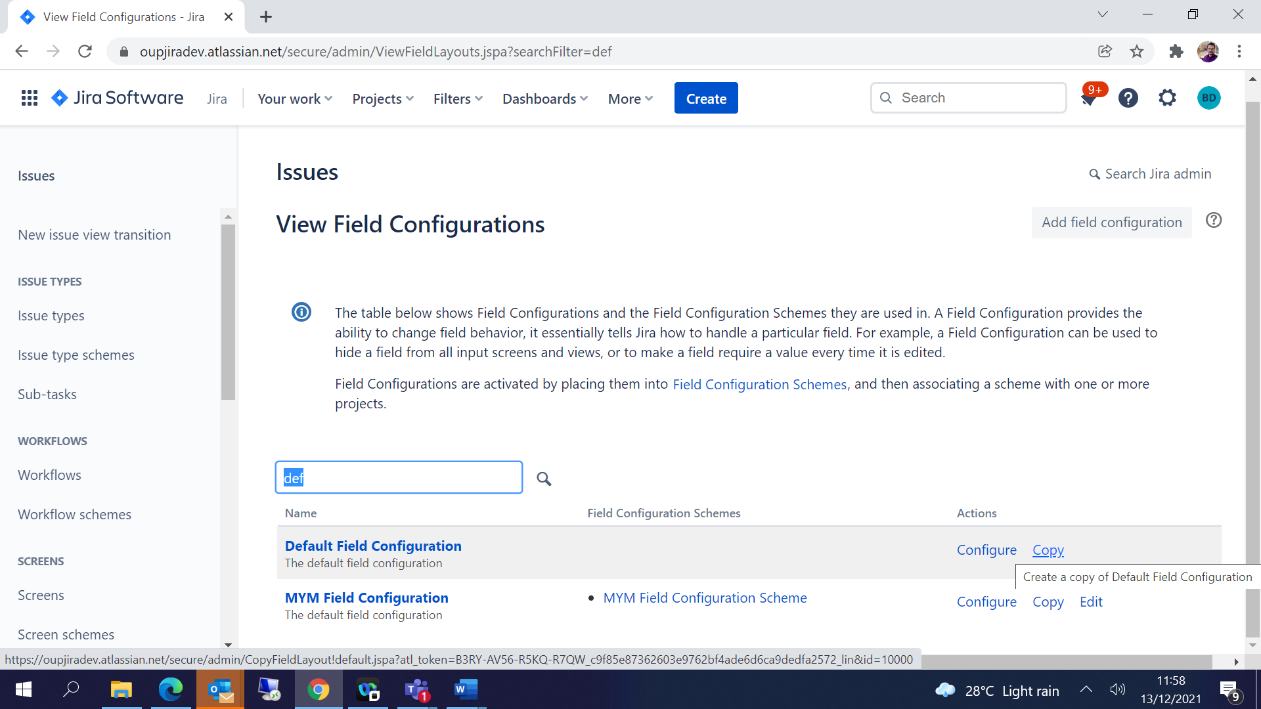

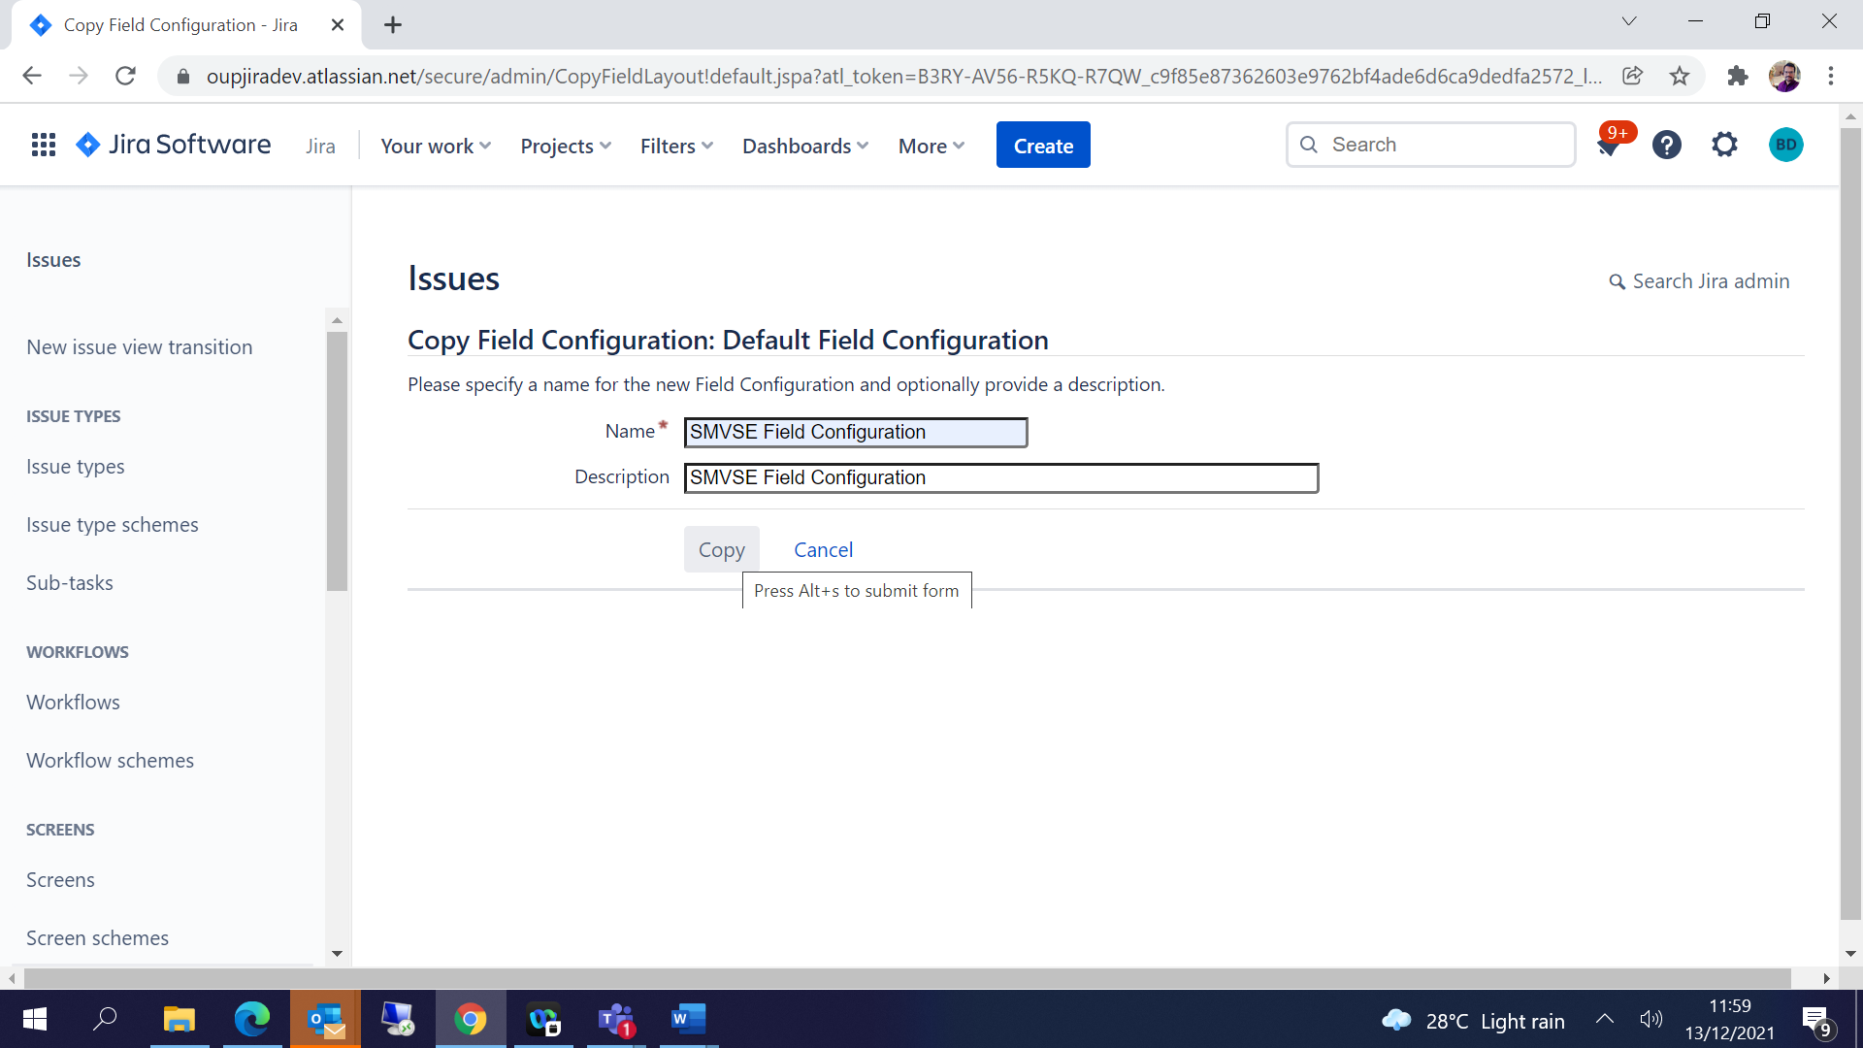

You can send the Mandate or Optional fields here-

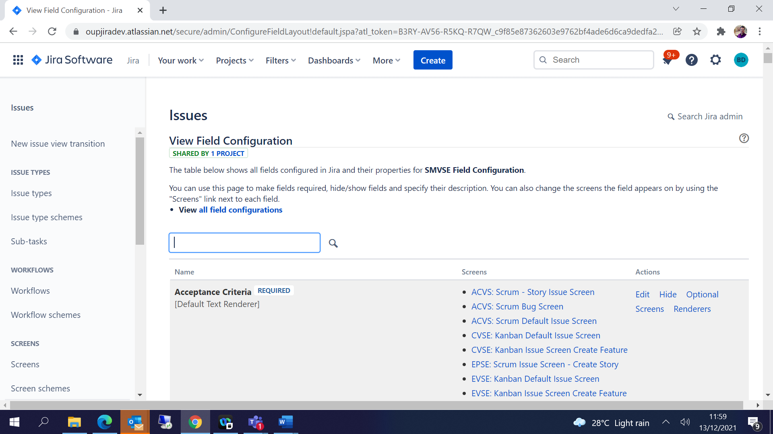

Create Field Configuration Scheme:

Click on Field Configuration schemes 🡪 Add Field configuration scheme🡪 Give some name and add-

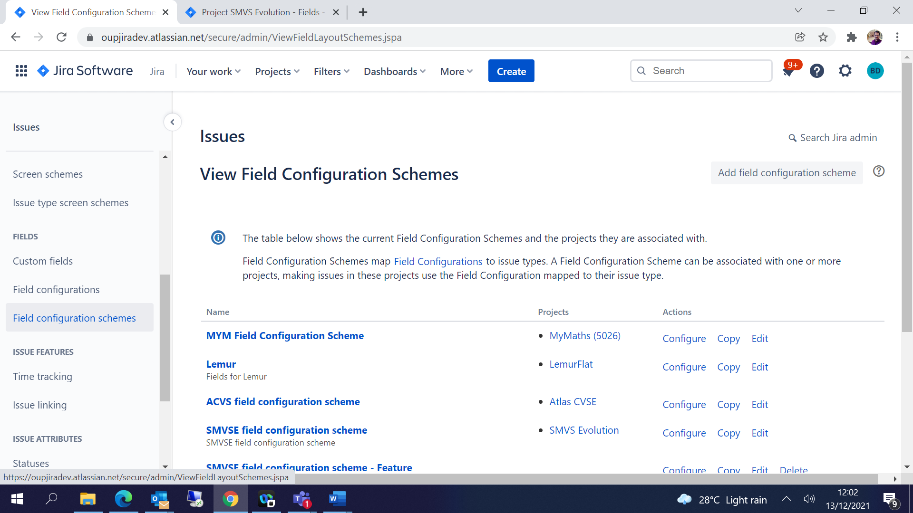

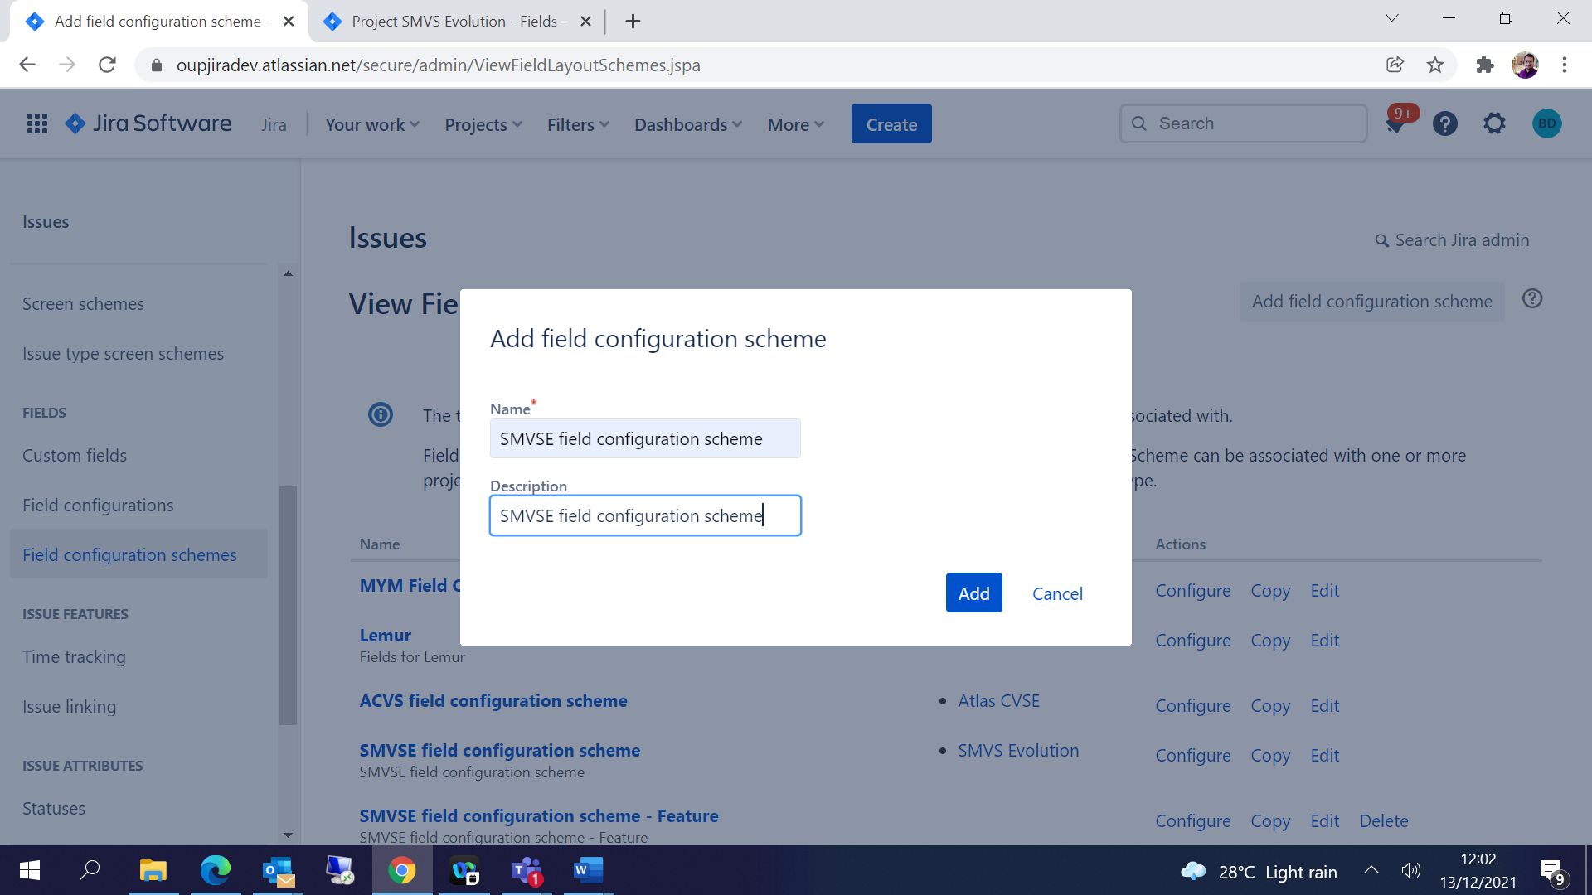

Associate an Issue type with Field Configuration:

Click on Associate an issue type with a field configuration🡪 Choose issue type and Field configuration and Add -

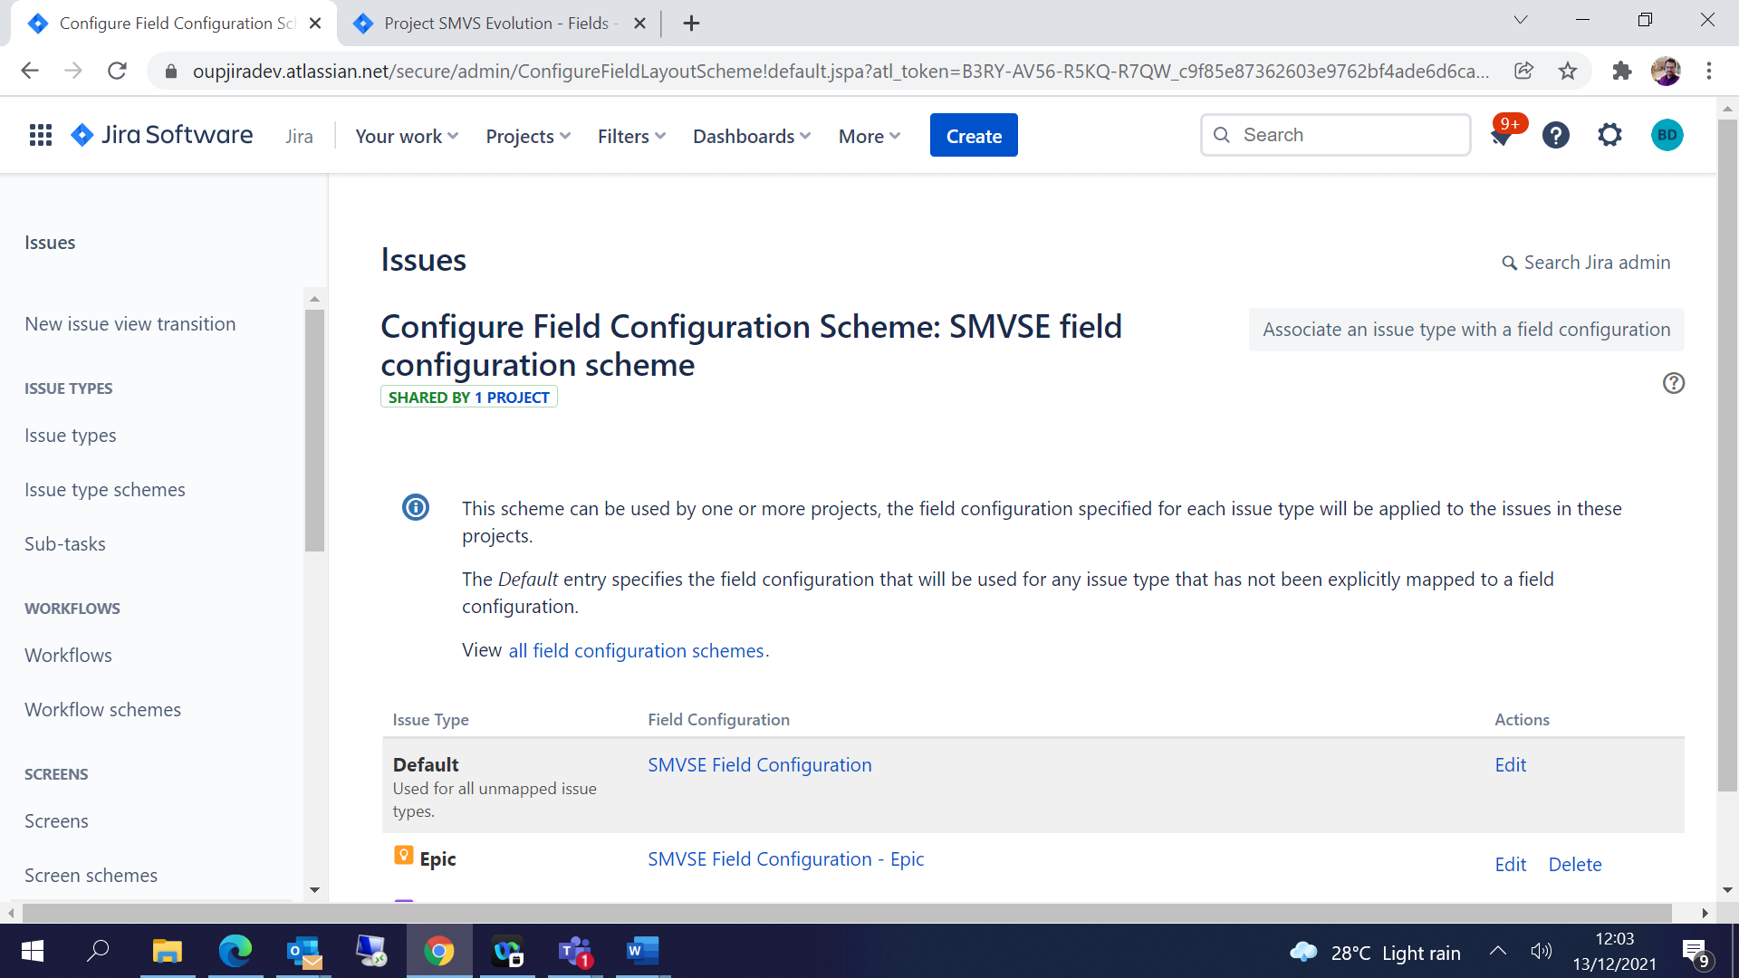

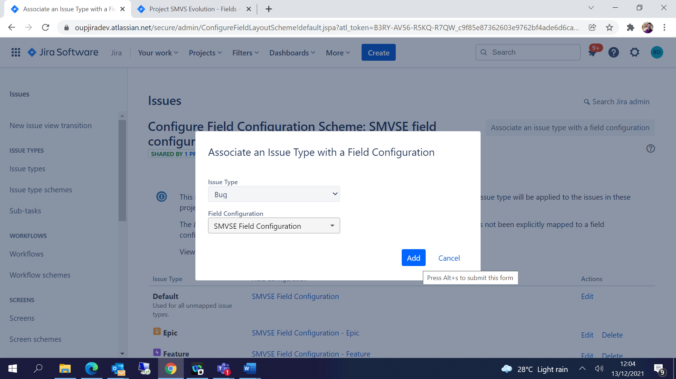

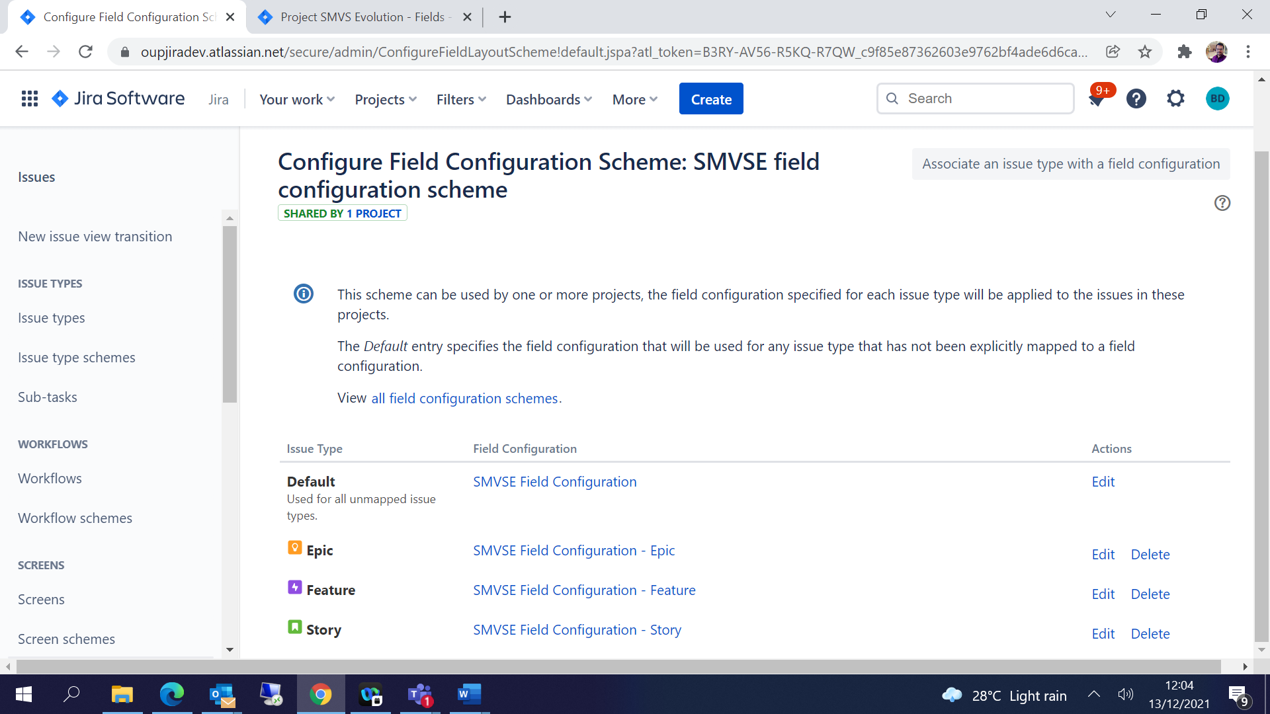

## Assign Field configuration to the project:

Project Settings 🡪Fields 🡪Actions🡪Choose the schema which is created previously and Associate-

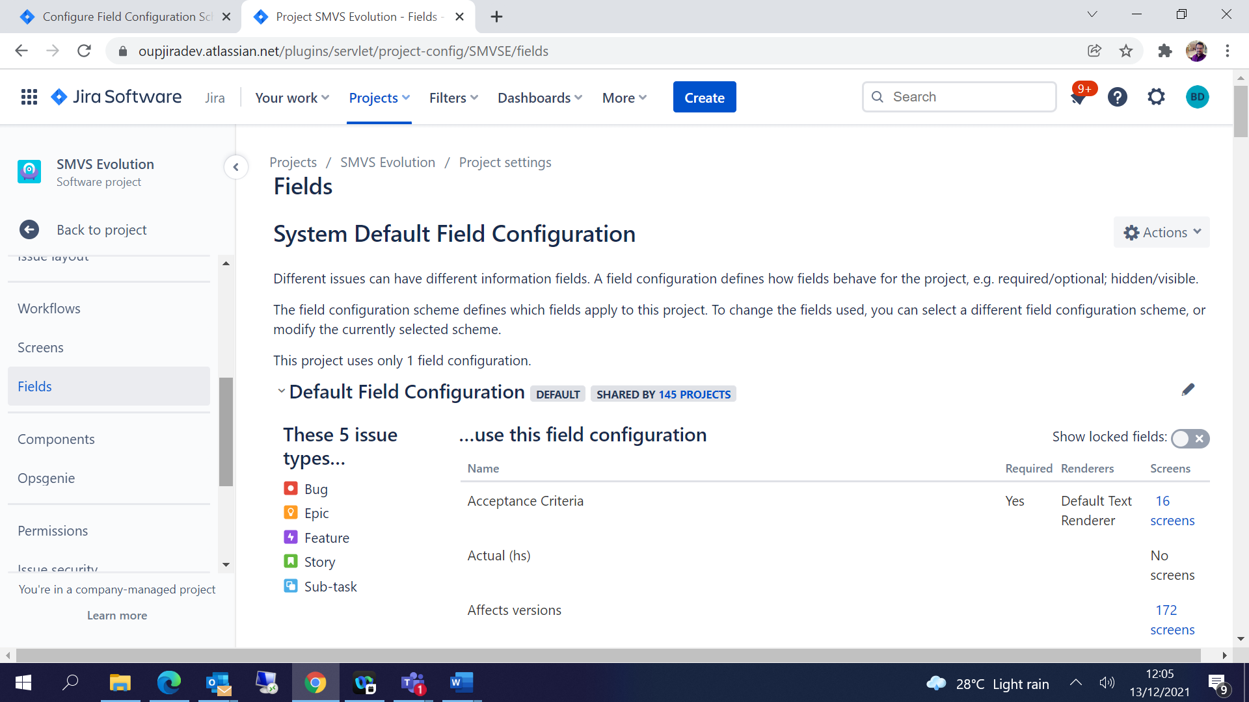

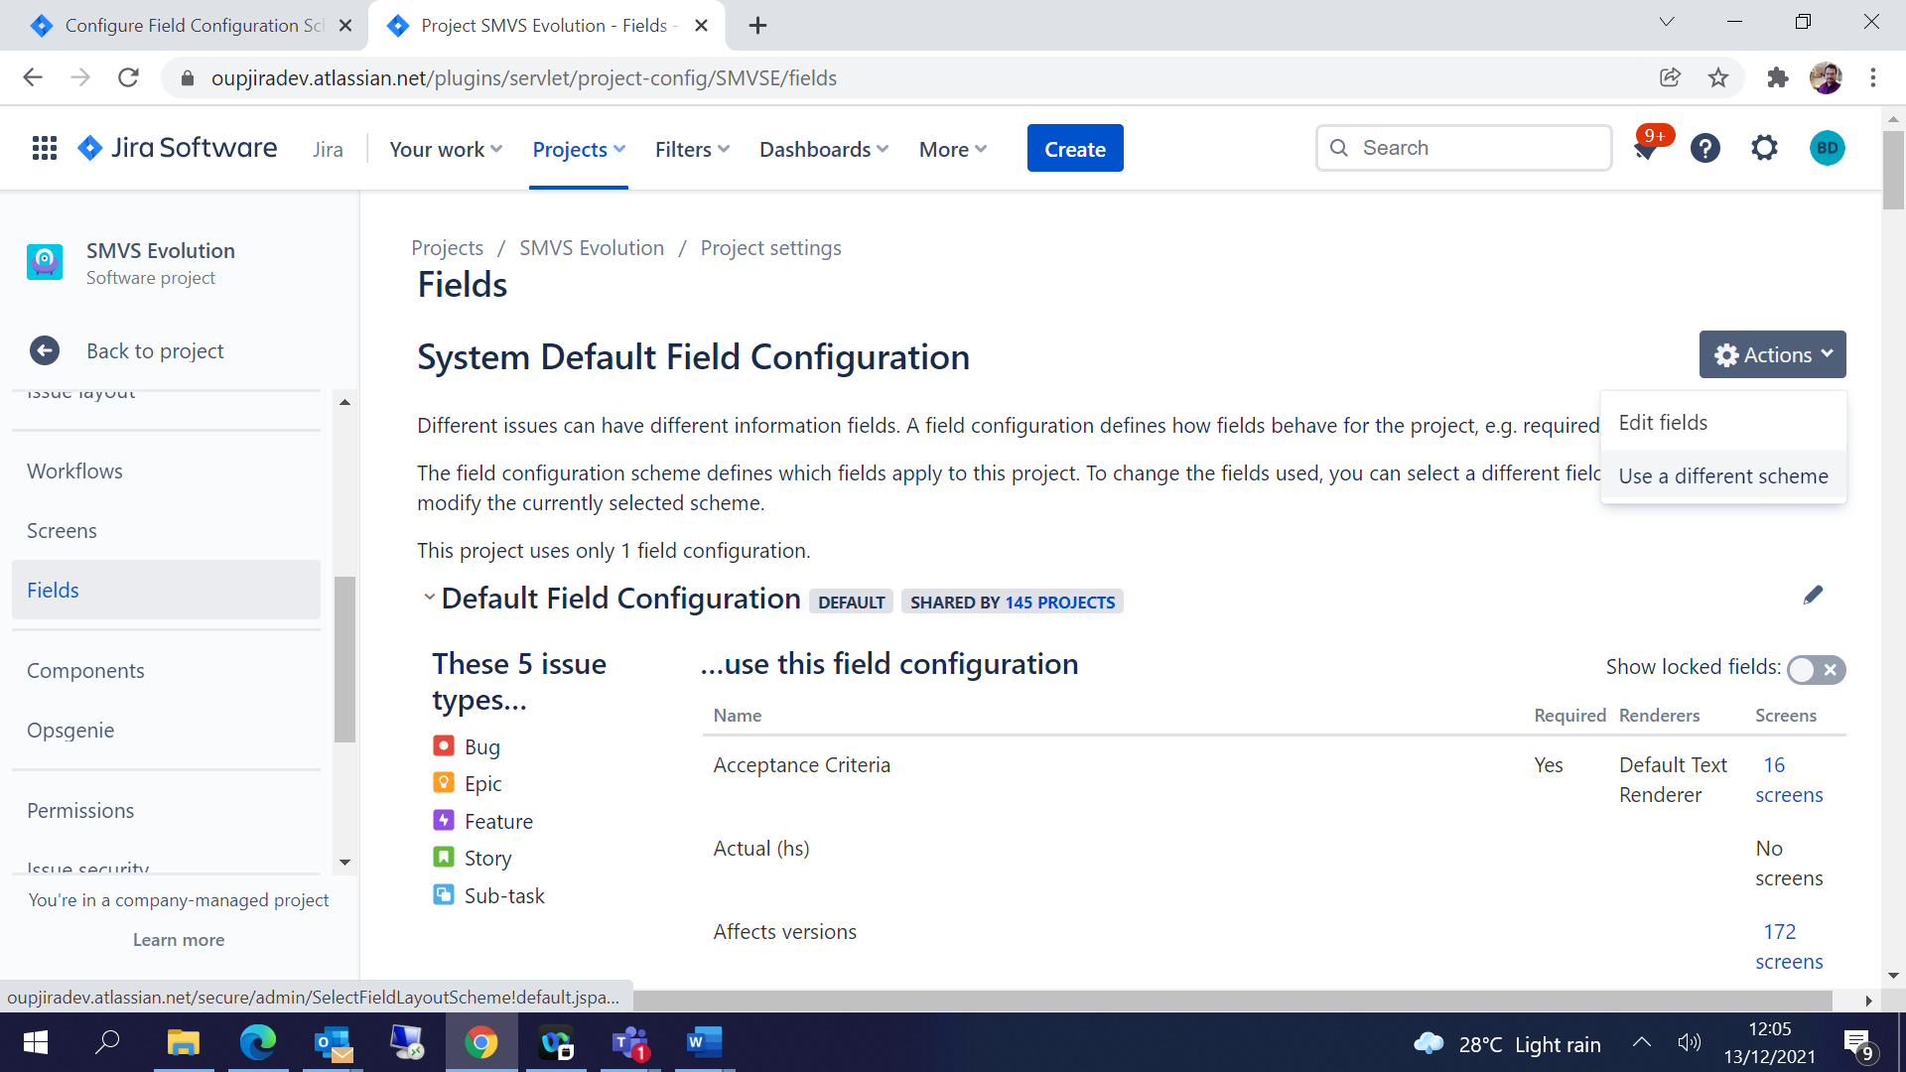

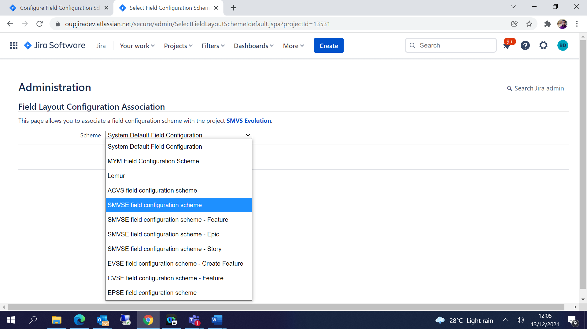

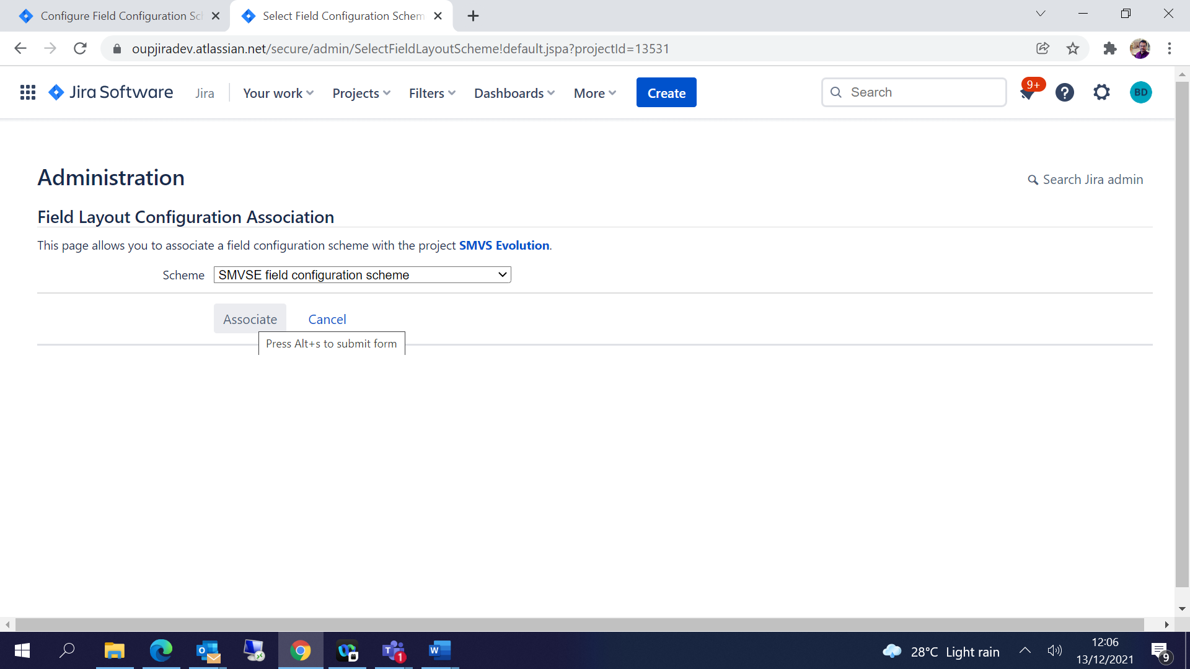

Each issue type can have its own field configuration.

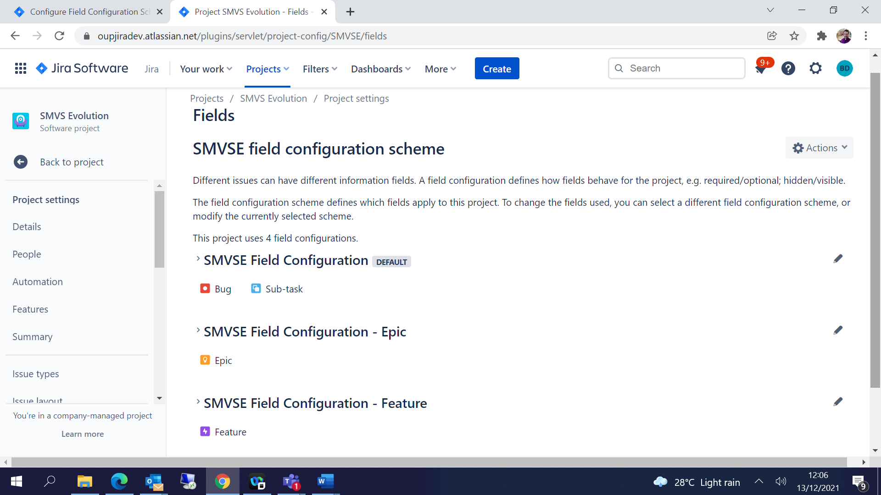

## Screens Configuration:

Issue type screen schemes-

Click on Issue type screen schemes 🡪 Add/ copy Issue type screen scheme which you need🡪 Give some name and save / Copy

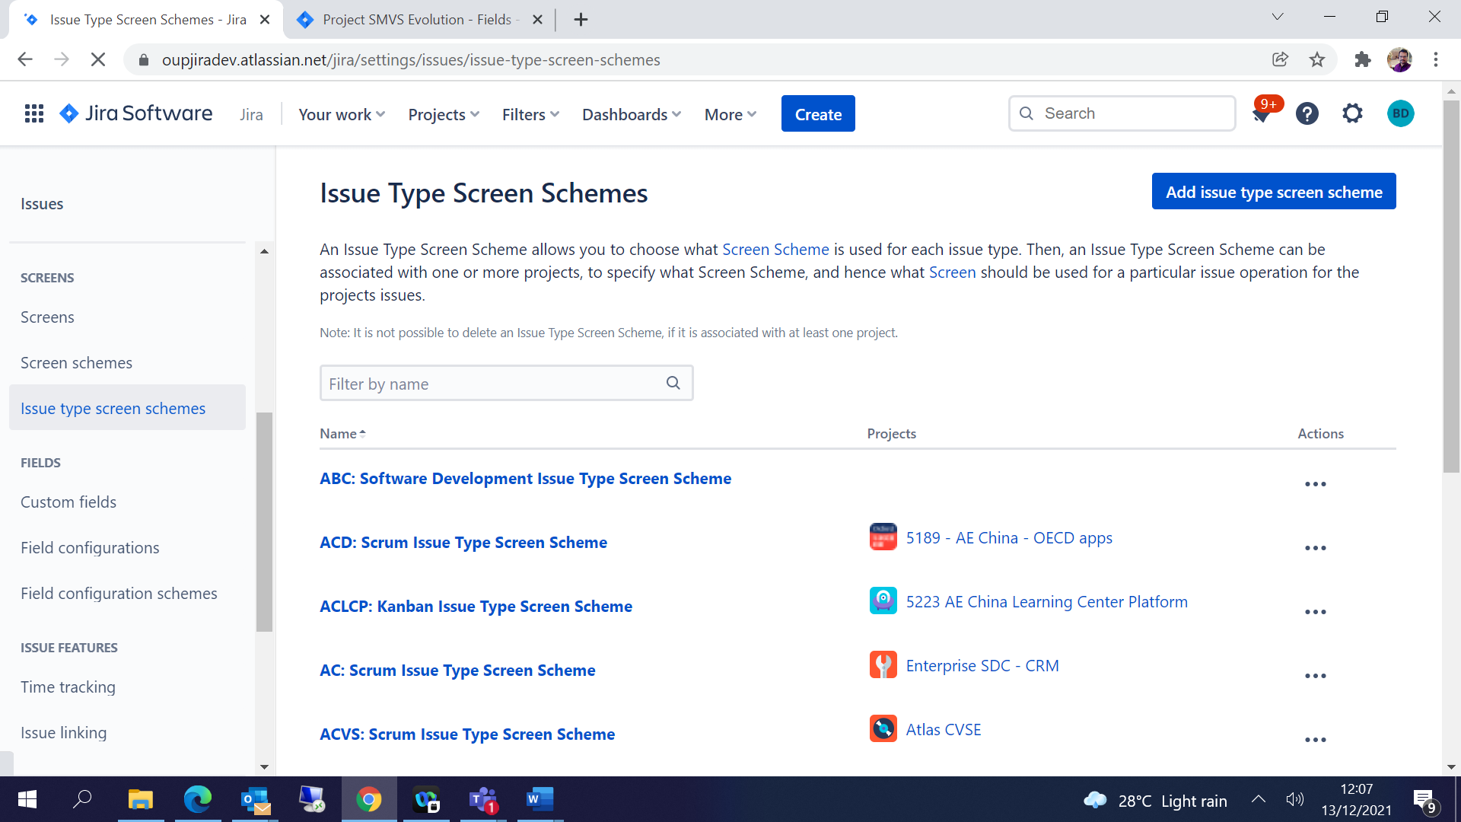

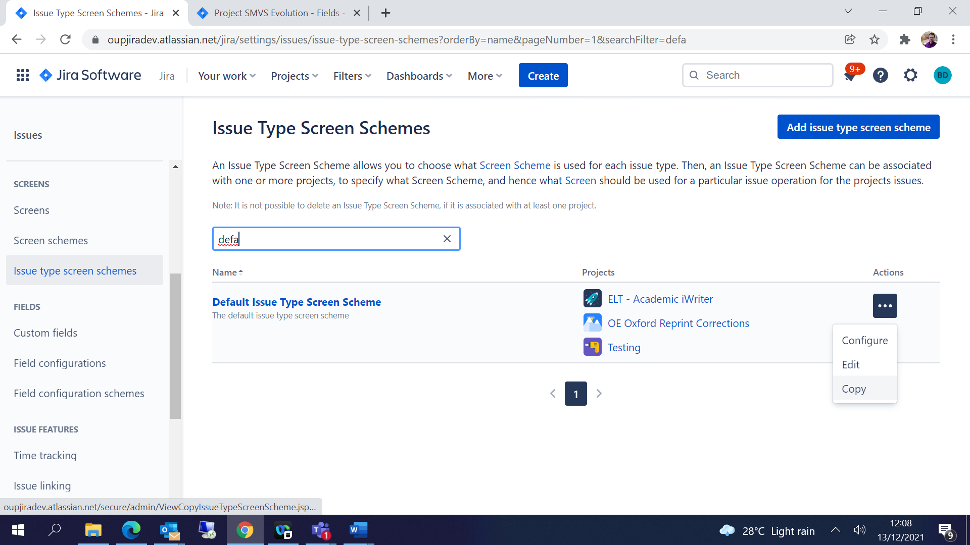

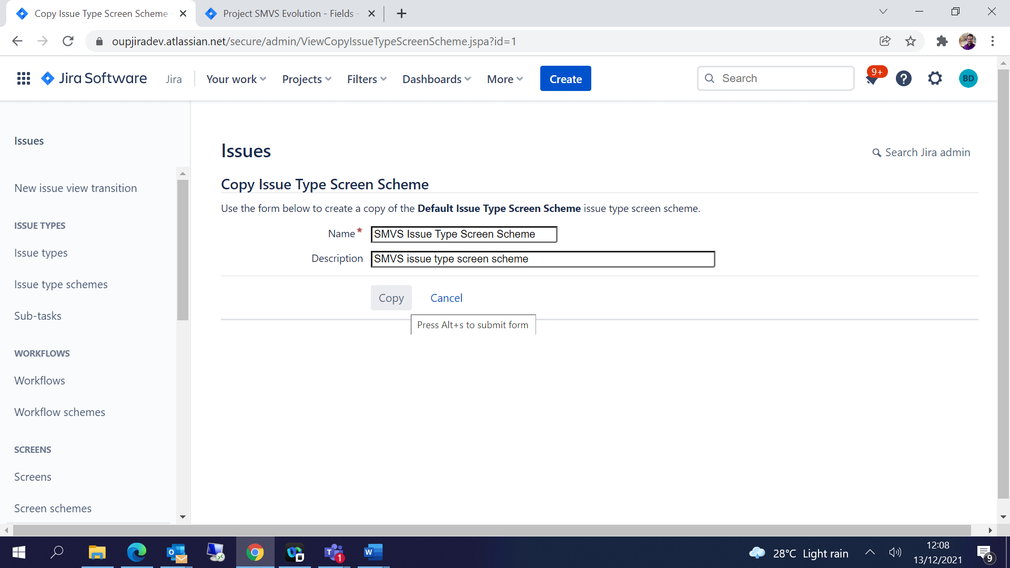

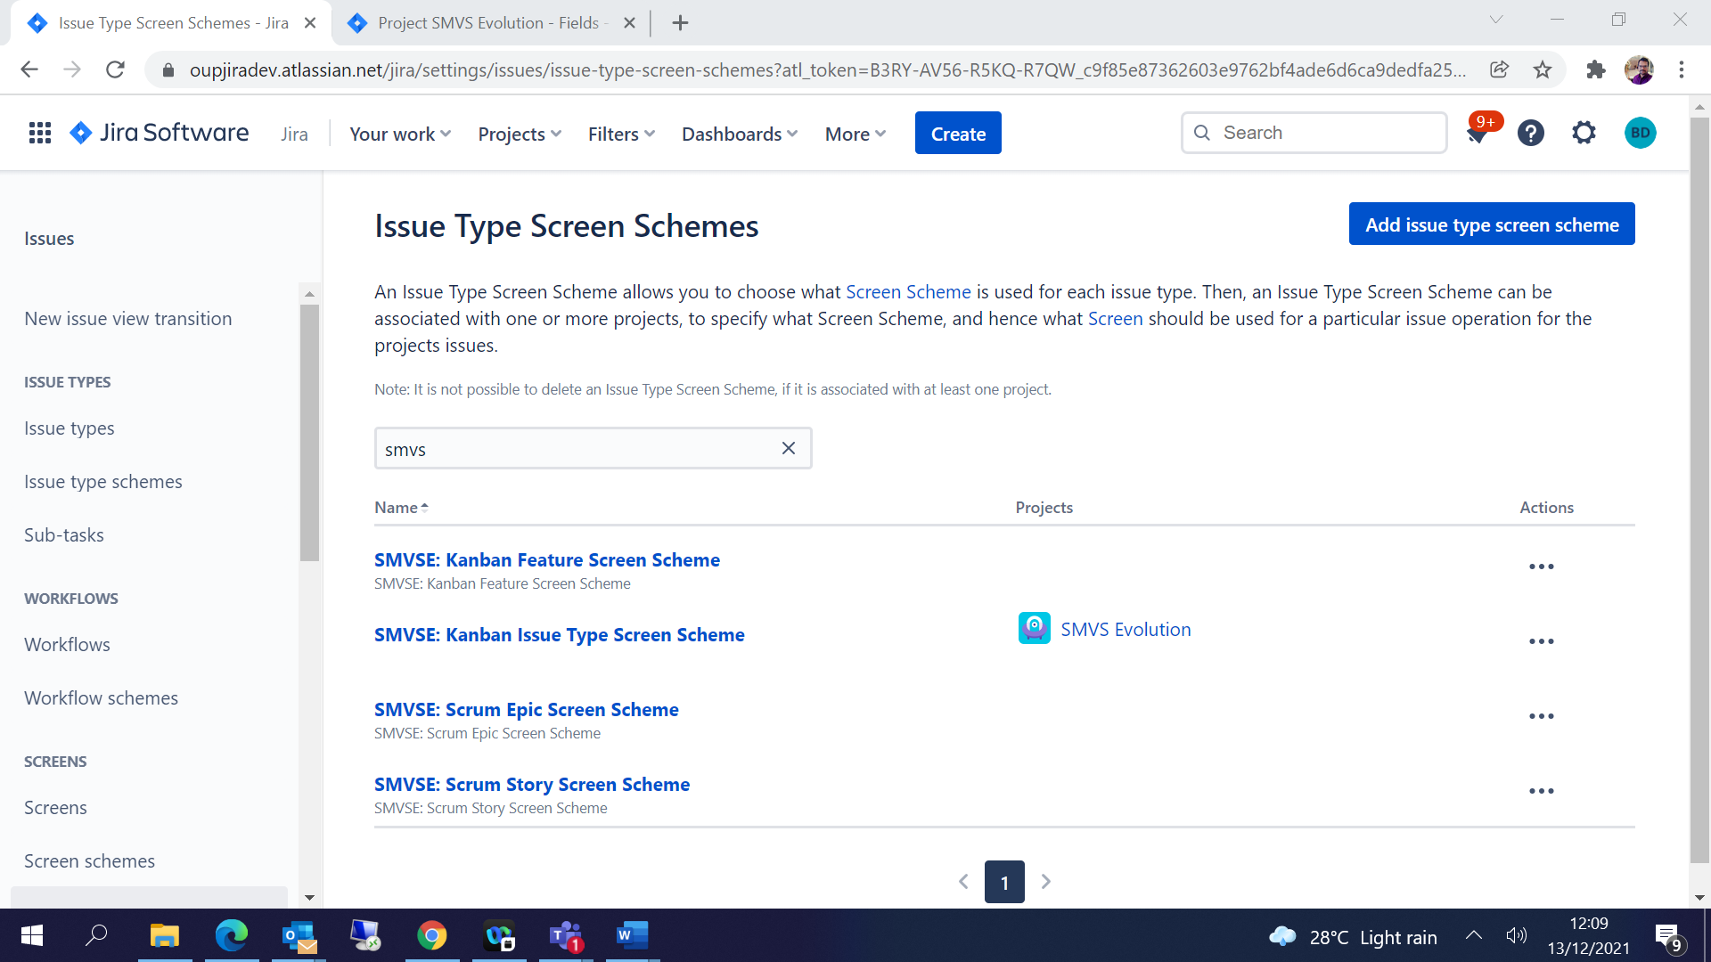

Screen schemes-

Click on Screen schemes 🡪 Add/ copy screen scheme which you need🡪 Give some name and save / Copy

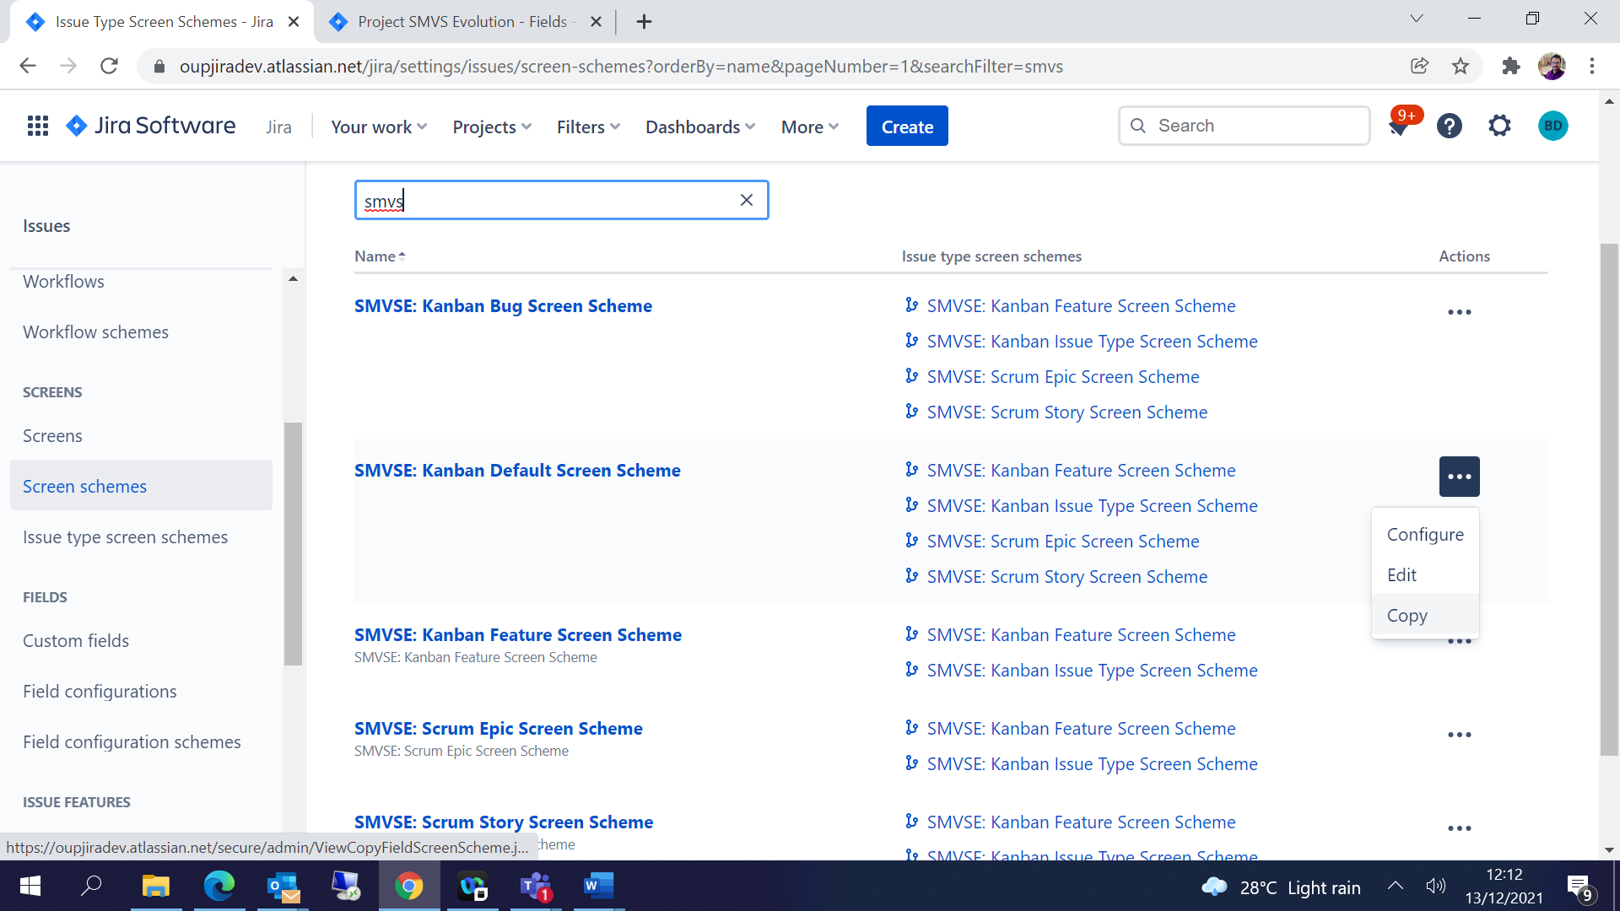

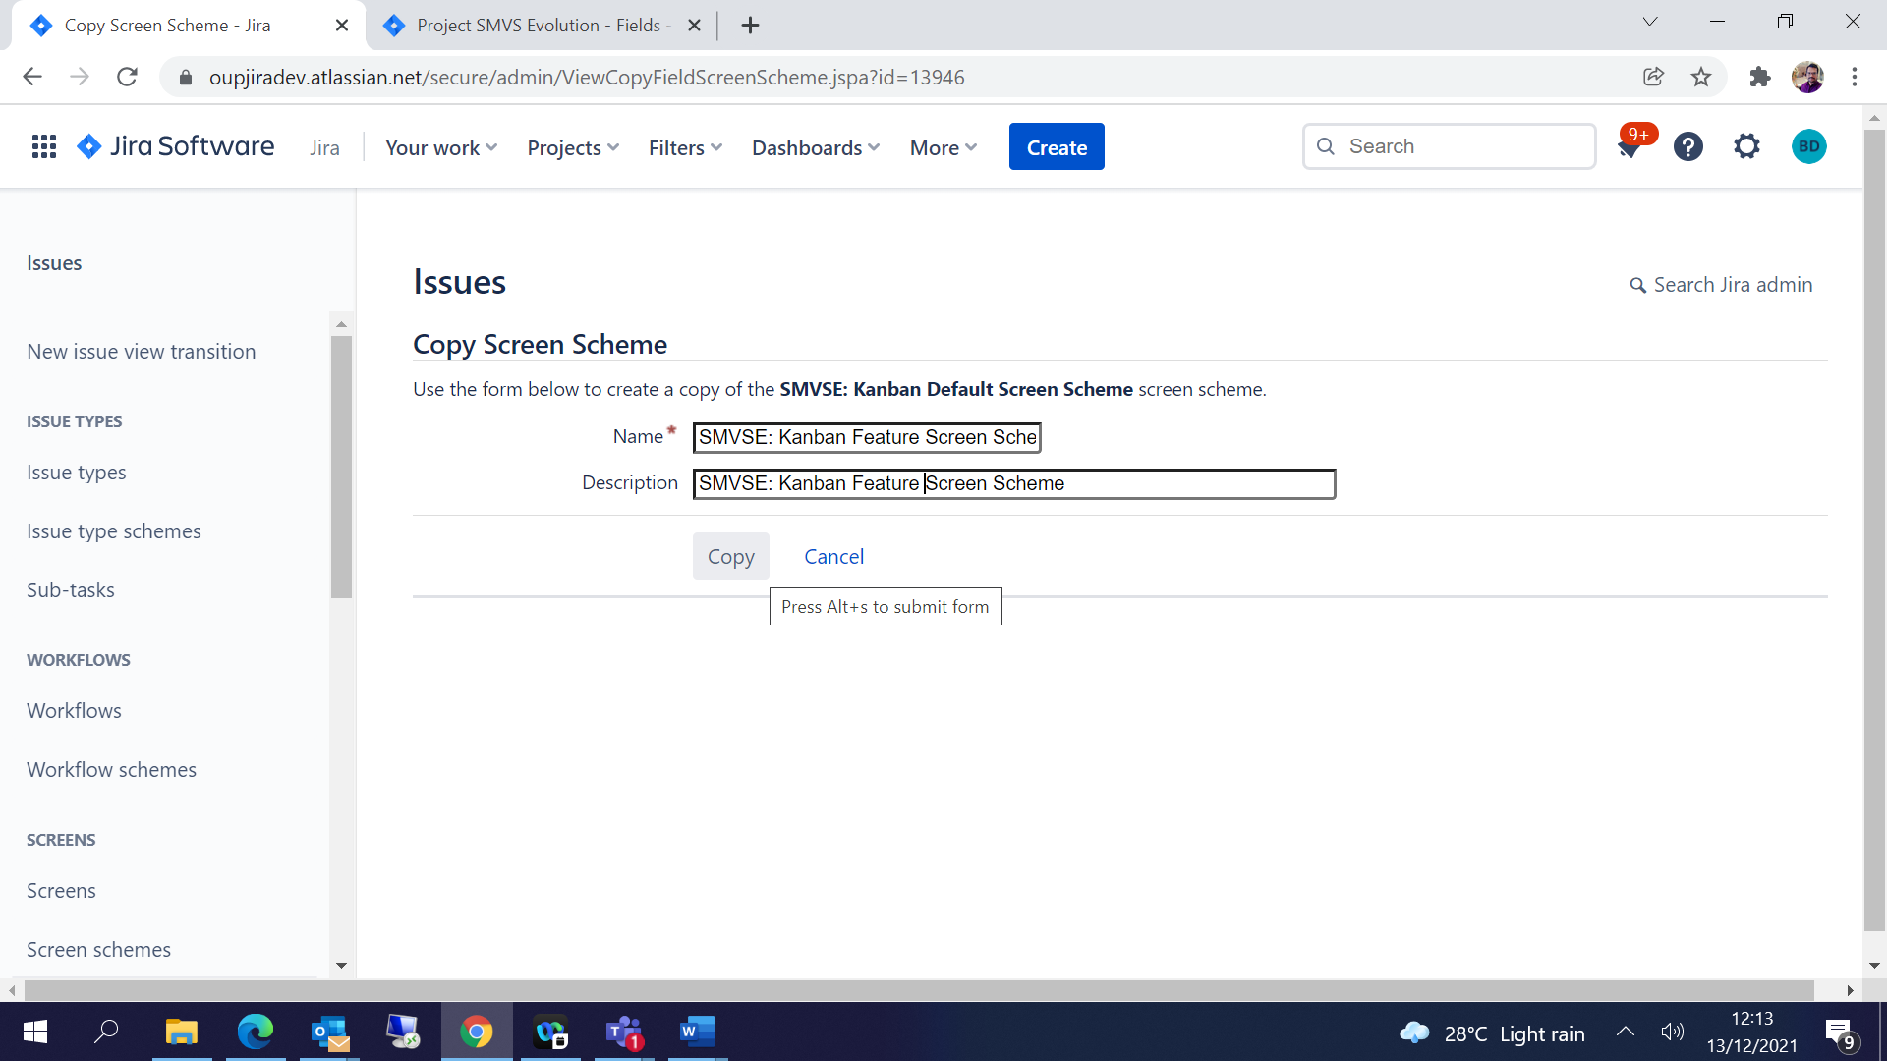

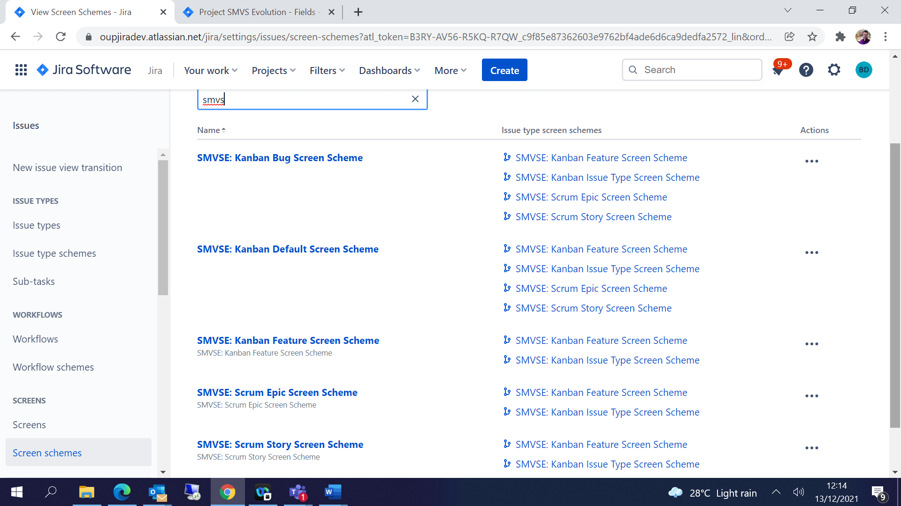

Screens:

Click on Screens 🡪 Add/ copy screens which you need🡪 Give some name and save / Copy

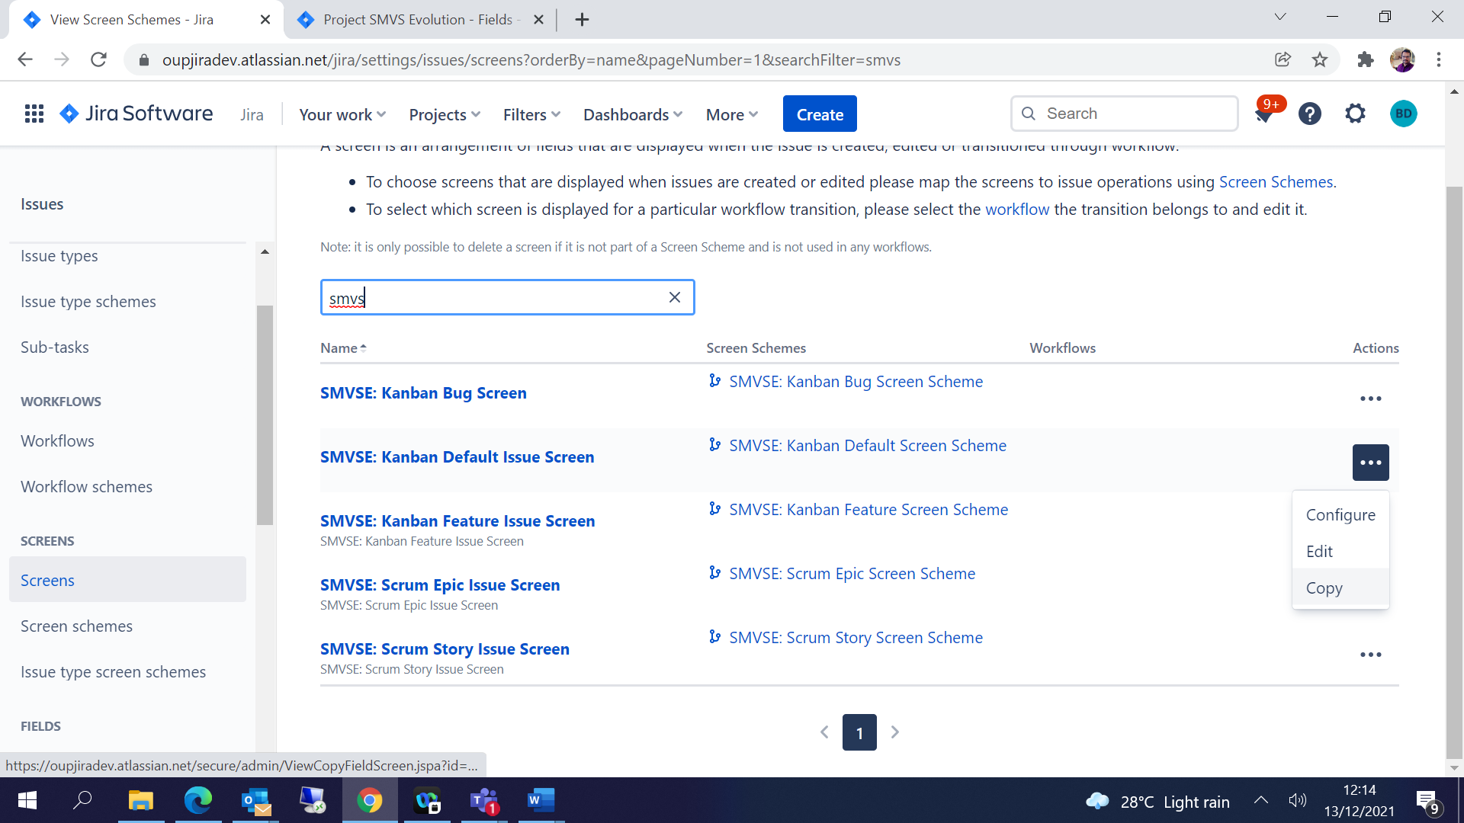

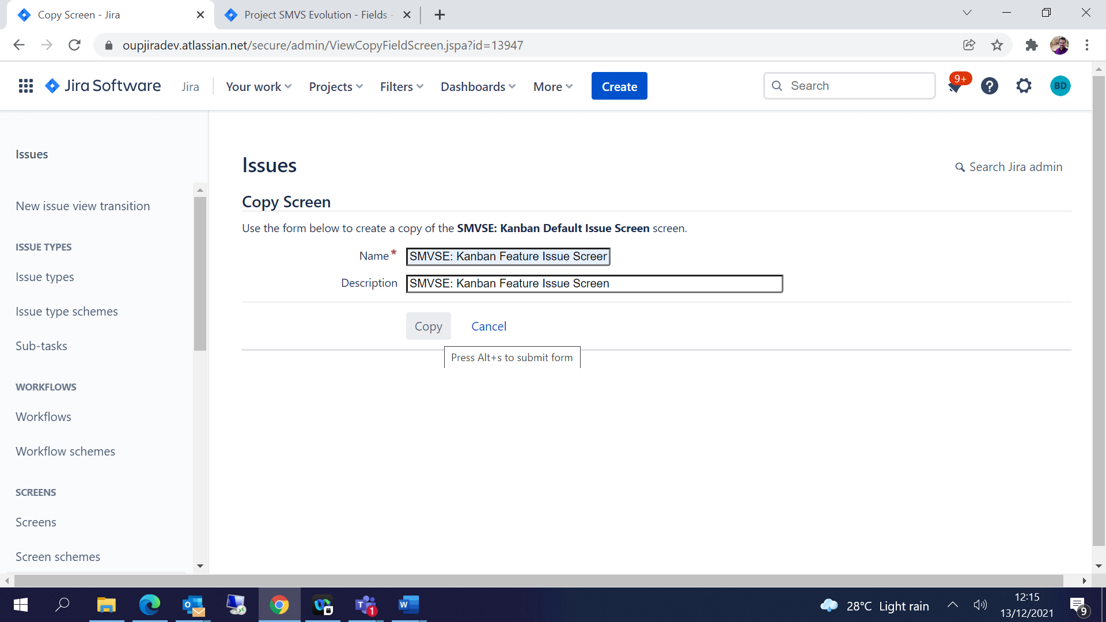

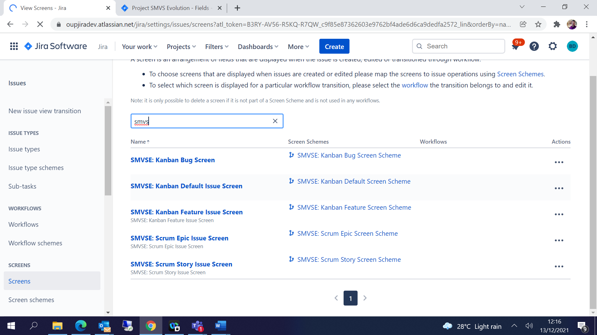

Configure screens-

Click on … 🡪Configure 🡪 you can add / remove the fields as per the requirement-

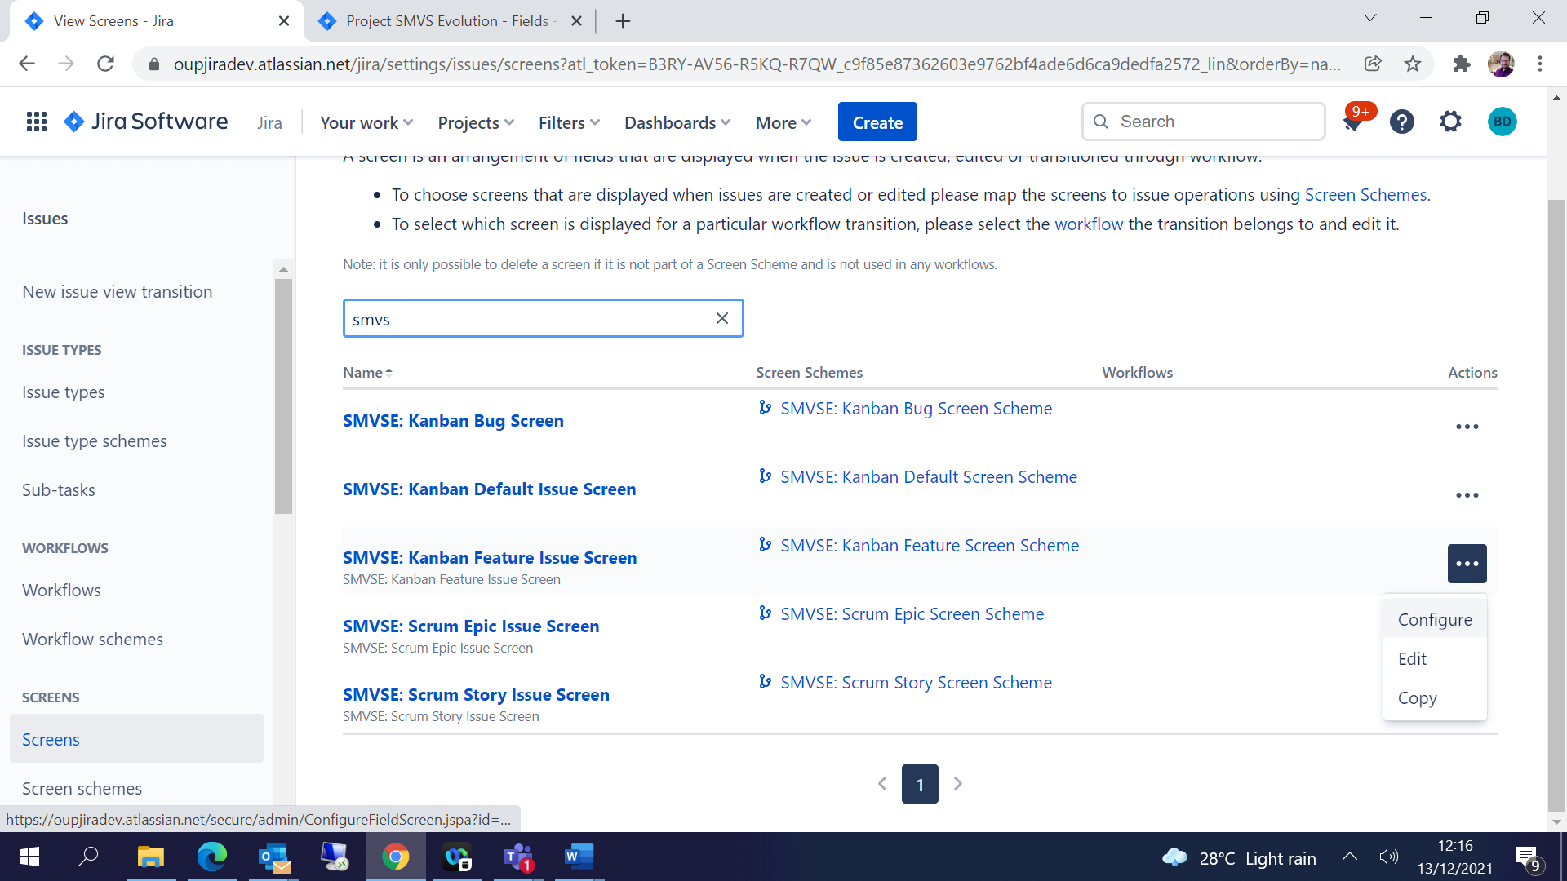

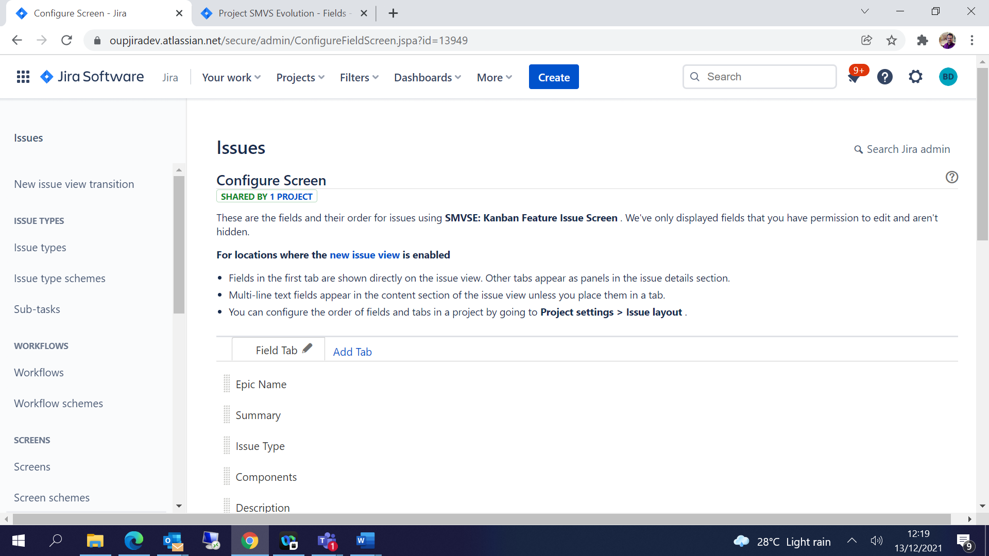

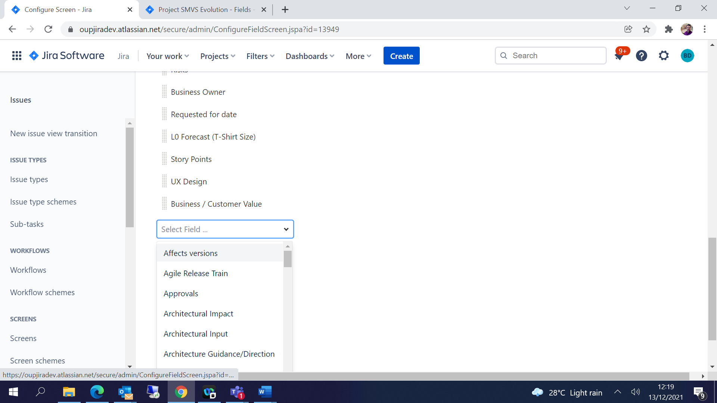

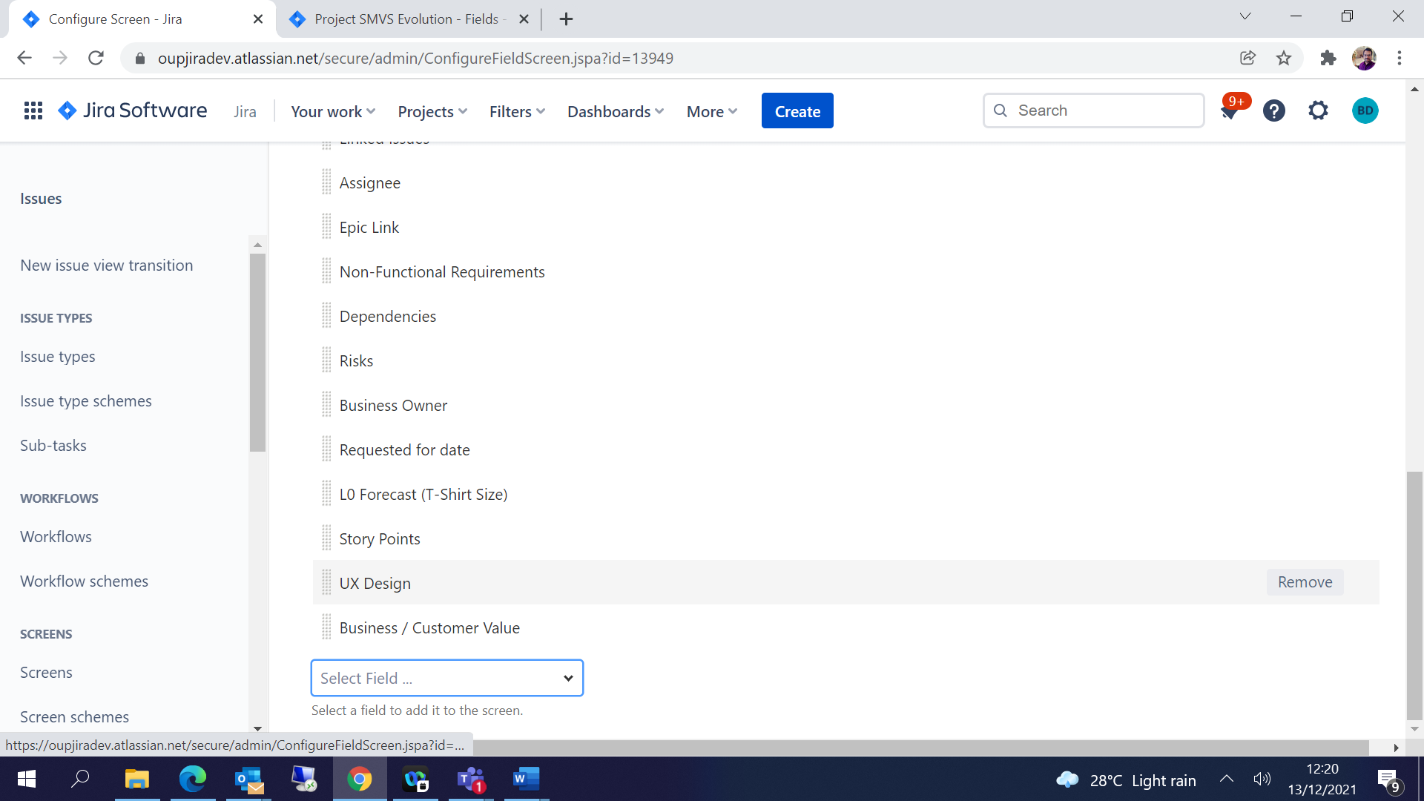

Configure screen scheme:

Click on … 🡪Configure 🡪 Edit and add the screen which is created in the previous step

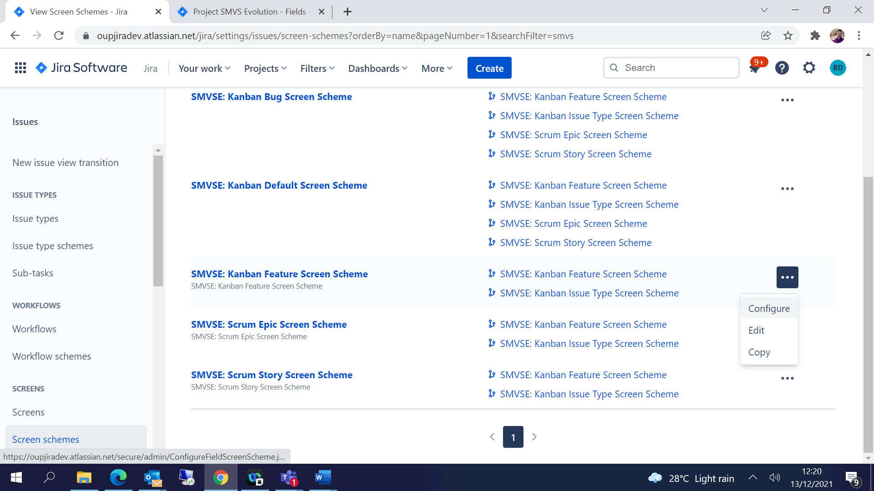

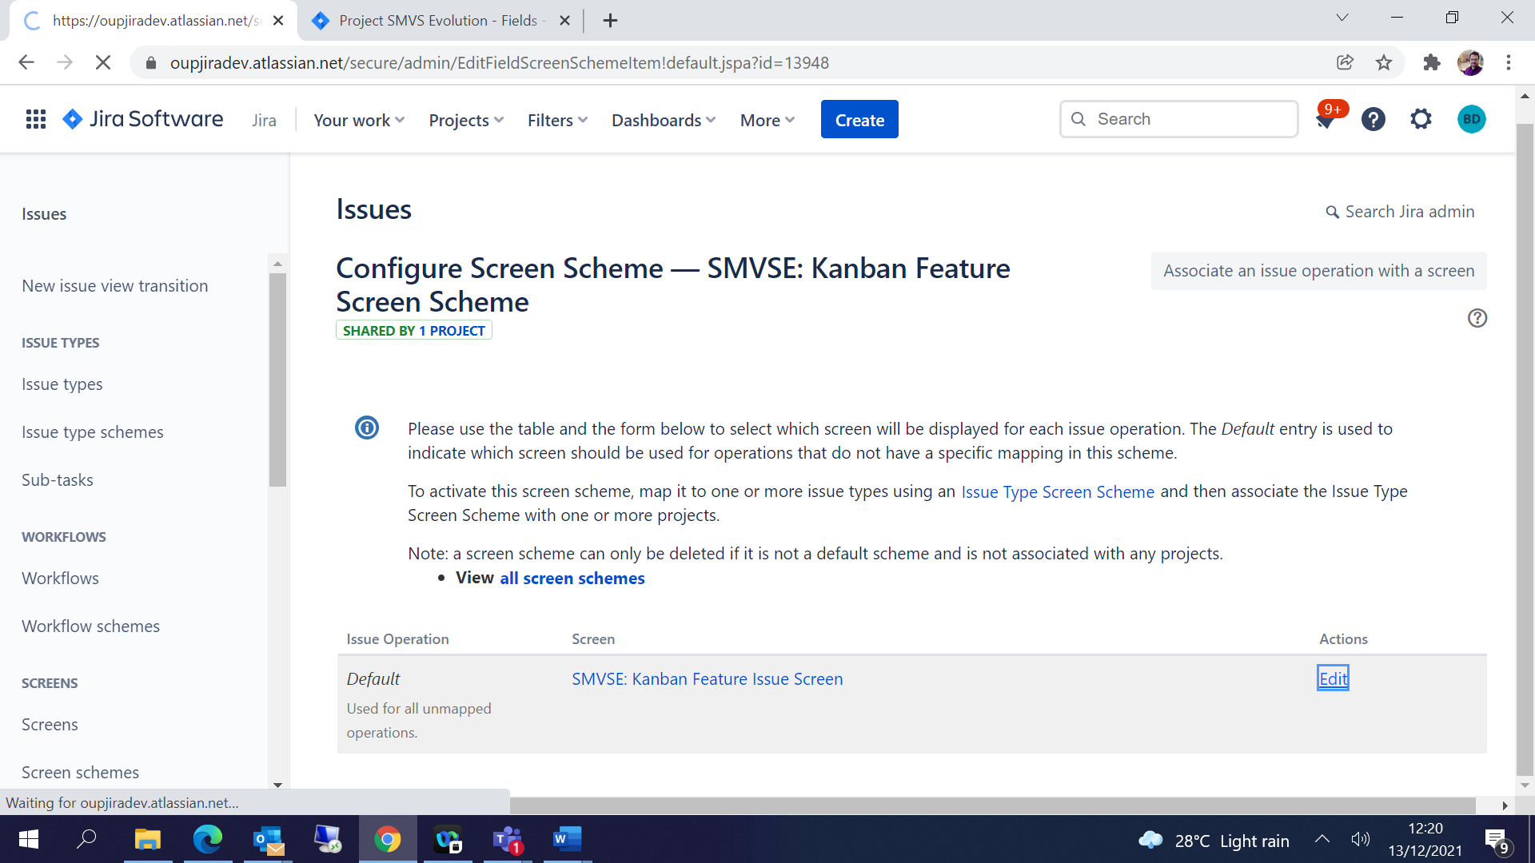

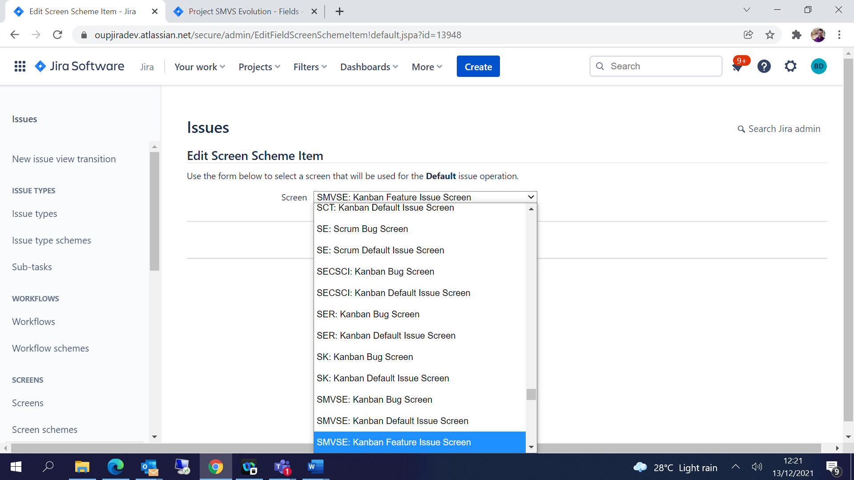

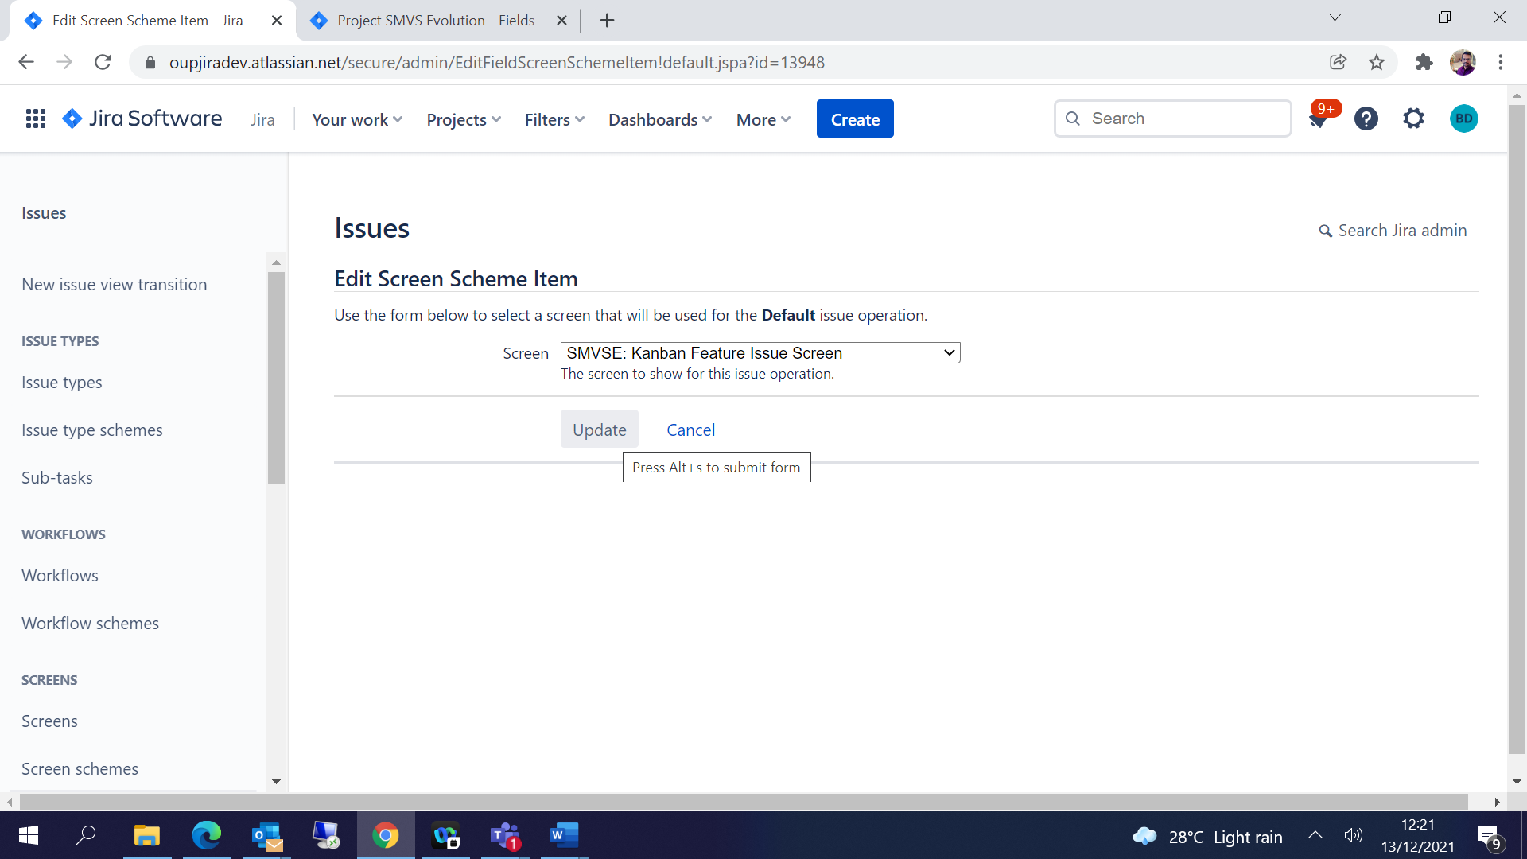

Configure issue type screen schemes:

Click on … 🡪Configure

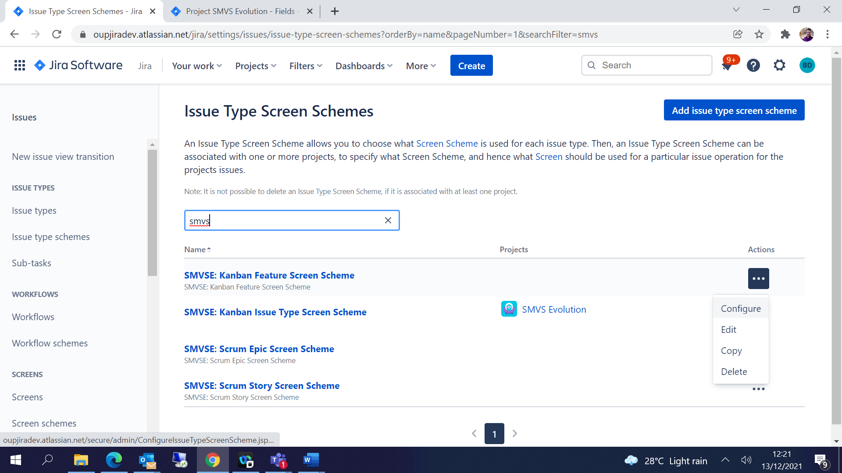

Click 🡪 Associate an issue type with a screen scheme🡪 choose issue type and screen🡪 Add-

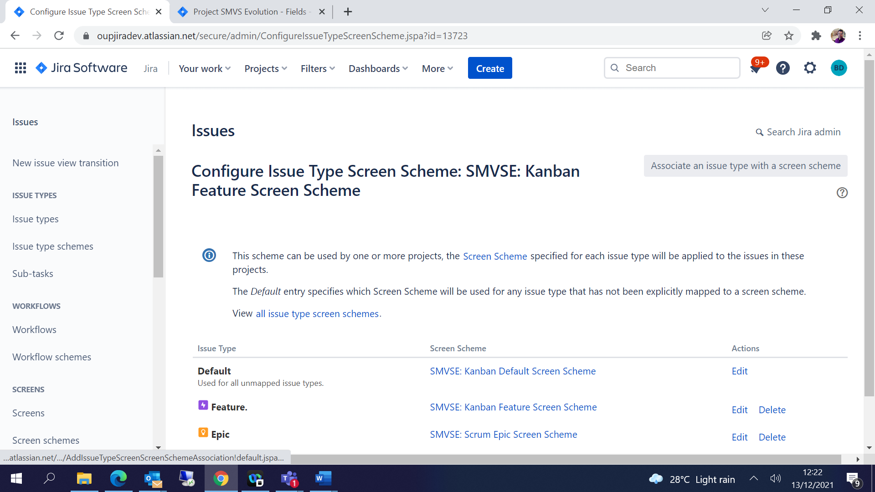

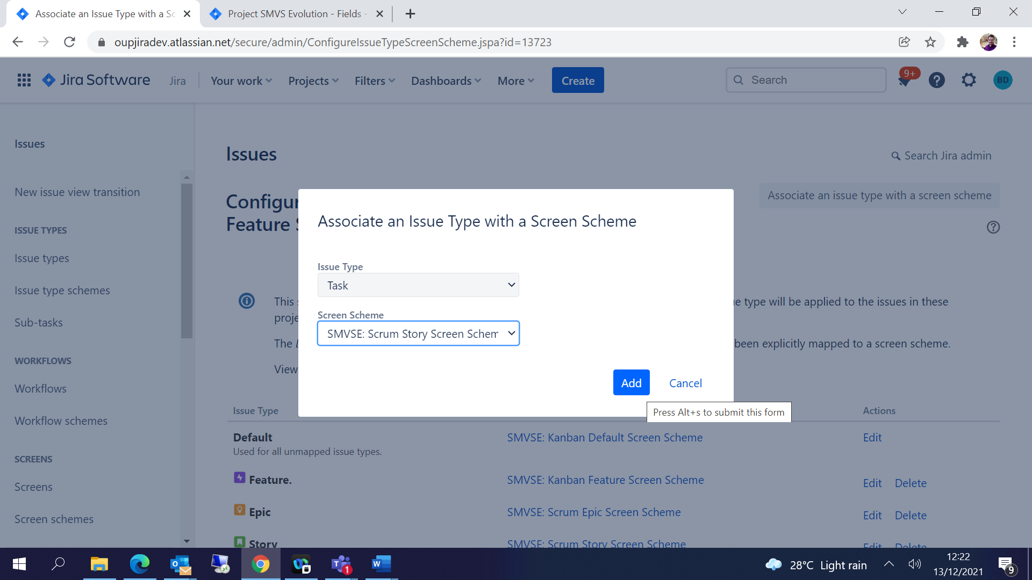

Each issue type can have its own screen schemes.

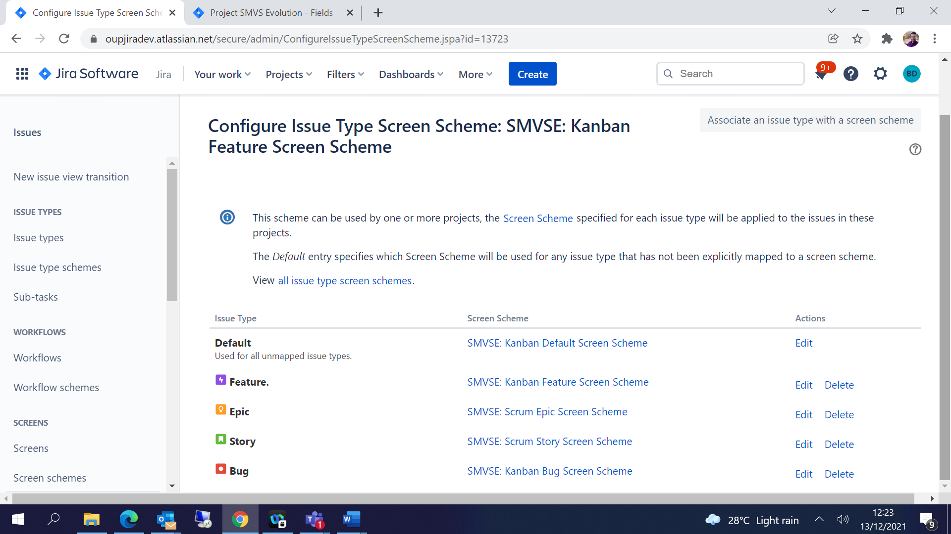

Assign the screens created for the project:

Click 🡪 Actions🡪 Use a different scheme🡪choose the **Issue type screen scheme** created as per the requirement-

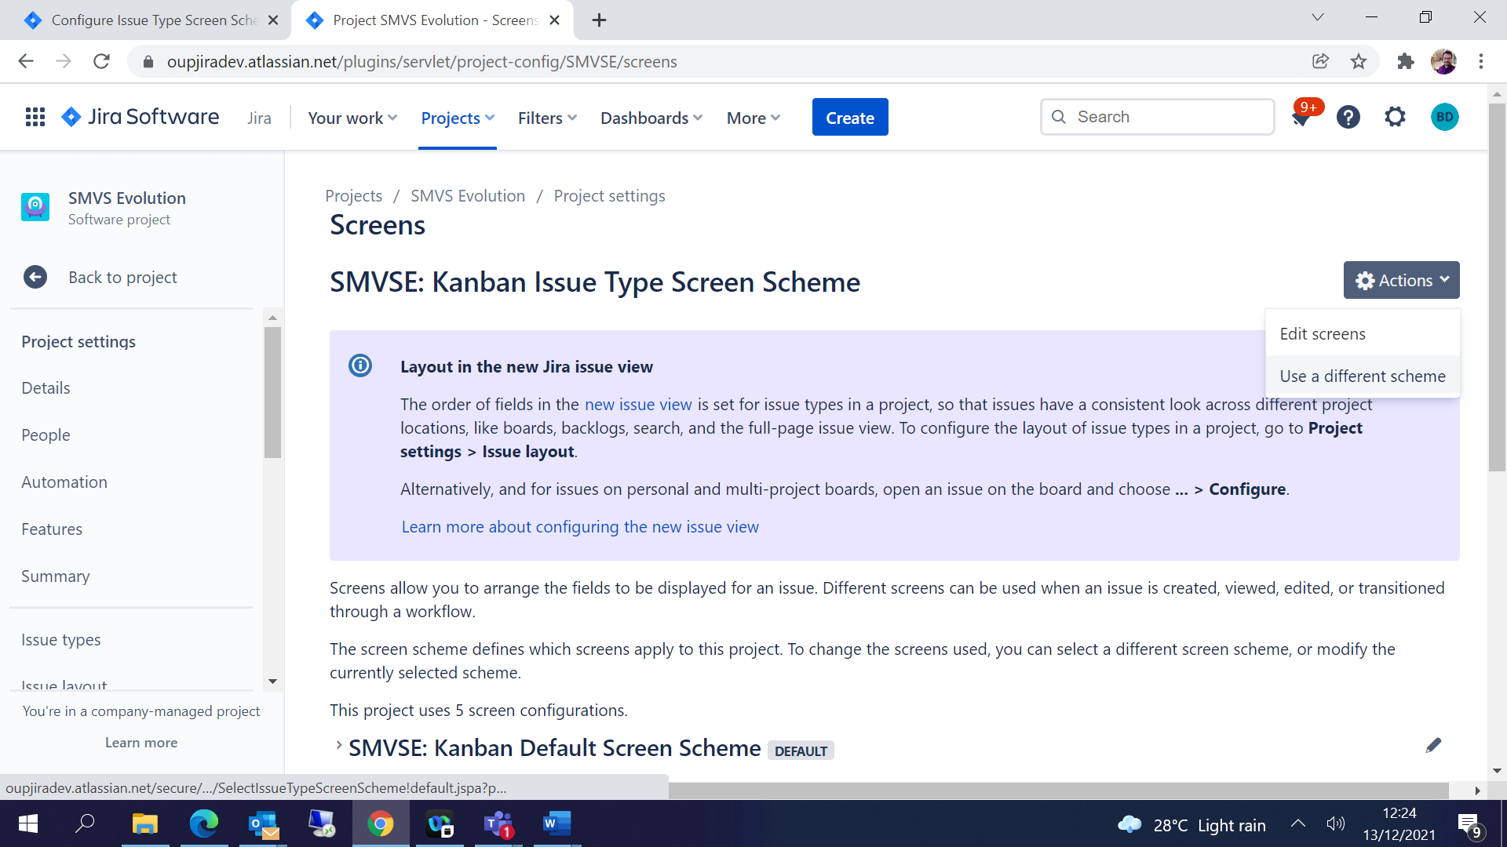

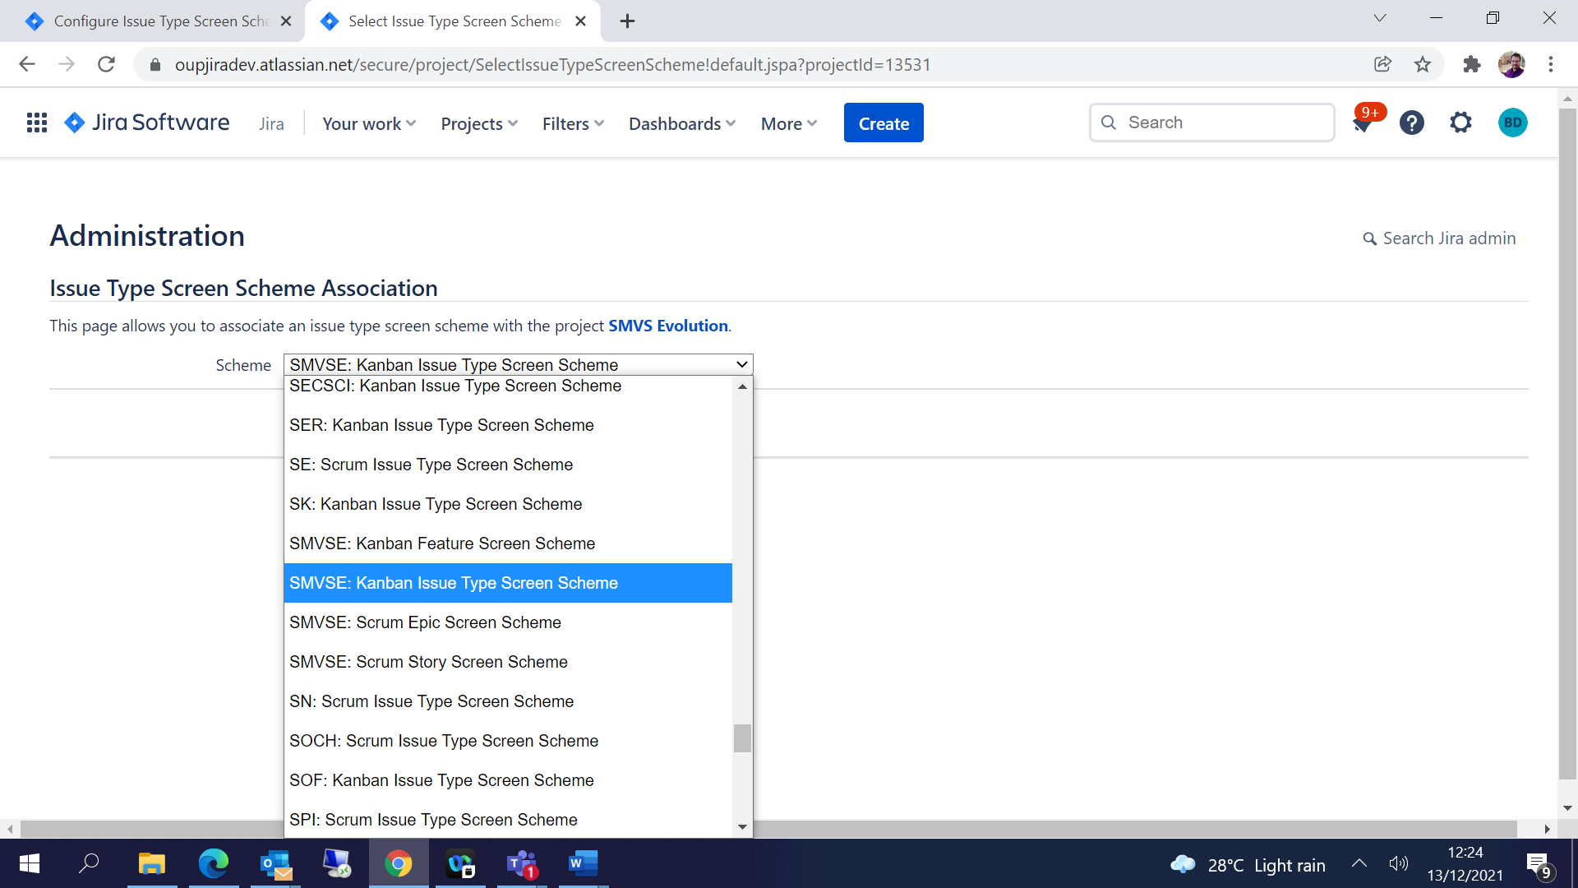

Click 🡪 Associate

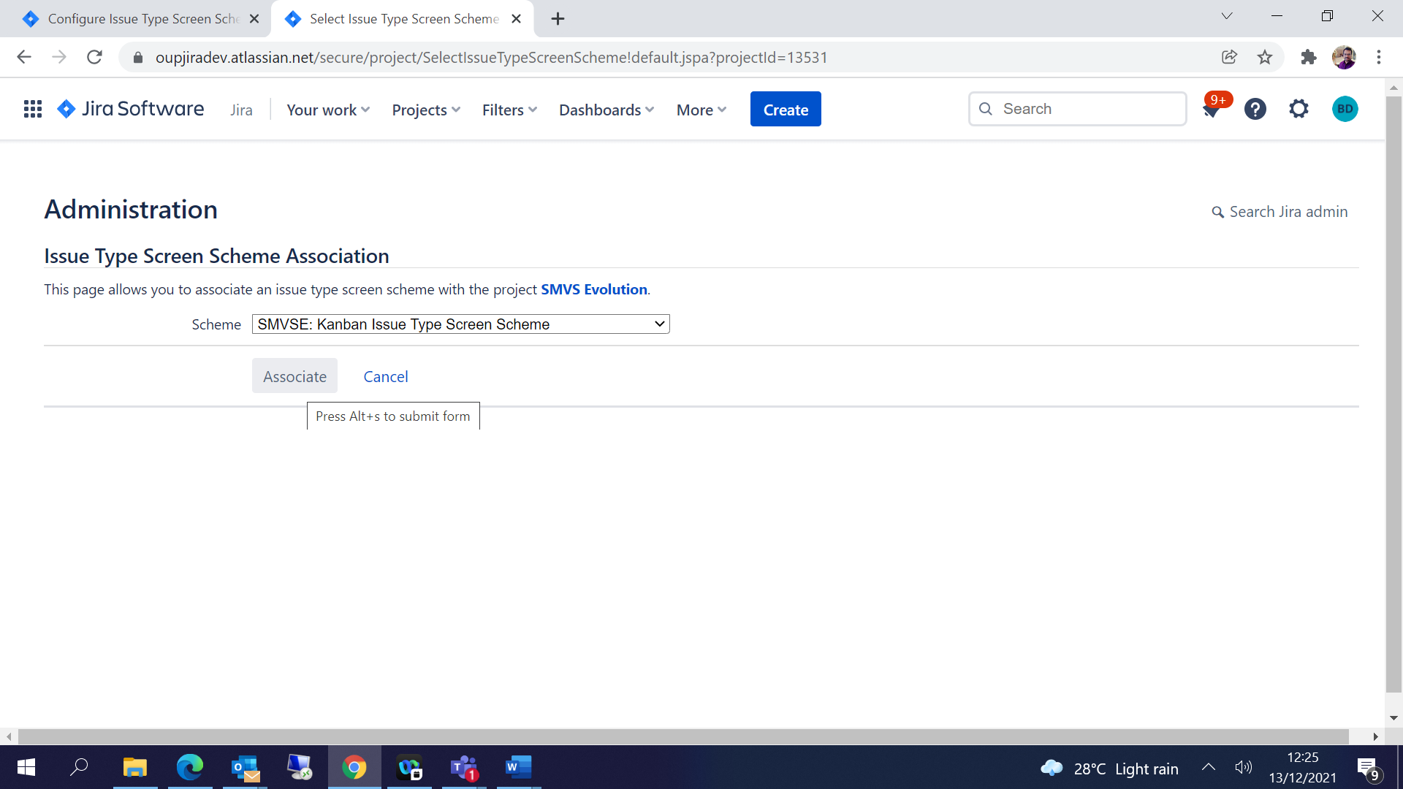

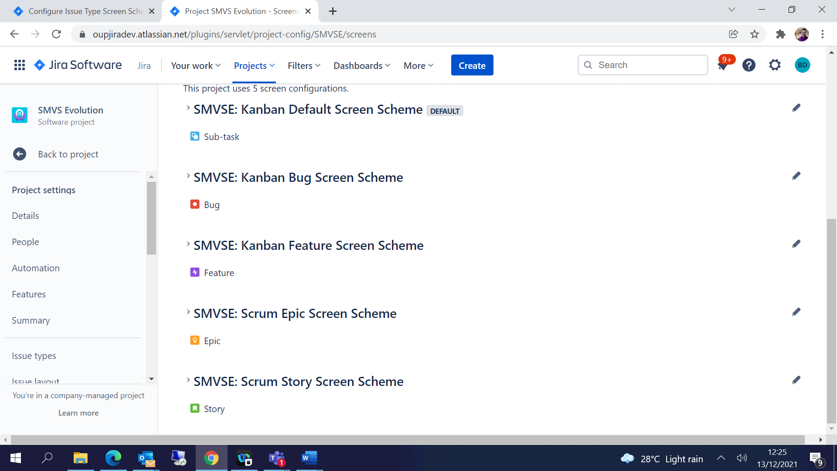

## Workflow Configuration:

JIRA Settings 🡪 Issues 🡪 Click on Workflow from left pane -

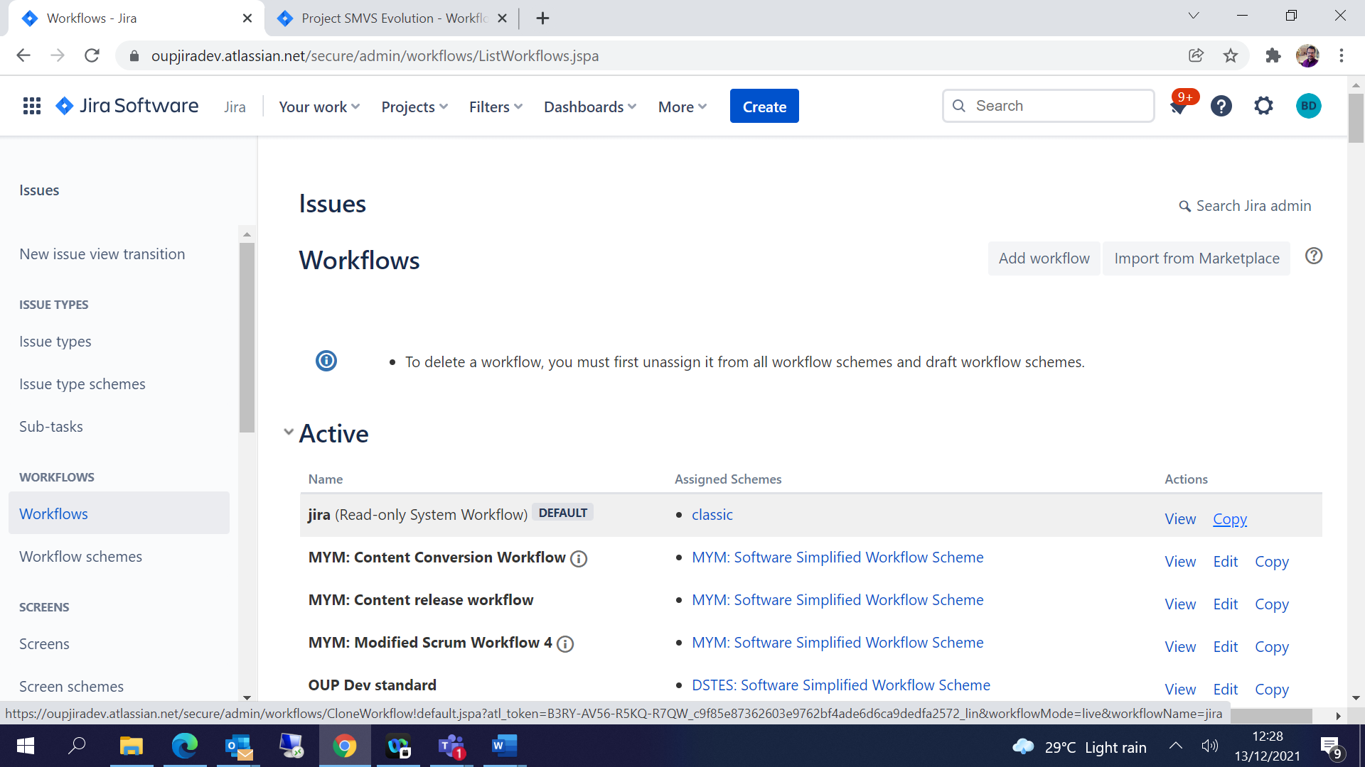

Copy / Add any existing workflow -

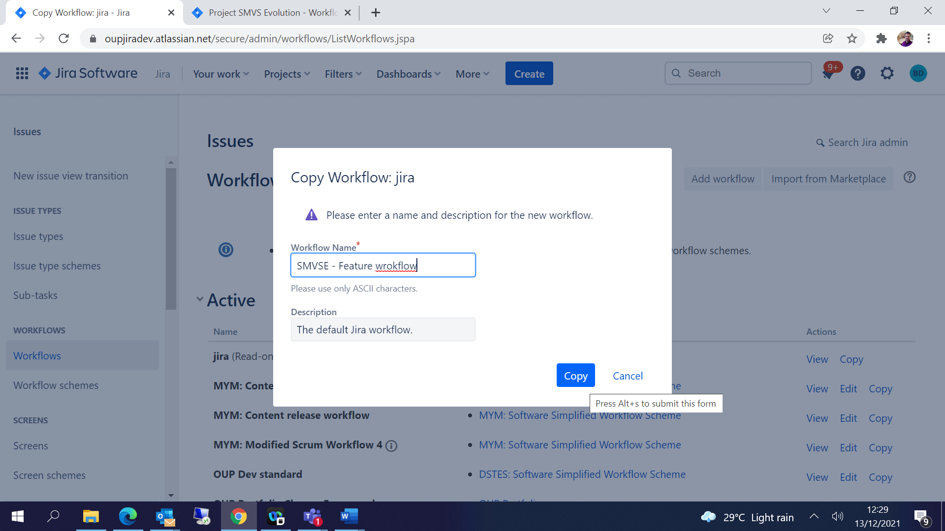

The workflow will move to Inactive list 🡪

Under Inactive 🡪 Edit the workflow

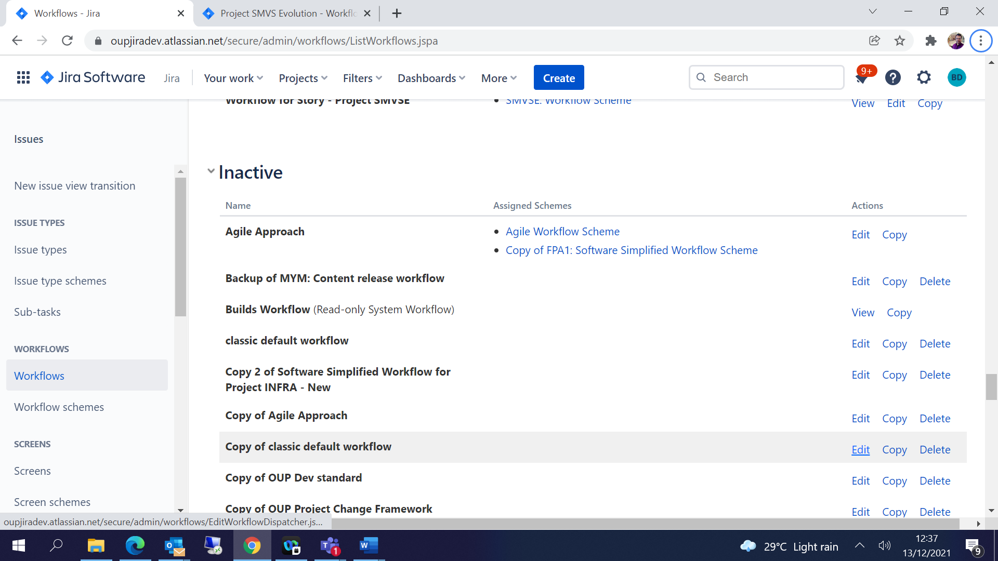

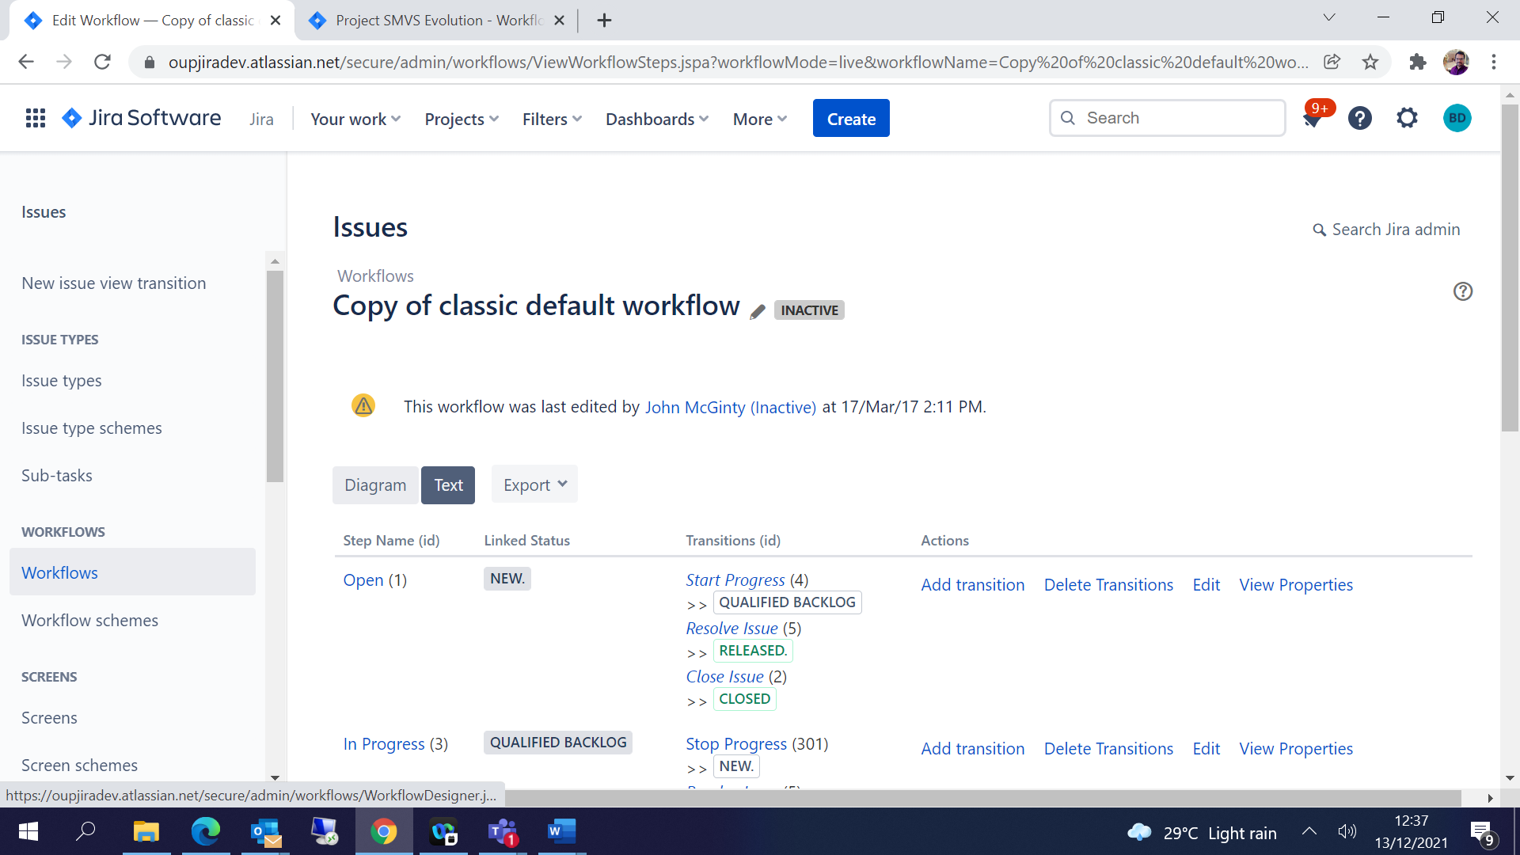

Select Diagram 🡪 Add Status based on requirements 🡪

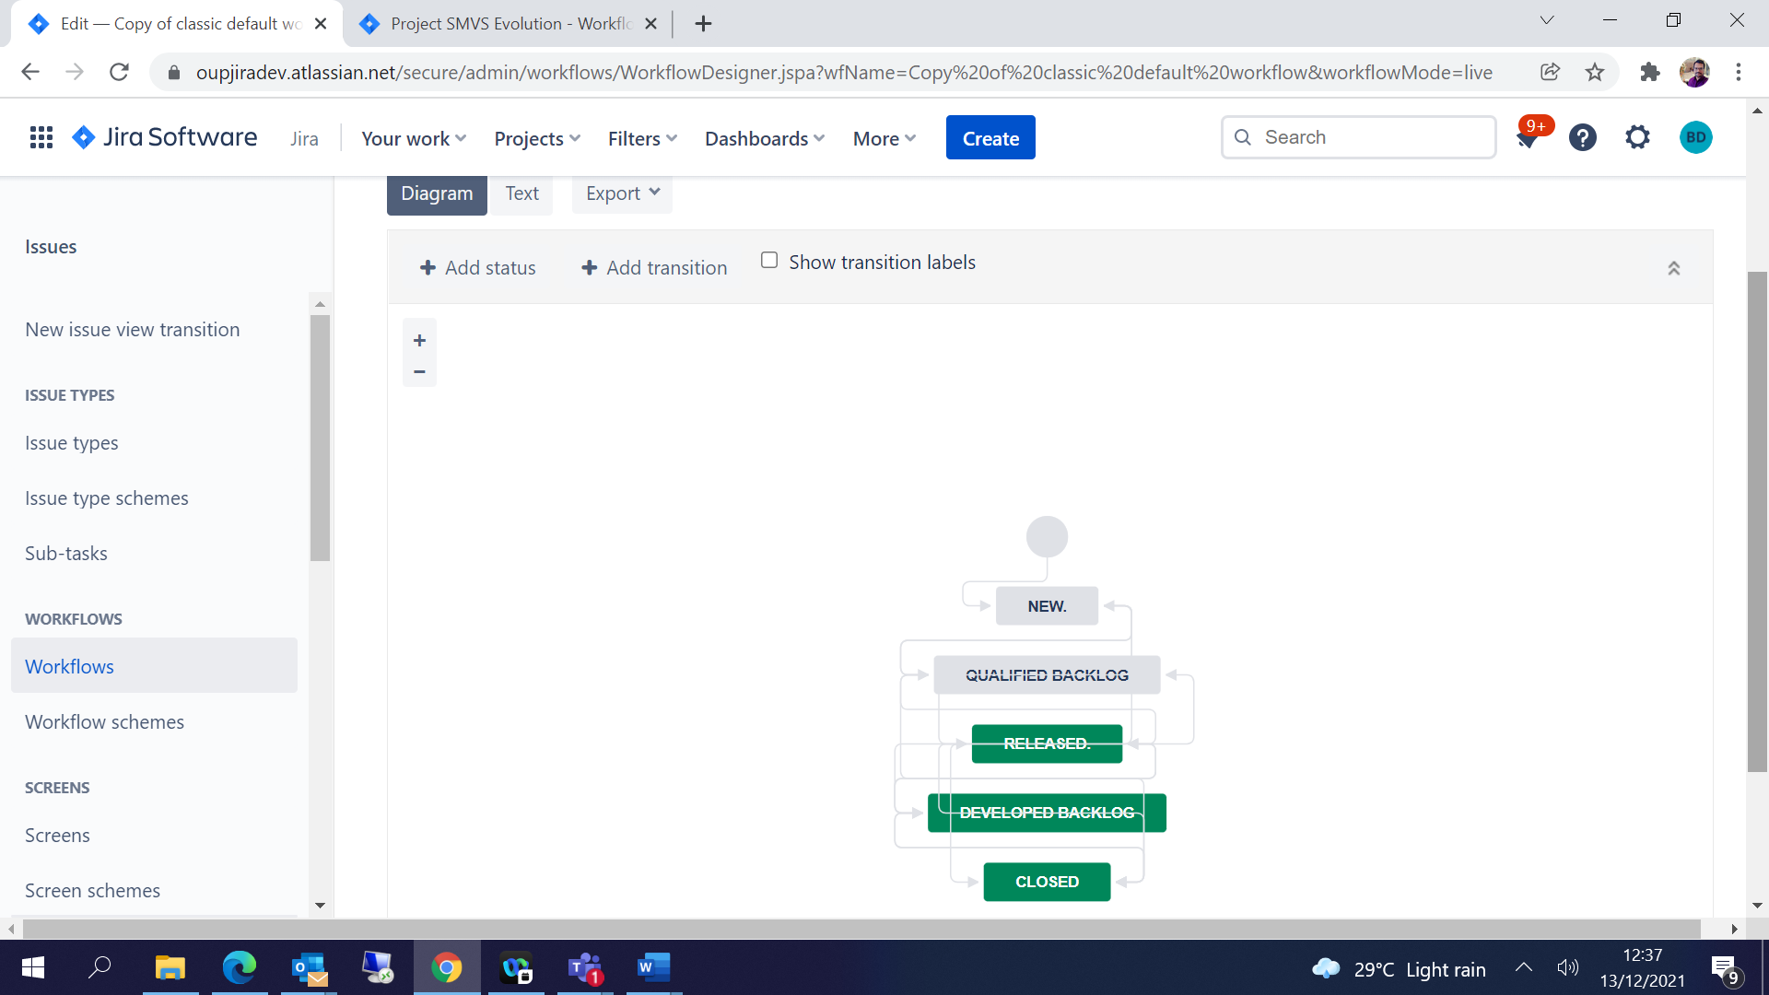

Add Status –

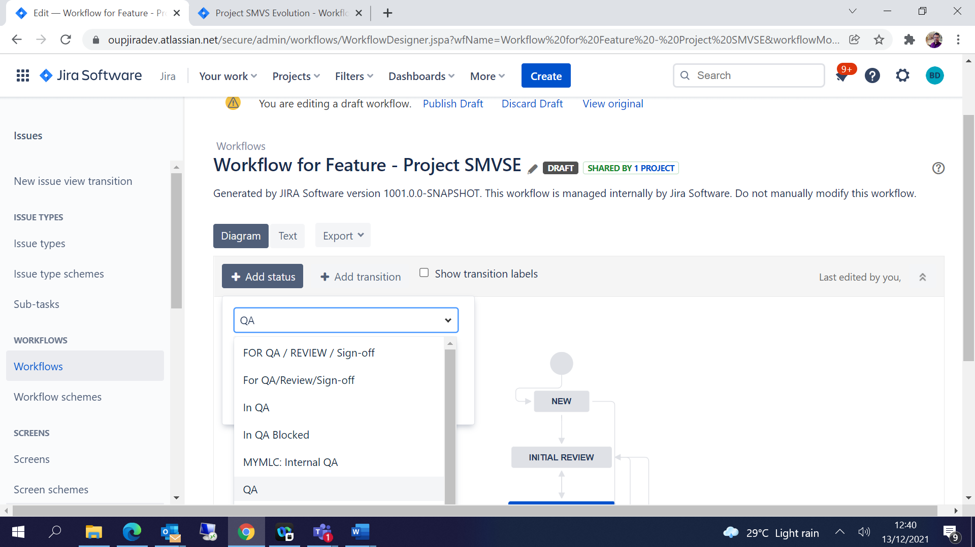

Add Transition 🡪 Select From Status and To Status and Add-

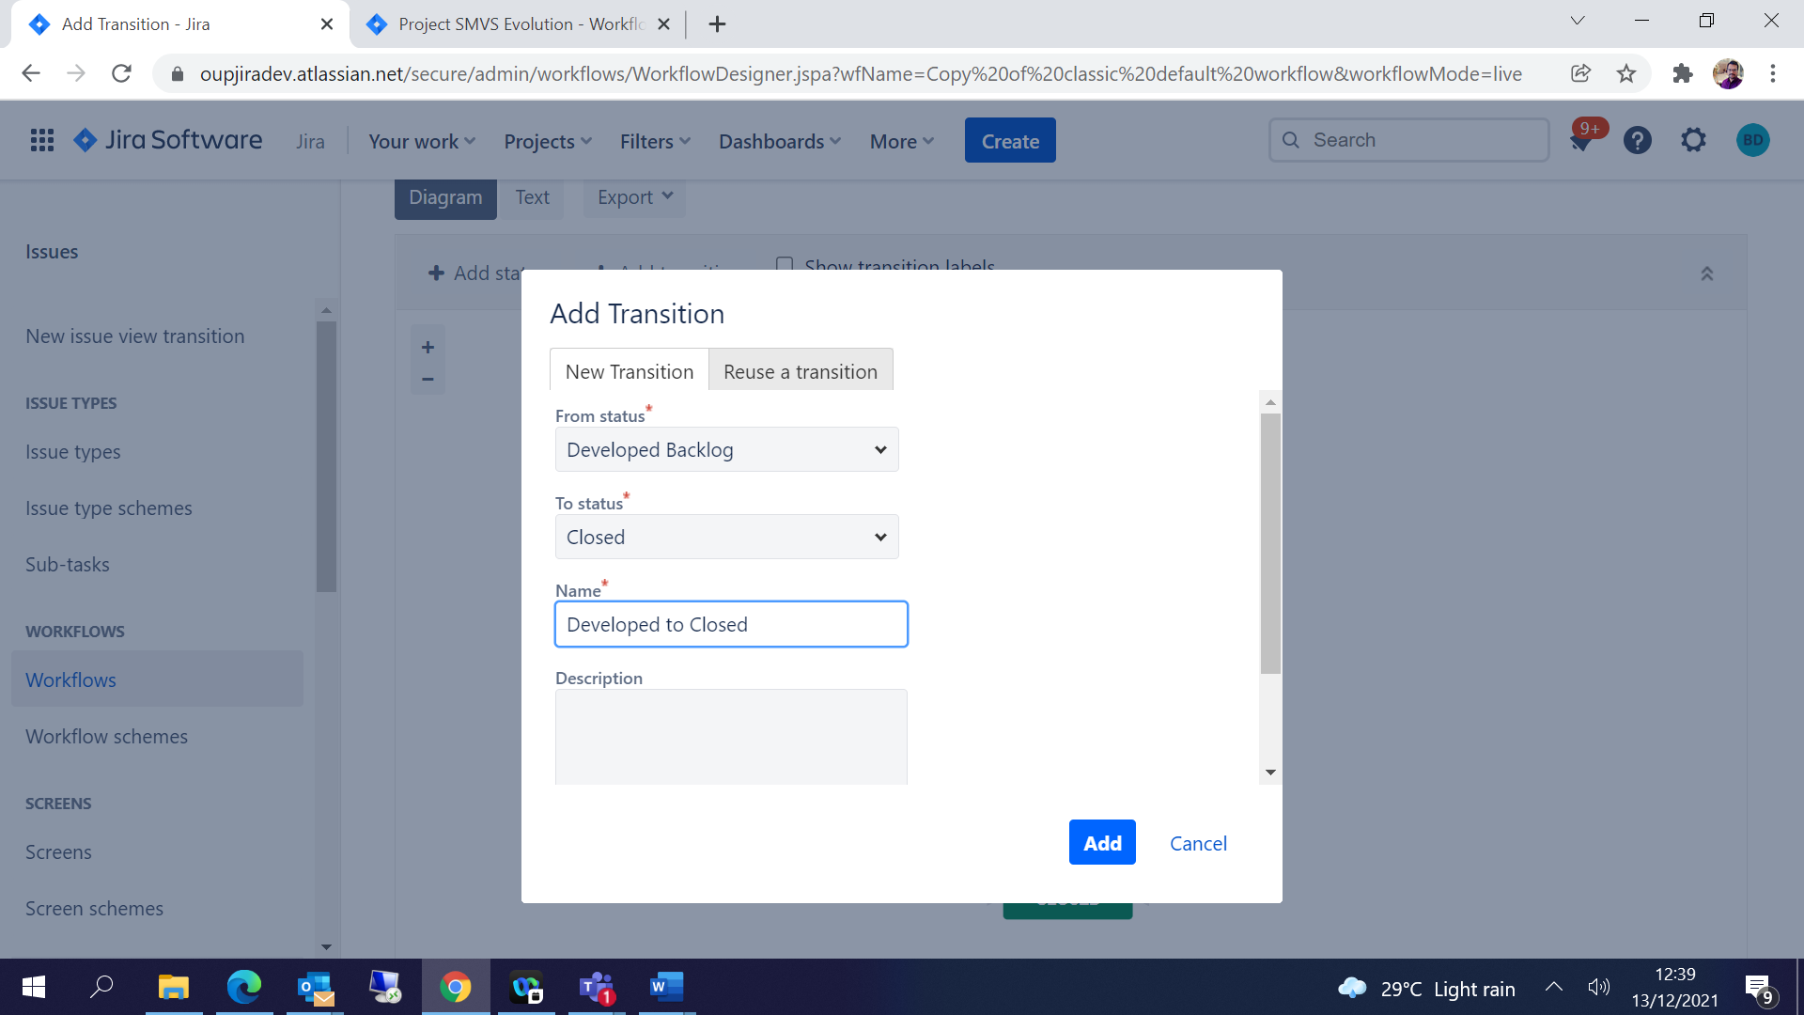

To order the Transitions in workflow 🡪

Select Transition and click on Post Functions🡪 Click on View Properties -

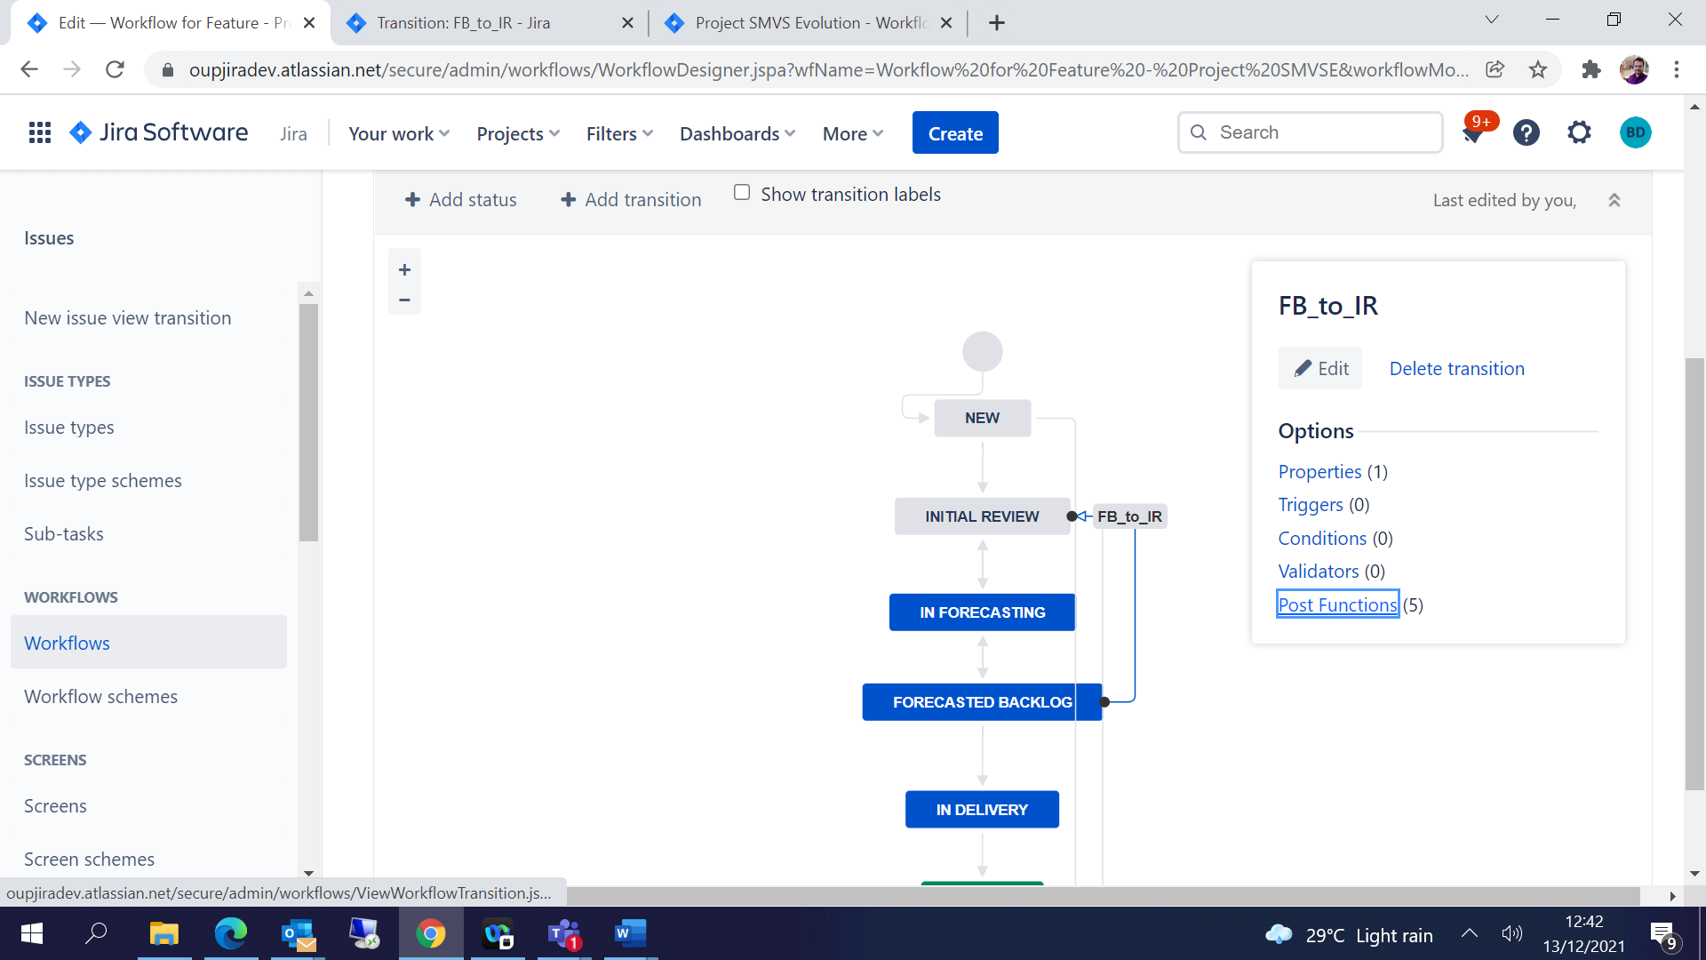

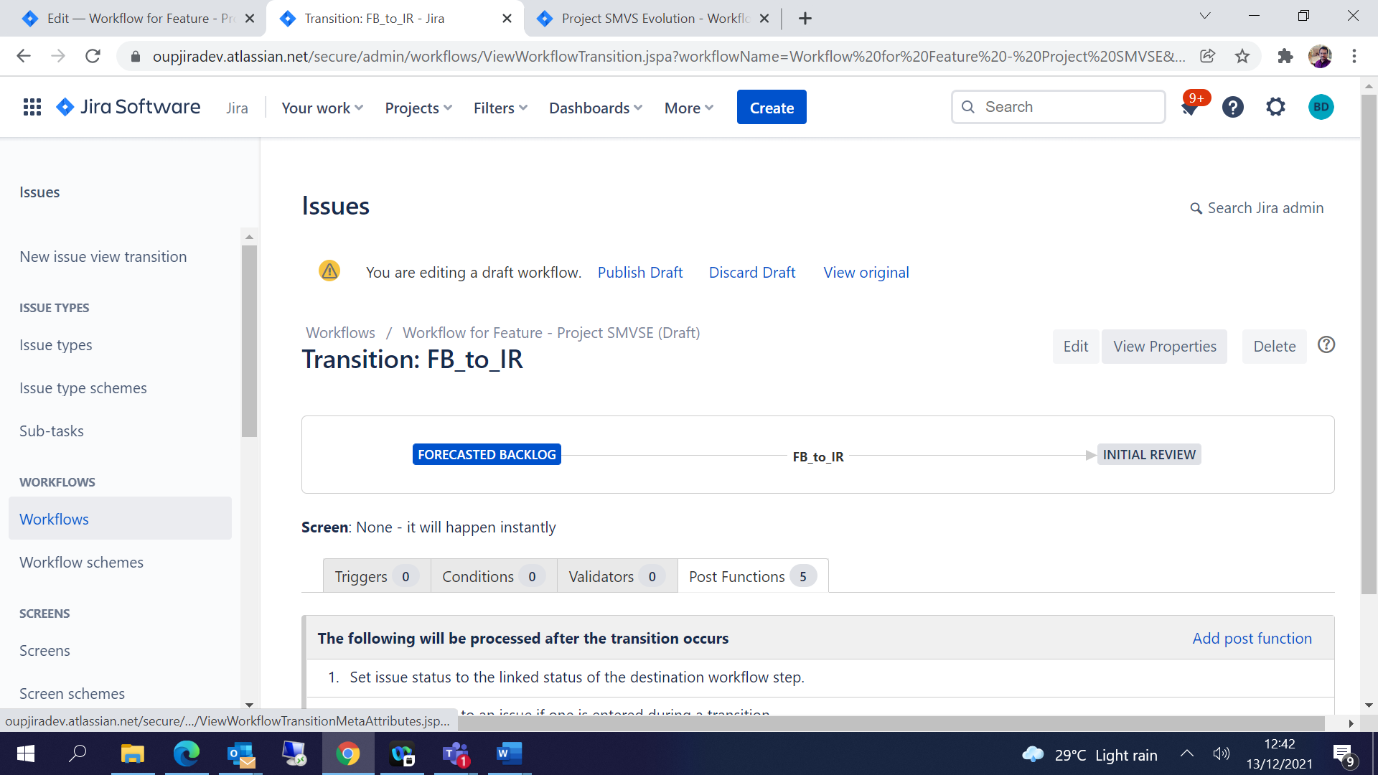

Under Transition Properties add Property Key and value as below:

Property Key = opsbar-sequence

Property Value = [0,1,2,…]

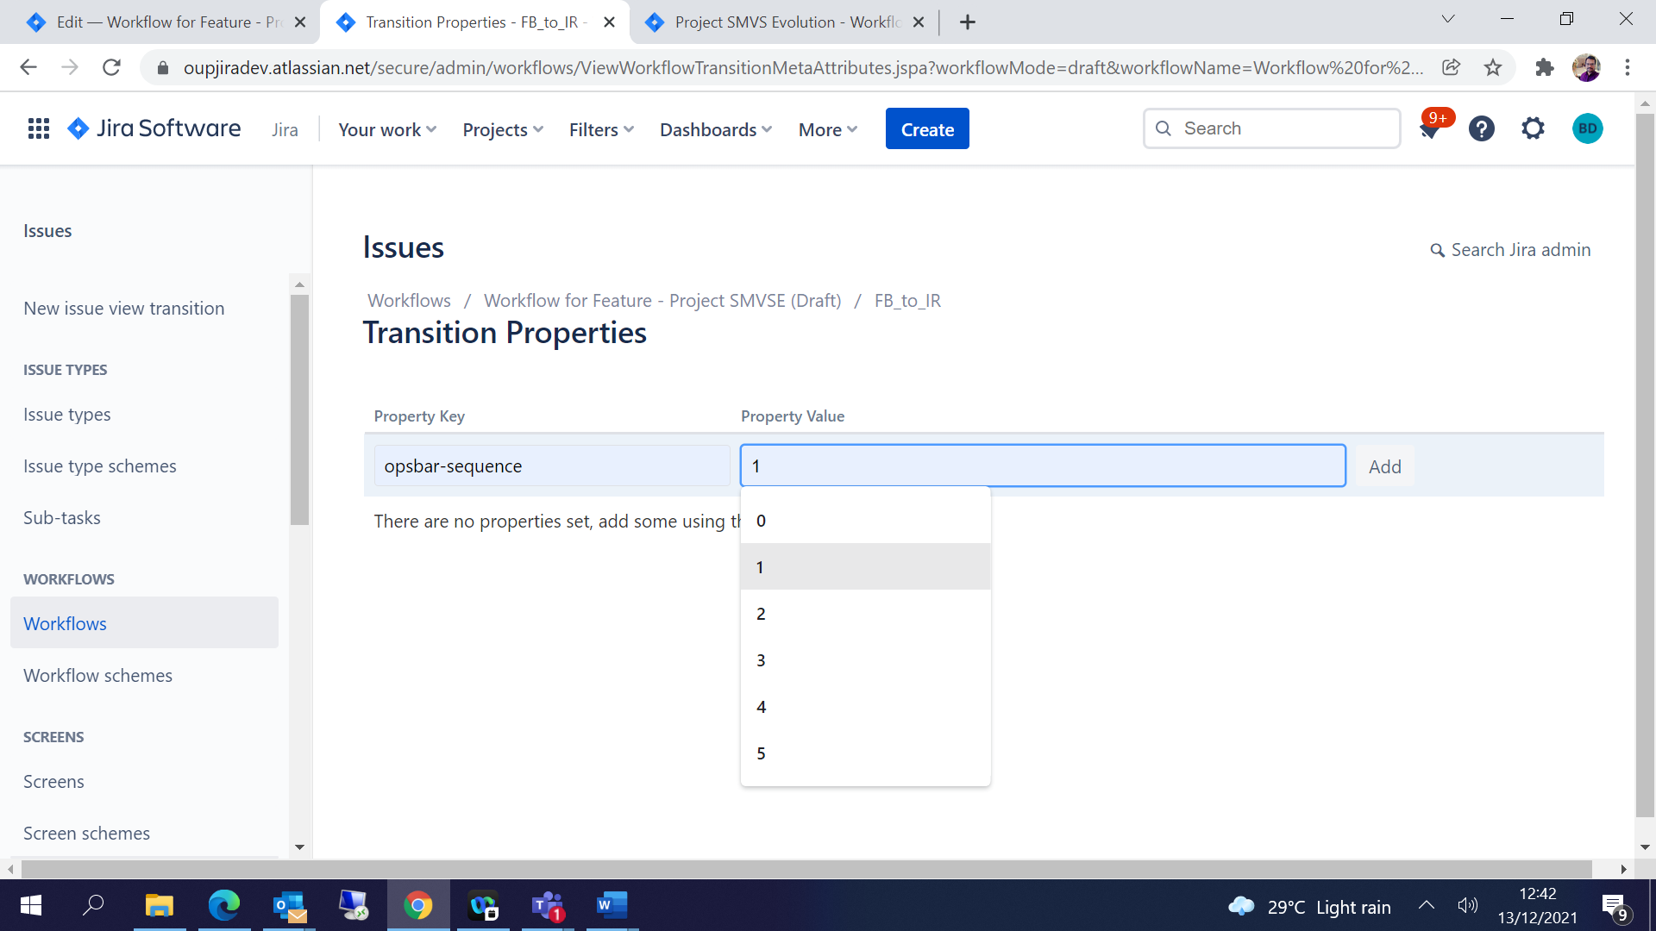

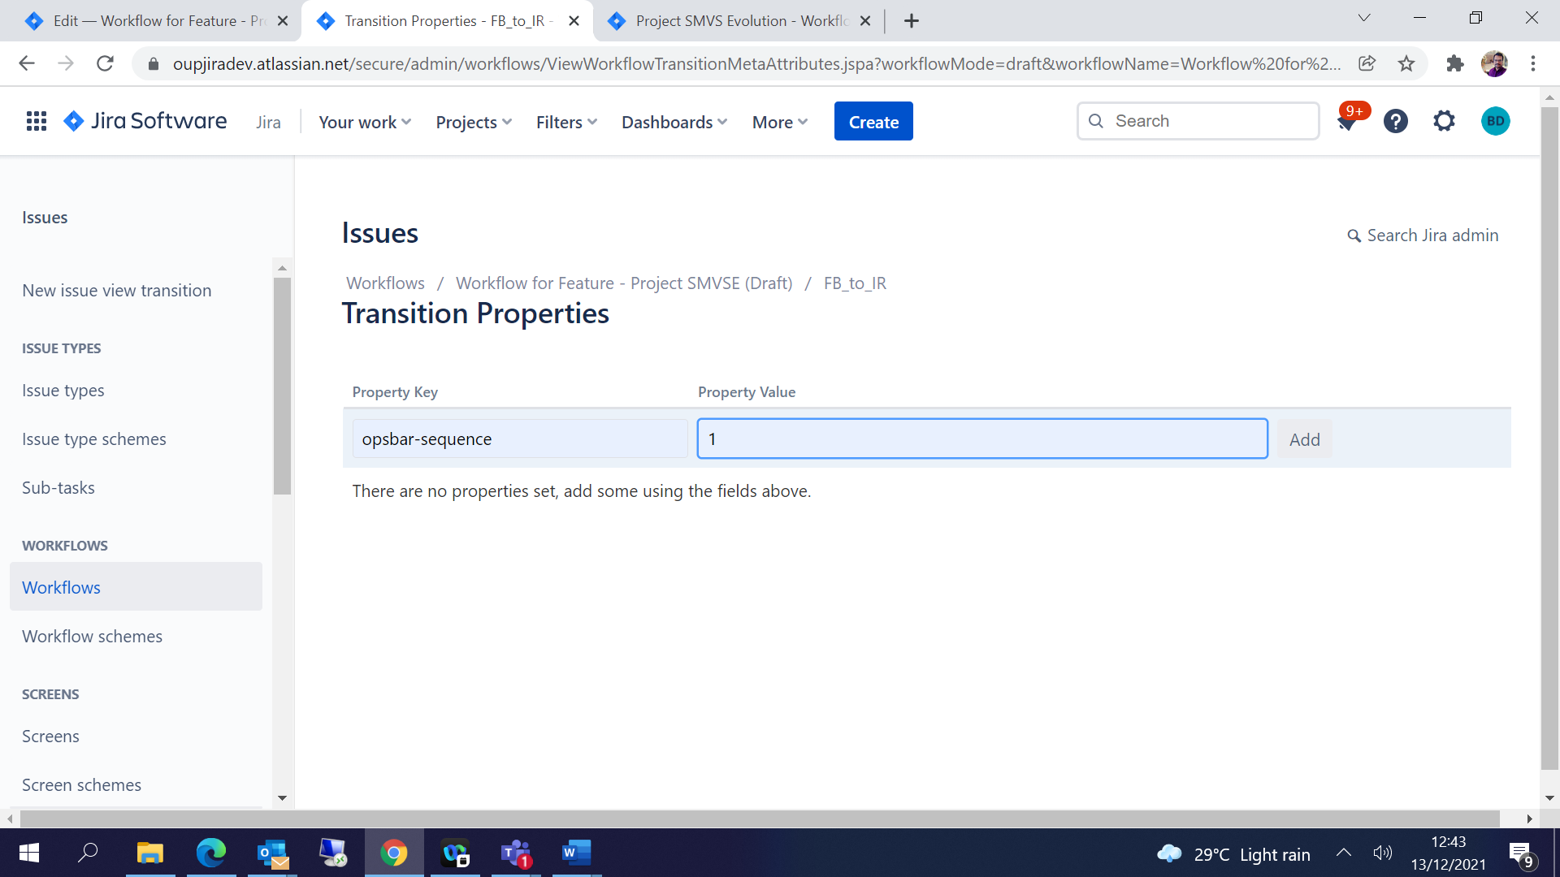

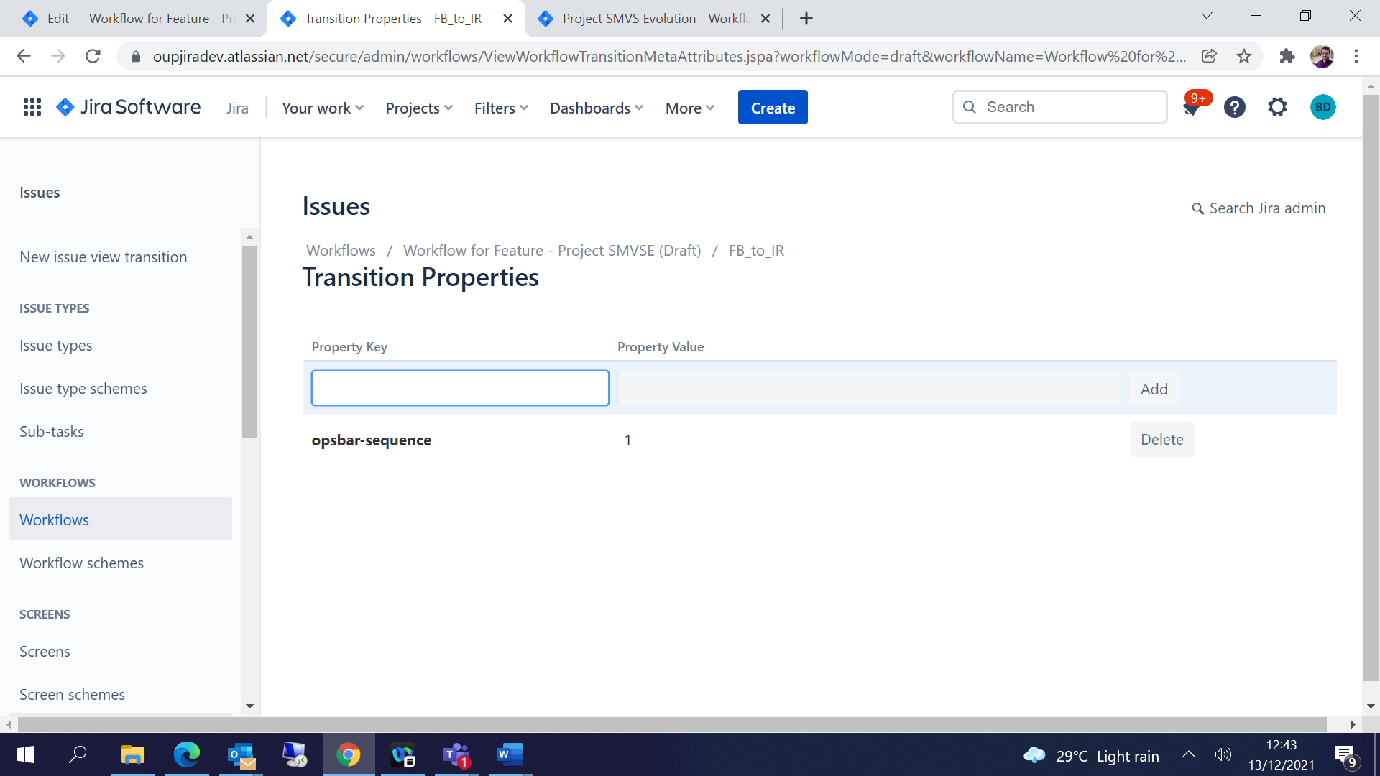

After you edit the workflow click on Publish Draft🡪

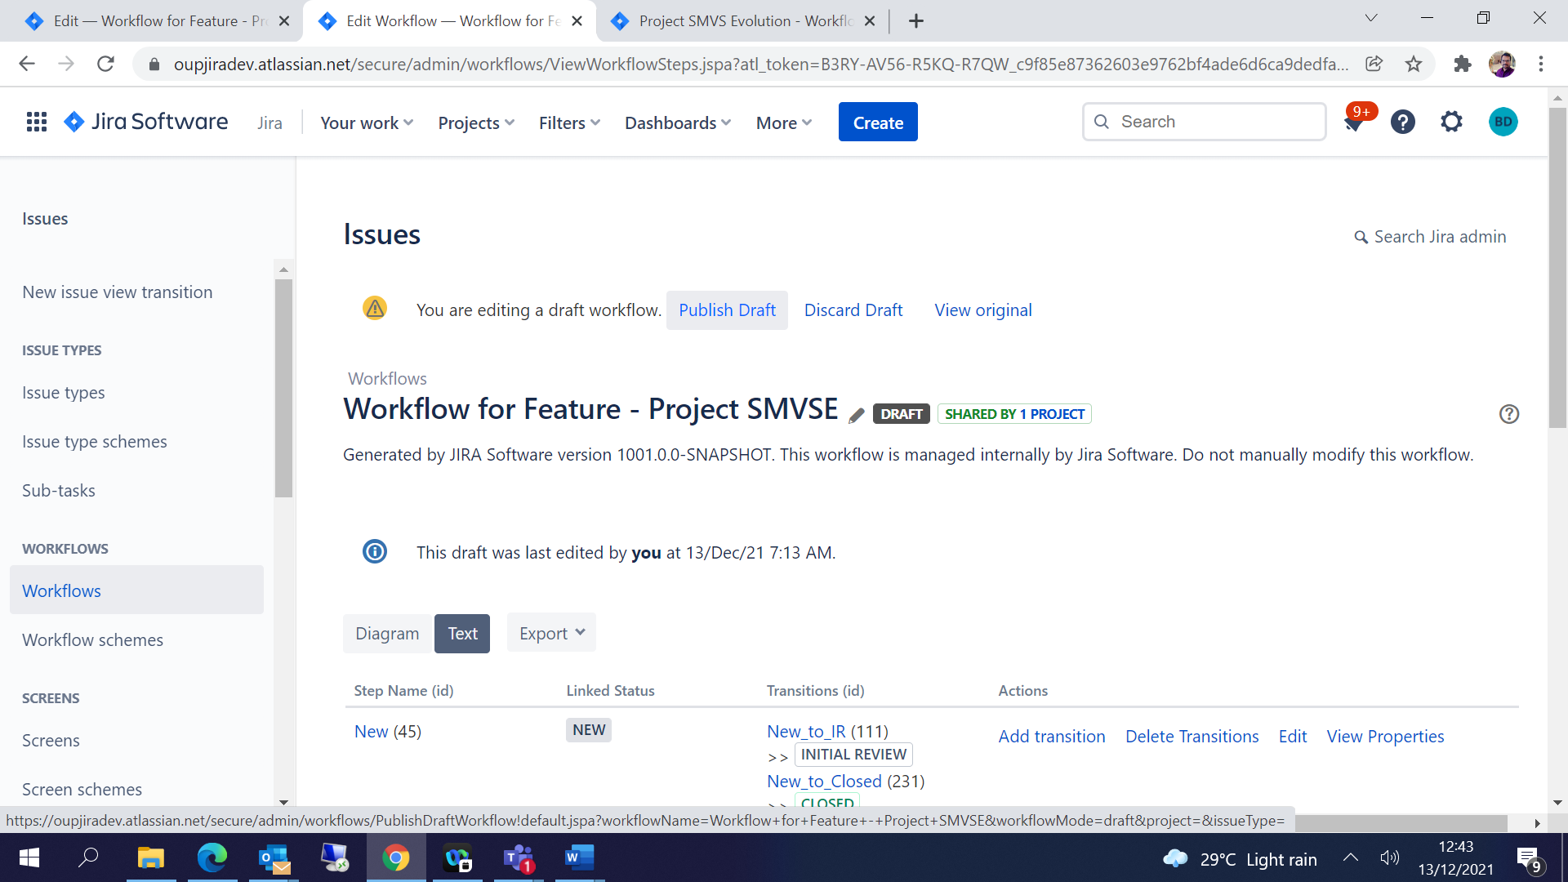

Add Workflow scheme-

JIRA Settings 🡪 Issues 🡪 Click on Workflow schemes from left pane 🡪 Add Workflow scheme

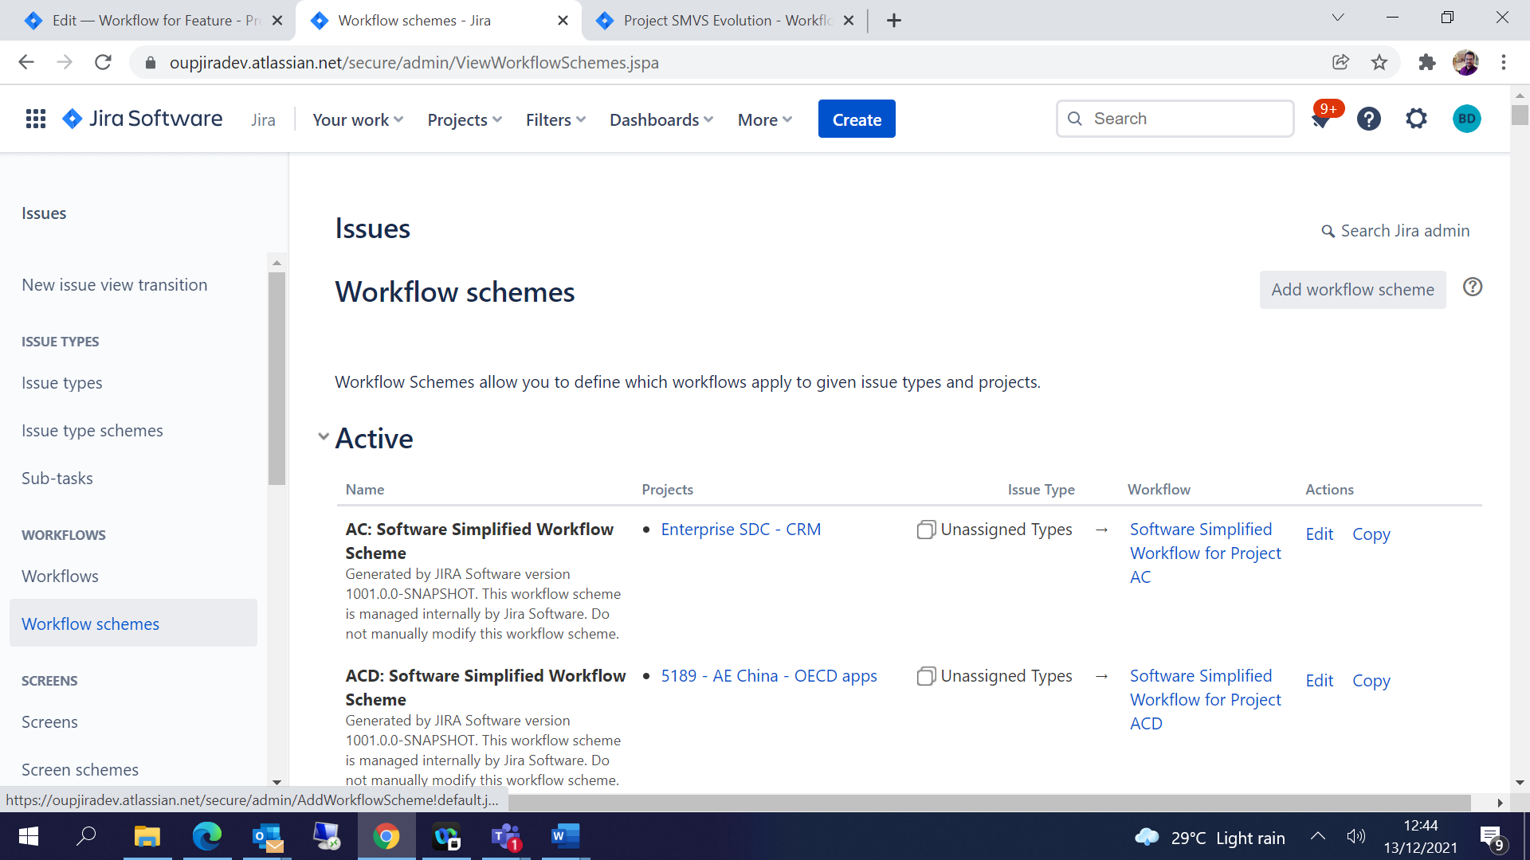

Give Name and Description and Add-

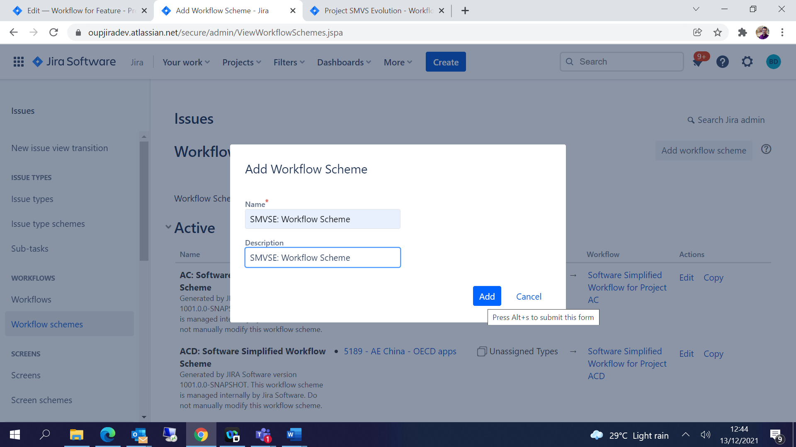

Click on Edit of the Workflow scheme which you created and

Add Existing workflow 🡪 choose the workflow created 🡪 Assign issue types accordingly and Click on Finish

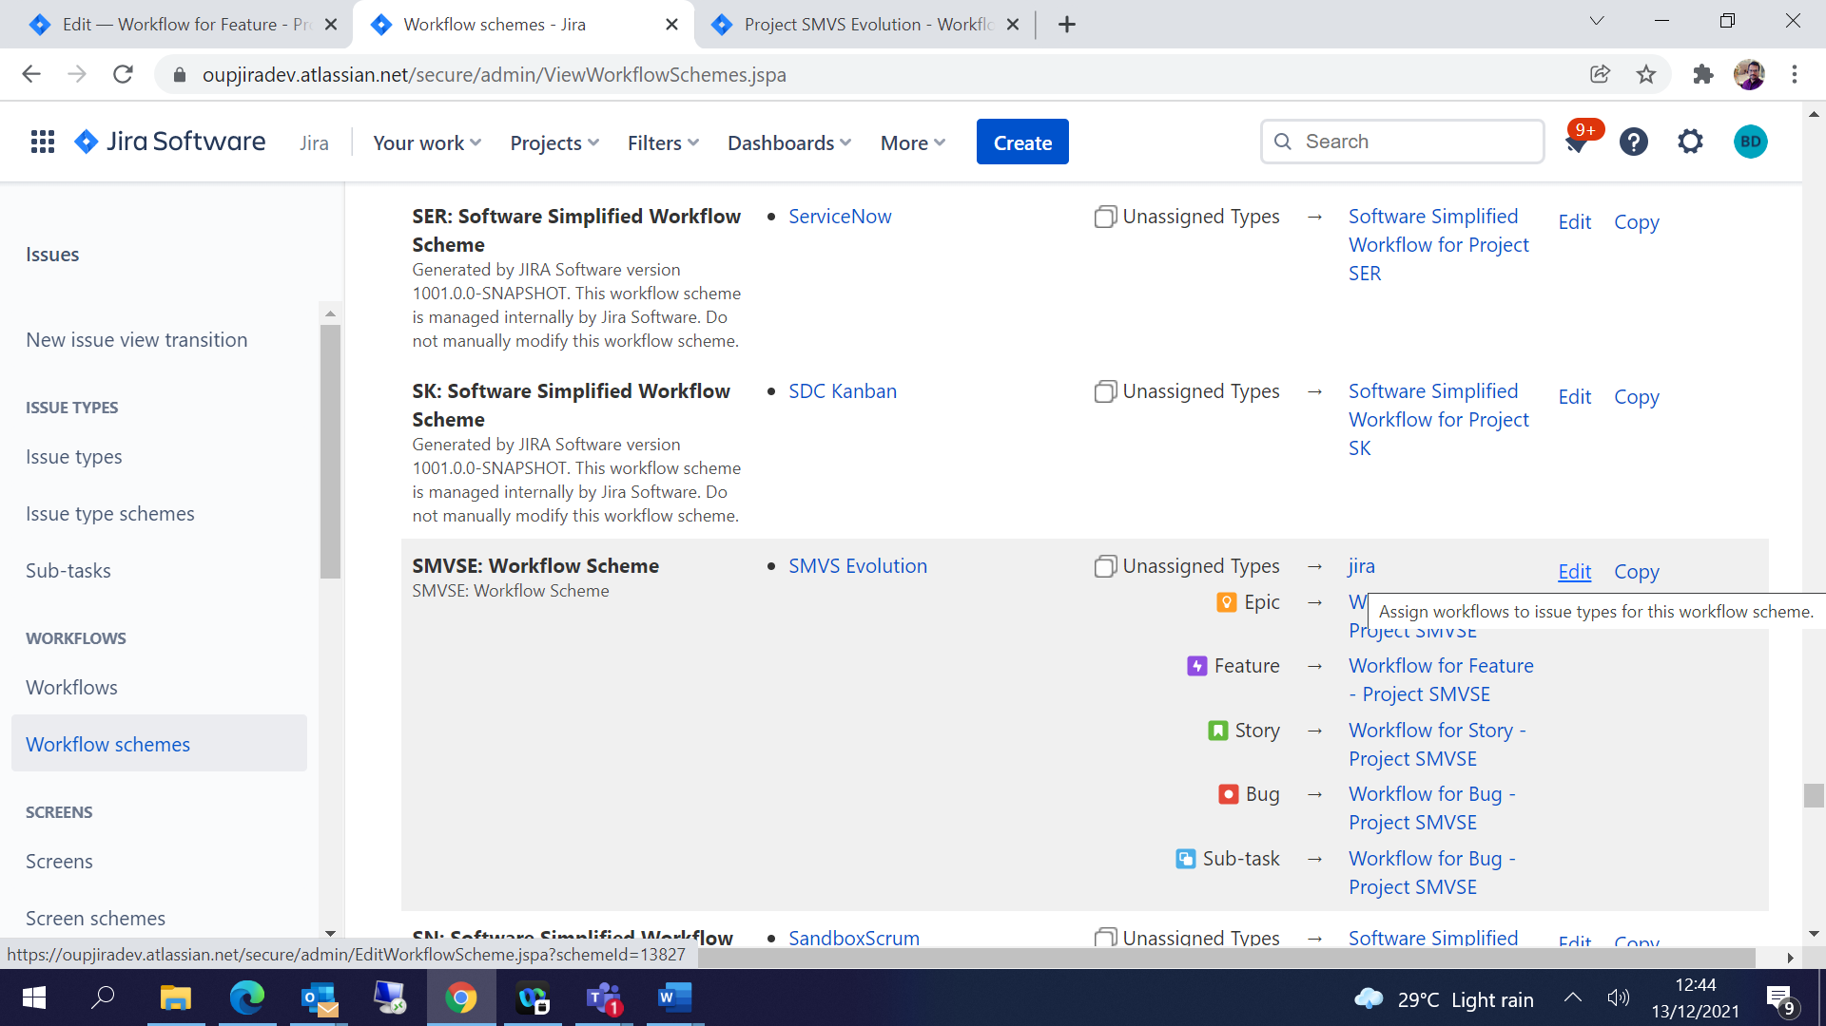

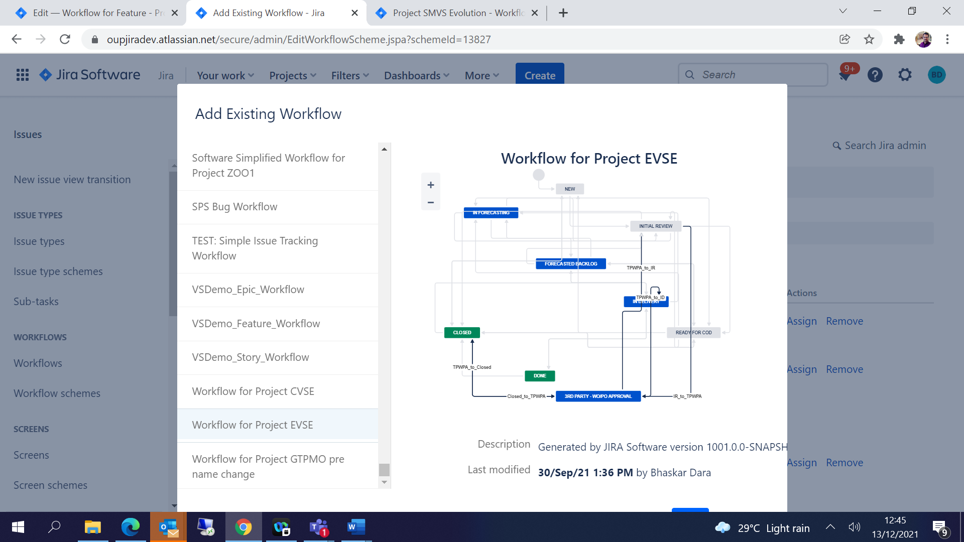

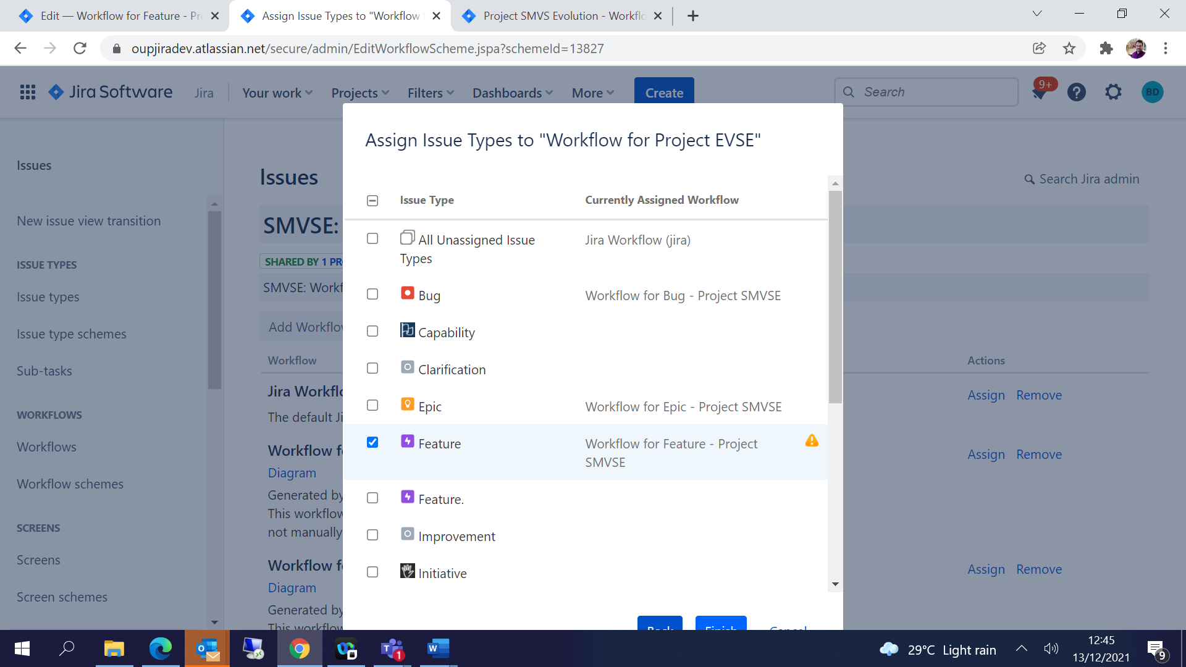

Now the Workflow Scheme is associated with all Issue Types workflow accordingly

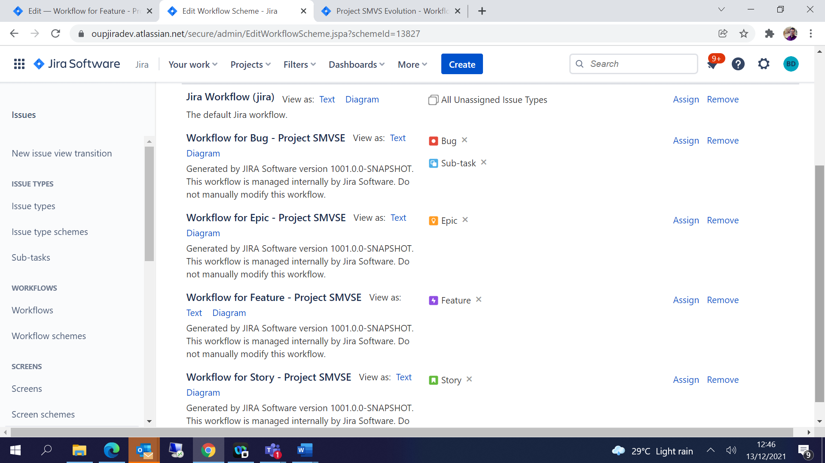

Associate workflow to your project:

Project Settings 🡪 Workflows🡪 Click on Switch Scheme

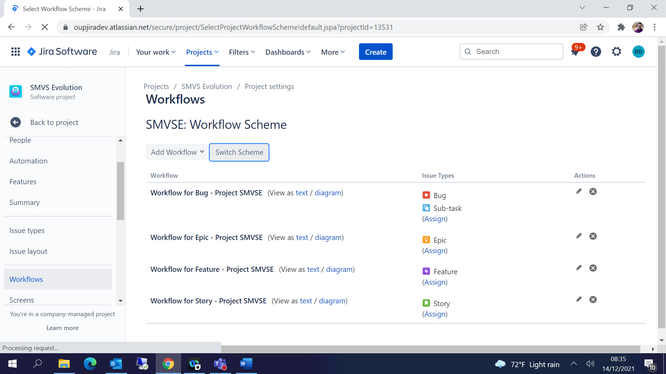

Choose the scheme which is created for the project 🡪 Click on Associate

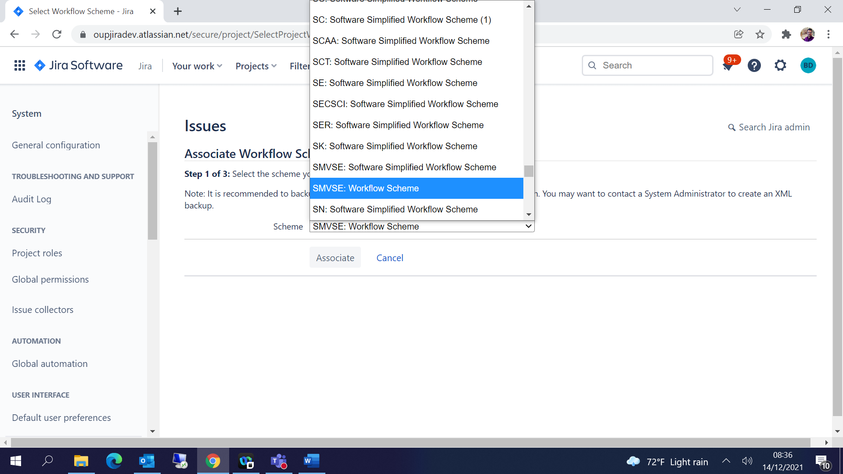

## Kanban / Scrum Board Settings:

Click on … 🡪 Board Settings

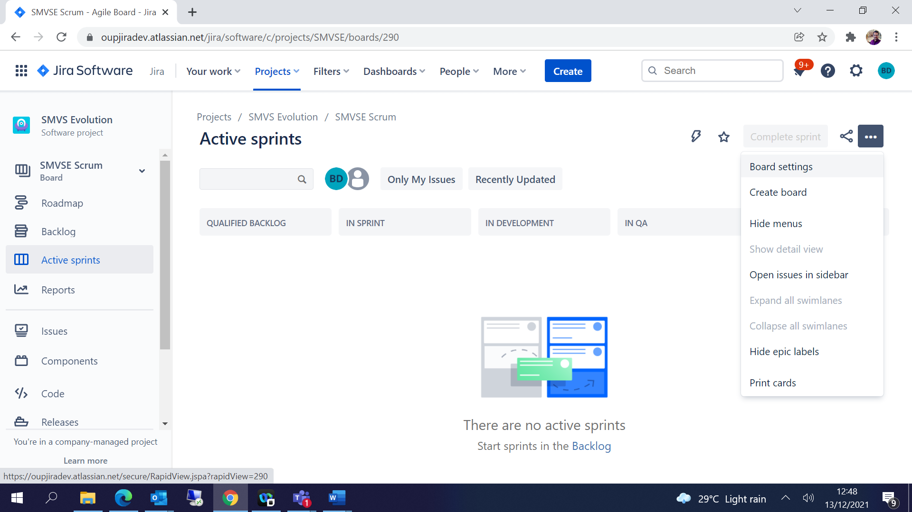

Under General 🡪 Add a Filter Query for what issue types to display on the board 🡪

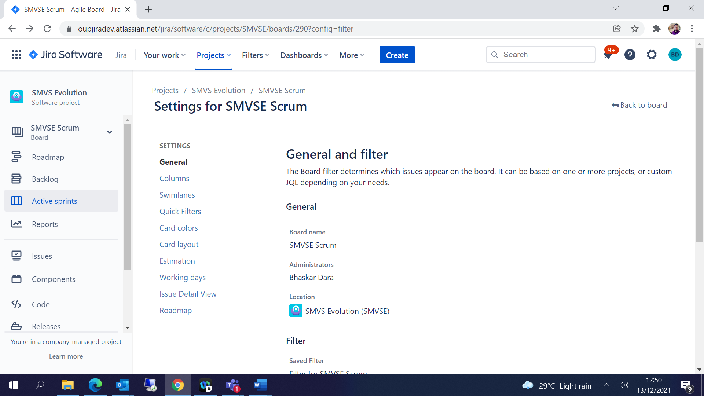

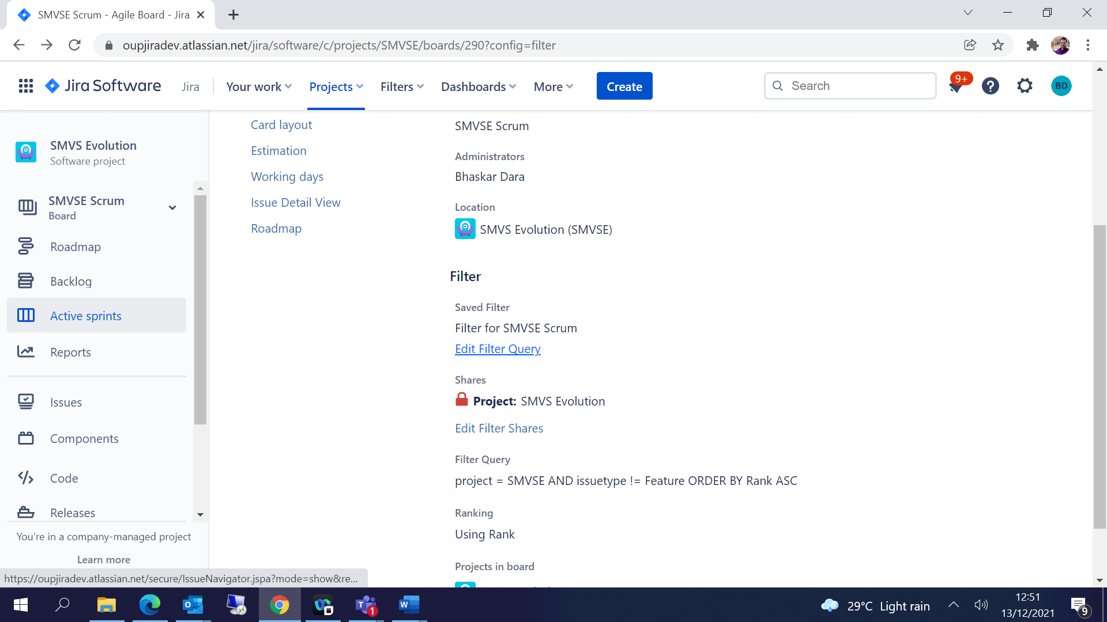

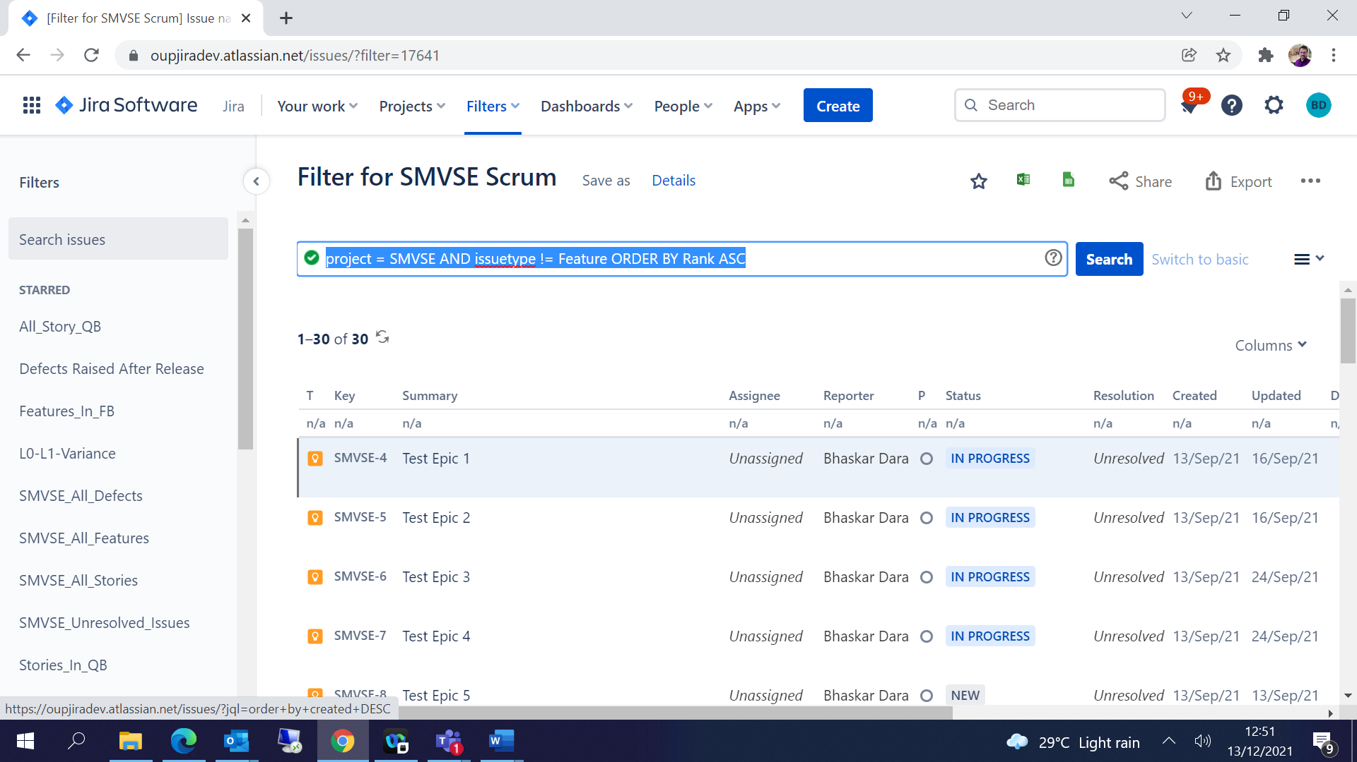

Columns 🡪 Add Column based on the statuses and project requirements-

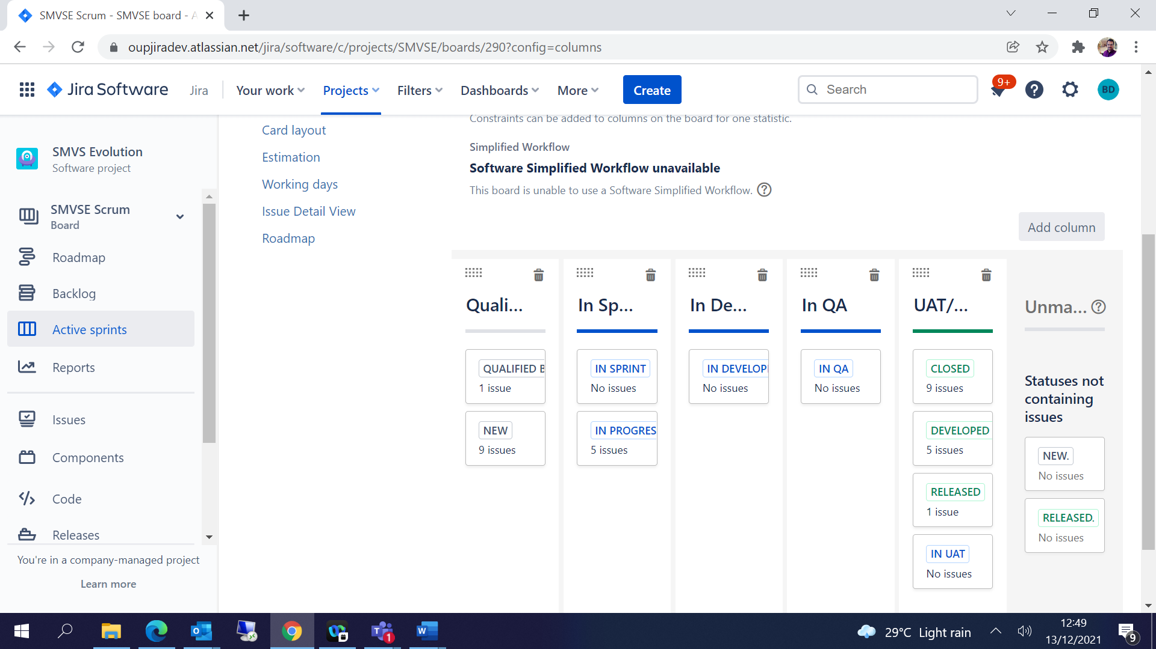

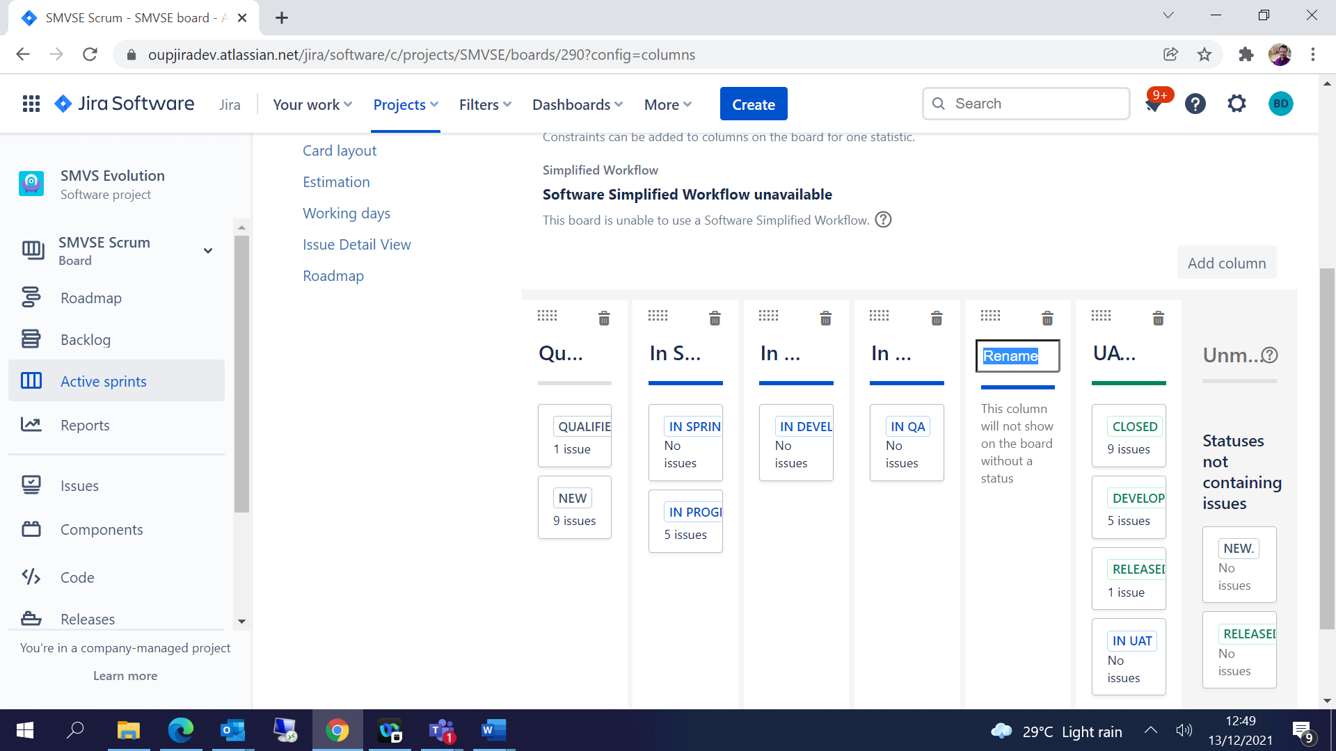

You can Drag the Statuses to the columns creates accordingly-

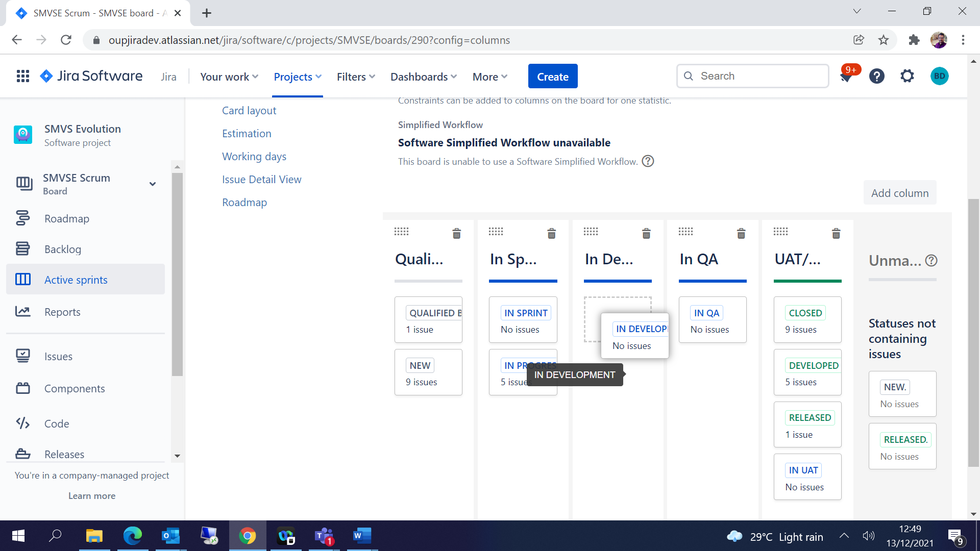

Swimlanes 🡪 you can group the issues based on the list to display in the board

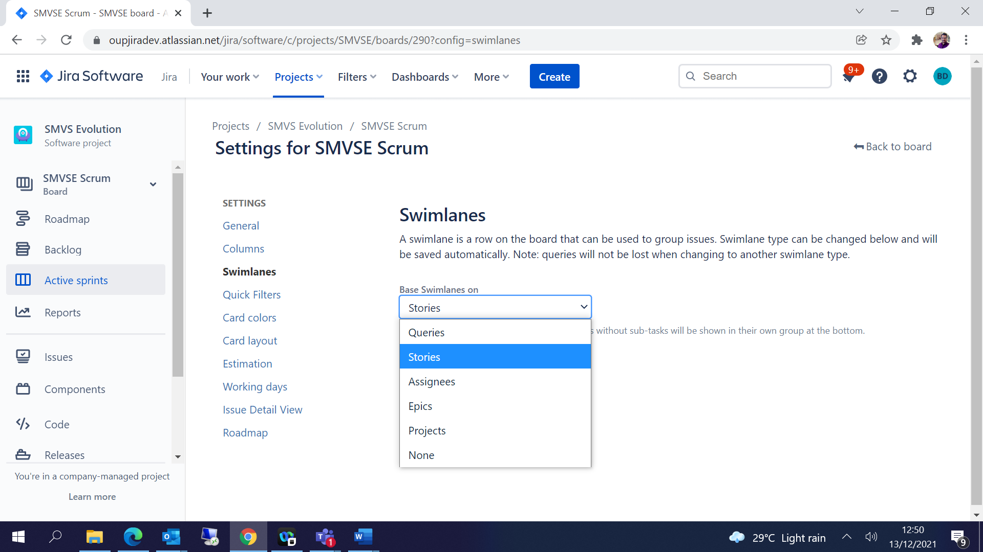

Quick Filters 🡪 Filters are used to display the required Issues on the board for easy tracking

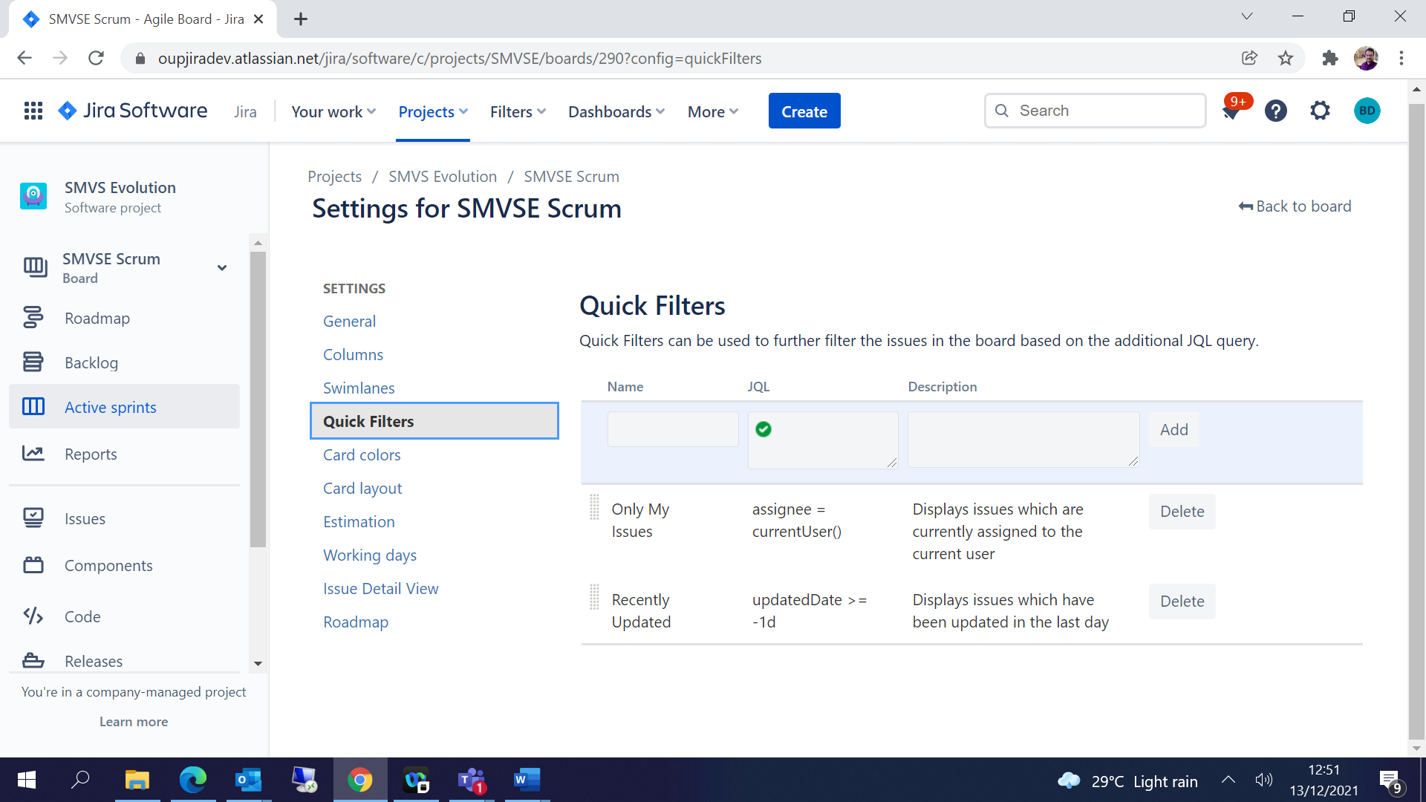

Estimation 🡪 Issues can be estimated using Story Points / Time Estimate based on the project requirements

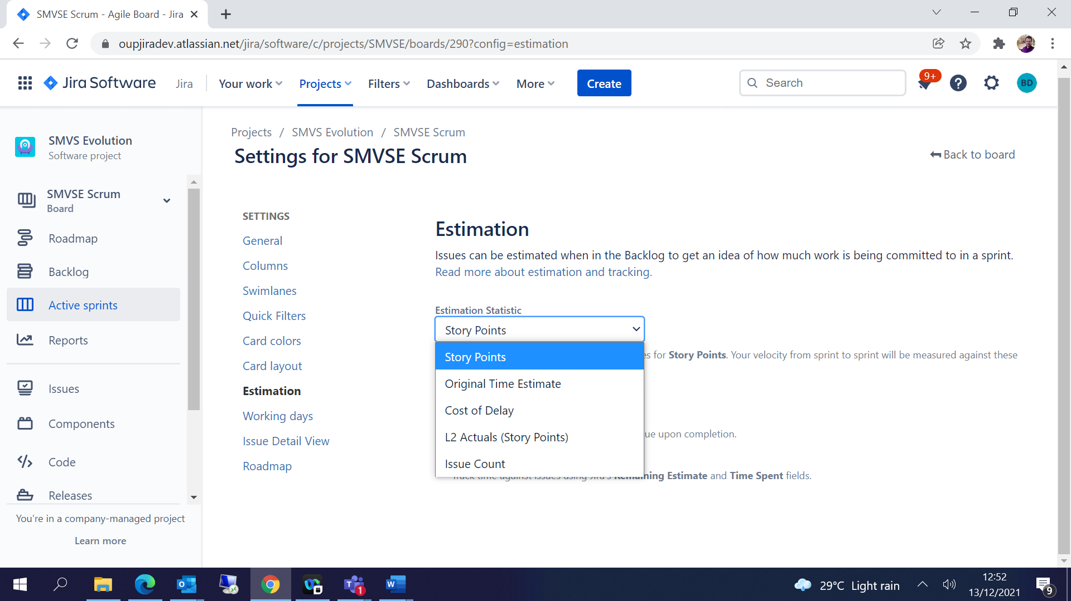

Working Days 🡪 Days can be configured based on the project requirement

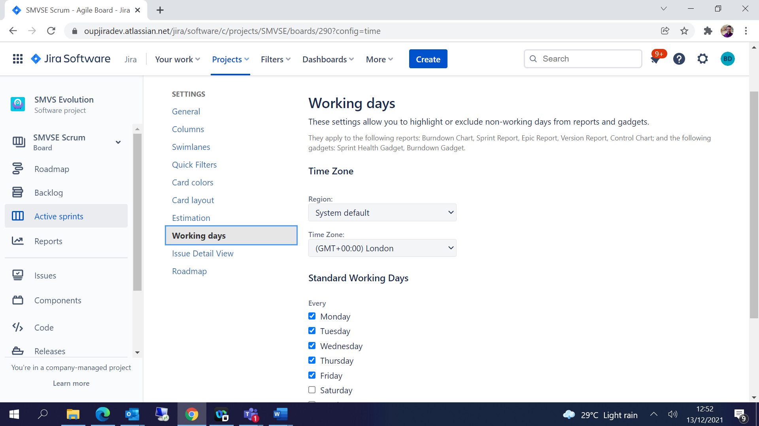

## Sprint Creation and Planning:

Create the Issues of type Epic / Story / Task. All the issues will be moved to Backlog by default

Click on **Create Sprint** button to create the spring and move the issues to the sprint accordingly

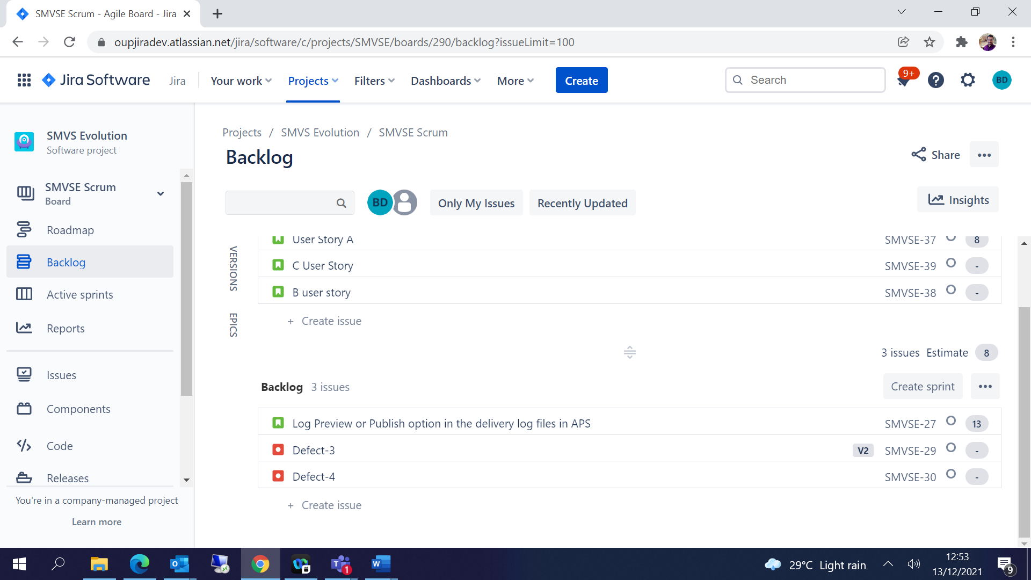

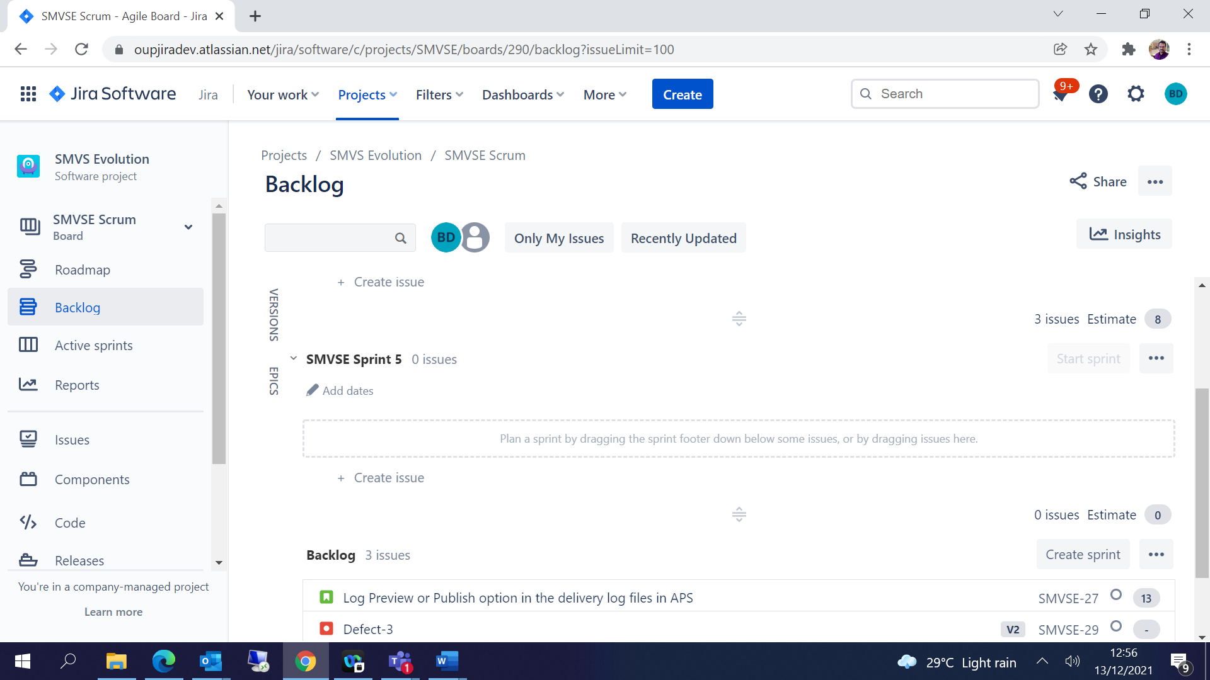

Add issues to sprint 🡪 Start Sprint 🡪 Give the start data and end data 🡪 Start

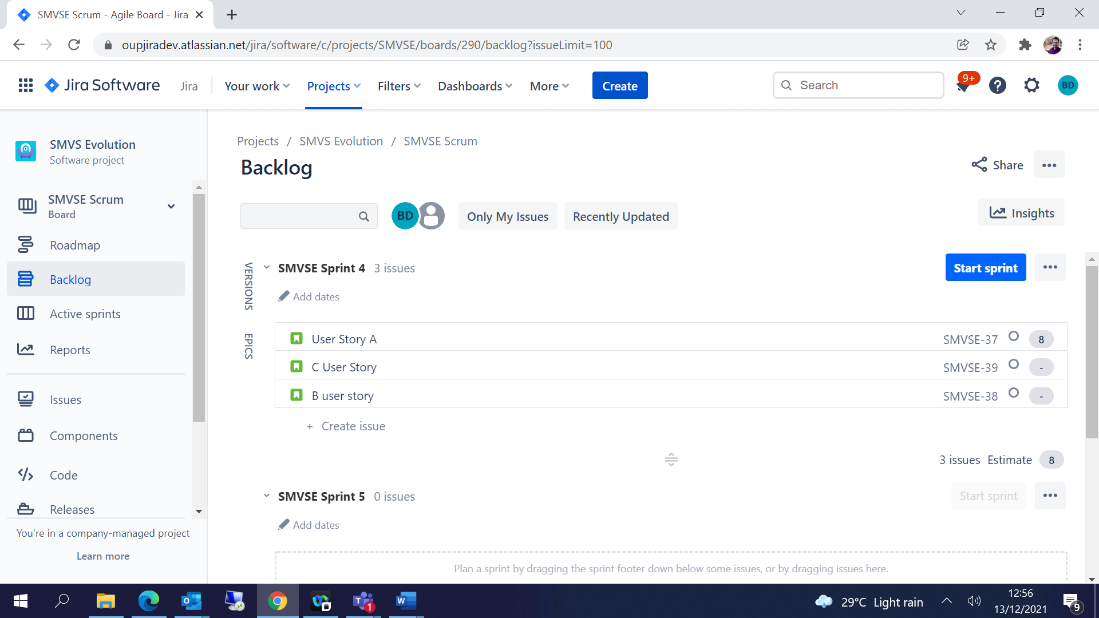

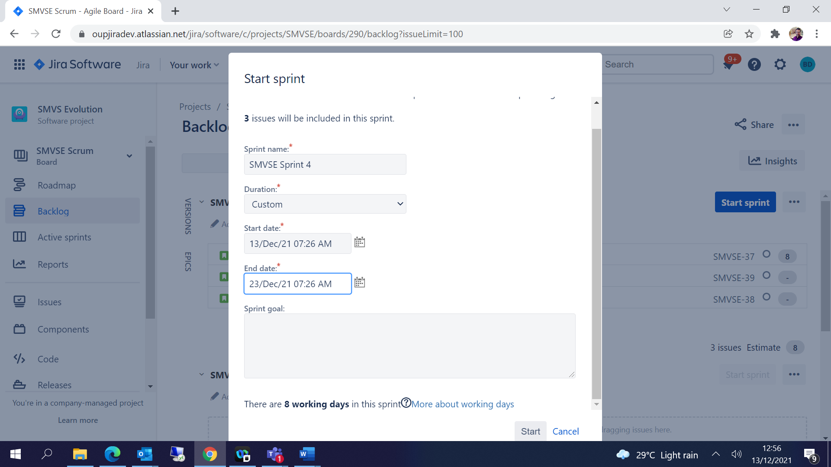

Kanban Board –

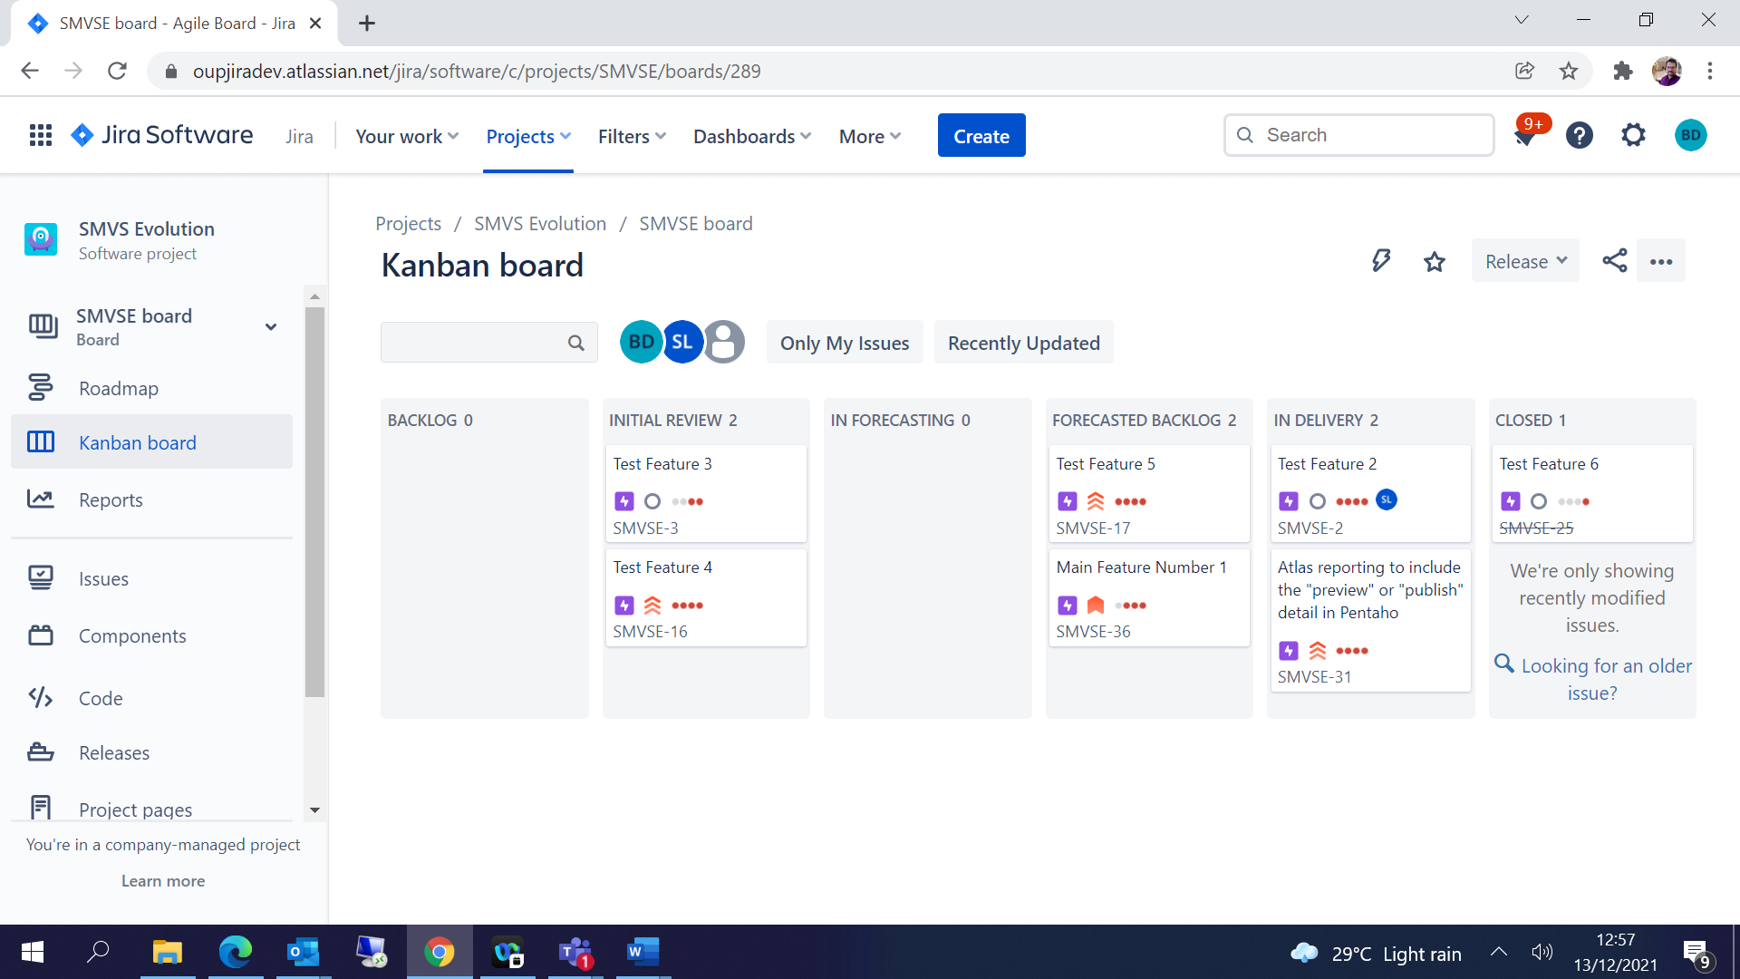

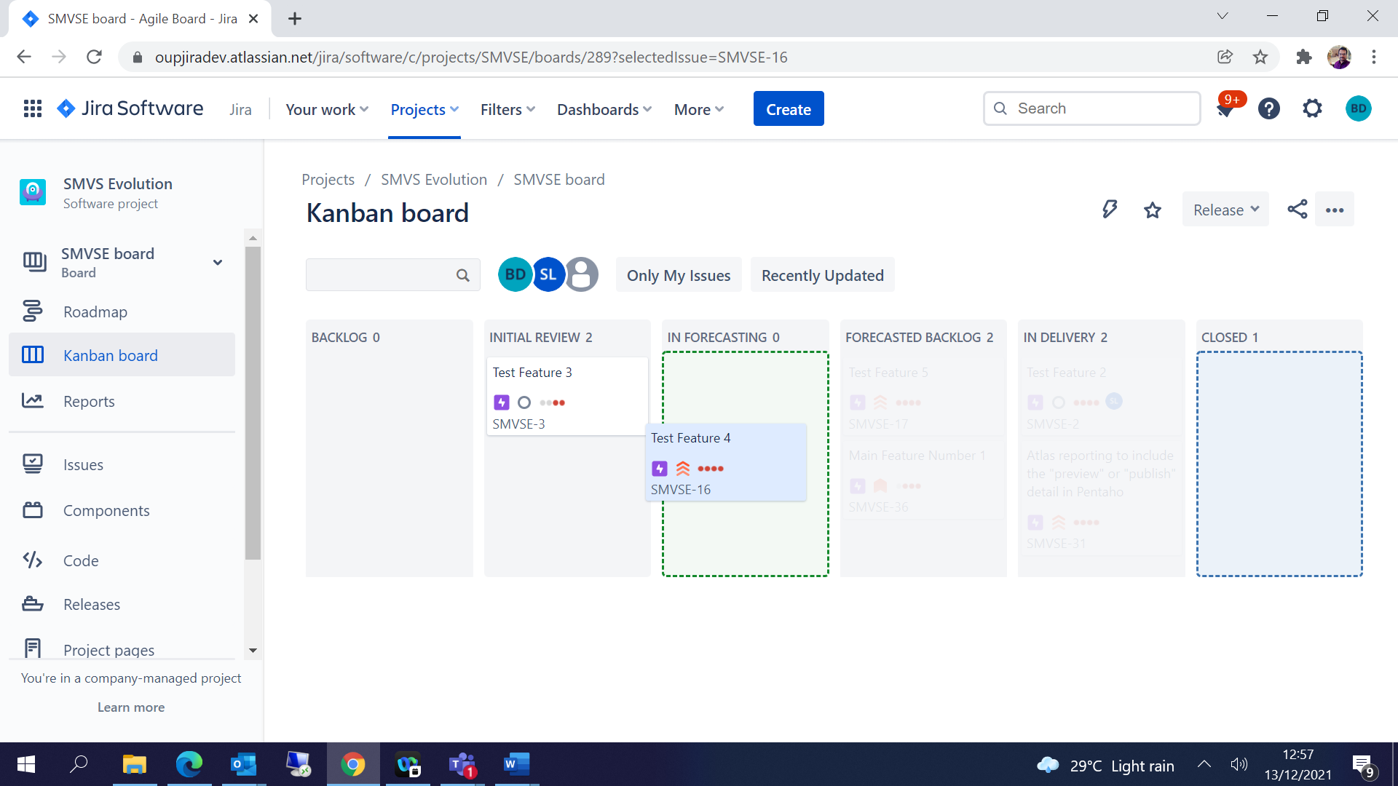

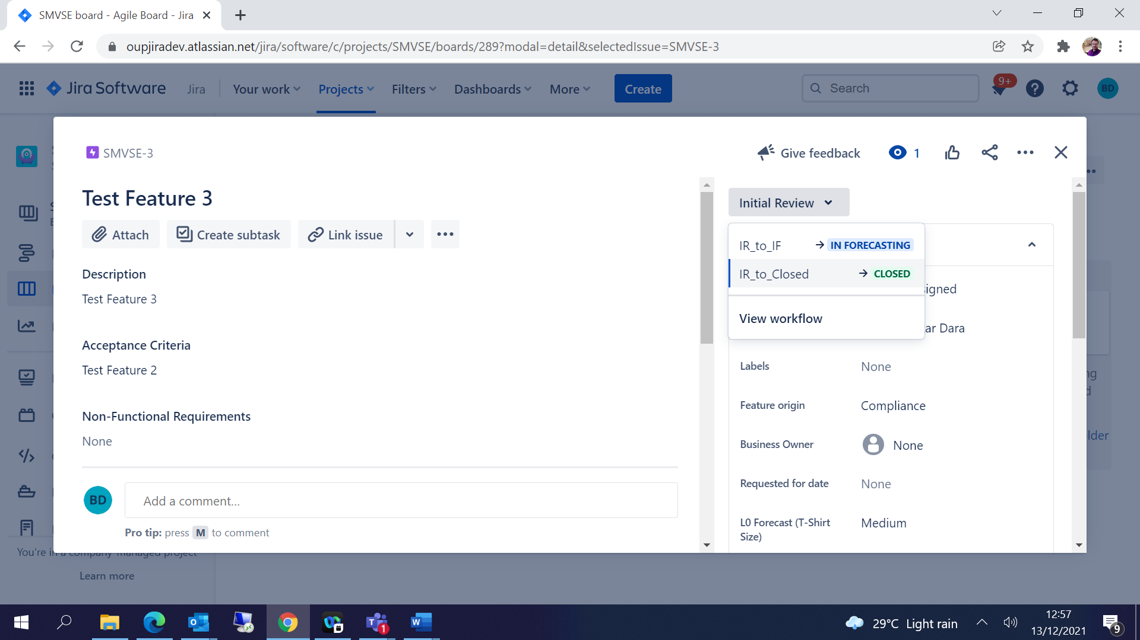

## Create Release / Version:

To create a release or version click on Create Version 🡪 Give Version name and Date 🡪 Save

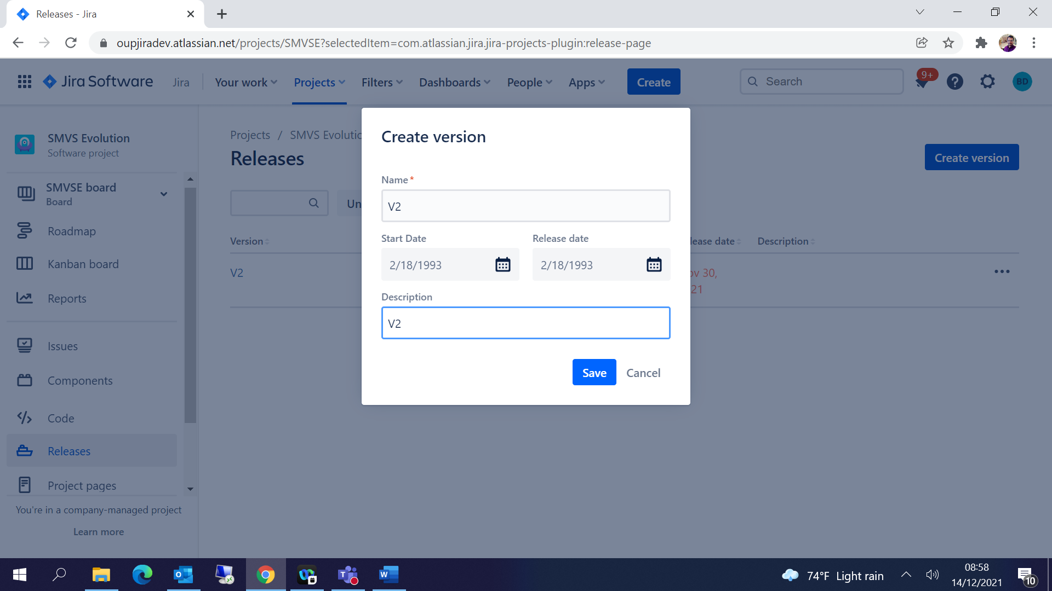

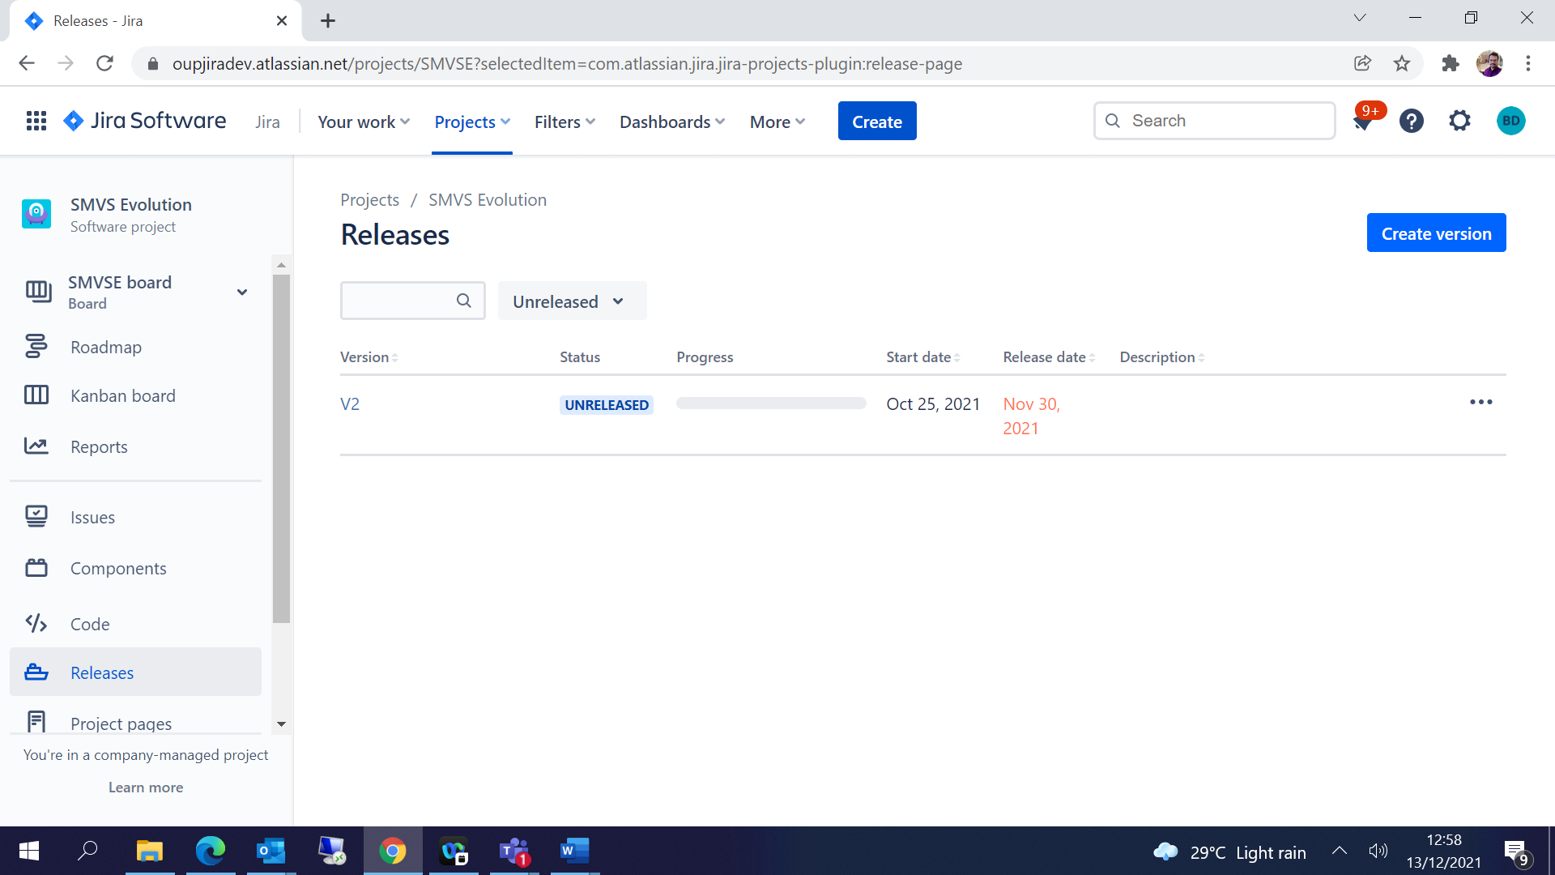

## Automation:

L0 Estimation:

1. Project Setting🡪 Automation🡪 Create Rule

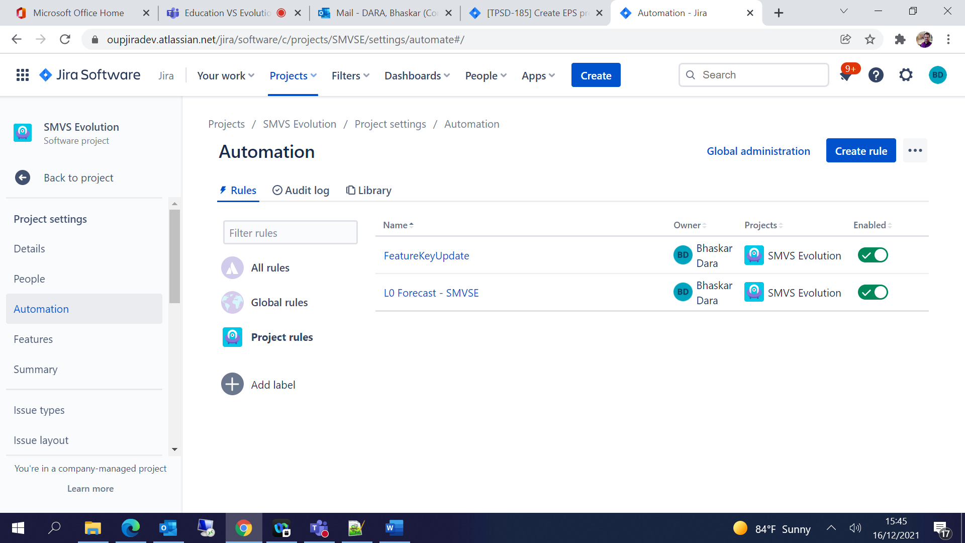

1. New Trigger 🡪

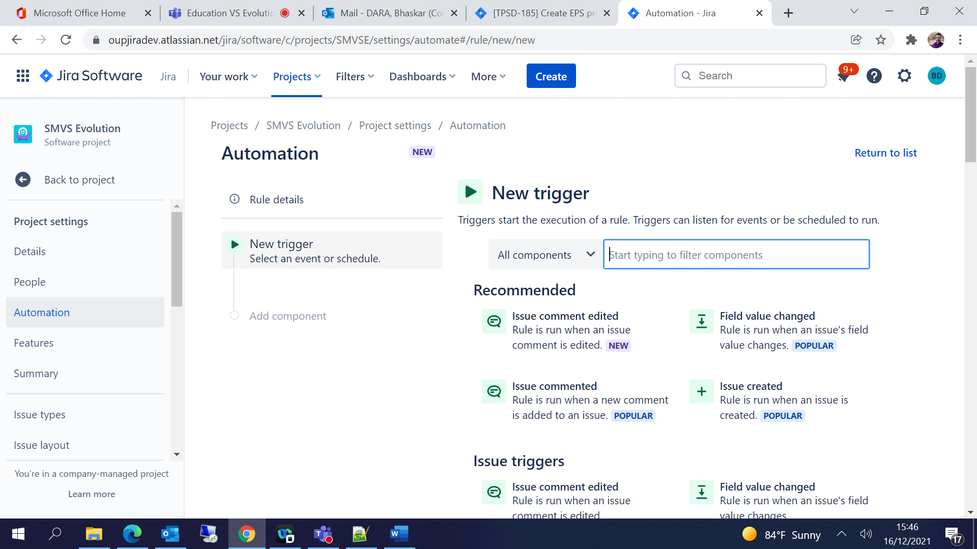

1. Select Field Value Changed-

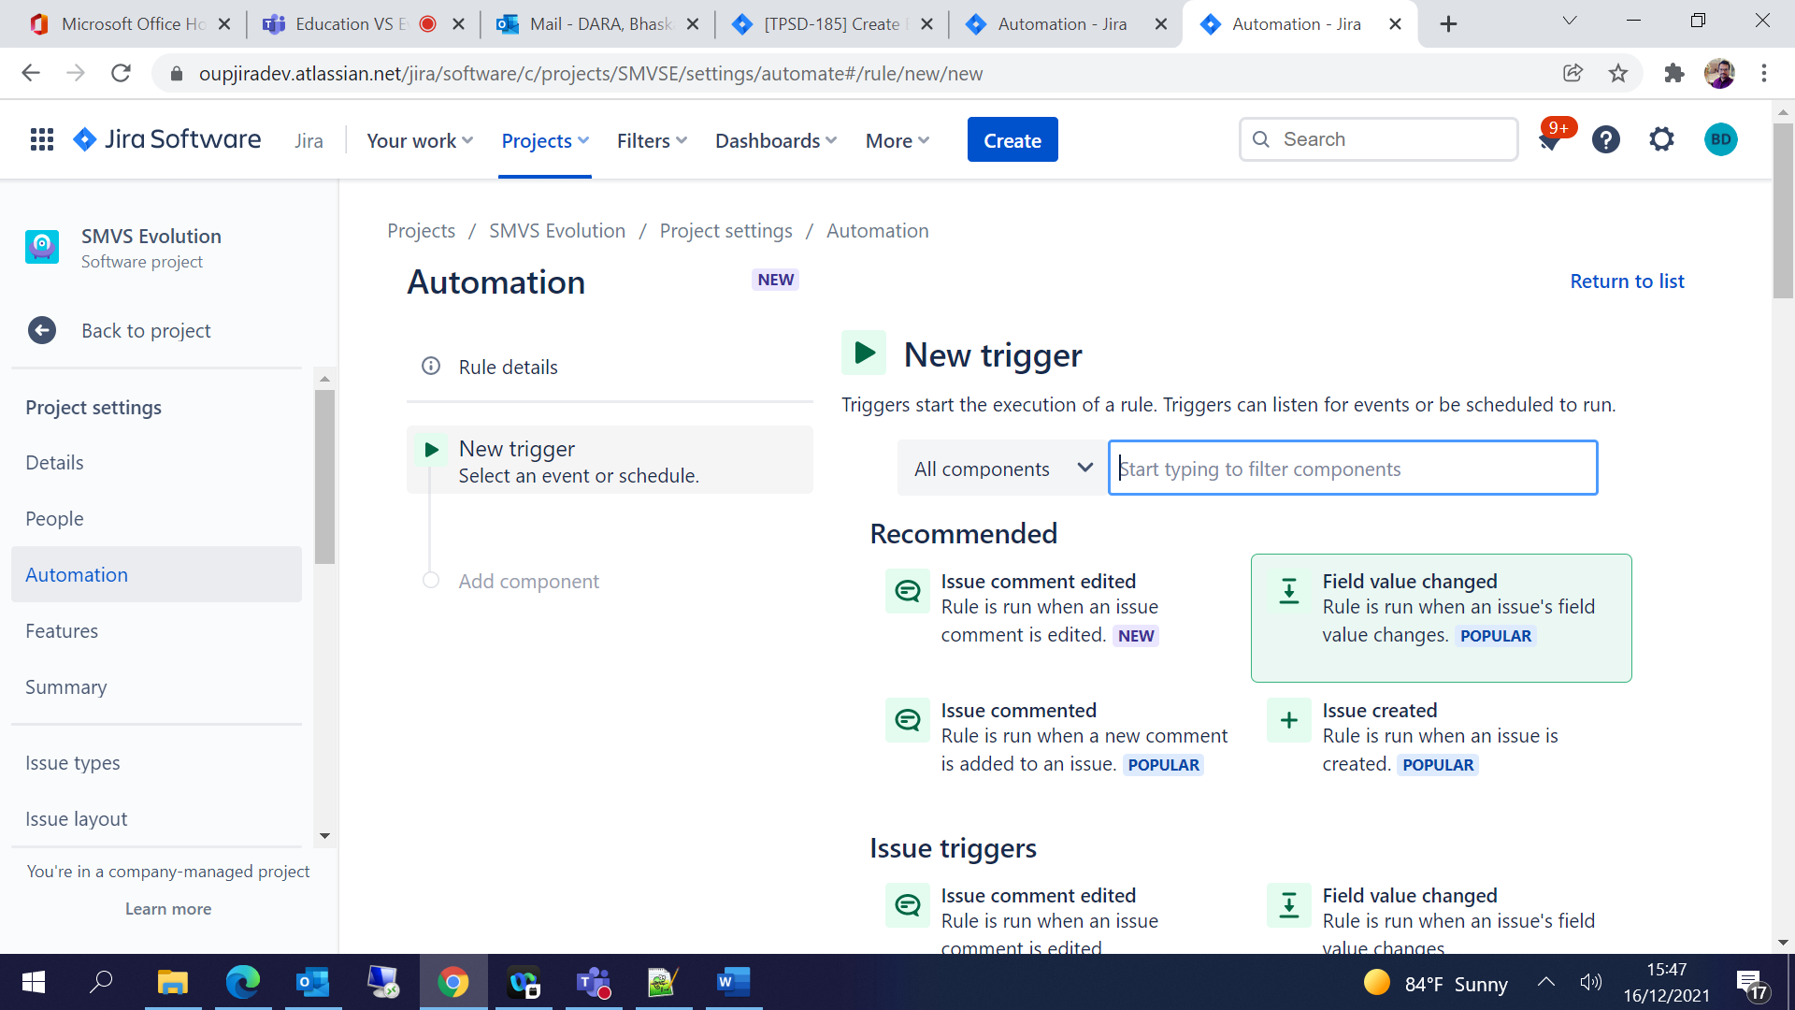

1. Select Fields to monitor for changes 🡪 Save

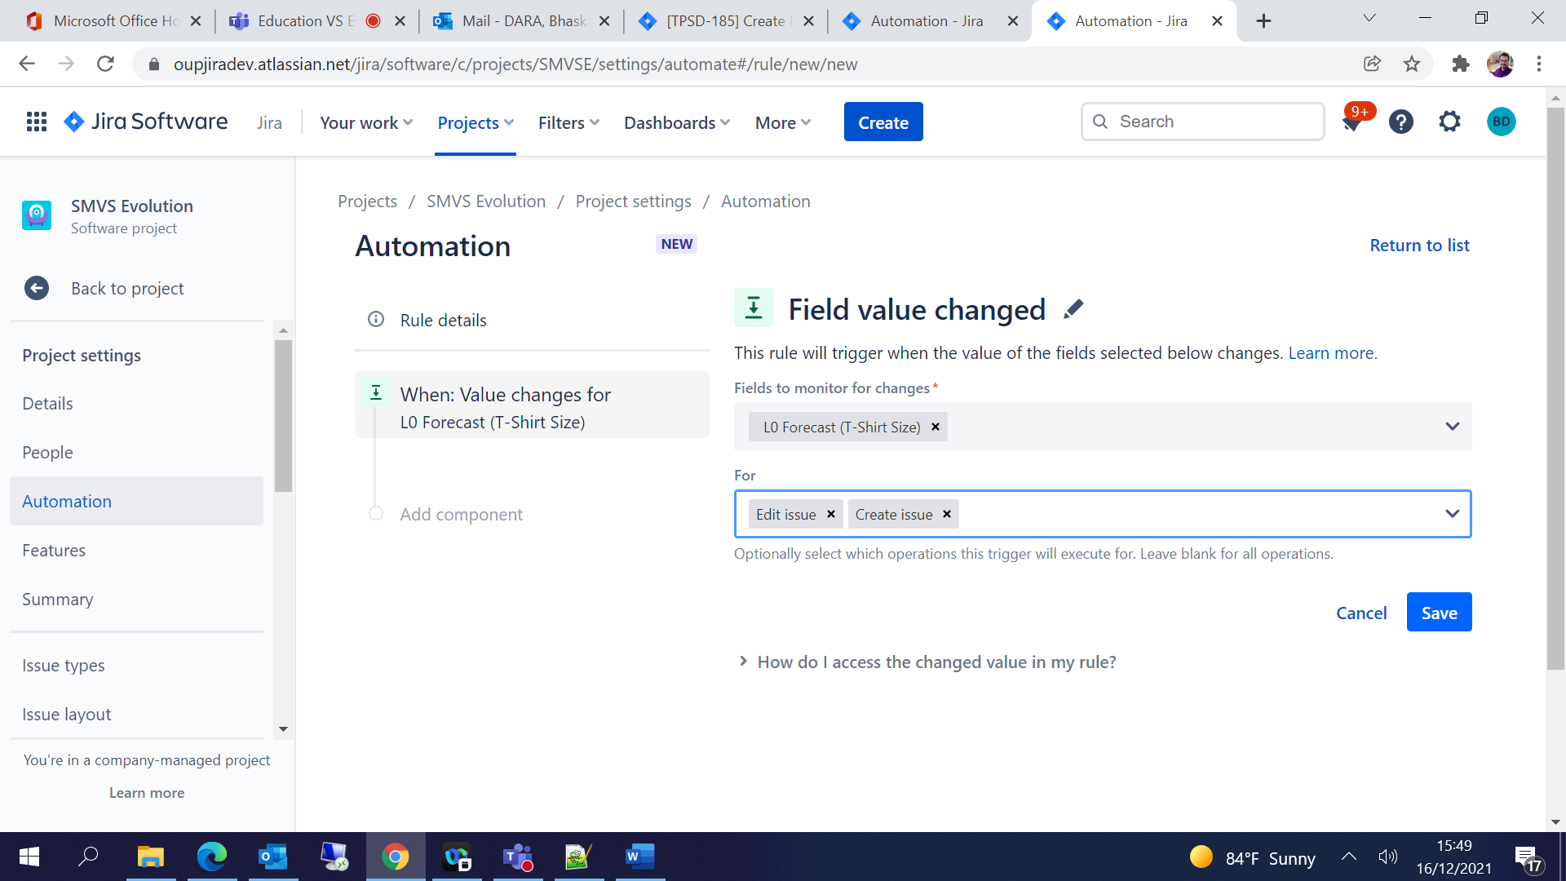

1. Select New Branch 🡪 Branch Rule / related issues -

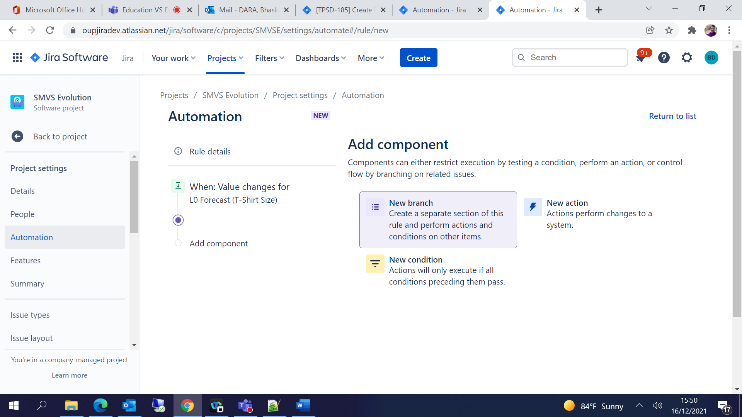

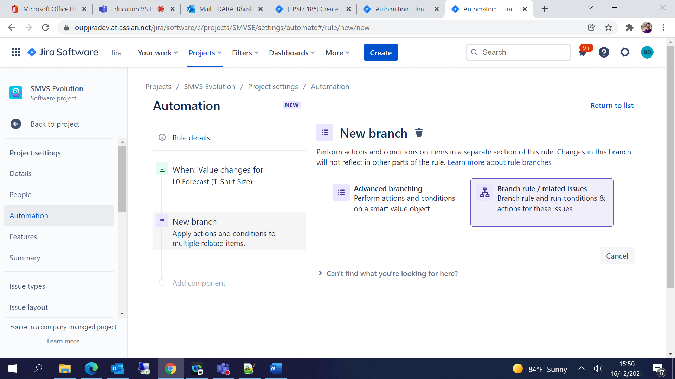

1. Select Current issue-

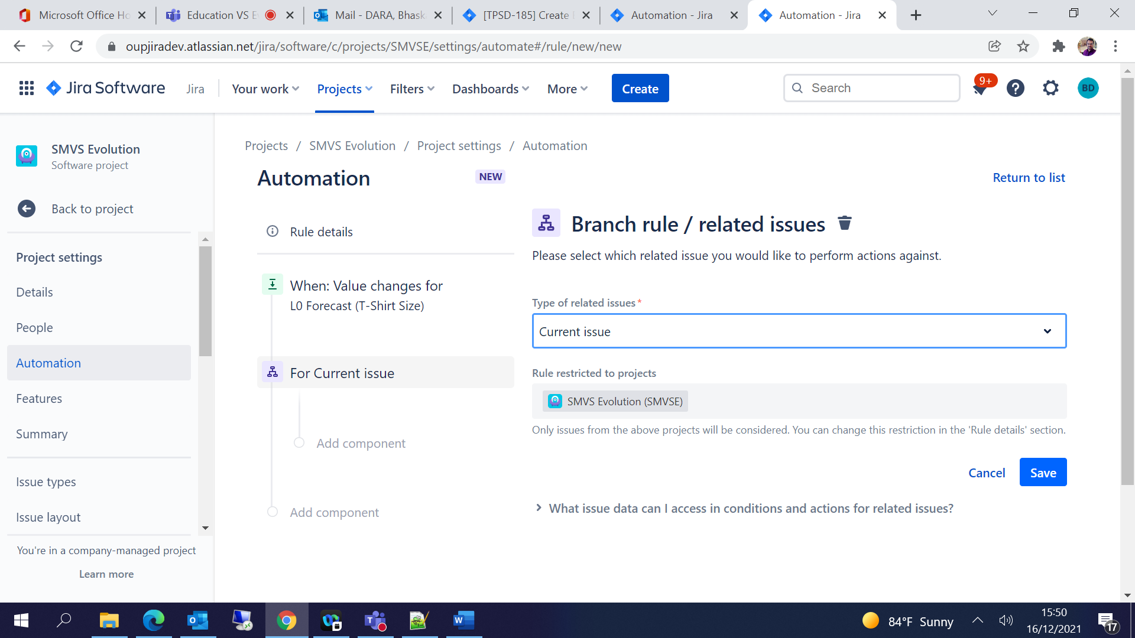

1. Select New Condition 🡪 JQL Condition🡪 Provide the JQL for filtering the issues 🡪 Save

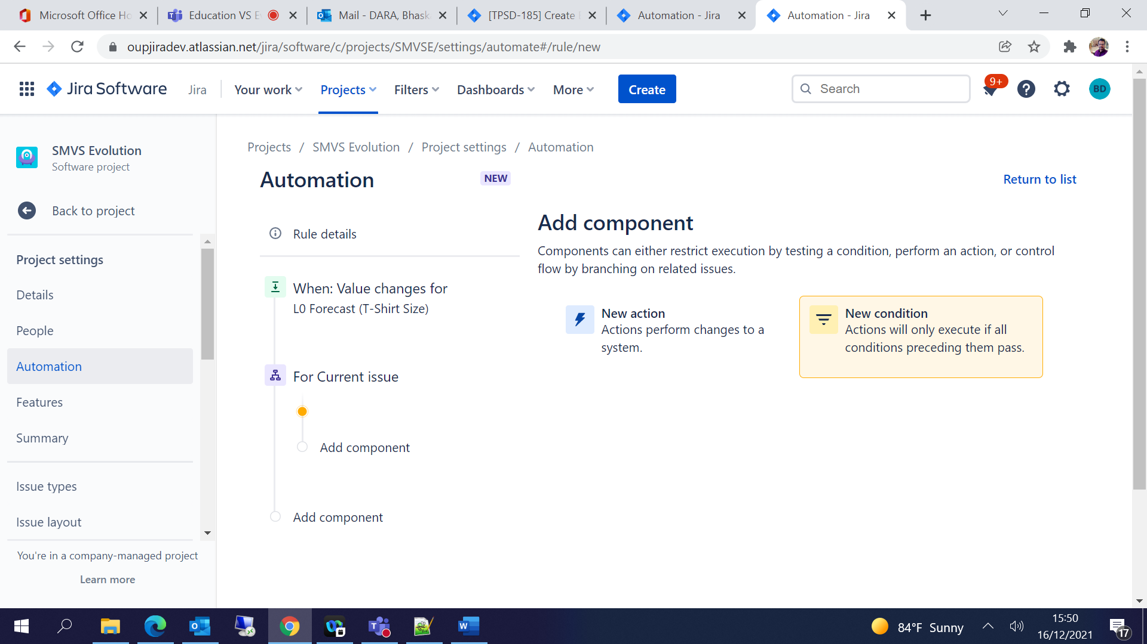

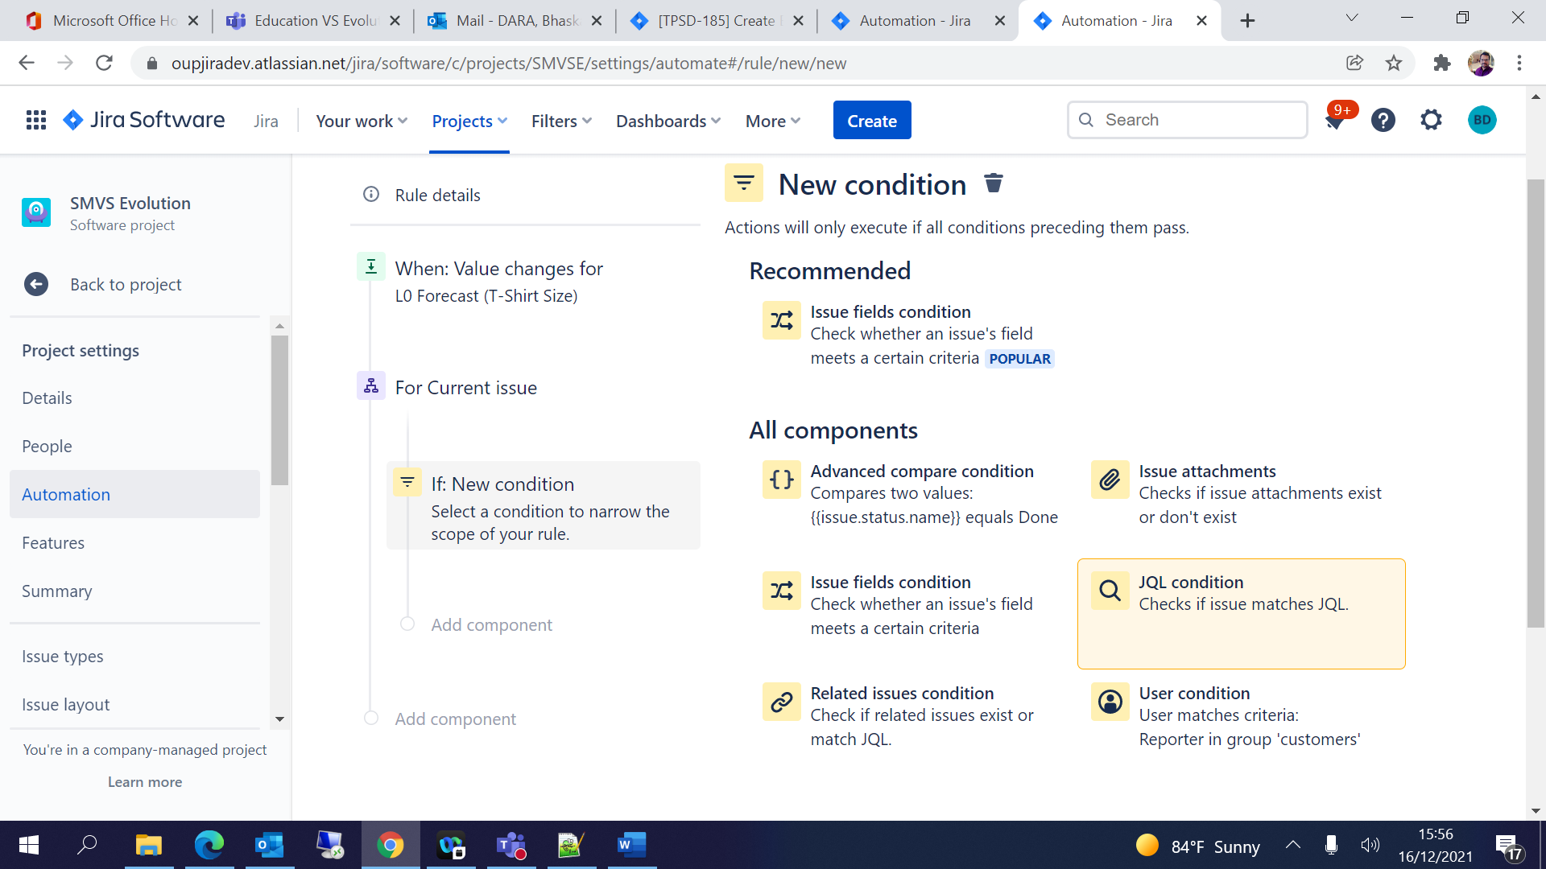

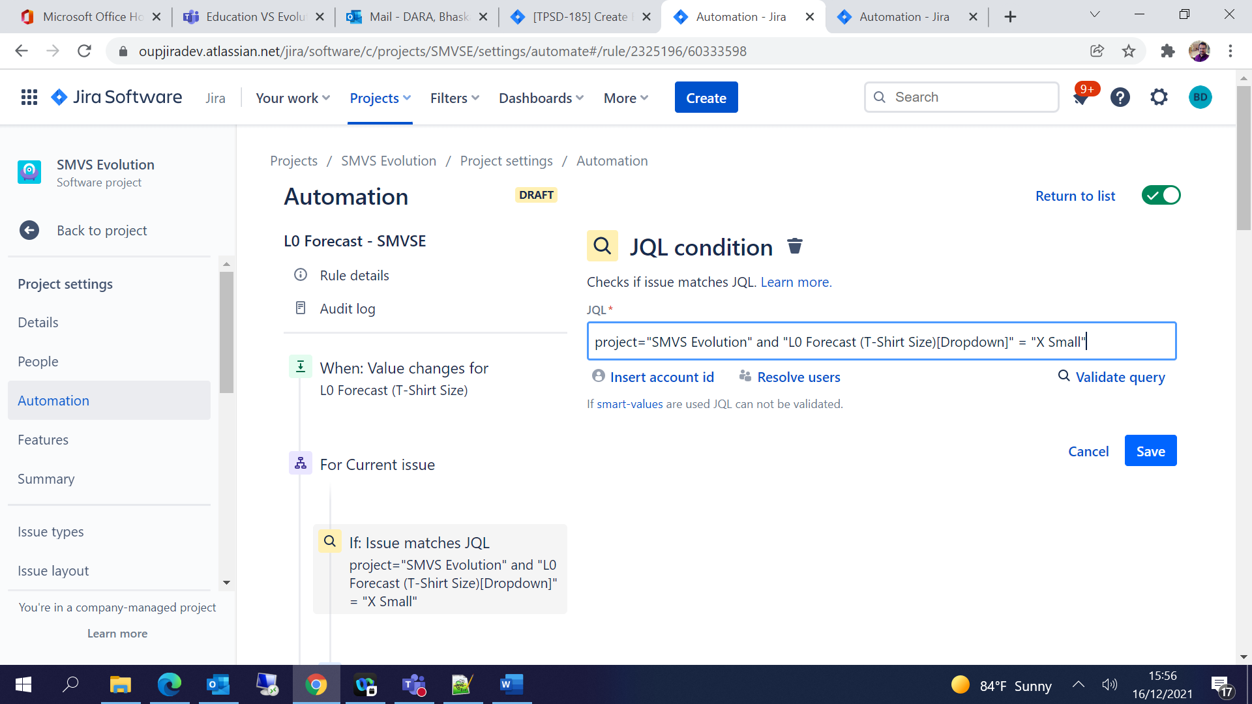

1. Select New Action 🡪 Edit Issue 🡪 Choose the Story Points field 🡪 Enter Story points w.r.t T-Shirt Size 🡪 Save

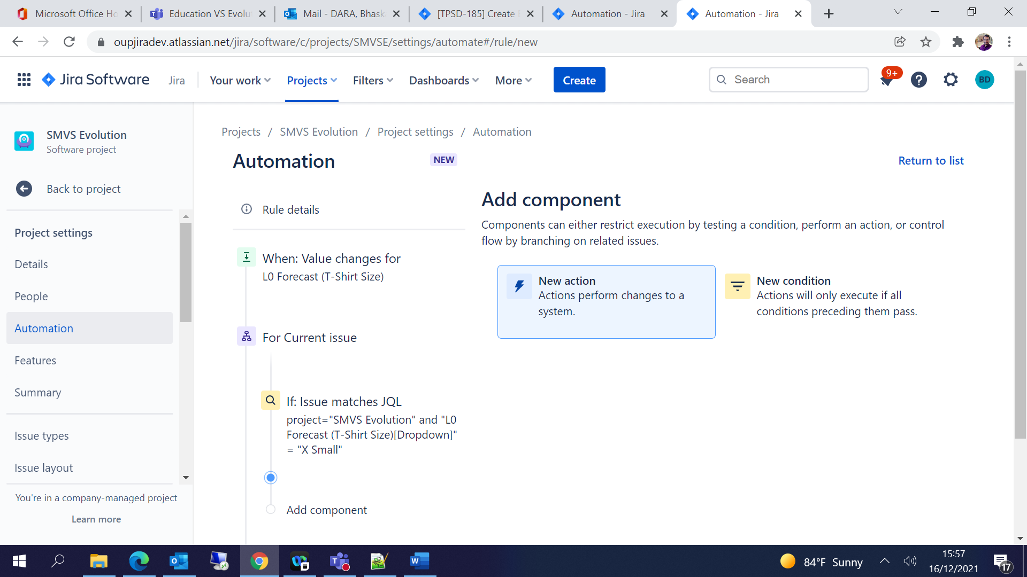

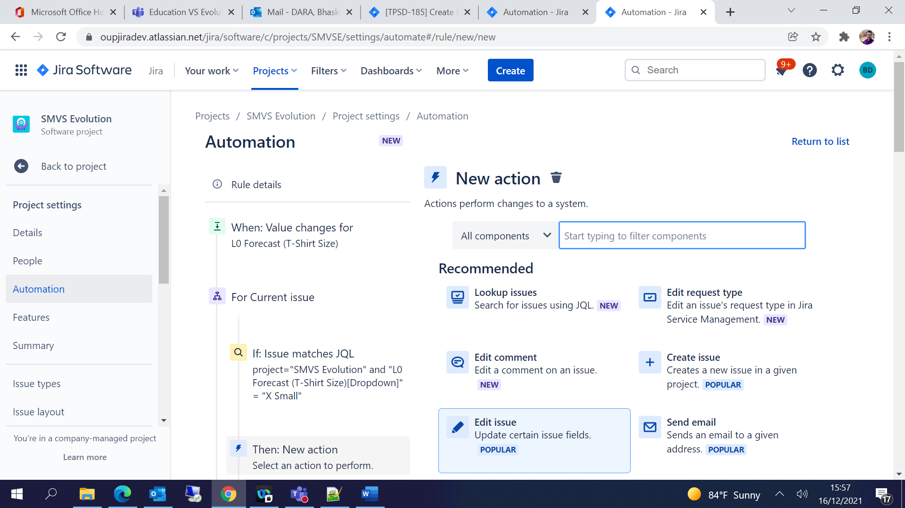

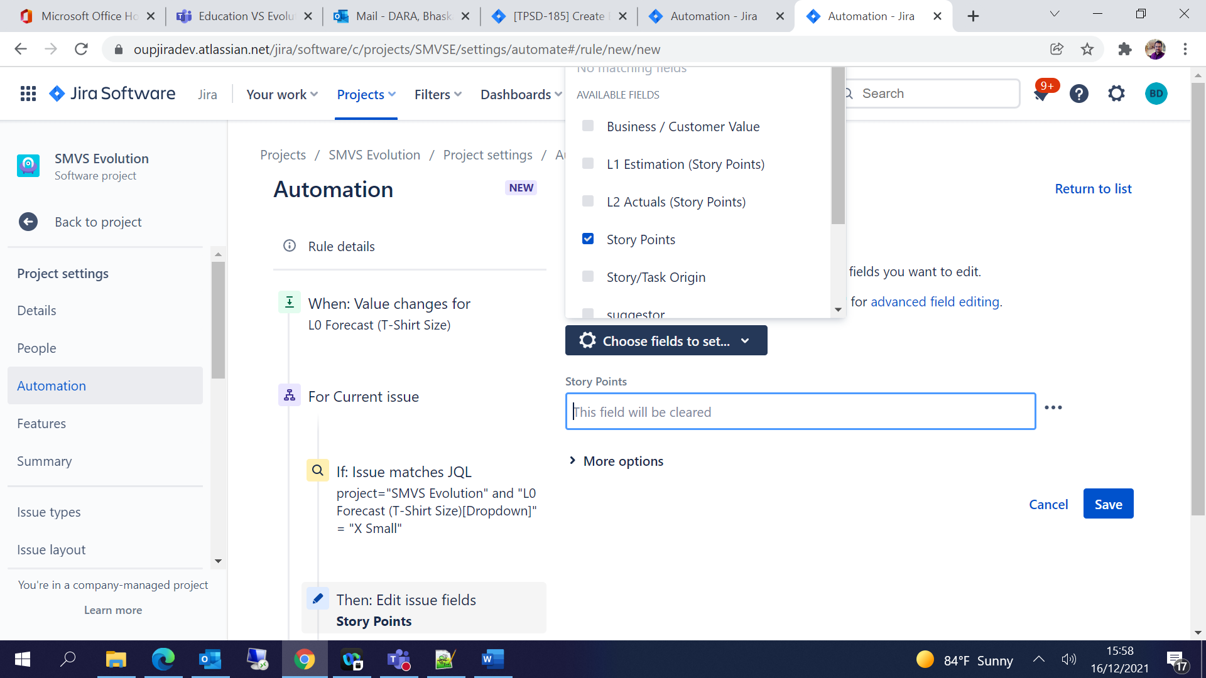

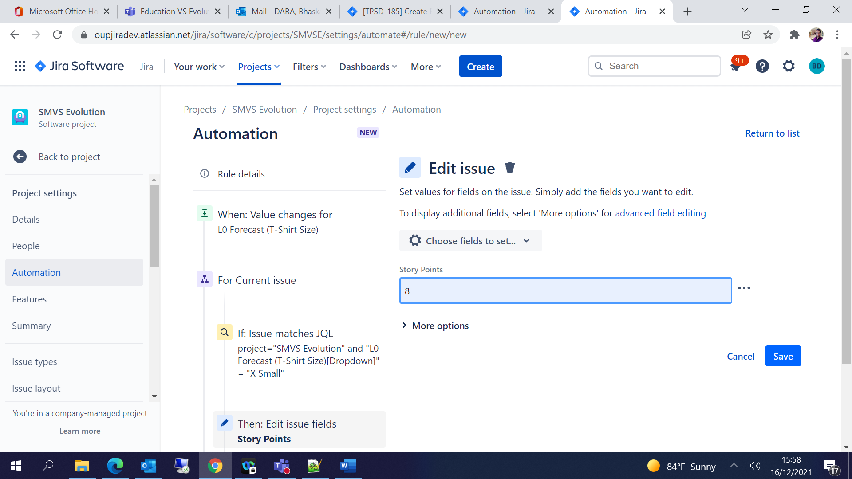

1. Add component under parent level

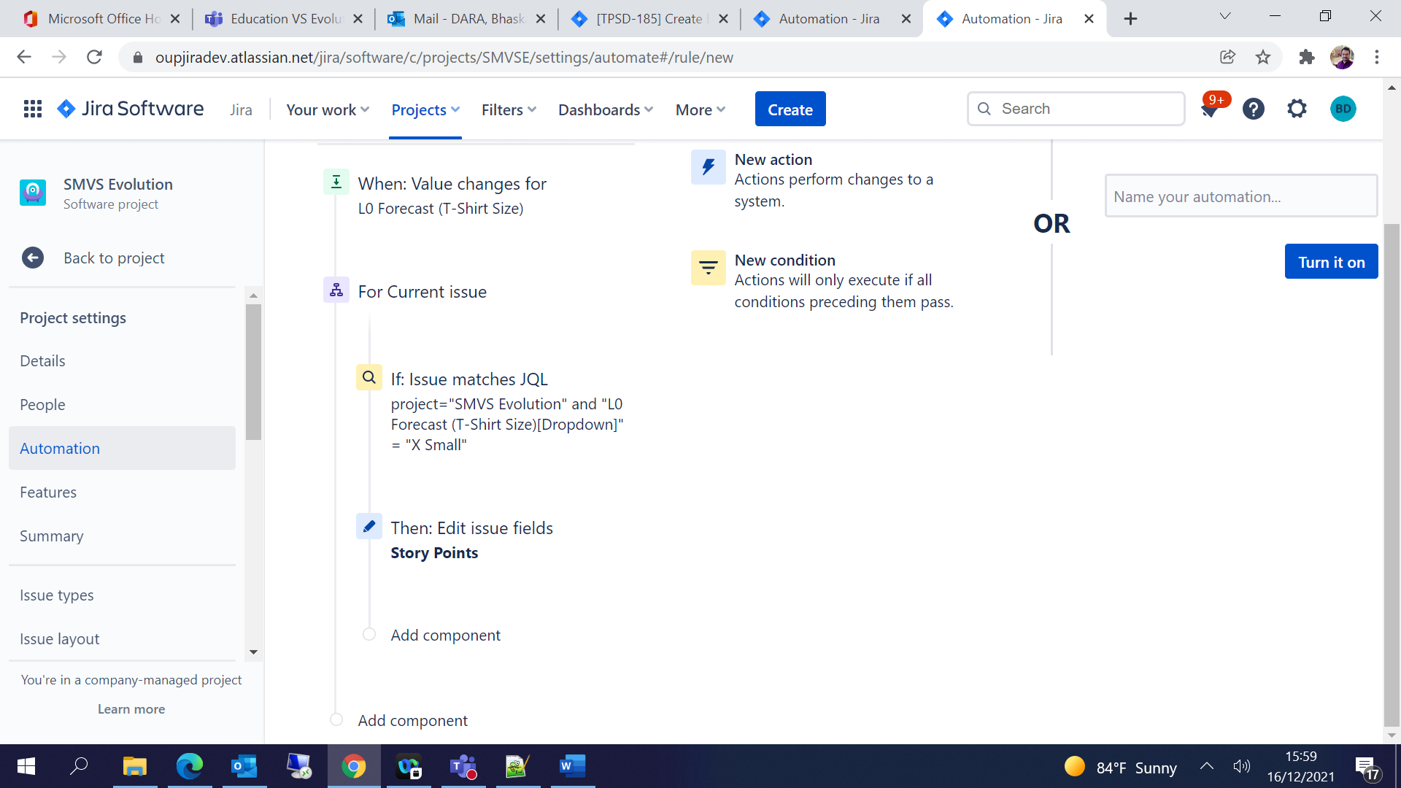

1. Select New Branch and repeat the steps from 5 to 9 for all the T-Shirt sizes (XS,S,M,L,XL):

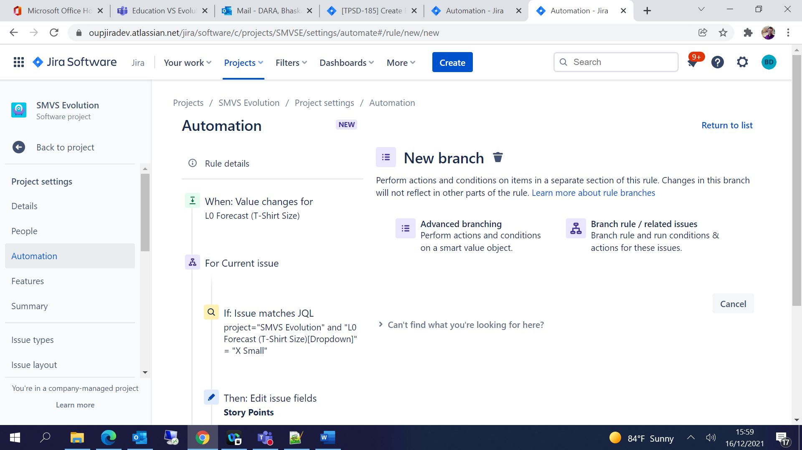

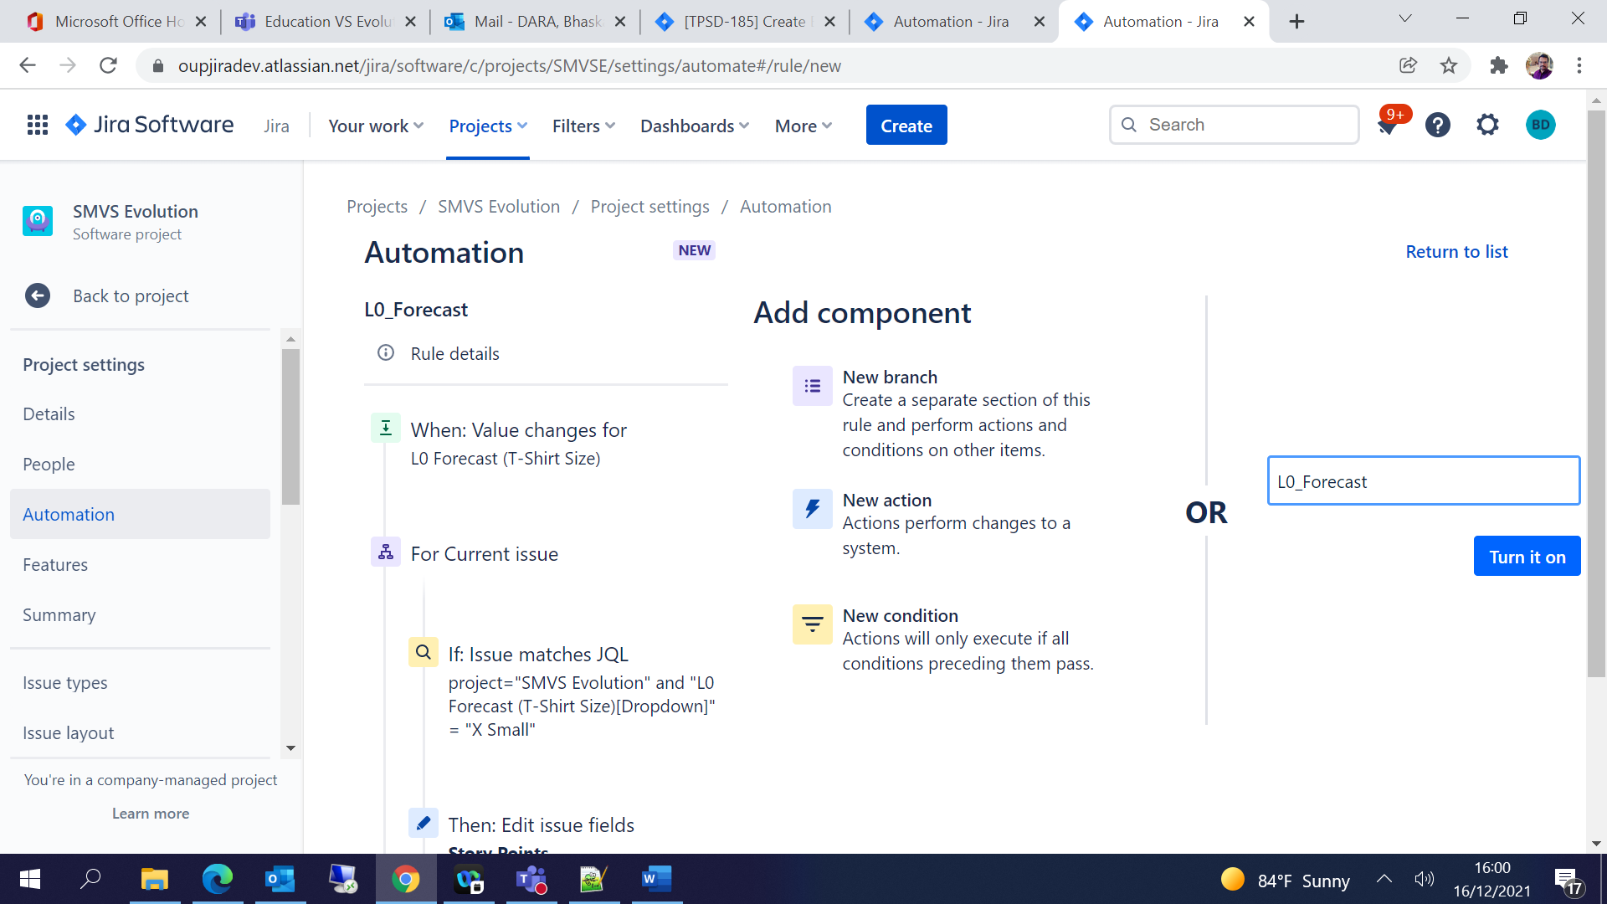

1. Publish the rule once you are done with the changes

You can see the status of the rules from Audit Log

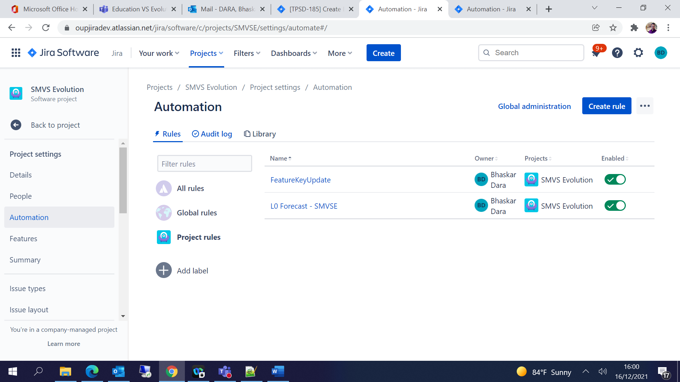

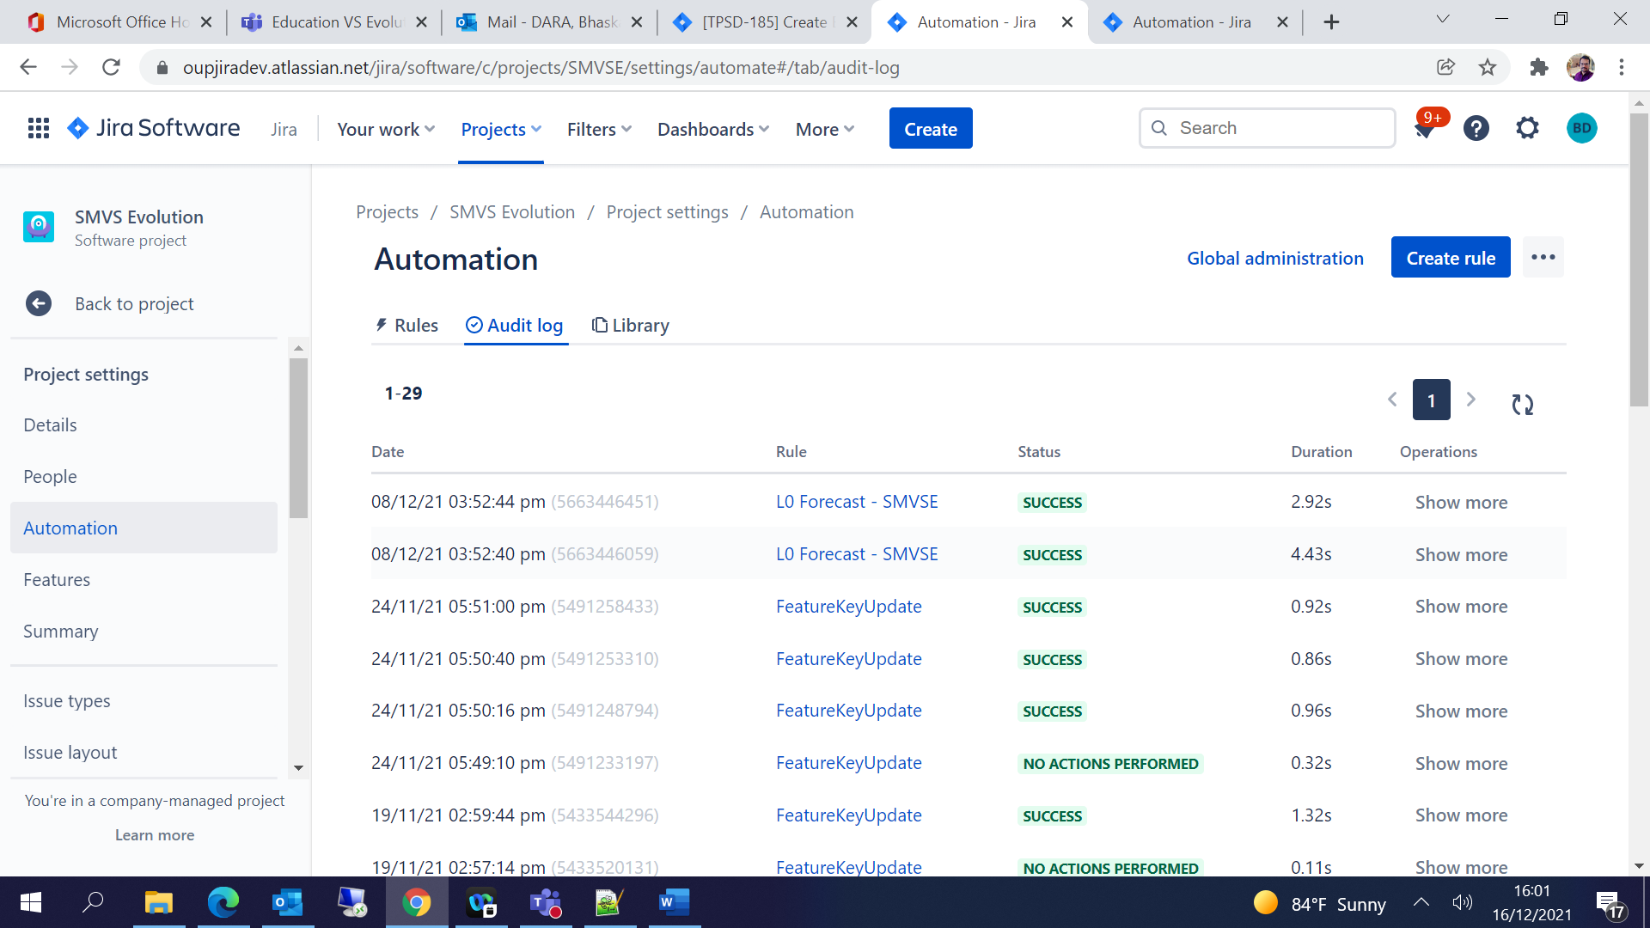

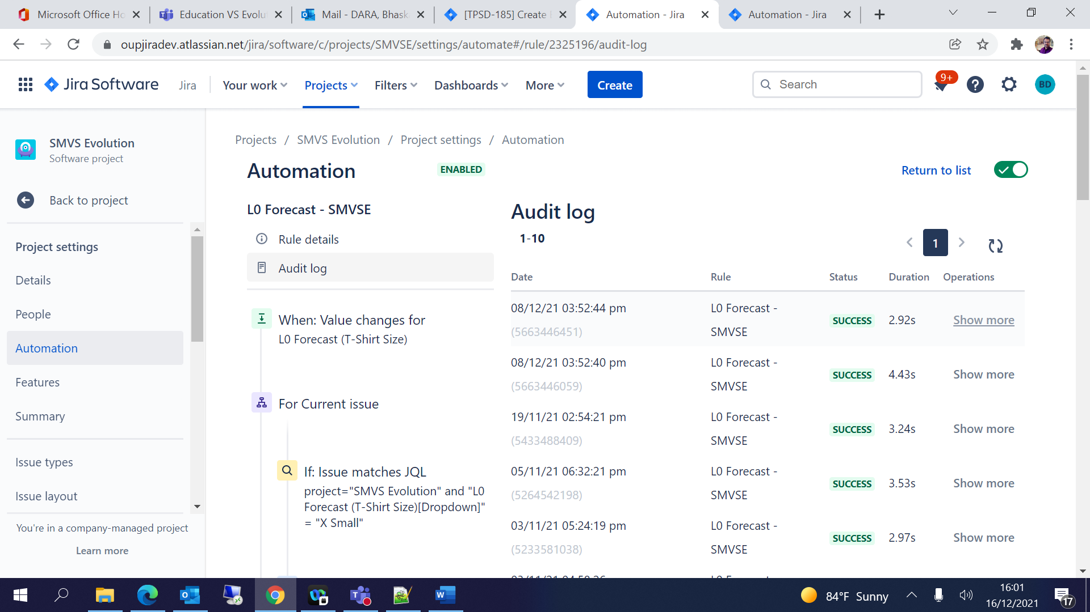

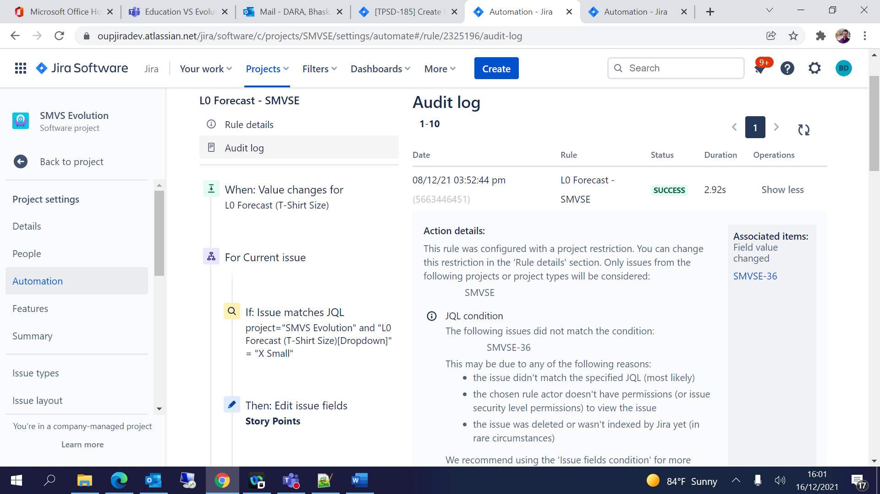

1. L1 Estimation:

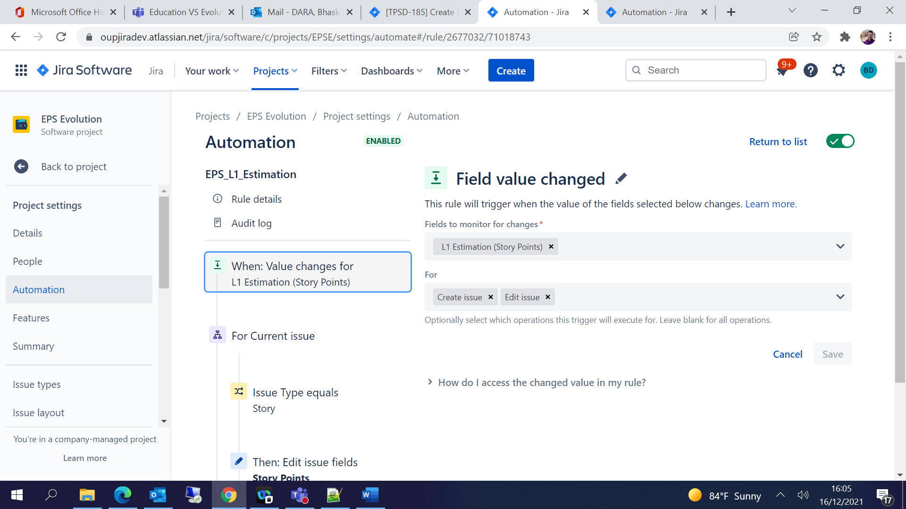

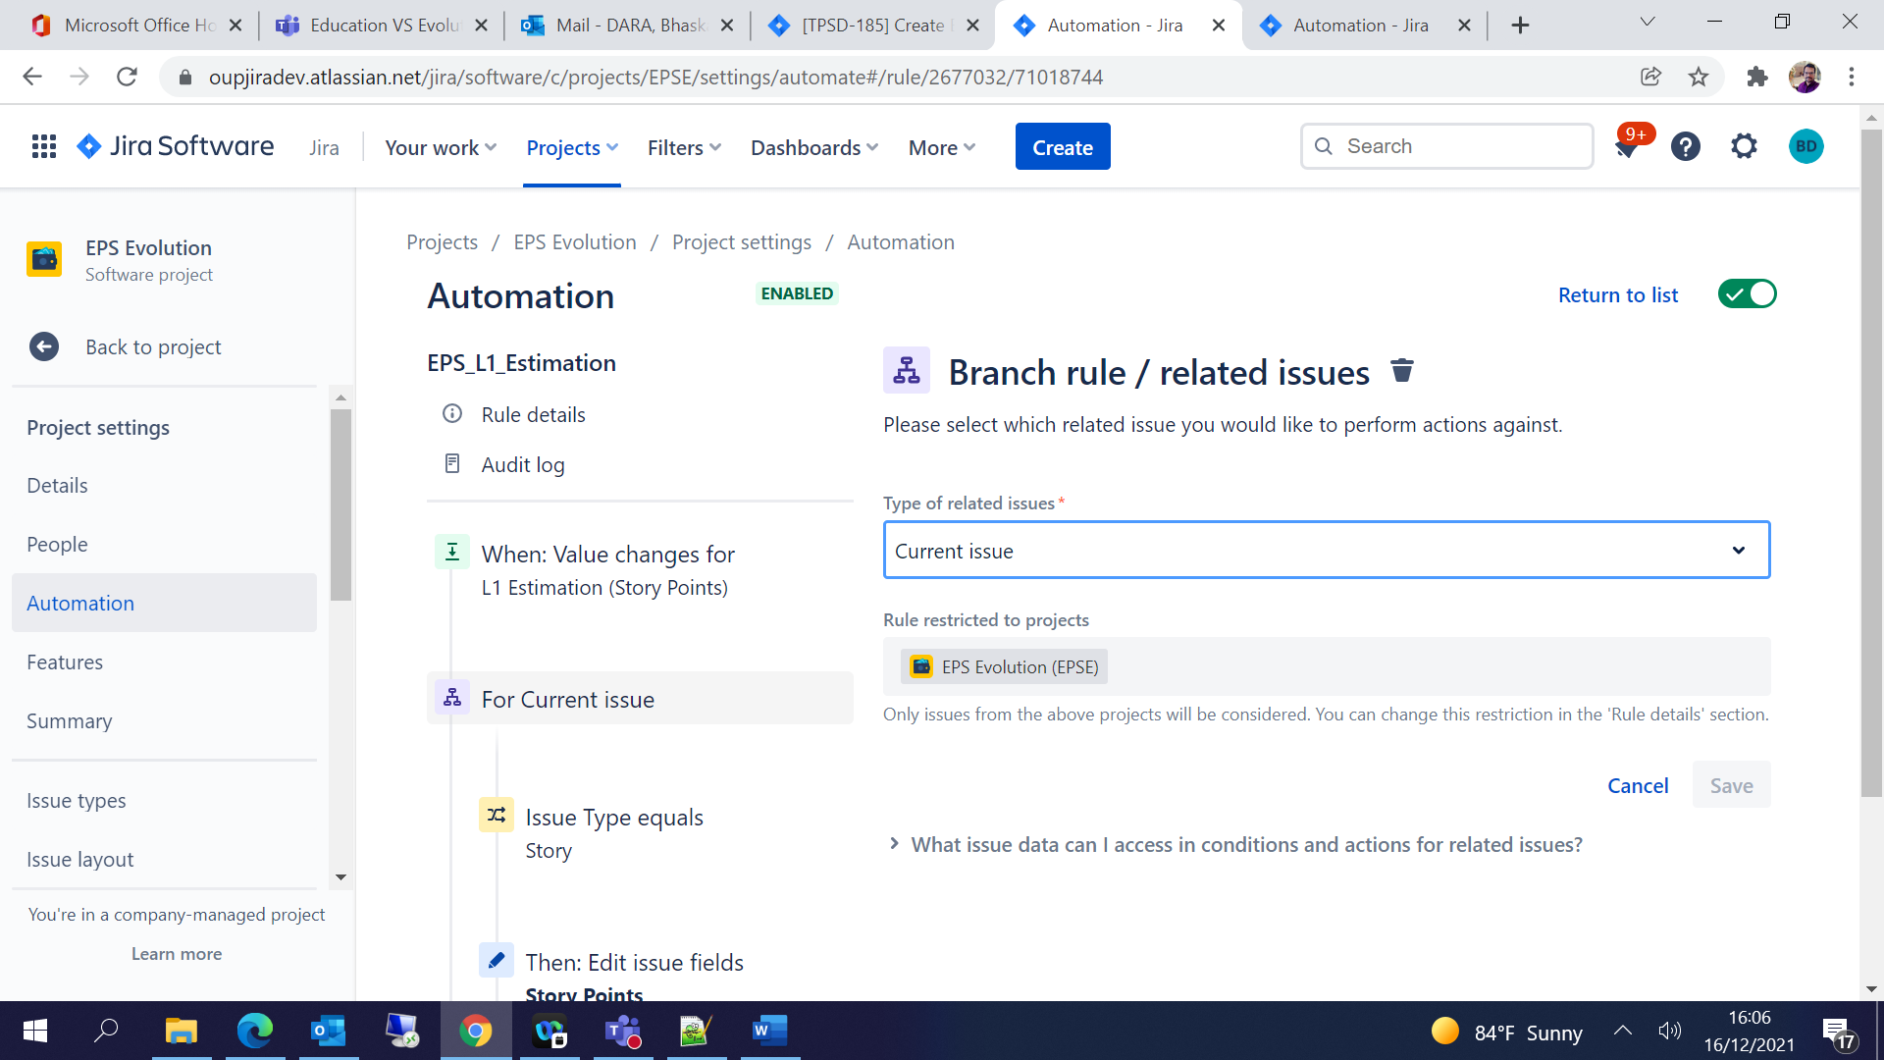

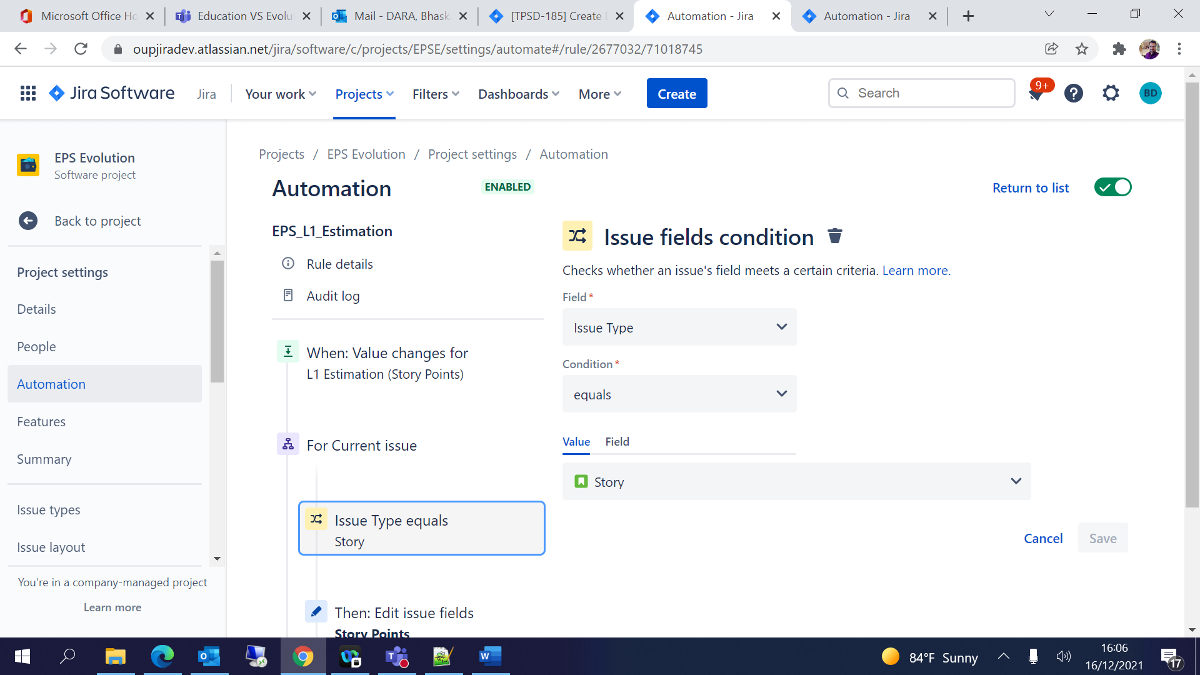

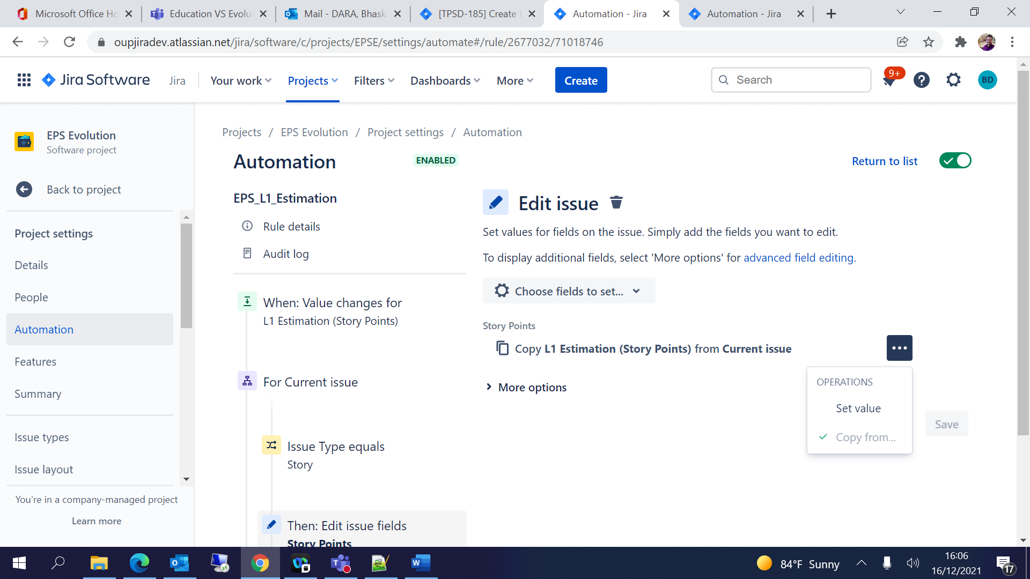

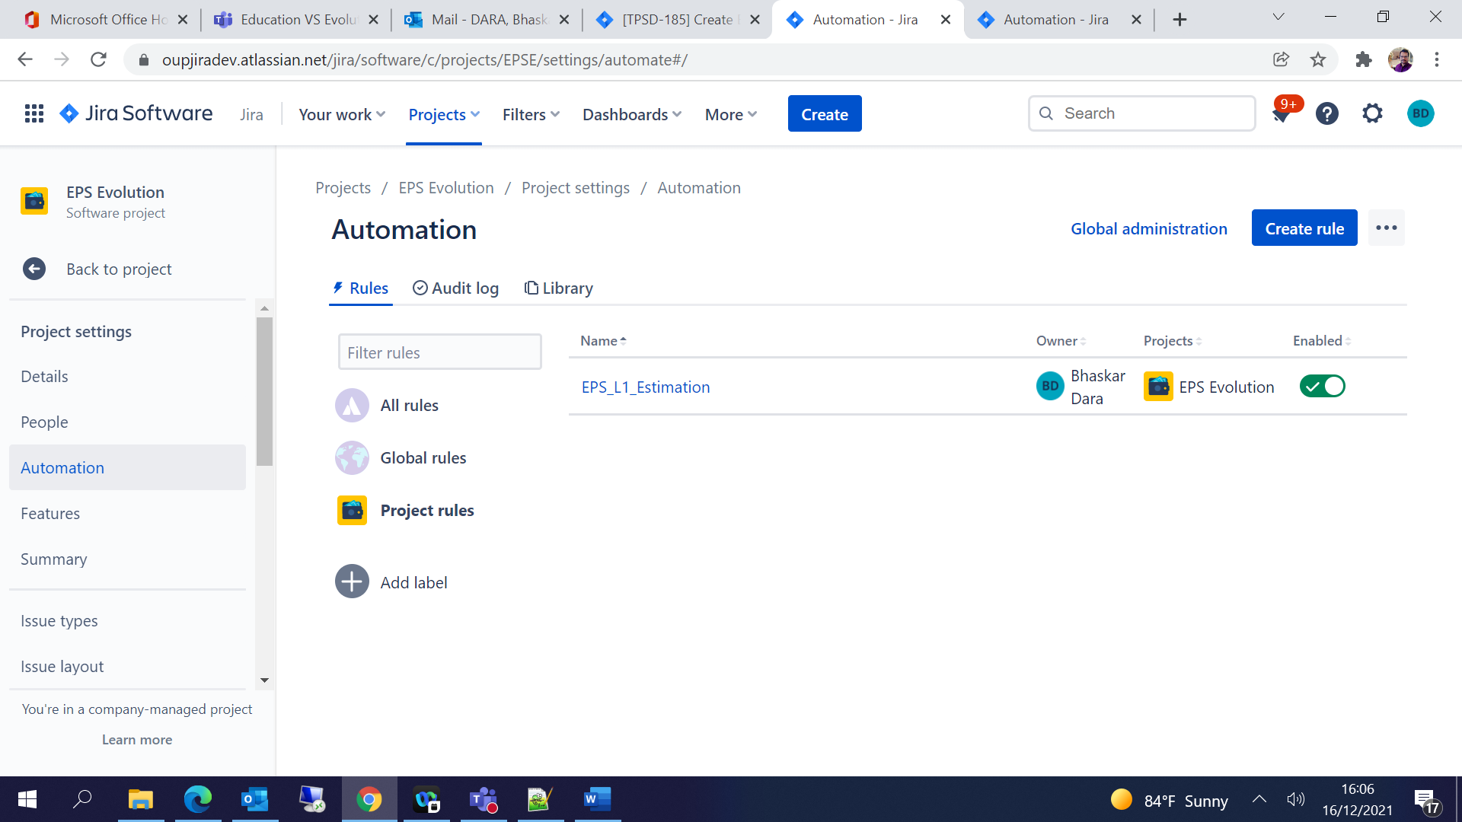

1. Business Owner:

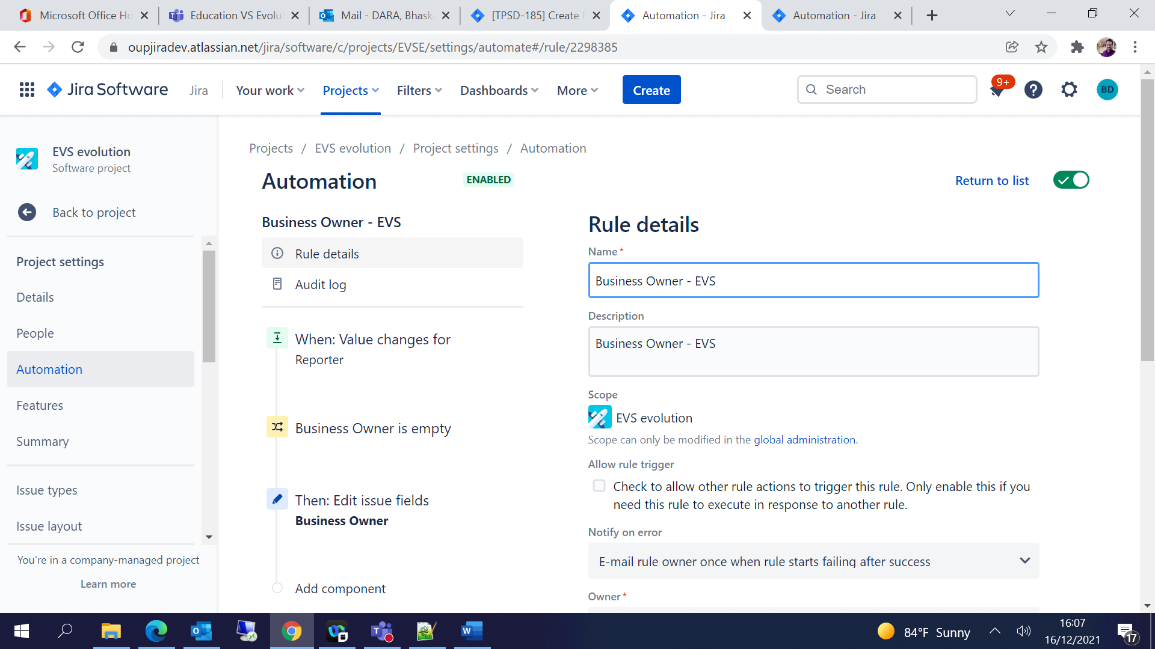

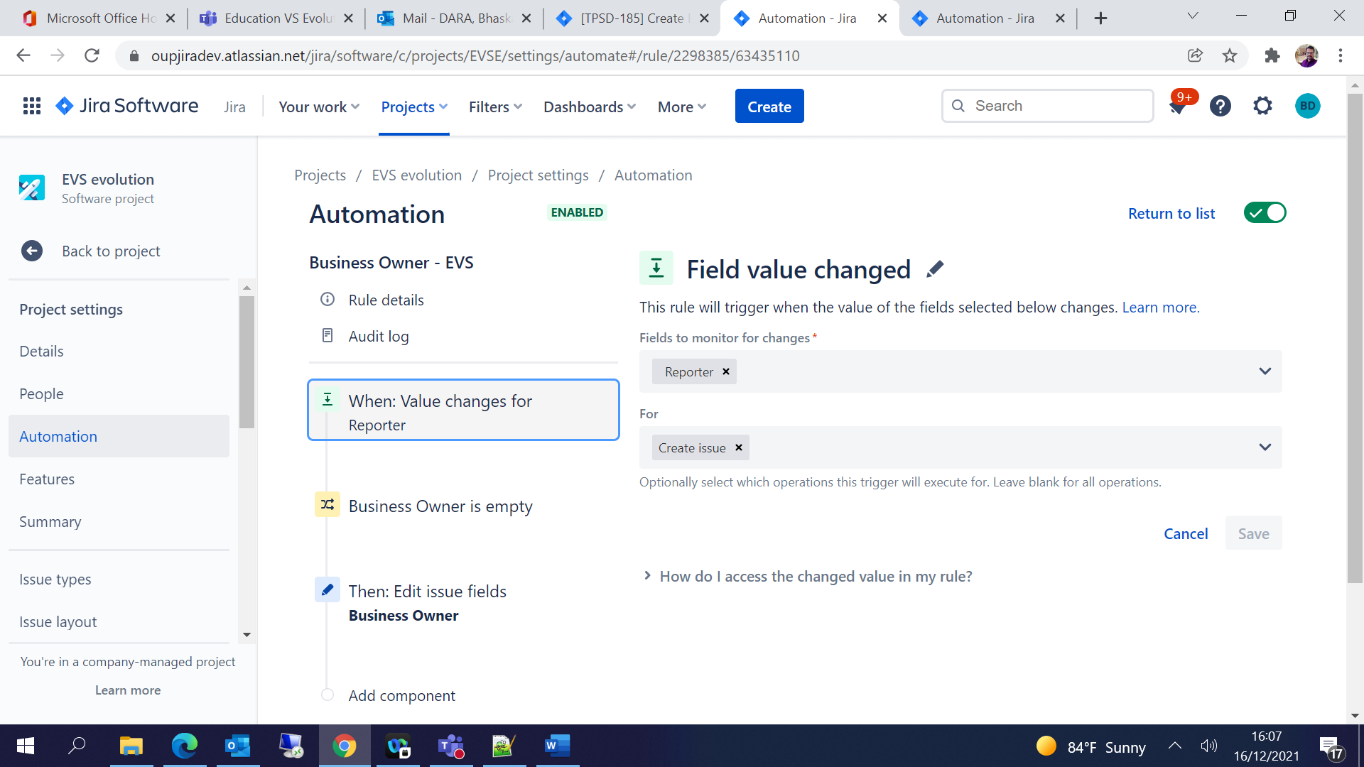

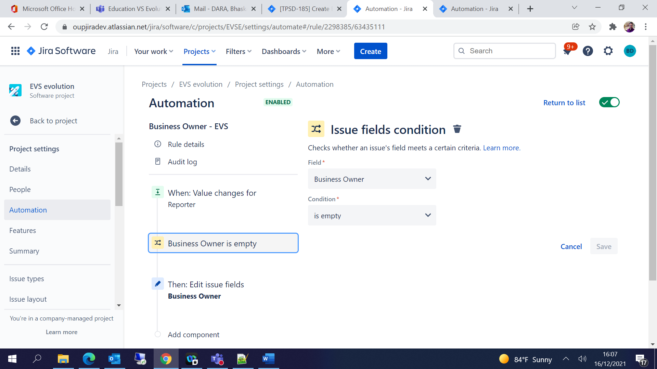

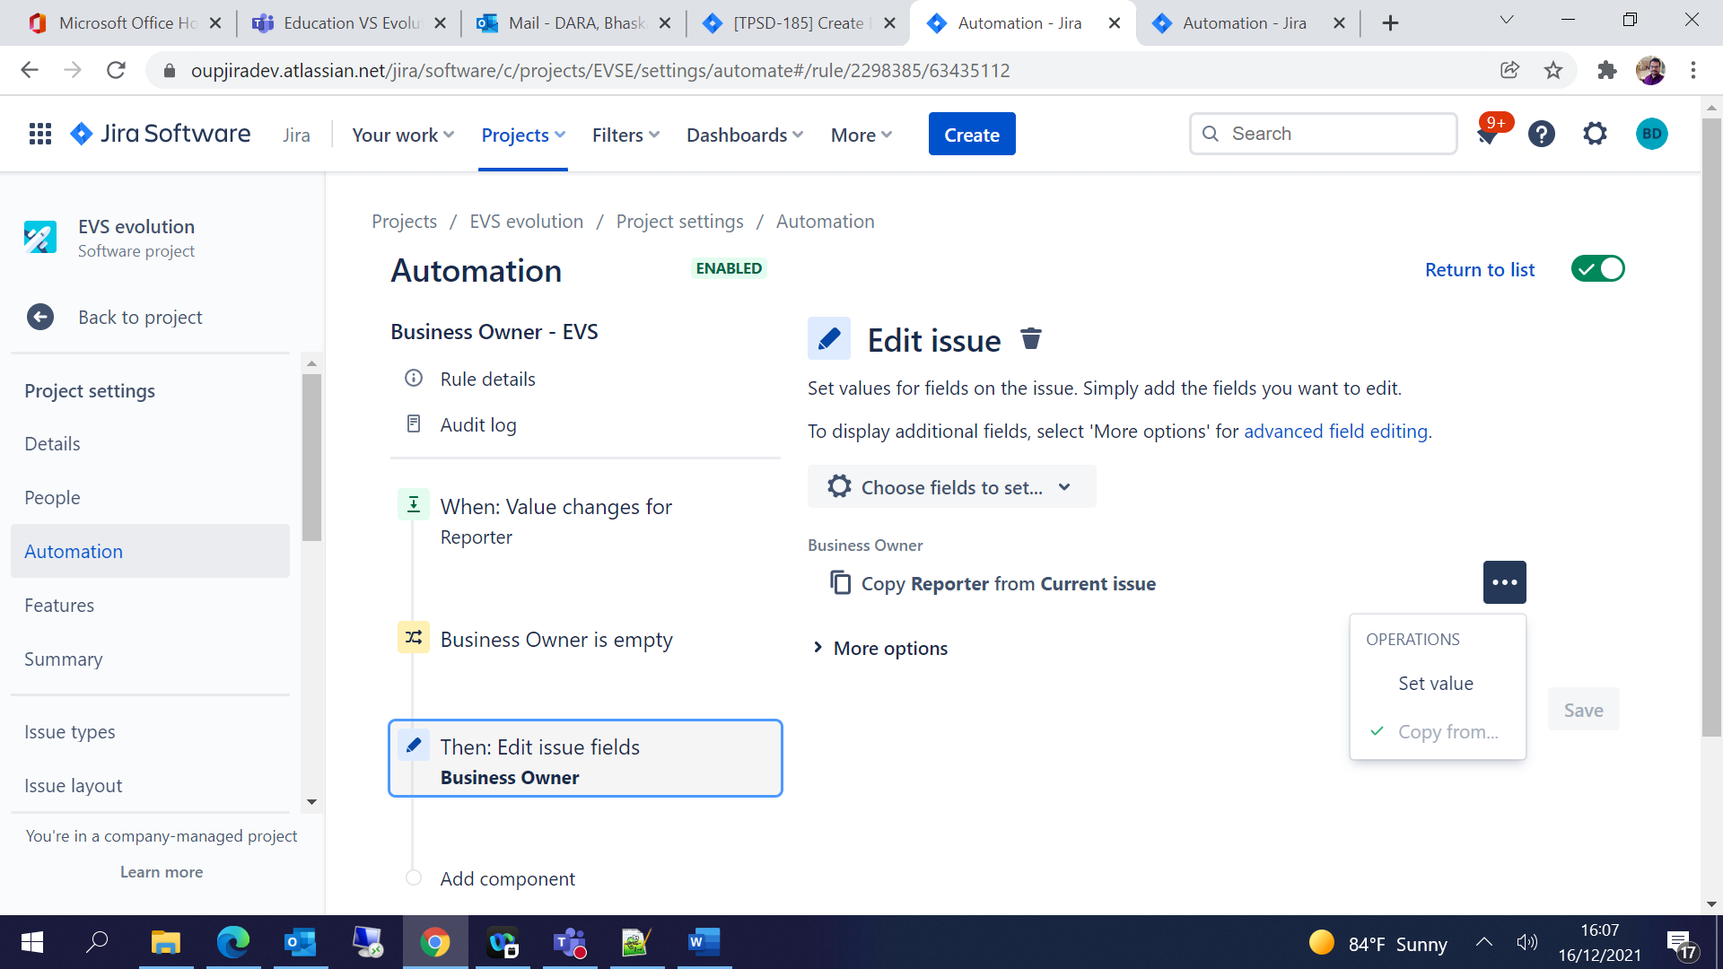

# Excel Automation for Metrics/ Reports:

Click on Filters 🡪 Advanced issue search:

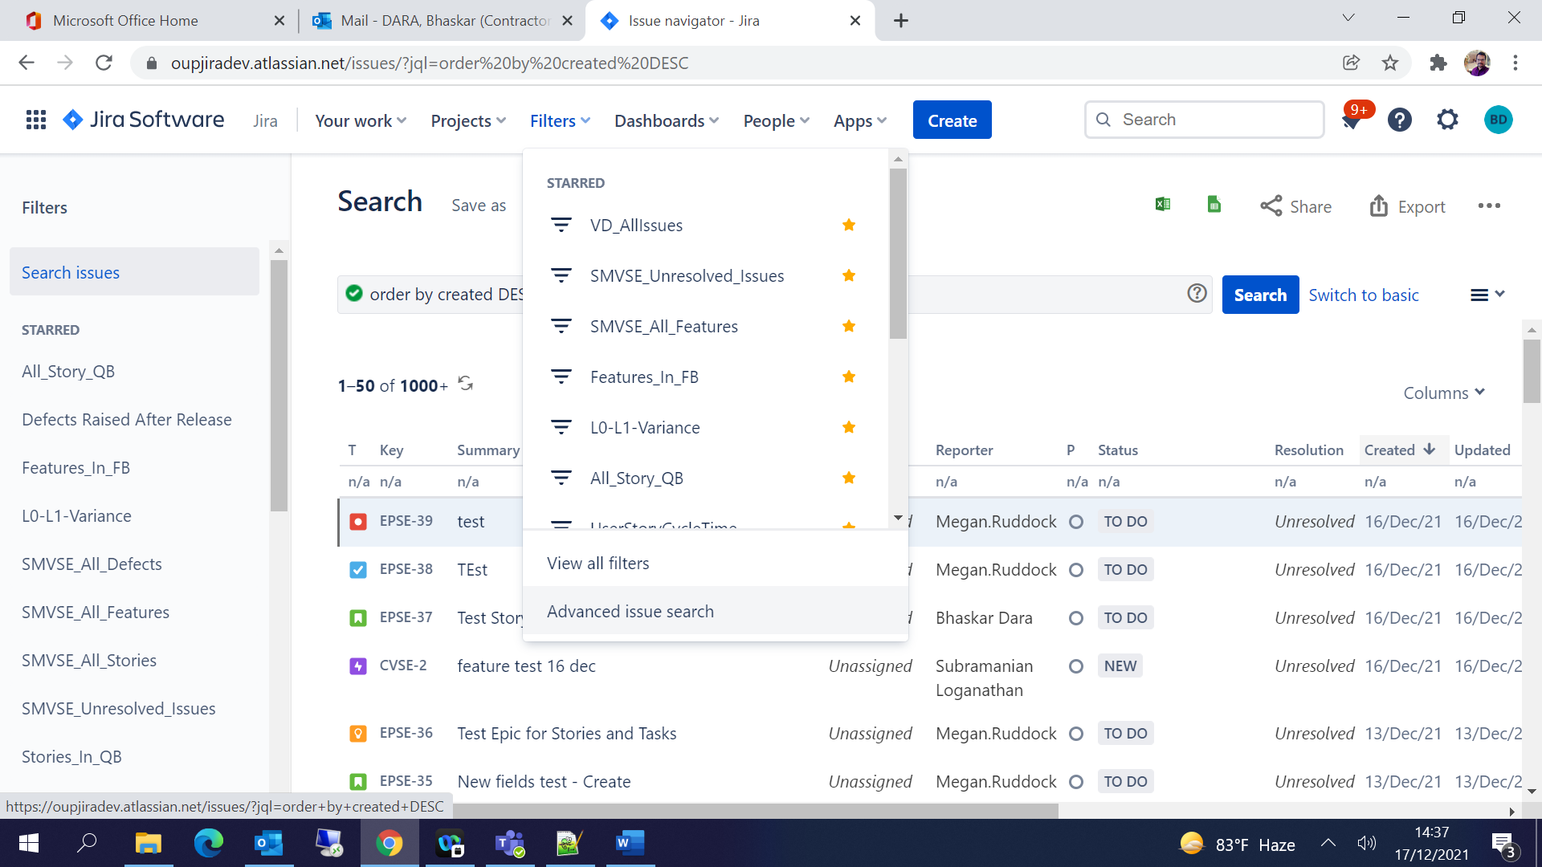

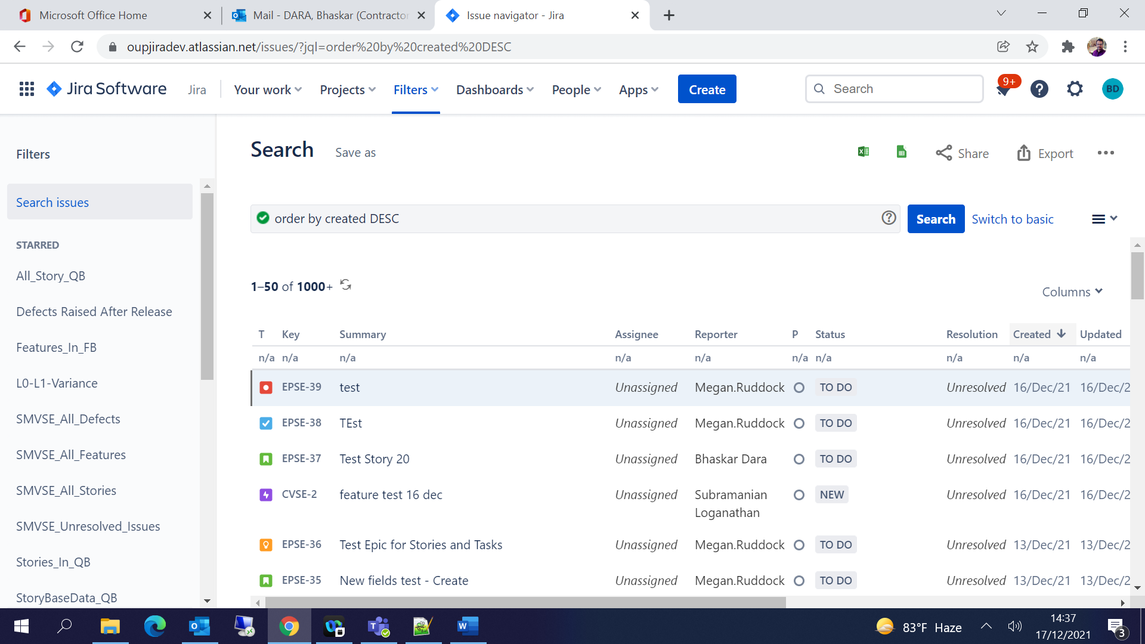

## Create a JQL

Query 🡪 Project = "SMVS Evolution" AND issuetype in (Story, Bug) AND status != new

And Save the JQL with some specific name.

Copy the URL and modify as per the query syntax:

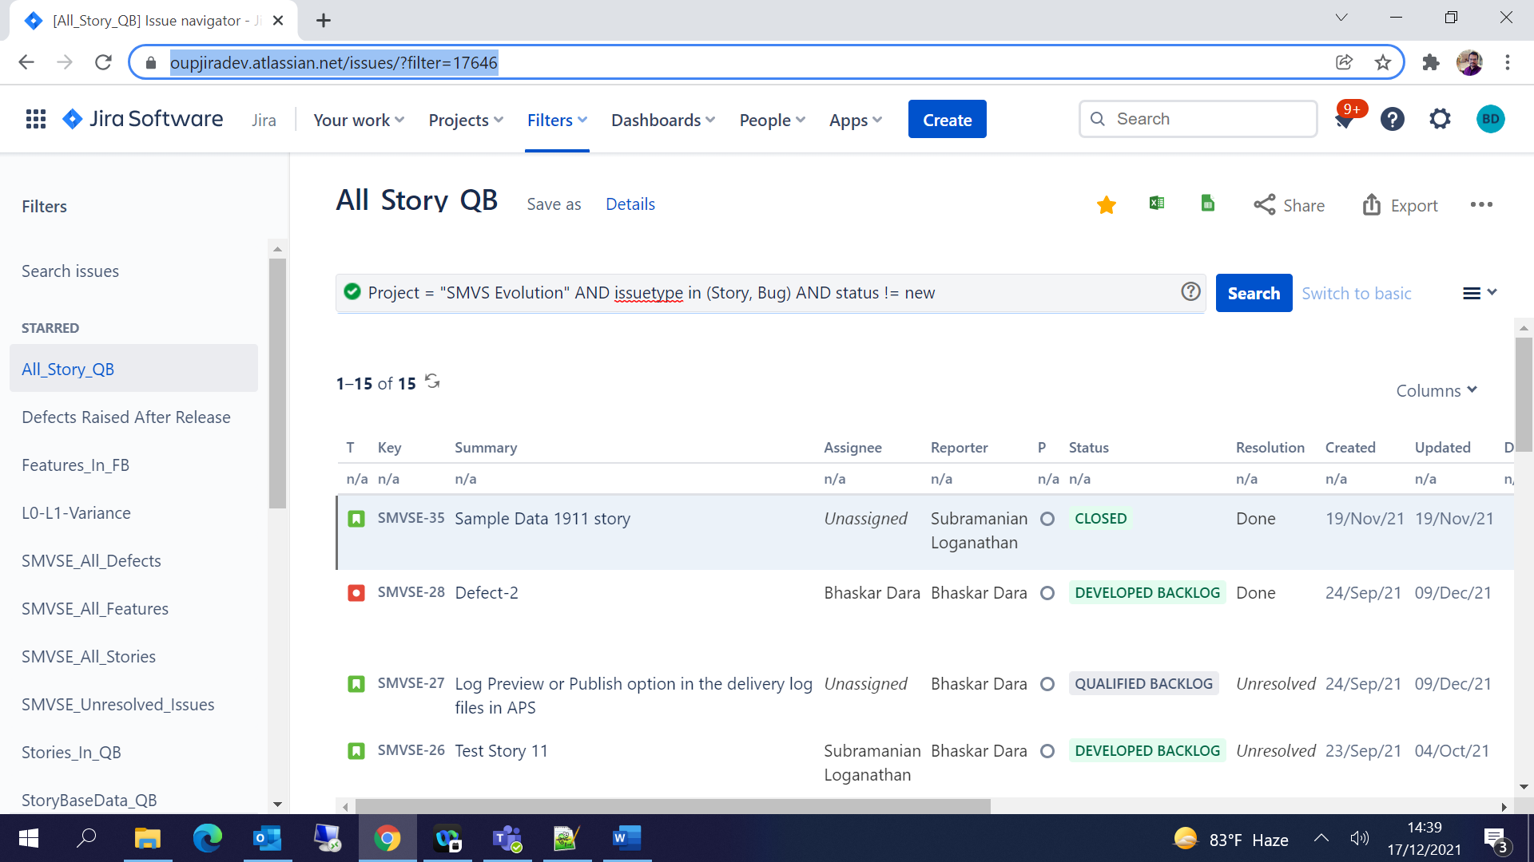

JQL for Story Base Data - [https://oupjiradev.atlassian.net/issues/?filter=**17646**](https://oupjiradev.atlassian.net/issues/?filter=17646)

Query Syntax for Excel - [https://oupjiradev.atlassian.net/sr/jira.issueviews:searchrequest-csv-current-fields/**17646**/SearchRequest-**17646**.csv](https://oupjiradev.atlassian.net/sr/jira.issueviews:searchrequest-csv-current-fields/17646/SearchRequest-17646.csv)

Prepare the queries for all the required base data from JIRA

Features Base Data:

<https://oupjiradev.atlassian.net/sr/jira.issueviews:searchrequest-csv-current-fields/17643/SearchRequest-17643.csv>

Story Base Data:

<https://oupjiradev.atlassian.net/sr/jira.issueviews:searchrequest-csv-current-fields/17646/SearchRequest-17646.csv>

Defects:

<https://oupjiradev.atlassian.net/sr/jira.issueviews:searchrequest-csv-current-fields/17650/SearchRequest-17650.csv>

<https://oupjiradev.atlassian.net/sr/jira.issueviews:searchrequest-csv-current-fields/17651/SearchRequest-17651.csv>

## API Token Generation from JIRA:

Profile 🡪 Account settings 🡪

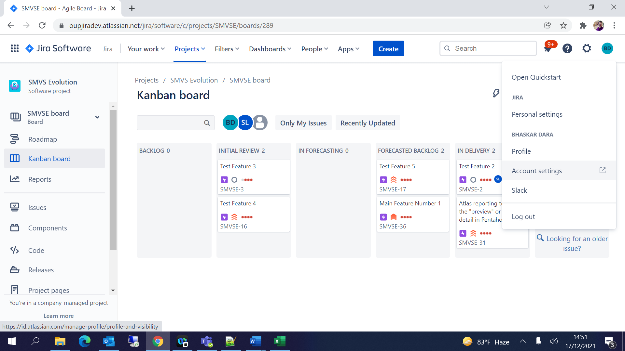

Security 🡪 API token 🡪 Click on Create and manage API token-

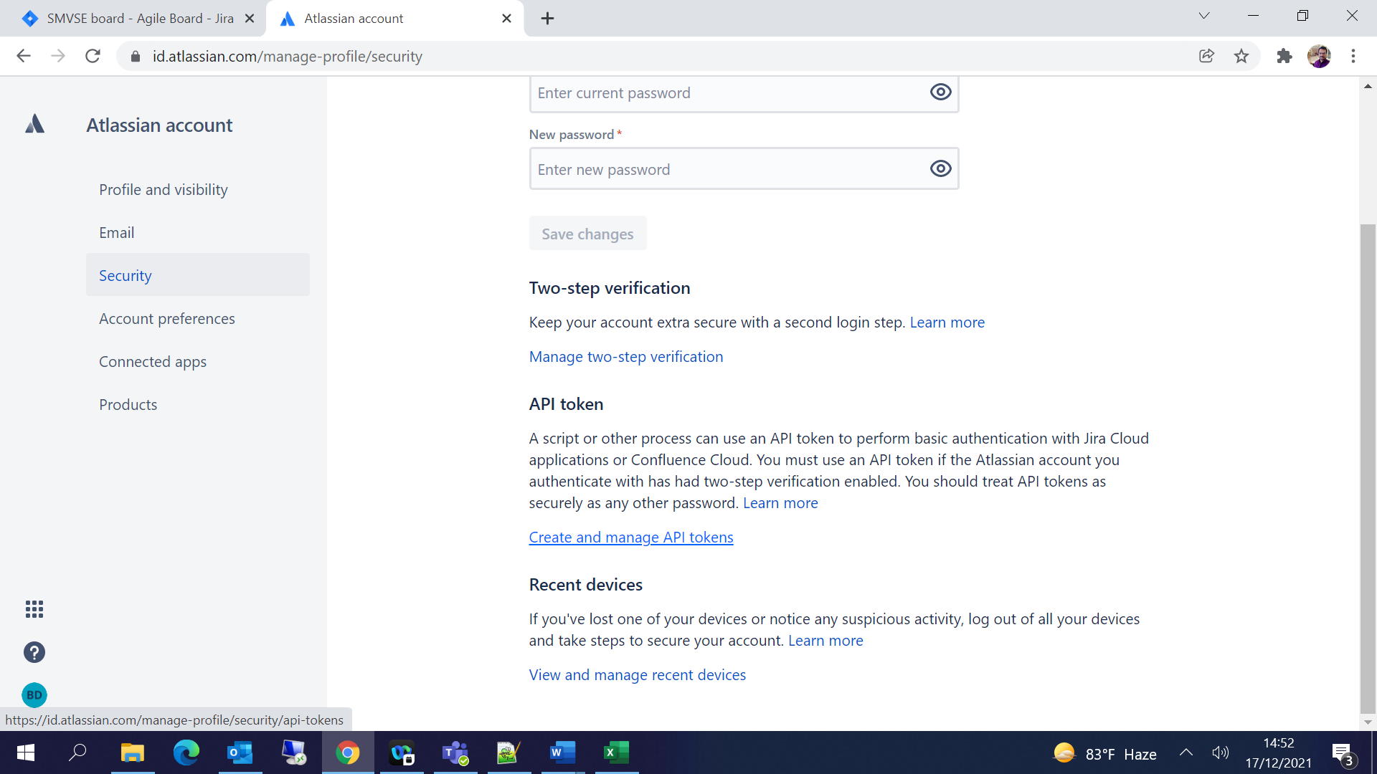

Click on Create API token 🡪 Give Label and Create -

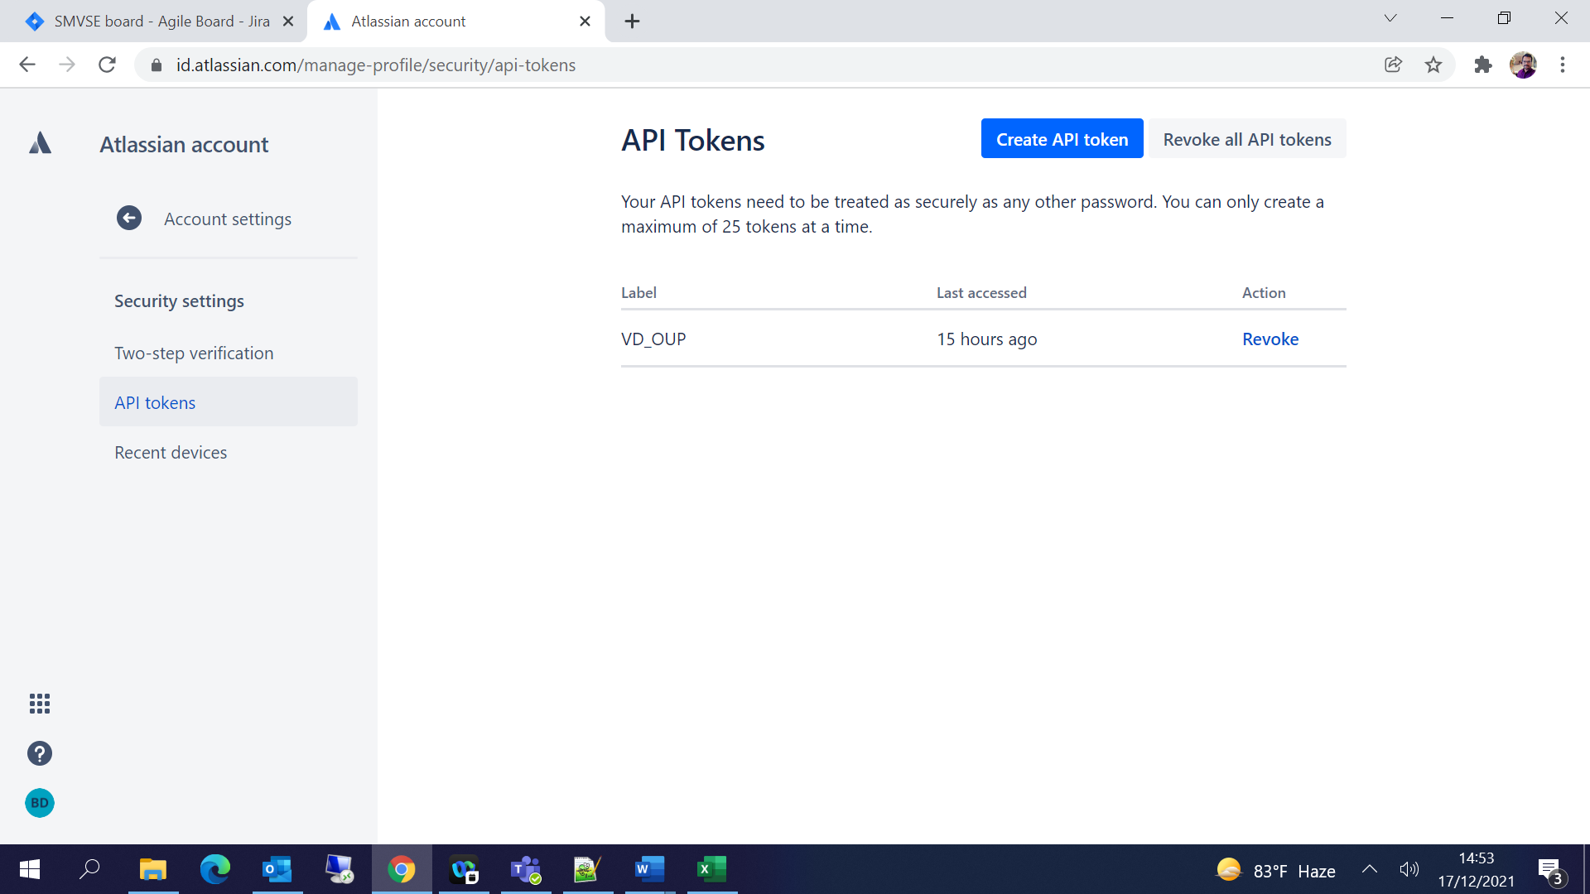

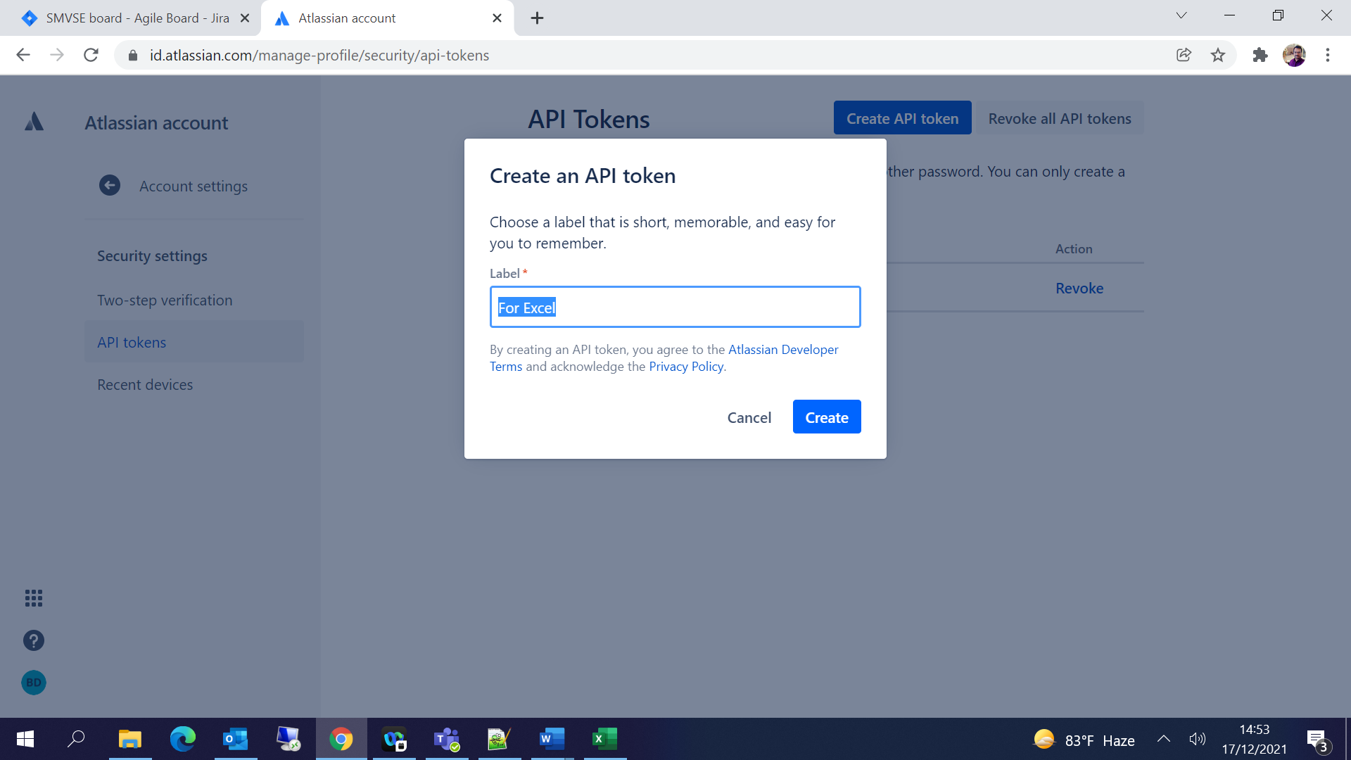

Copy the API token and save it. Make sure you copy your new API token. You won’t be able to see this token again.

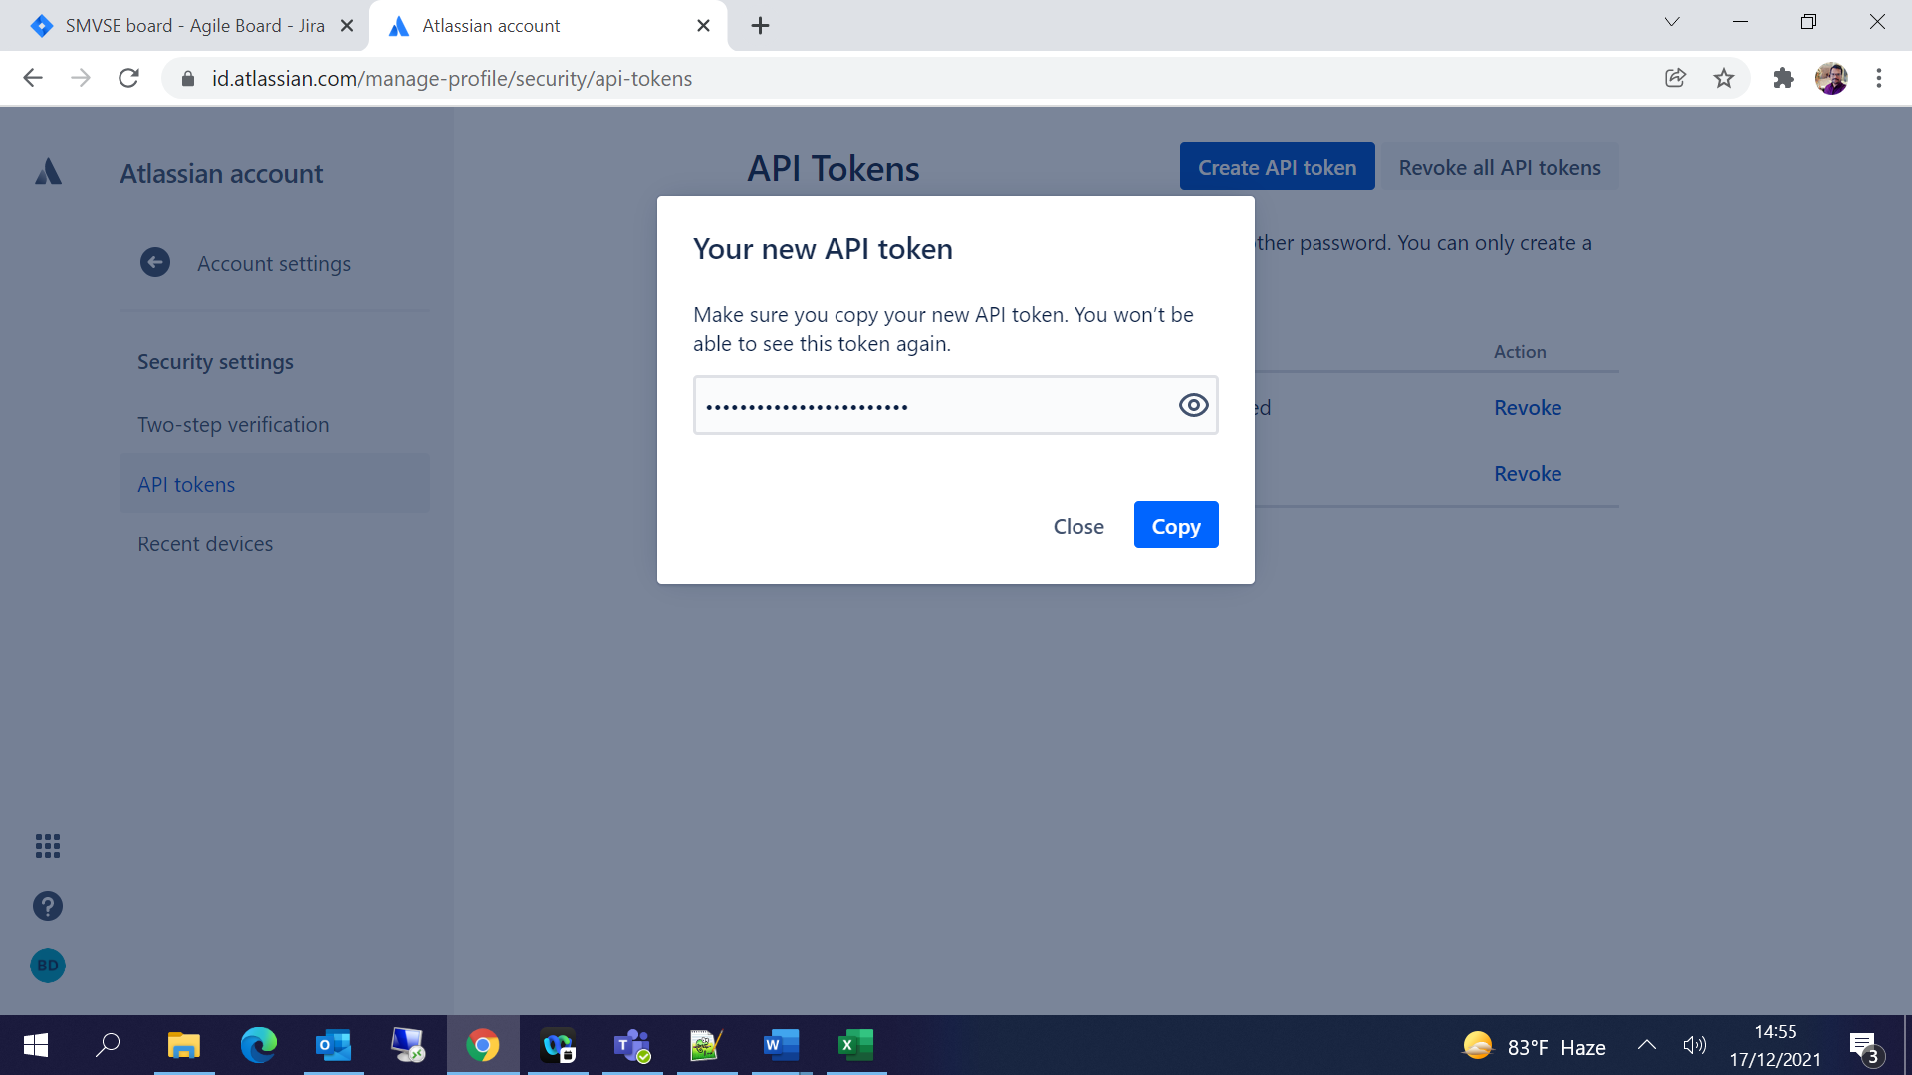

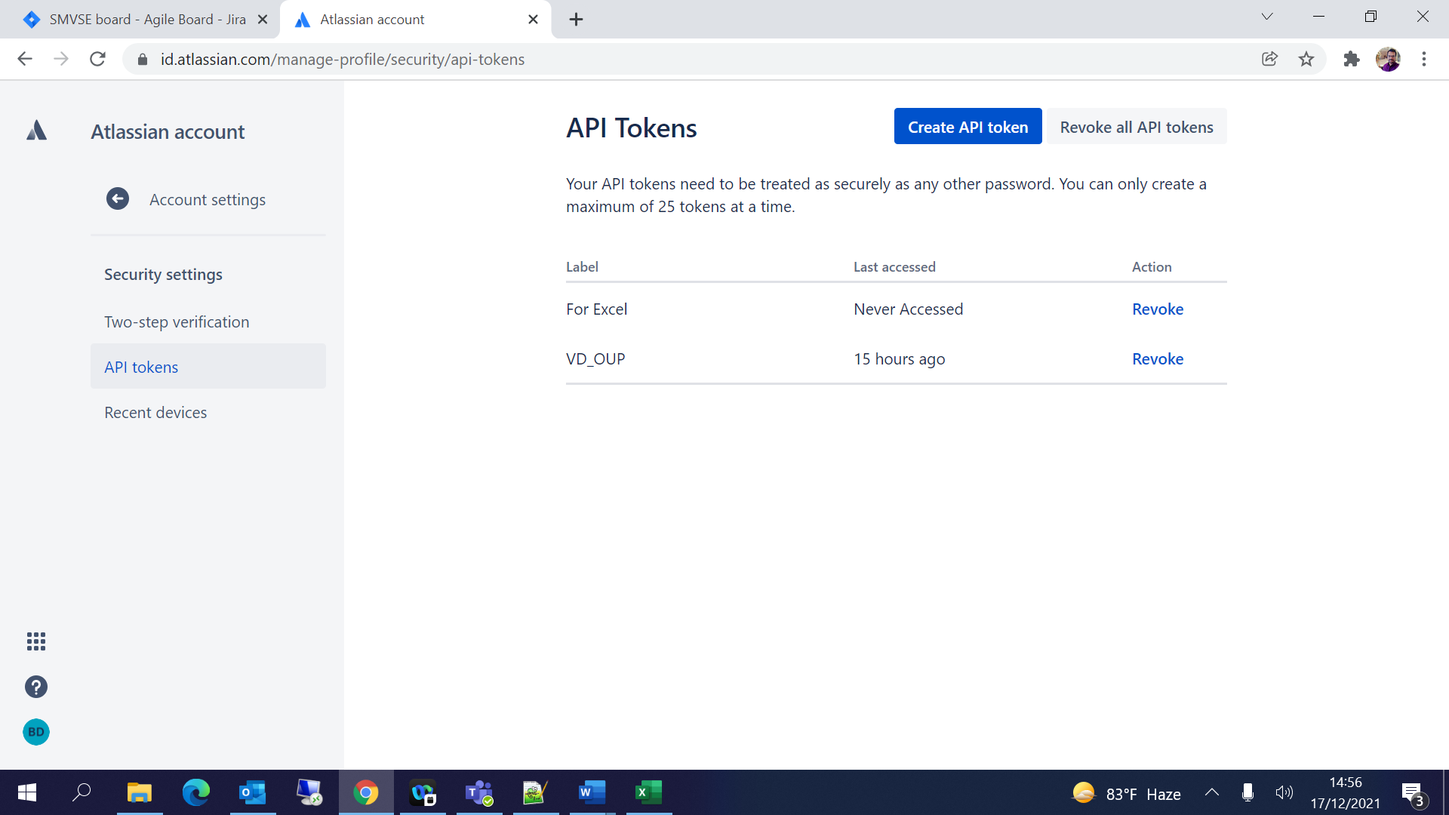

## Excel Configuration:

Excel 🡪 Data 🡪 Get Data 🡪 From Other Sources 🡪From Web🡪

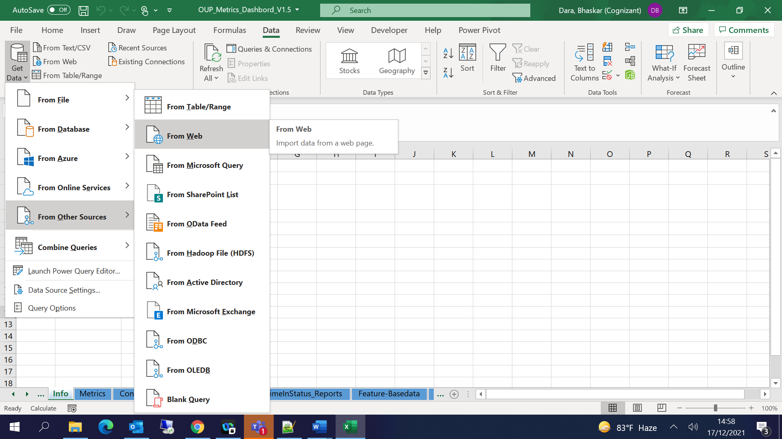

A window will popup asking for URL, Provide the URL which we created from JQL 🡪 Click on OK

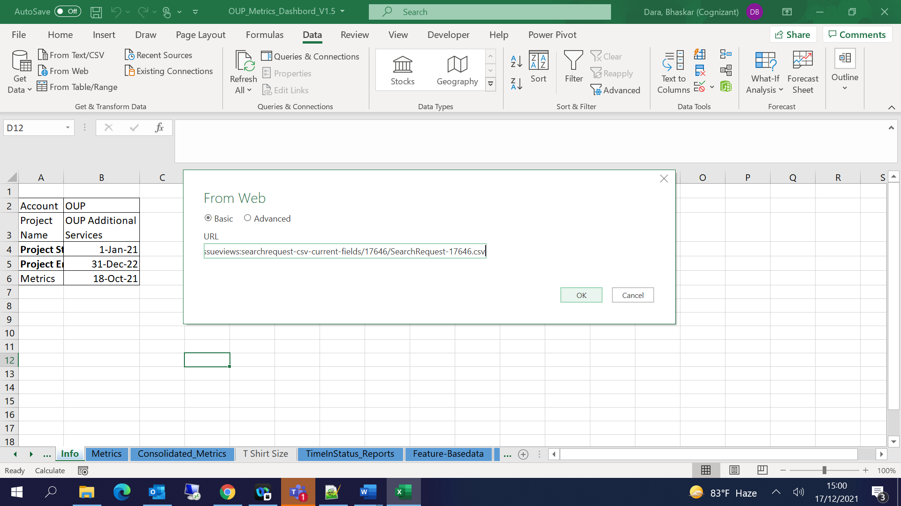

Provide Username as your email id, Password is the API token generated from JIRA 🡪Click on Connect

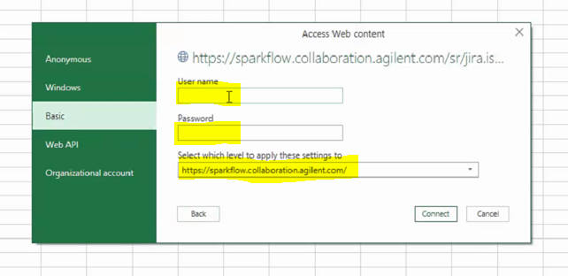

The data from the JIRA will be loaded automatically to Excel sheet:

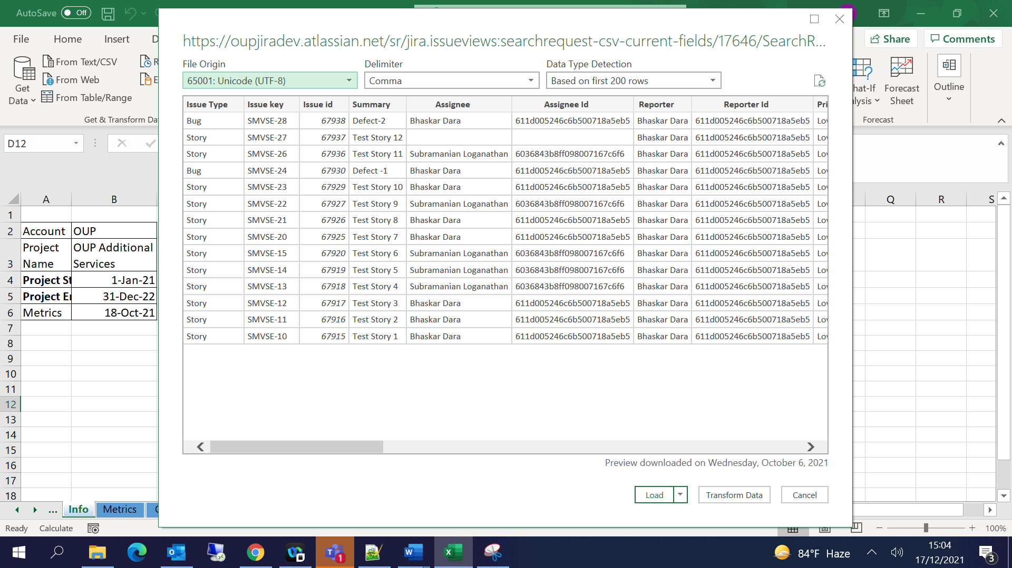

Click on Load

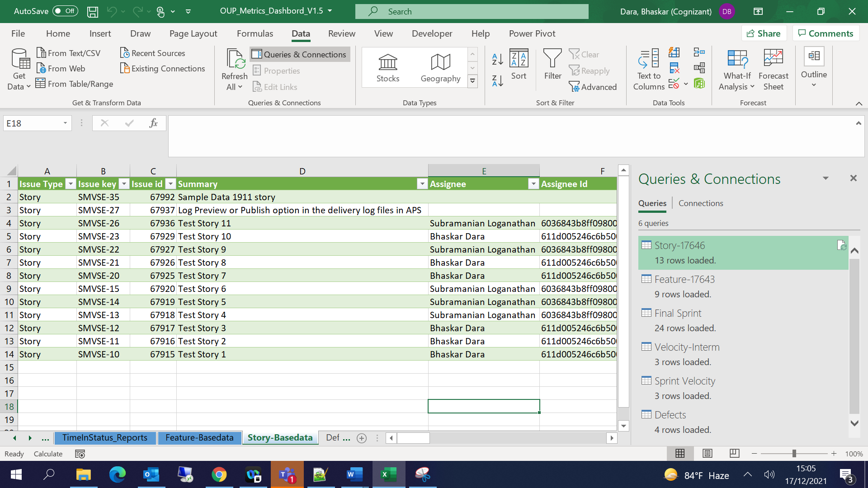

Repeat the process for all the queries to get the base data.

Add 52 new columns for Story Base data sheet alone for updating the Sprint data:

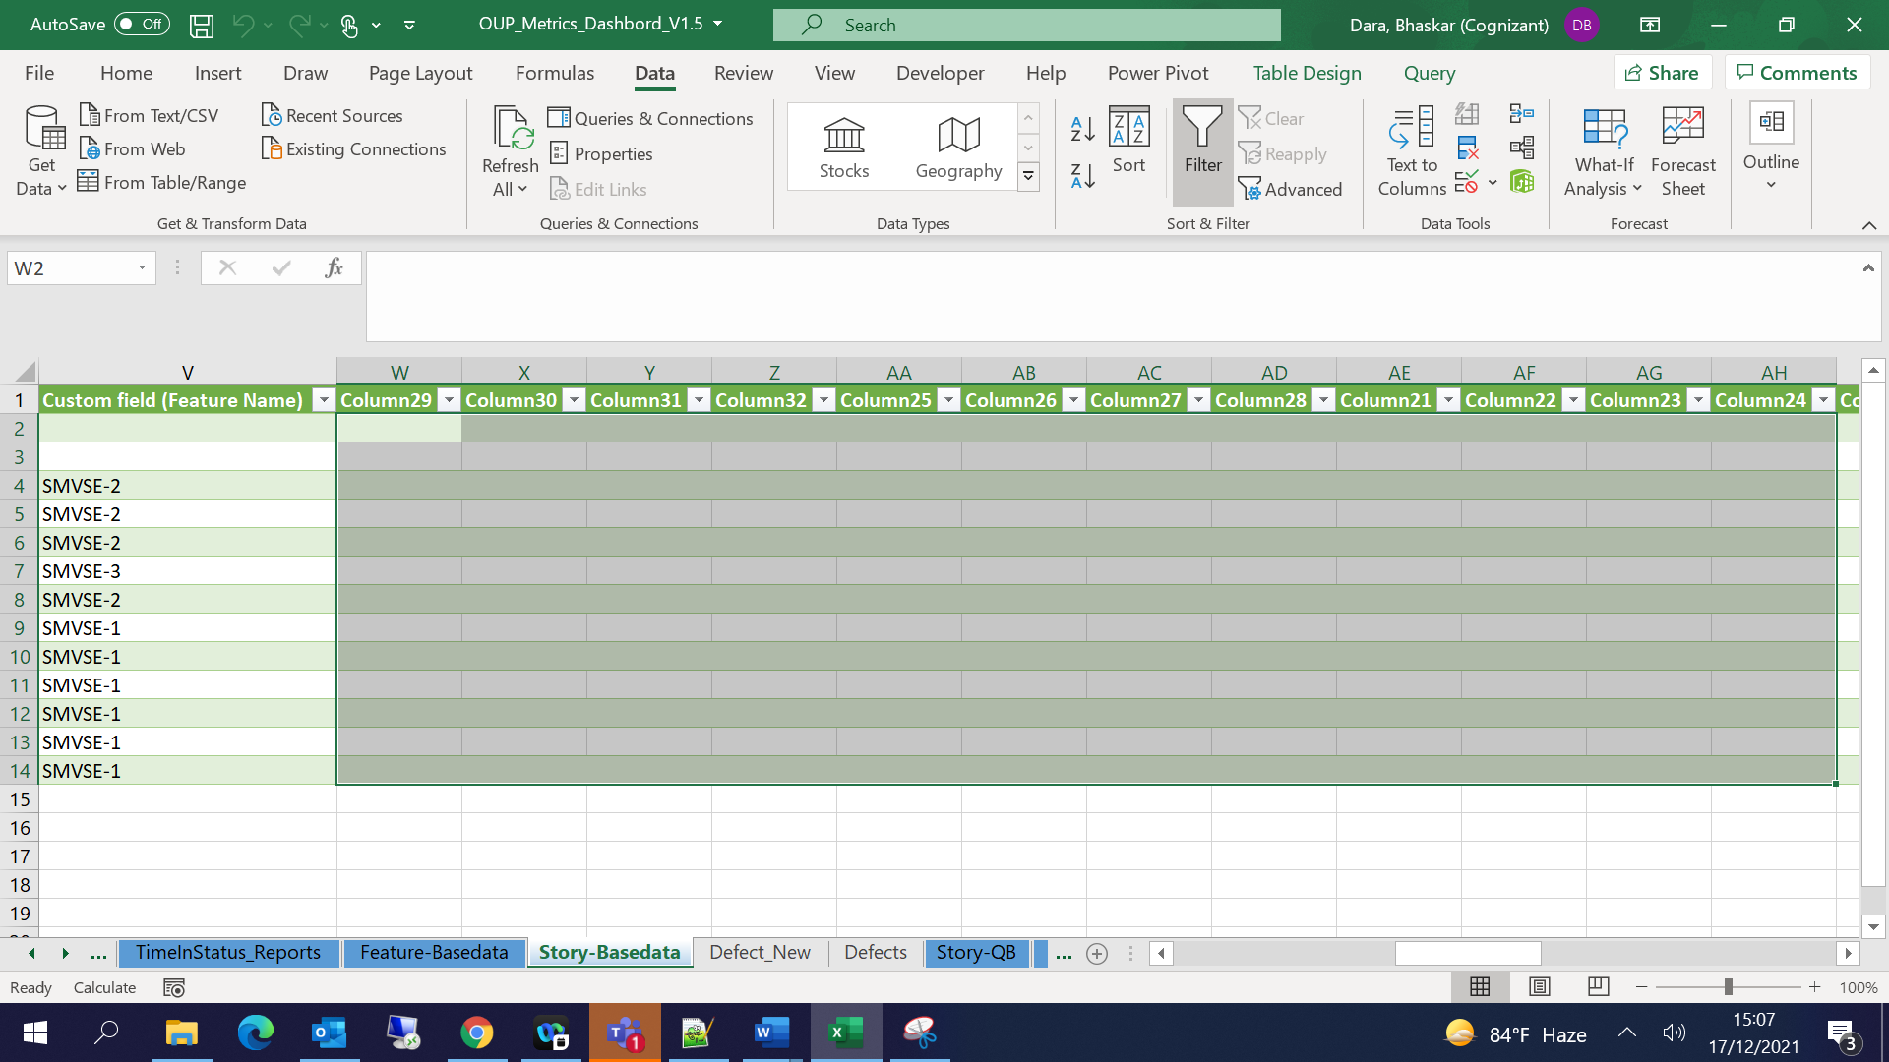

Feature Base data:

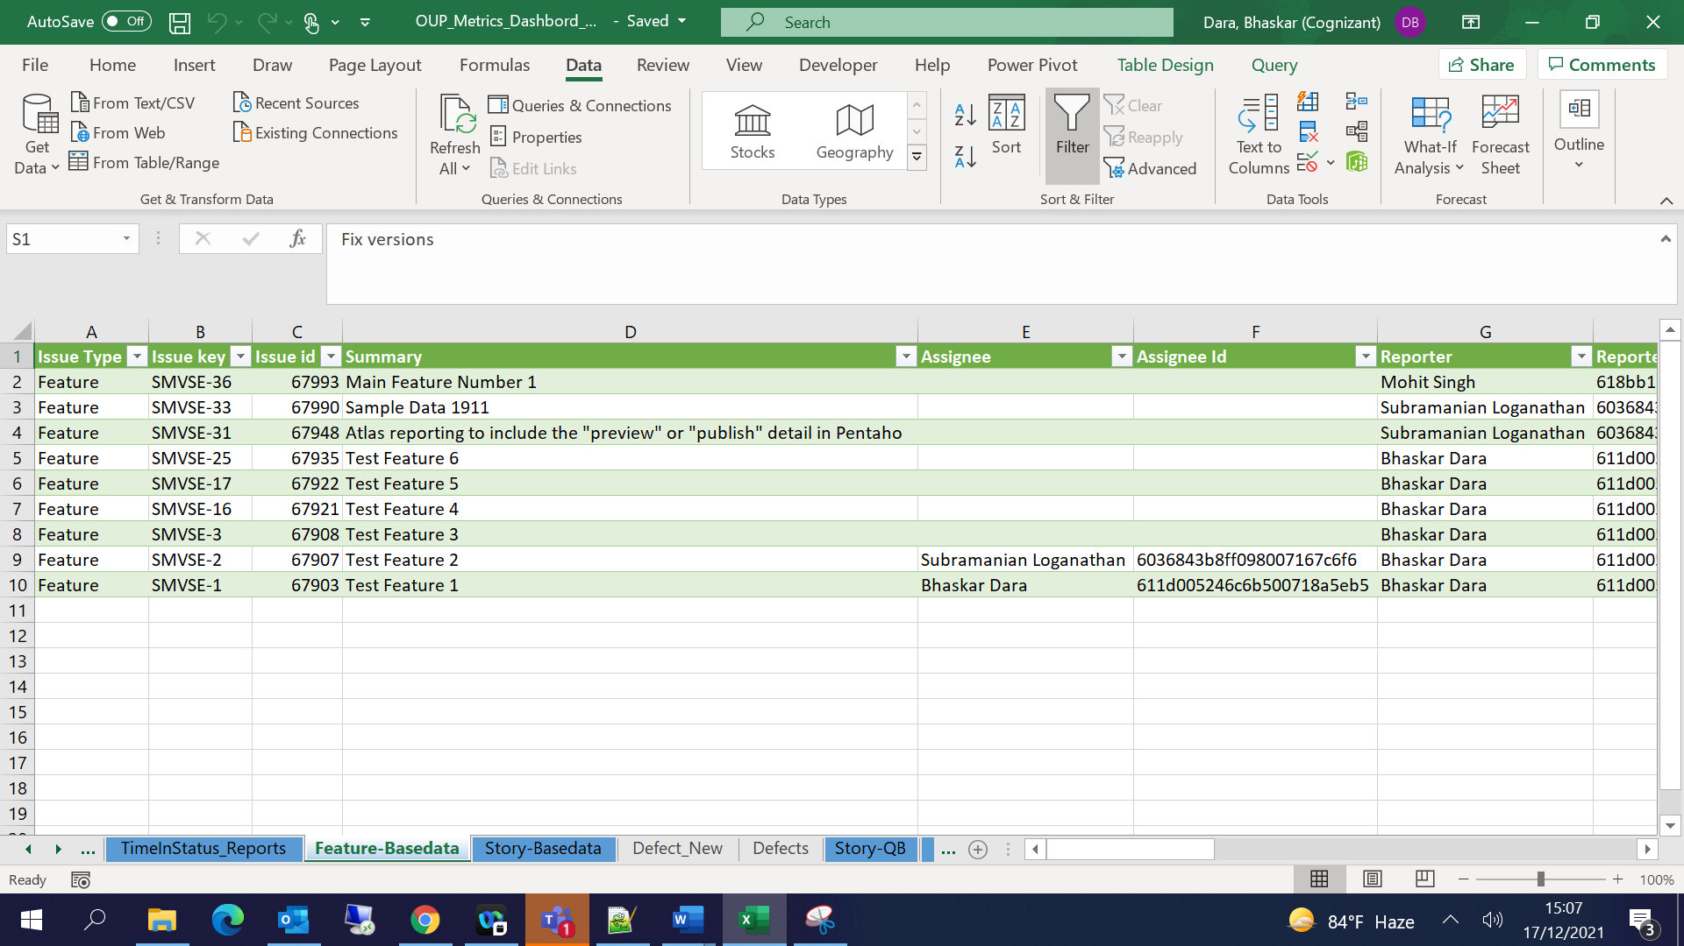

Defects:

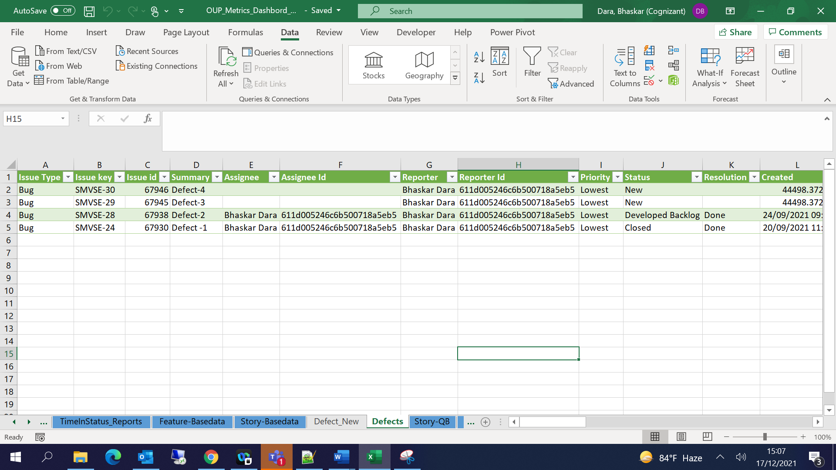

For other queries using rest-api:

Get Data🡪 From other Sources 🡪 Blank Query 🡪 Advanced Editor

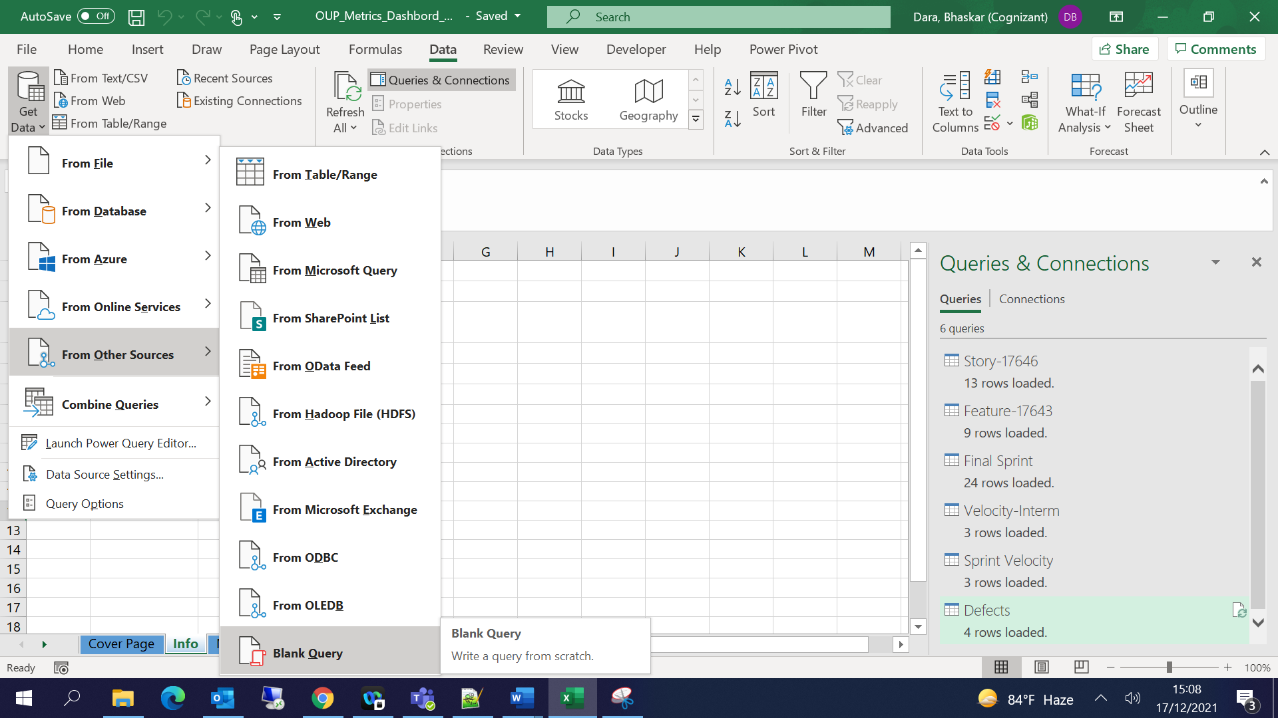

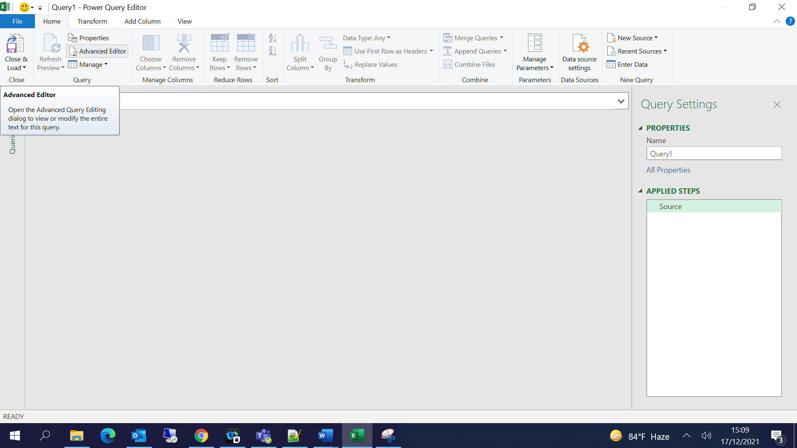

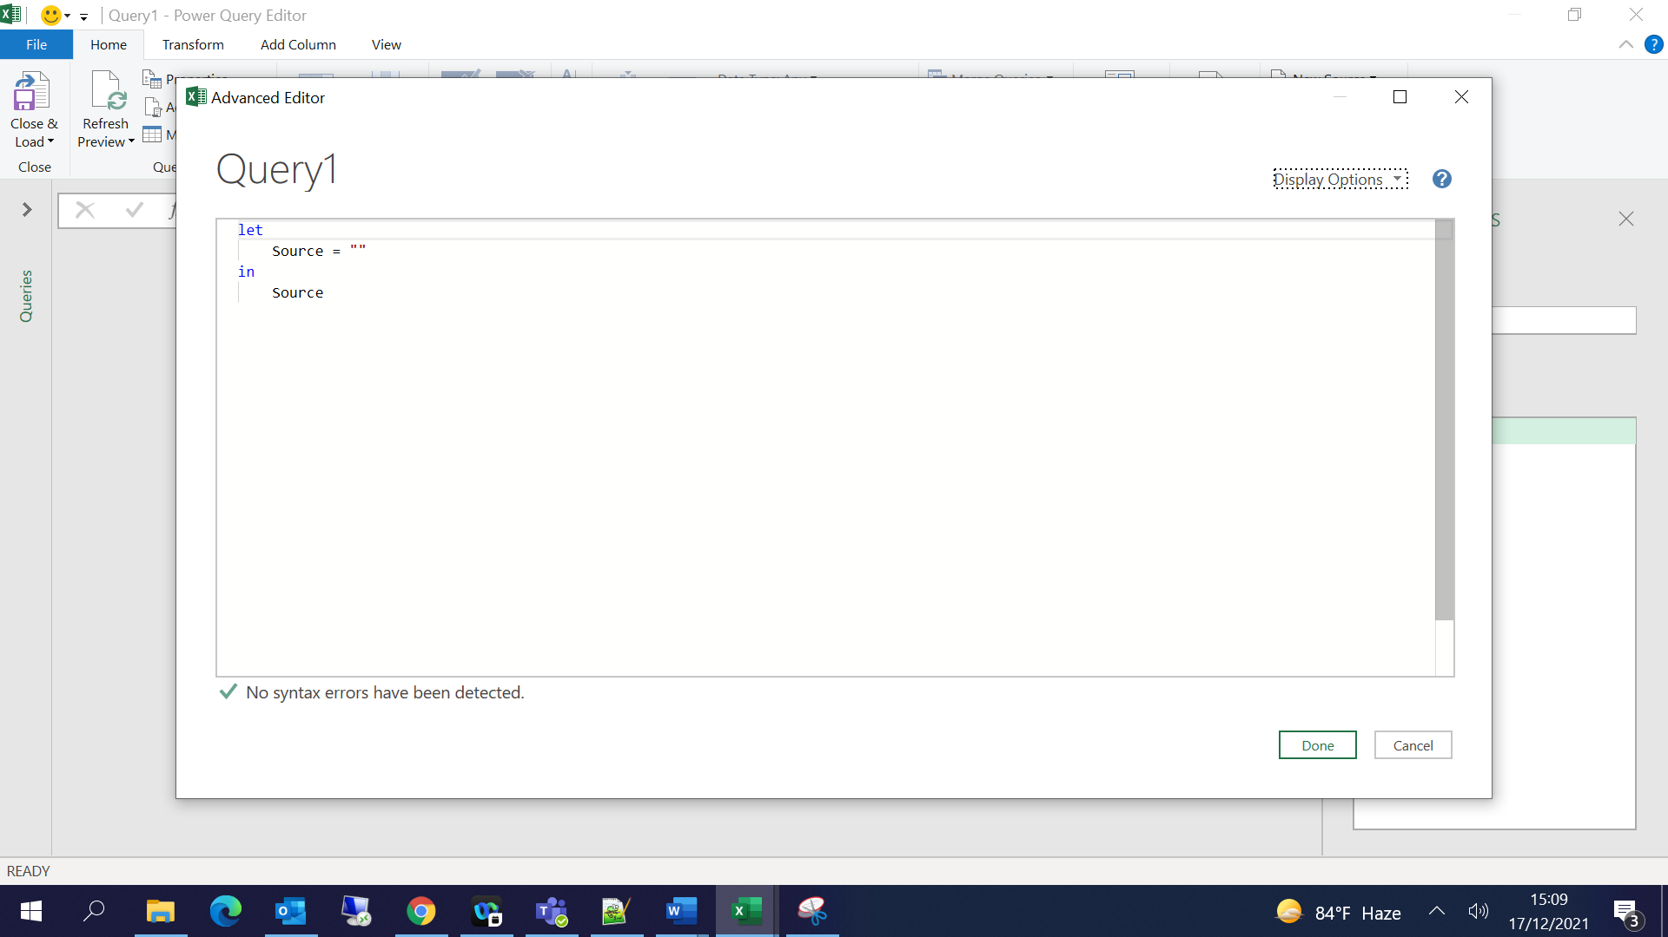

Copy the query from below and Click on Done

**Final Sprint:**

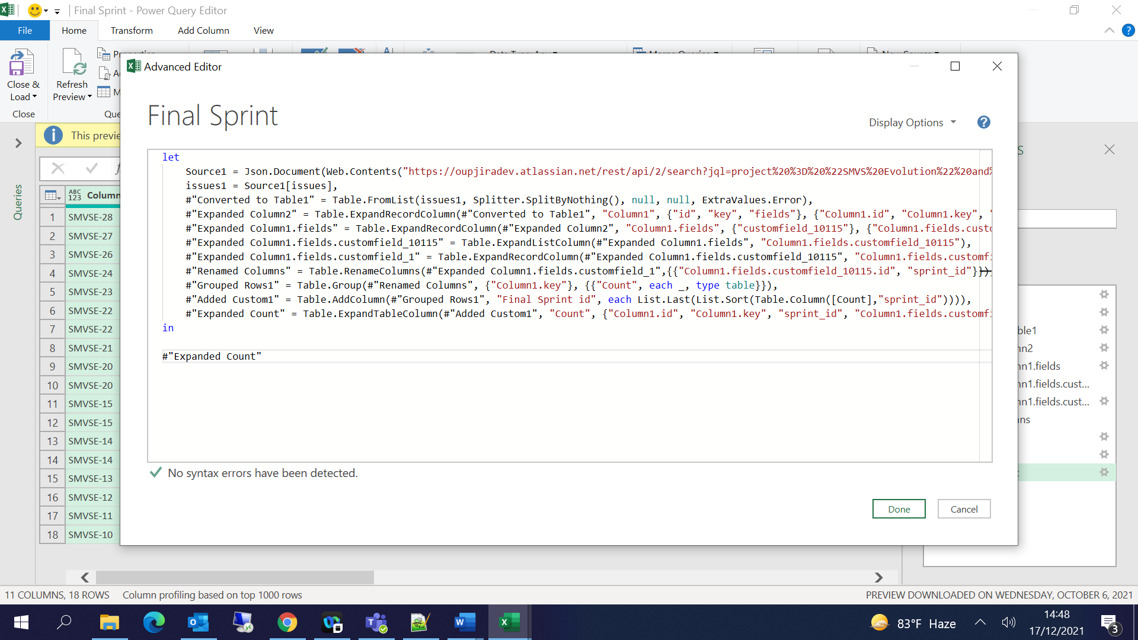

let

Source1 = Json.Document(Web.Contents("https://oupjiradev.atlassian.net/rest/api/2/search?jql=project%20%3D%20%22SMVS%20Evolution%22%20and%20issuetype%20in%20(Story%2C%20Bug)")),

issues1 = Source1[issues],

#"Converted to Table1" = Table.FromList(issues1, Splitter.SplitByNothing(), null, null, ExtraValues.Error),

#"Expanded Column2" = Table.ExpandRecordColumn(#"Converted to Table1", "Column1", {"id", "key", "fields"}, {"Column1.id", "Column1.key", "Column1.fields"}),

#"Expanded Column1.fields" = Table.ExpandRecordColumn(#"Expanded Column2", "Column1.fields", {"customfield_10115"}, {"Column1.fields.customfield_10115"}),

#"Expanded Column1.fields.customfield_10115" = Table.ExpandListColumn(#"Expanded Column1.fields", "Column1.fields.customfield_10115"),

#"Expanded Column1.fields.customfield_1" = Table.ExpandRecordColumn(#"Expanded Column1.fields.customfield_10115", "Column1.fields.customfield_10115", {"id", "name", "state", "boardId", "goal", "startDate", "endDate"}, {"Column1.fields.customfield_10115.id", "Column1.fields.customfield_10115.name", "Column1.fields.customfield_10115.state", "Column1.fields.customfield_10115.boardId", "Column1.fields.customfield_10115.goal", "Column1.fields.customfield_10115.startDate", "Column1.fields.customfield_10115.endDate"}),

#"Renamed Columns" = Table.RenameColumns(#"Expanded Column1.fields.customfield_1",{{"Column1.fields.customfield_10115.id", "sprint_id"}}),

#"Grouped Rows1" = Table.Group(#"Renamed Columns", {"Column1.key"}, {{"Count", each _, type table}}),

#"Added Custom1" = Table.AddColumn(#"Grouped Rows1", "Final Sprint id", each List.Last(List.Sort(Table.Column([Count],"sprint_id")))),

#"Expanded Count" = Table.ExpandTableColumn(#"Added Custom1", "Count", {"Column1.id", "Column1.key", "sprint_id", "Column1.fields.customfield_10115.name", "Column1.fields.customfield_10115.state", "Column1.fields.customfield_10115.boardId", "Column1.fields.customfield_10115.goal", "Column1.fields.customfield_10115.startDate", "Column1.fields.customfield_10115.endDate"}, {"Count.Column1.id", "Count.Column1.key", "Count.sprint_id", "Count.Column1.fields.customfield_10115.name", "Count.Column1.fields.customfield_10115.state", "Count.Column1.fields.customfield_10115.boardId", "Count.Column1.fields.customfield_10115.goal", "Count.Column1.fields.customfield_10115.startDate", "Count.Column1.fields.customfield_10115.endDate"})

in

#"Expanded Count"

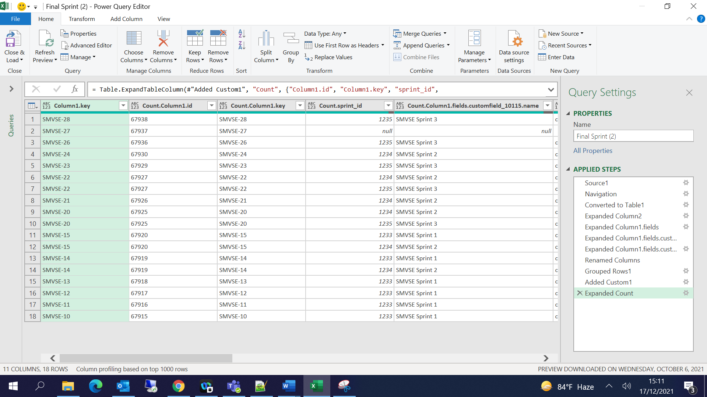

Click on Close & Load:

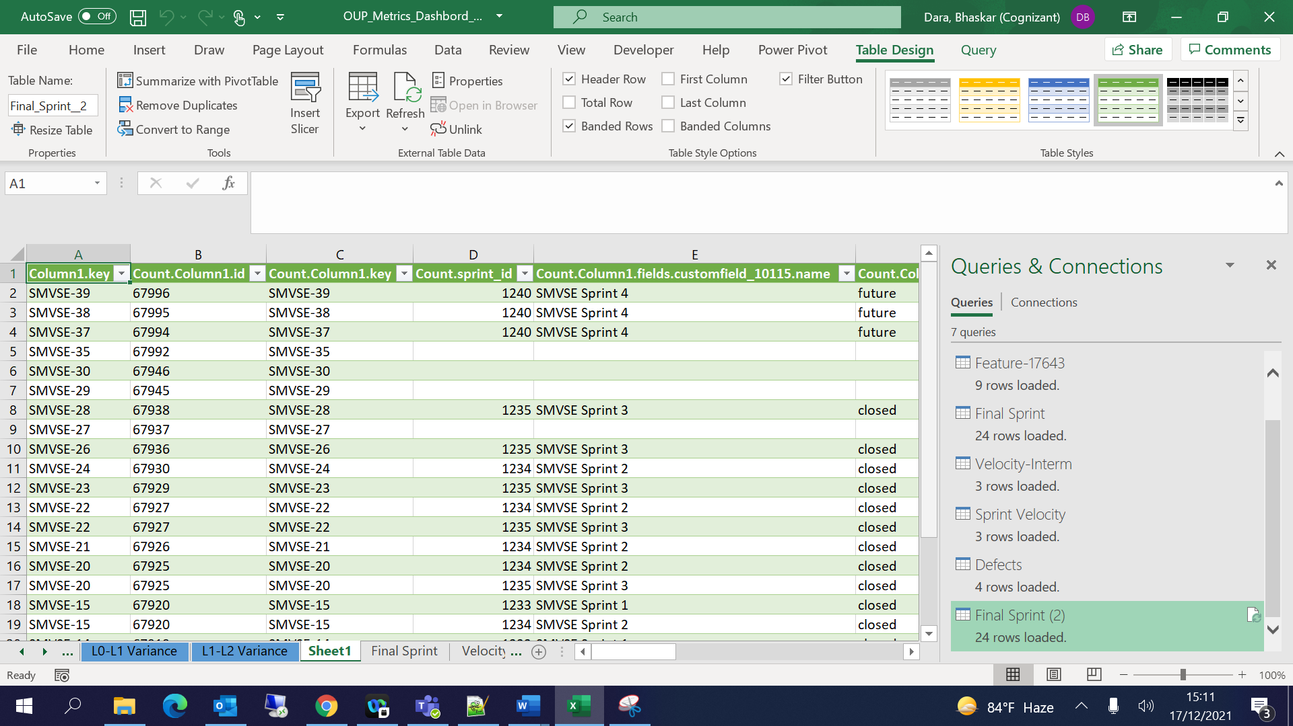

Velocity Interm:

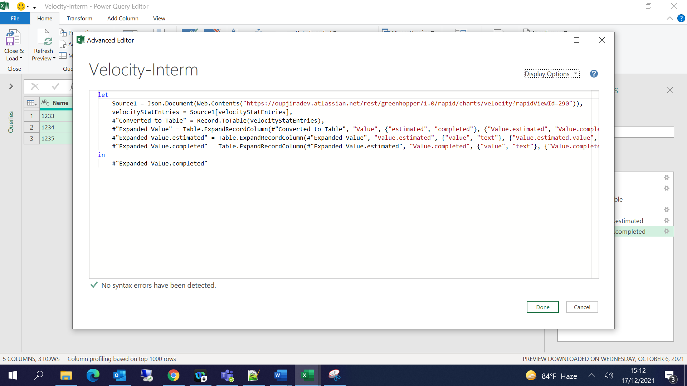

let

Source1 = Json.Document(Web.Contents("https://oupjiradev.atlassian.net/rest/greenhopper/1.0/rapid/charts/velocity?rapidViewId=290")),

velocityStatEntries = Source1[velocityStatEntries],

#"Converted to Table" = Record.ToTable(velocityStatEntries),

#"Expanded Value" = Table.ExpandRecordColumn(#"Converted to Table", "Value", {"estimated", "completed"}, {"Value.estimated", "Value.completed"}),

#"Expanded Value.estimated" = Table.ExpandRecordColumn(#"Expanded Value", "Value.estimated", {"value", "text"}, {"Value.estimated.value", "Value.estimated.text"}),

#"Expanded Value.completed" = Table.ExpandRecordColumn(#"Expanded Value.estimated", "Value.completed", {"value", "text"}, {"Value.completed.value", "Value.completed.text"})

in

#"Expanded Value.completed"

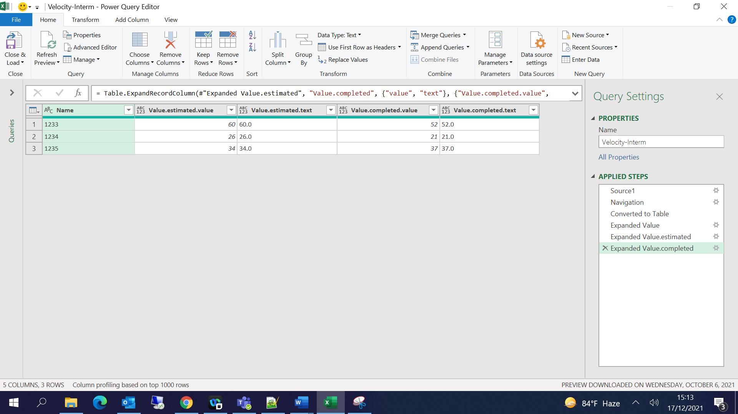

Sprint Velocity:

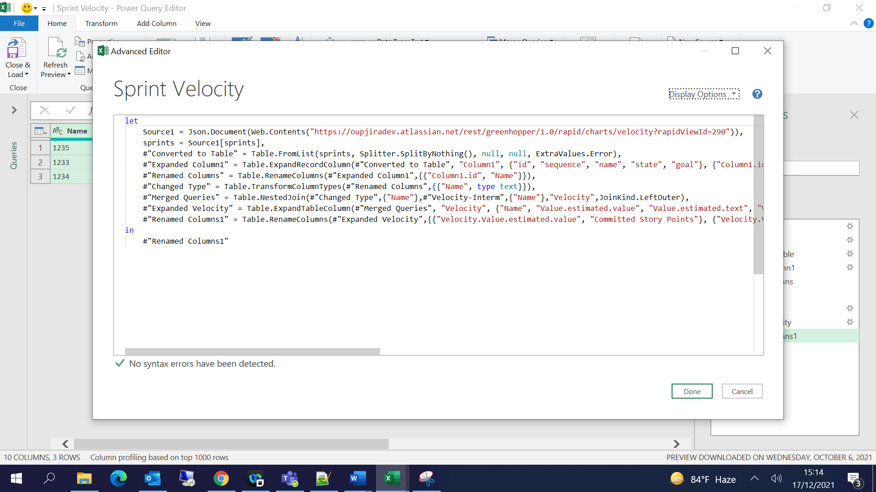

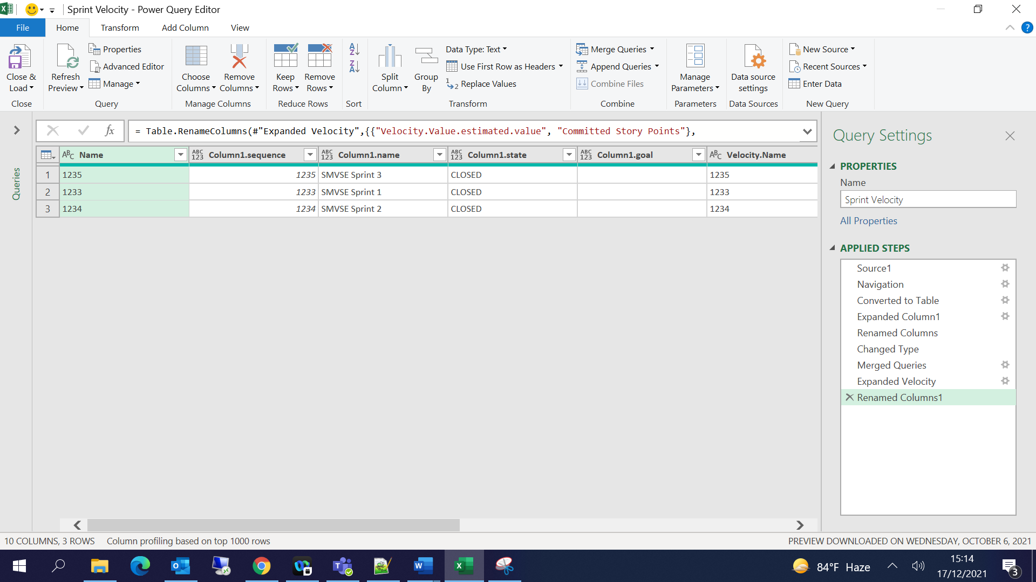

## Metric Calculations:

Story Base Data Sheet 🡪 Add new columns as below and update the formulas accordingly:

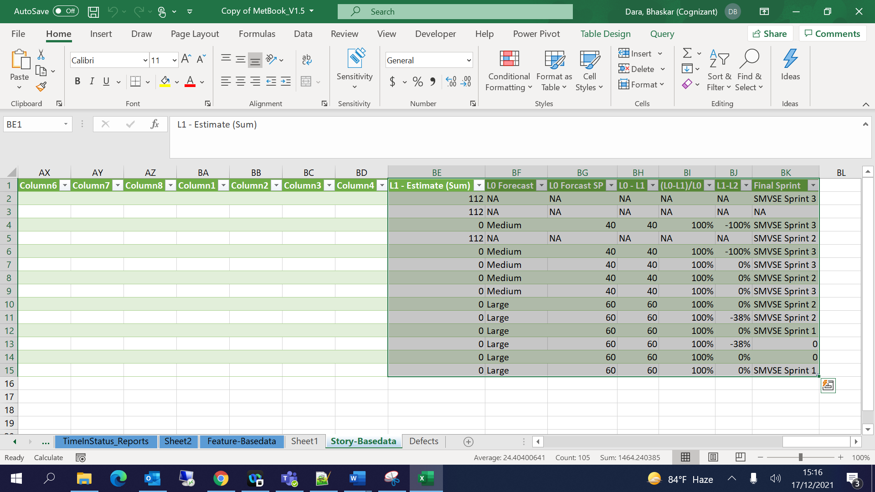

L1 - Estimate (Sum) 🡪 =SUMIFS(S:S,V:V,[@[Custom field (Epic Link)]])

L0 Forecast 🡪 =IFERROR(VLOOKUP([@[Custom field (Feature Name)]],'Feature-Basedata'!B:S,18,0),"NA")

L0 Forcast SP 🡪 =IFERROR(VLOOKUP([@[L0 Forecast]],'T Shirt Size'!A:B,2,0),"NA")

L0 - L1 🡪 =IFERROR([@[L0 Forcast SP]]-[@[L1 - Estimate (Sum)]],"NA")

(L0-L1)/L0 🡪 =IFERROR([@[L0 - L1]]/[@[L0 Forcast SP]],"NA")

L1-L2 🡪 =IFERROR(([@[Custom field (L2 Actuals (Story Points))]]-[@[Custom field (L1 Estimation (Story Points))]])/[@[Custom field (L1 Estimation (Story Points))]],"NA")

Final Sprint 🡪 =IFERROR(VLOOKUP(B2,'Final Sprint'!A:L,12,0),"NA")

In Final Sprint Sheet🡪 Add new column🡪 Final Sprint Name🡪 =VLOOKUP([@[Final Sprint id]],D:E,2,0)

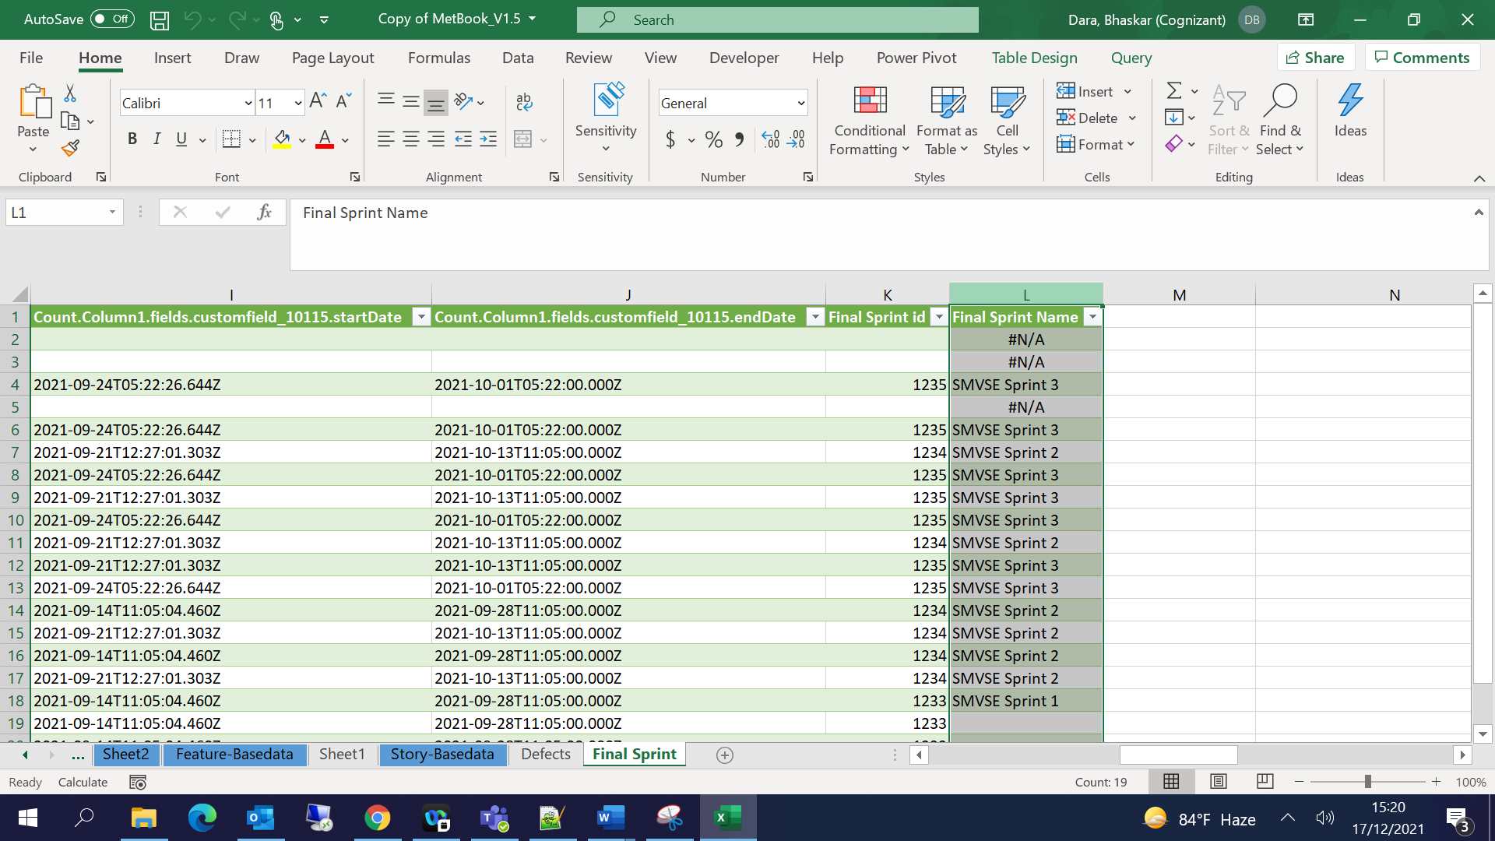

In Sprint Velocity Sheet 🡪 Add new column 🡪 Percentage Velocity 🡪 =[@[Delivered Story Points]]/[@[Committed Story Points]]

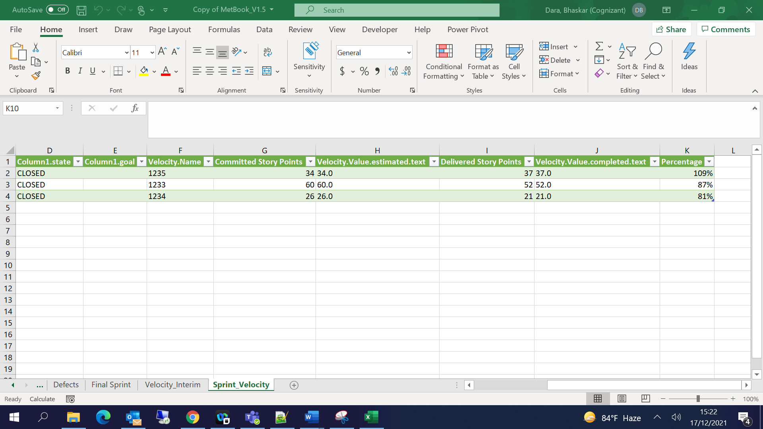

Create New Sheet for T Shirt Size:

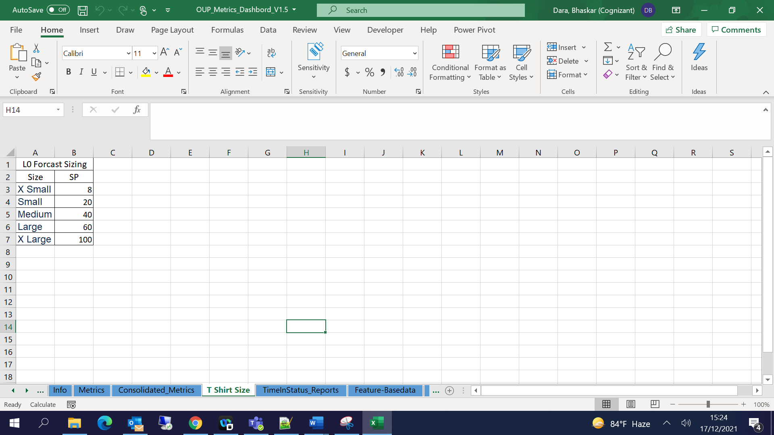

Add pivots as per the requirements:

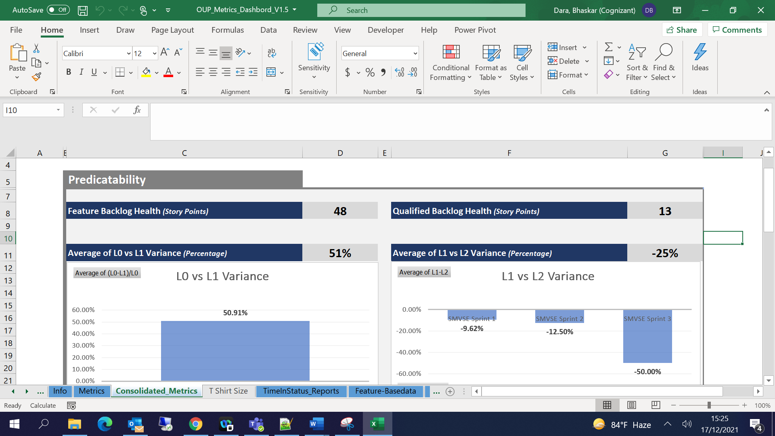

# Time In Status Configuration:

Open Jira dashboard 🡪 Add gadget 🡪 Time In Status

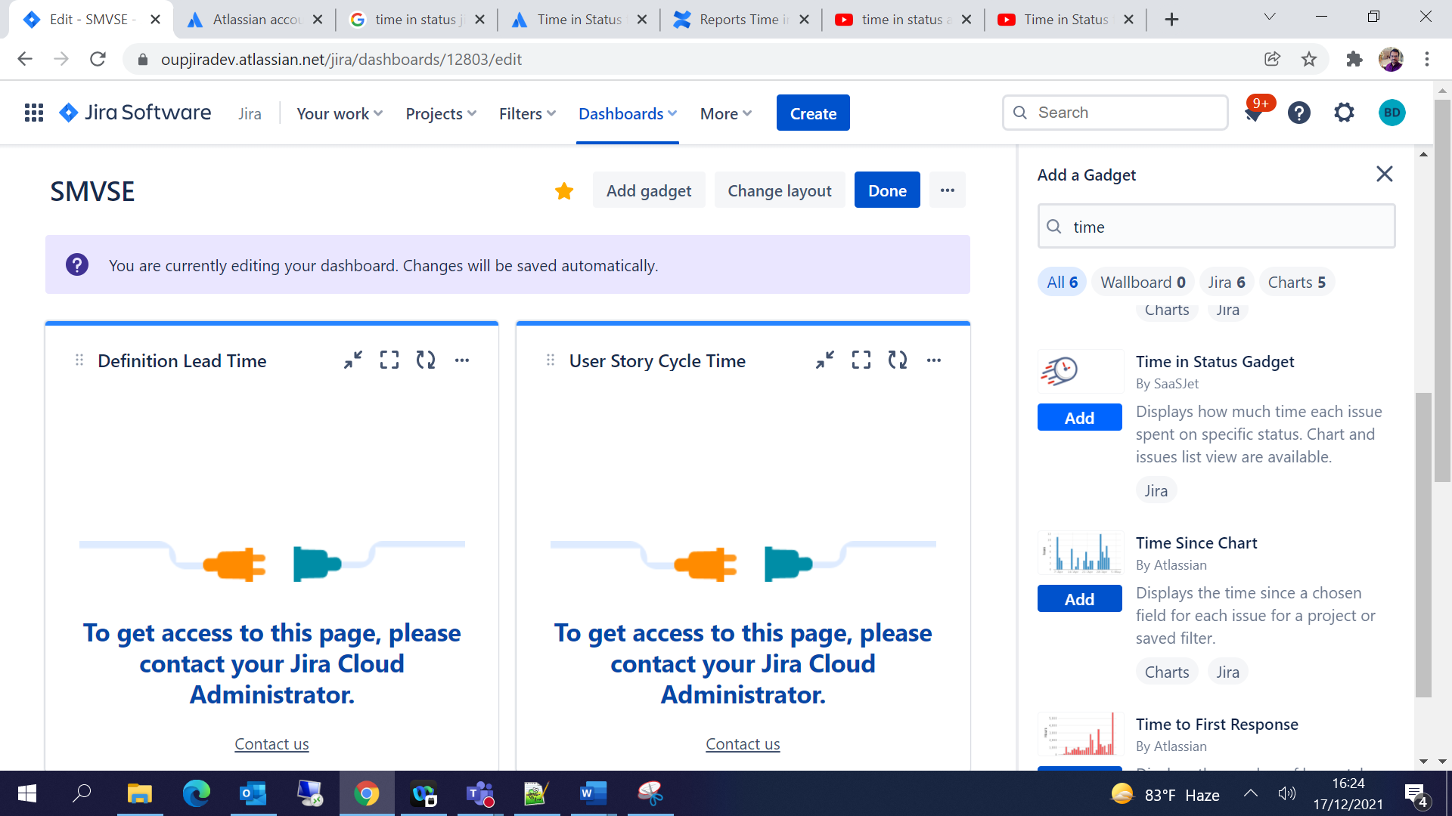

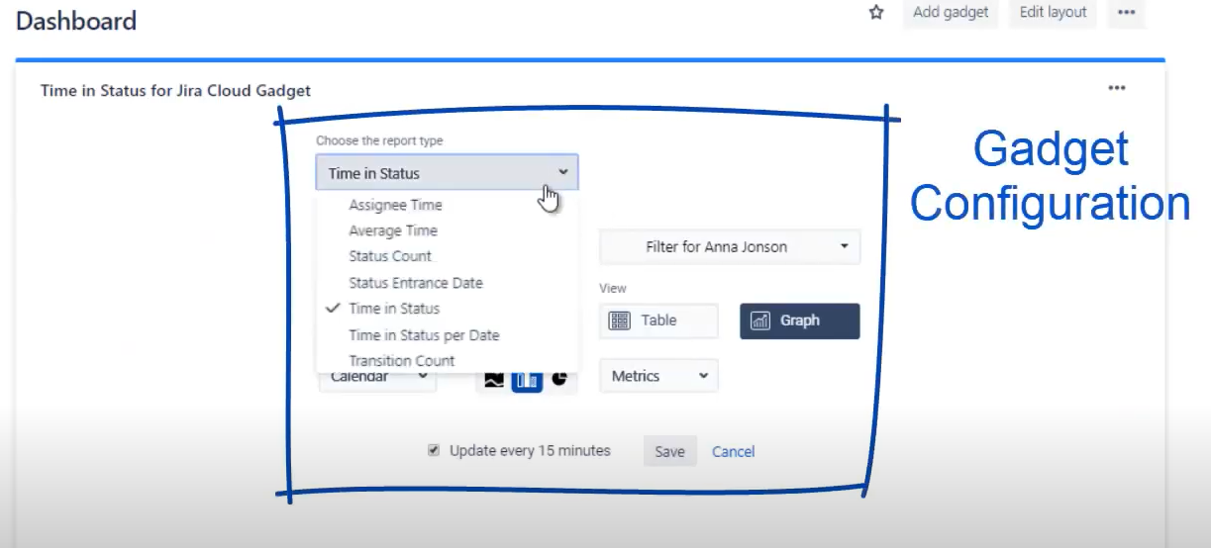

Select Average Time and modify the settings accordingly

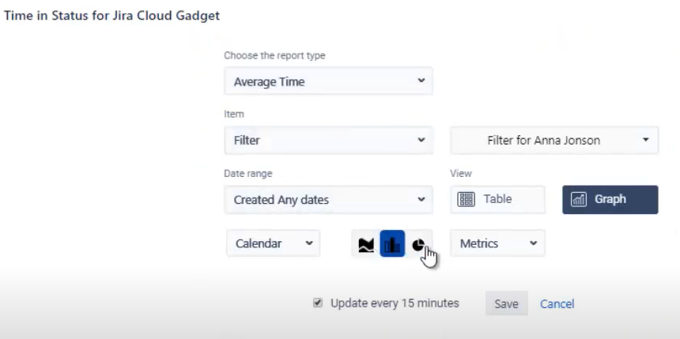

Apply the filter as per the requirement Story base data / feature base data

Select Date range as per the requirement🡪Save

Repeat the steps for all the reports as per the requirement

Definition Lead Time:

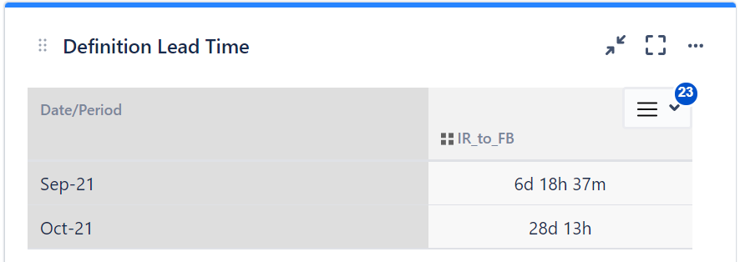

User Story Cycle Time:

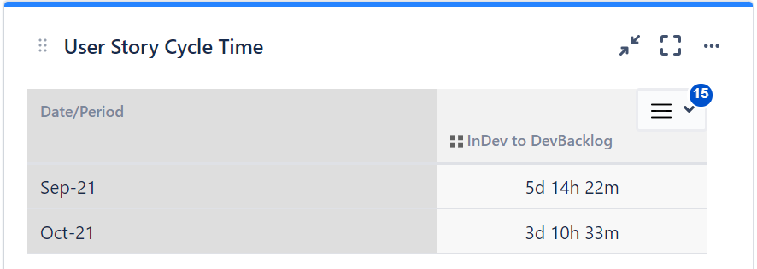

User Story Lead Time:

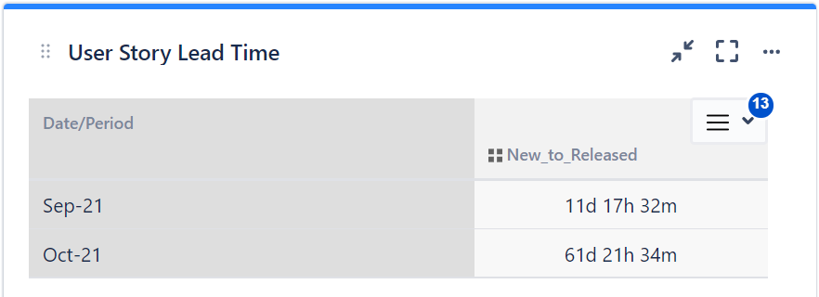

# Power BI Configuration:

Open PowerBI Desktop app🡪

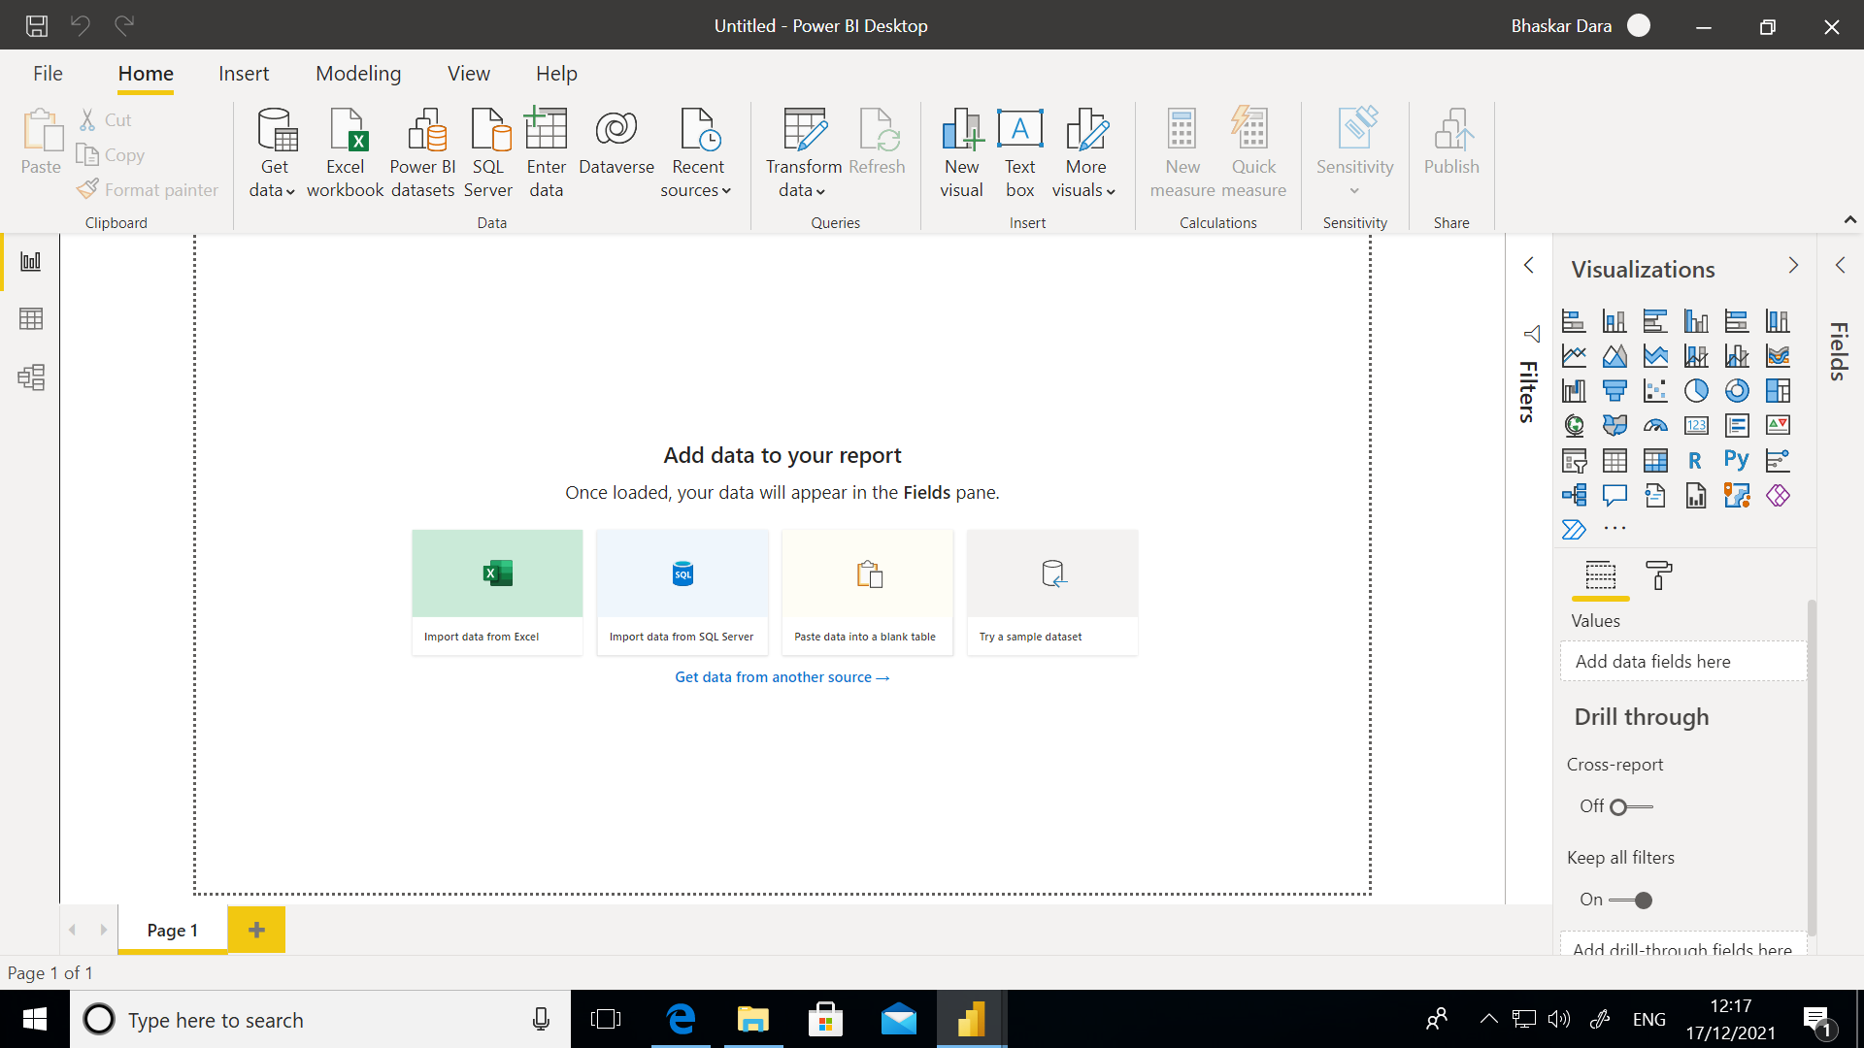

Get Data🡪 Blank Query 🡪 Advanced Editor:

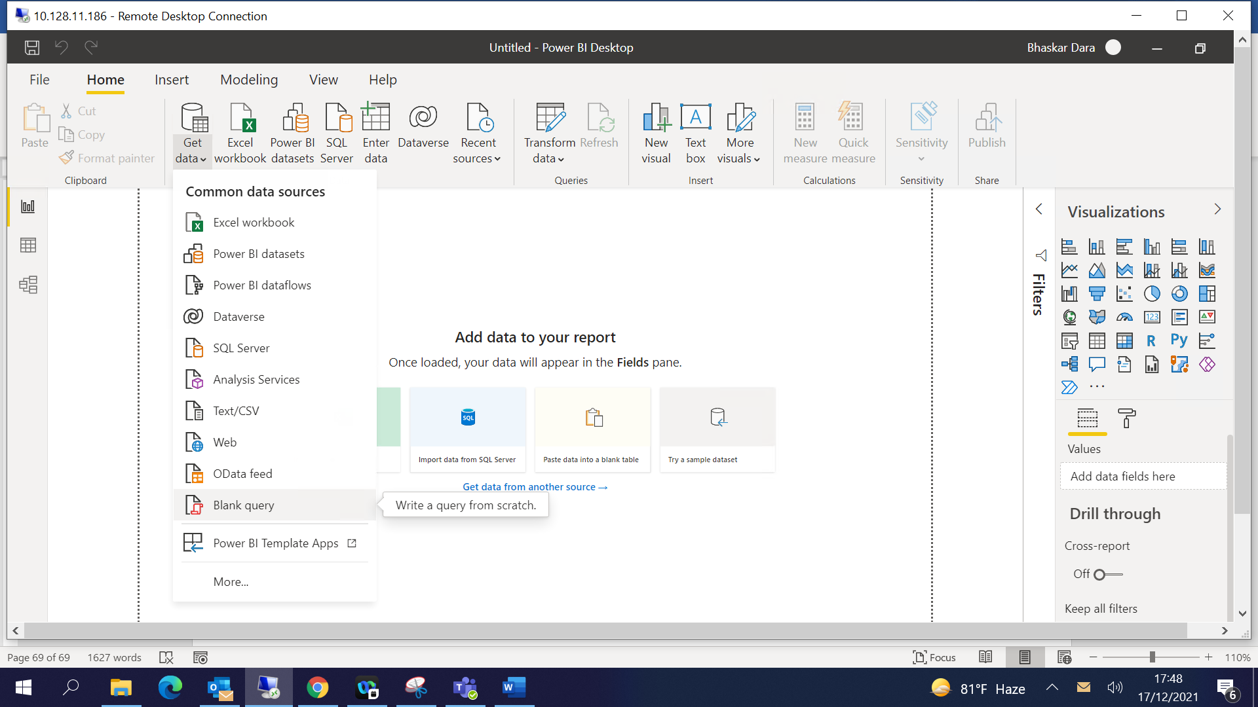

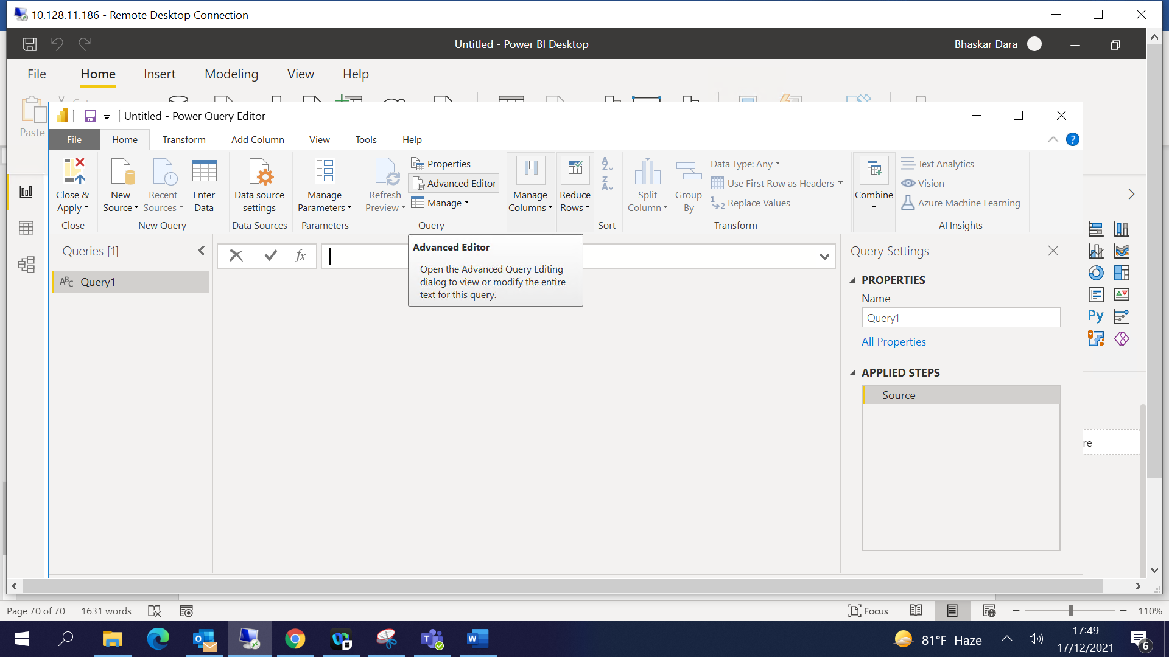

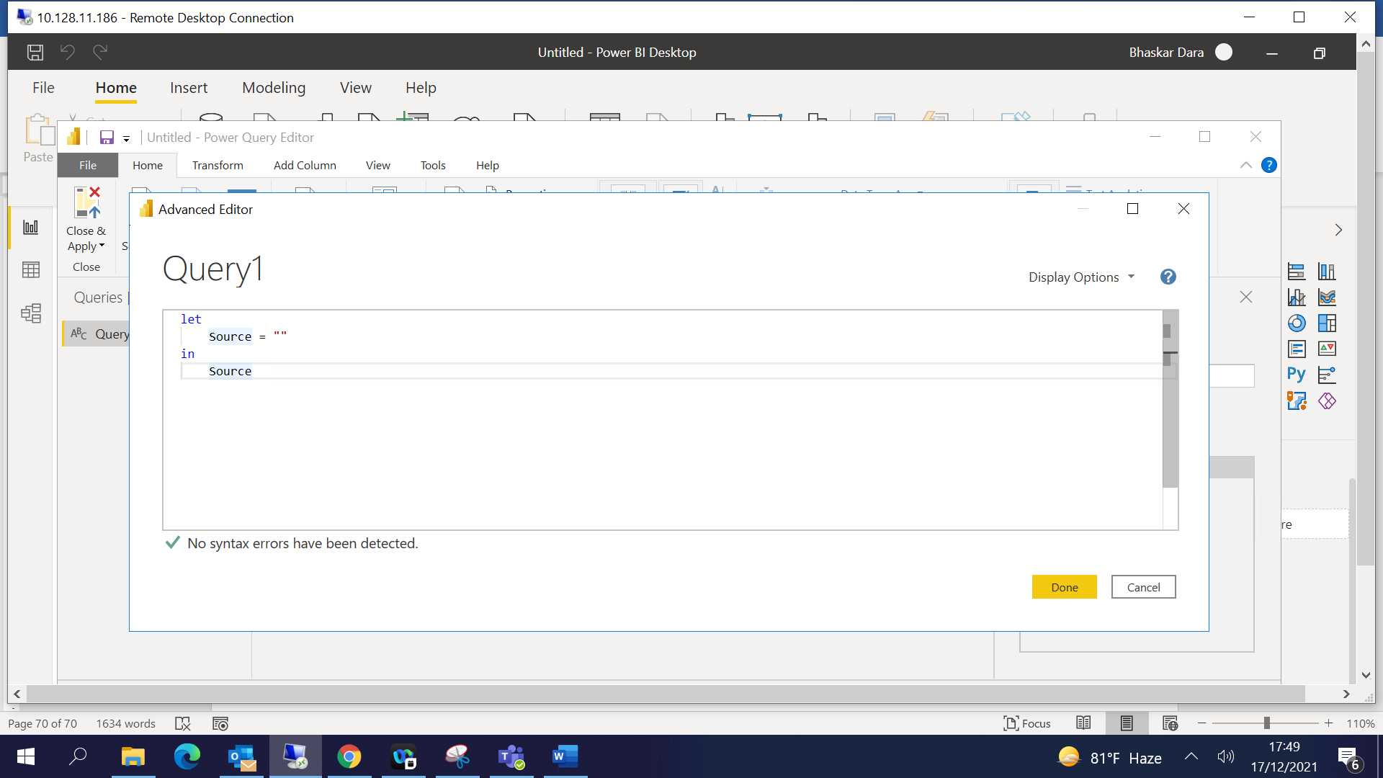

Paste the queries as required 🡪 Story Base Data:

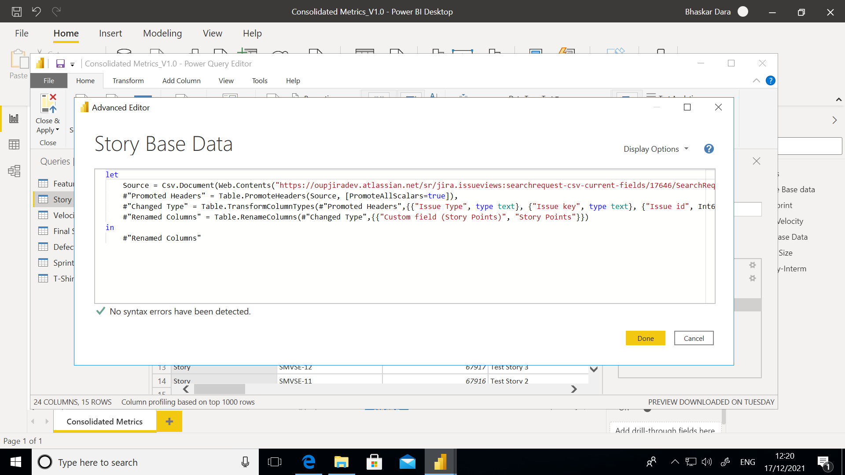

let

Source = Csv.Document(Web.Contents("https://oupjiradev.atlassian.net/sr/jira.issueviews:searchrequest-csv-current-fields/17646/SearchRequest-17646.csv"),[Delimiter=",", Encoding=65001, QuoteStyle=QuoteStyle.None]),

#"Promoted Headers" = Table.PromoteHeaders(Source, [PromoteAllScalars=true]),

#"Changed Type" = Table.TransformColumnTypes(#"Promoted Headers",{{"Issue Type", type text}, {"Issue key", type text}, {"Issue id", Int64.Type}, {"Summary", type text}, {"Assignee", type text}, {"Assignee Id", type text}, {"Reporter", type text}, {"Reporter Id", type text}, {"Priority", type text}, {"Status", type text}, {"Resolution", type text}, {"Created", type datetime}, {"Updated", type datetime}, {"Due date", type text}, {"Sprint", type text}, {"Sprint_1", type text}, {"Custom field (L1 Estimation (Story Points))", Int64.Type}, {"Custom field (L2 Actuals (Story Points))", Int64.Type}, {"Custom field (Story Points)", Int64.Type}, {"Outward issue link (Blocks)", type text}, {"Outward issue link (Problem/Incident)", type text}, {"Fix versions", type text}, {"Custom field (Epic Link)", type text}, {"Custom field (Feature Name)", type text}}),

#"Renamed Columns" = Table.RenameColumns(#"Changed Type",{{"Custom field (Story Points)", "Story Points"}})

in

#"Renamed Columns"

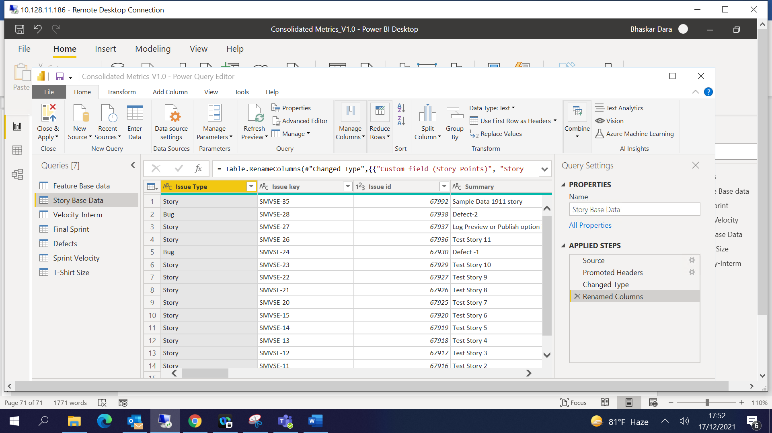

Feature Base Data:

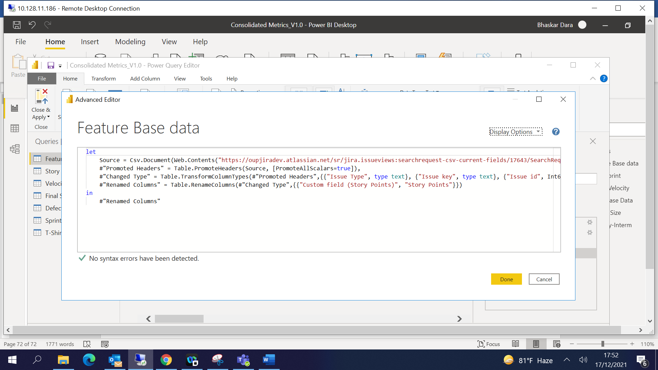

let

Source = Csv.Document(Web.Contents("https://oupjiradev.atlassian.net/sr/jira.issueviews:searchrequest-csv-current-fields/17643/SearchRequest-17643.csv"),[Delimiter=",", Columns=21, Encoding=65001, QuoteStyle=QuoteStyle.None]),

#"Promoted Headers" = Table.PromoteHeaders(Source, [PromoteAllScalars=true]),

#"Changed Type" = Table.TransformColumnTypes(#"Promoted Headers",{{"Issue Type", type text}, {"Issue key", type text}, {"Issue id", Int64.Type}, {"Summary", type text}, {"Assignee", type text}, {"Assignee Id", type text}, {"Reporter", type text}, {"Reporter Id", type text}, {"Priority", type text}, {"Status", type text}, {"Resolution", type text}, {"Created", type datetime}, {"Updated", type datetime}, {"Due date", type text}, {"Custom field (Story Points)", Int64.Type}, {"Outward issue link (Blocks)", type text}, {"Outward issue link (Relates)", type text}, {"Outward issue link (Relates)_1", type text}, {"Fix versions", type text}, {"Custom field (L0 Forecast (T-Shirt Size))", type text}, {"Custom field (Defect_Category)", type text}}),

#"Renamed Columns" = Table.RenameColumns(#"Changed Type",{{"Custom field (Story Points)", "Story Points"}})

in

#"Renamed Columns"

Defects:

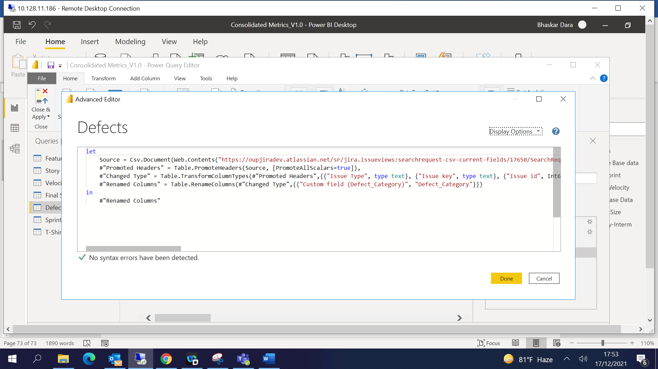

let

Source = Csv.Document(Web.Contents("https://oupjiradev.atlassian.net/sr/jira.issueviews:searchrequest-csv-current-fields/17650/SearchRequest-17650.csv"),[Delimiter=",", Encoding=65001, QuoteStyle=QuoteStyle.None]),

#"Promoted Headers" = Table.PromoteHeaders(Source, [PromoteAllScalars=true]),

#"Changed Type" = Table.TransformColumnTypes(#"Promoted Headers",{{"Issue Type", type text}, {"Issue key", type text}, {"Issue id", Int64.Type}, {"Summary", type text}, {"Assignee", type text}, {"Assignee Id", type text}, {"Reporter", type text}, {"Reporter Id", type text}, {"Priority", type text}, {"Status", type text}, {"Resolution", type text}, {"Created", type datetime}, {"Updated", type datetime}, {"Due date", type text}, {"Sprint", type text}, {"Custom field (Story Points)", Int64.Type}, {"Outward issue link (Blocks)", type text}, {"Fix versions", type text}, {"Custom field (L0 Forecast (T-Shirt Size))", type text}, {"Custom field (Defect_Category)", type text}}),

#"Renamed Columns" = Table.RenameColumns(#"Changed Type",{{"Custom field (Defect_Category)", "Defect_Category"}})

in

#"Renamed Columns"

Sprint Velocity:

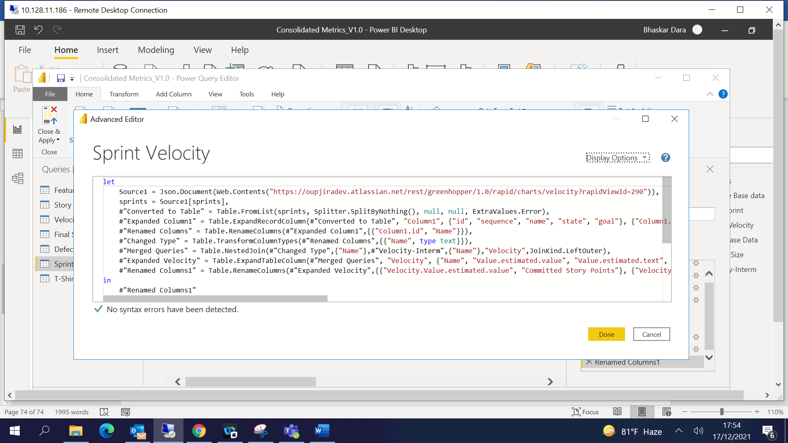

let

Source1 = Json.Document(Web.Contents("https://oupjiradev.atlassian.net/rest/greenhopper/1.0/rapid/charts/velocity?rapidViewId=290")),

sprints = Source1[sprints],

#"Converted to Table" = Table.FromList(sprints, Splitter.SplitByNothing(), null, null, ExtraValues.Error),

#"Expanded Column1" = Table.ExpandRecordColumn(#"Converted to Table", "Column1", {"id", "sequence", "name", "state", "goal"}, {"Column1.id", "Column1.sequence", "Column1.name", "Column1.state", "Column1.goal"}),

#"Renamed Columns" = Table.RenameColumns(#"Expanded Column1",{{"Column1.id", "Name"}}),

#"Changed Type" = Table.TransformColumnTypes(#"Renamed Columns",{{"Name", type text}}),

#"Merged Queries" = Table.NestedJoin(#"Changed Type",{"Name"},#"Velocity-Interm",{"Name"},"Velocity",JoinKind.LeftOuter),

#"Expanded Velocity" = Table.ExpandTableColumn(#"Merged Queries", "Velocity", {"Name", "Value.estimated.value", "Value.estimated.text", "Value.completed.value", "Value.completed.text"}, {"Velocity.Name", "Velocity.Value.estimated.value", "Velocity.Value.estimated.text", "Velocity.Value.completed.value", "Velocity.Value.completed.text"}),

#"Renamed Columns1" = Table.RenameColumns(#"Expanded Velocity",{{"Velocity.Value.estimated.value", "Committed Story Points"}, {"Velocity.Value.completed.value", "Delivered Story Points"}, {"Column1.name", "SprintName"}})

in

#"Renamed Columns1"

Final Sprint:

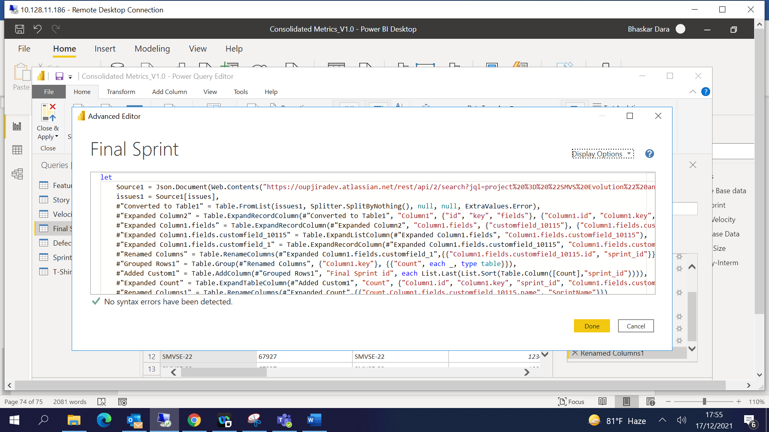

let

Source1 = Json.Document(Web.Contents("https://oupjiradev.atlassian.net/rest/api/2/search?jql=project%20%3D%20%22SMVS%20Evolution%22%20and%20issuetype%20in%20(Story%2C%20Bug)")),

issues1 = Source1[issues],

#"Converted to Table1" = Table.FromList(issues1, Splitter.SplitByNothing(), null, null, ExtraValues.Error),

#"Expanded Column2" = Table.ExpandRecordColumn(#"Converted to Table1", "Column1", {"id", "key", "fields"}, {"Column1.id", "Column1.key", "Column1.fields"}),

#"Expanded Column1.fields" = Table.ExpandRecordColumn(#"Expanded Column2", "Column1.fields", {"customfield_10115"}, {"Column1.fields.customfield_10115"}),

#"Expanded Column1.fields.customfield_10115" = Table.ExpandListColumn(#"Expanded Column1.fields", "Column1.fields.customfield_10115"),

#"Expanded Column1.fields.customfield_1" = Table.ExpandRecordColumn(#"Expanded Column1.fields.customfield_10115", "Column1.fields.customfield_10115", {"id", "name", "state", "boardId", "goal", "startDate", "endDate"}, {"Column1.fields.customfield_10115.id", "Column1.fields.customfield_10115.name", "Column1.fields.customfield_10115.state", "Column1.fields.customfield_10115.boardId", "Column1.fields.customfield_10115.goal", "Column1.fields.customfield_10115.startDate", "Column1.fields.customfield_10115.endDate"}),

#"Renamed Columns" = Table.RenameColumns(#"Expanded Column1.fields.customfield_1",{{"Column1.fields.customfield_10115.id", "sprint_id"}}),

#"Grouped Rows1" = Table.Group(#"Renamed Columns", {"Column1.key"}, {{"Count", each _, type table}}),

#"Added Custom1" = Table.AddColumn(#"Grouped Rows1", "Final Sprint id", each List.Last(List.Sort(Table.Column([Count],"sprint_id")))),

#"Expanded Count" = Table.ExpandTableColumn(#"Added Custom1", "Count", {"Column1.id", "Column1.key", "sprint_id", "Column1.fields.customfield_10115.name", "Column1.fields.customfield_10115.state", "Column1.fields.customfield_10115.boardId", "Column1.fields.customfield_10115.goal", "Column1.fields.customfield_10115.startDate", "Column1.fields.customfield_10115.endDate"}, {"Count.Column1.id", "Count.Column1.key", "Count.sprint_id", "Count.Column1.fields.customfield_10115.name", "Count.Column1.fields.customfield_10115.state", "Count.Column1.fields.customfield_10115.boardId", "Count.Column1.fields.customfield_10115.goal", "Count.Column1.fields.customfield_10115.startDate", "Count.Column1.fields.customfield_10115.endDate"}),

#"Renamed Columns1" = Table.RenameColumns(#"Expanded Count",{{"Count.Column1.fields.customfield_10115.name", "SprintName"}})

in

#"Renamed Columns1"

Velocity-Interm:

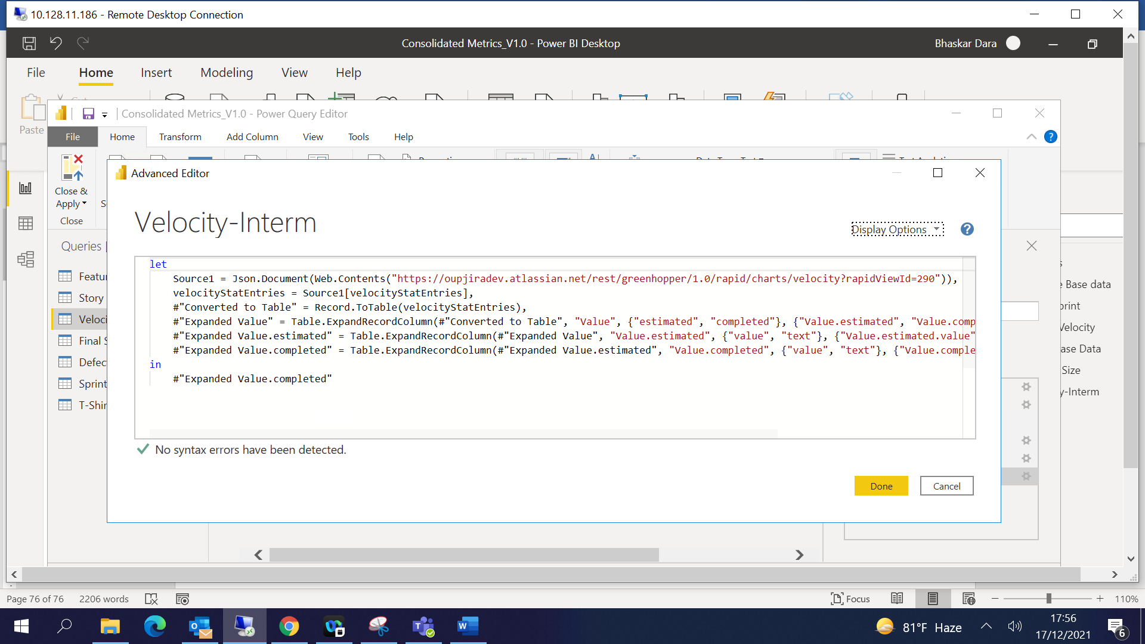

let

Source1 = Json.Document(Web.Contents("https://oupjiradev.atlassian.net/rest/greenhopper/1.0/rapid/charts/velocity?rapidViewId=290")),

velocityStatEntries = Source1[velocityStatEntries],

#"Converted to Table" = Record.ToTable(velocityStatEntries),

#"Expanded Value" = Table.ExpandRecordColumn(#"Converted to Table", "Value", {"estimated", "completed"}, {"Value.estimated", "Value.completed"}),

#"Expanded Value.estimated" = Table.ExpandRecordColumn(#"Expanded Value", "Value.estimated", {"value", "text"}, {"Value.estimated.value", "Value.estimated.text"}),

#"Expanded Value.completed" = Table.ExpandRecordColumn(#"Expanded Value.estimated", "Value.completed", {"value", "text"}, {"Value.completed.value", "Value.completed.text"})

in

#"Expanded Value.completed"

Add new table in powerBI by using Transform Data 🡪 Enter Data

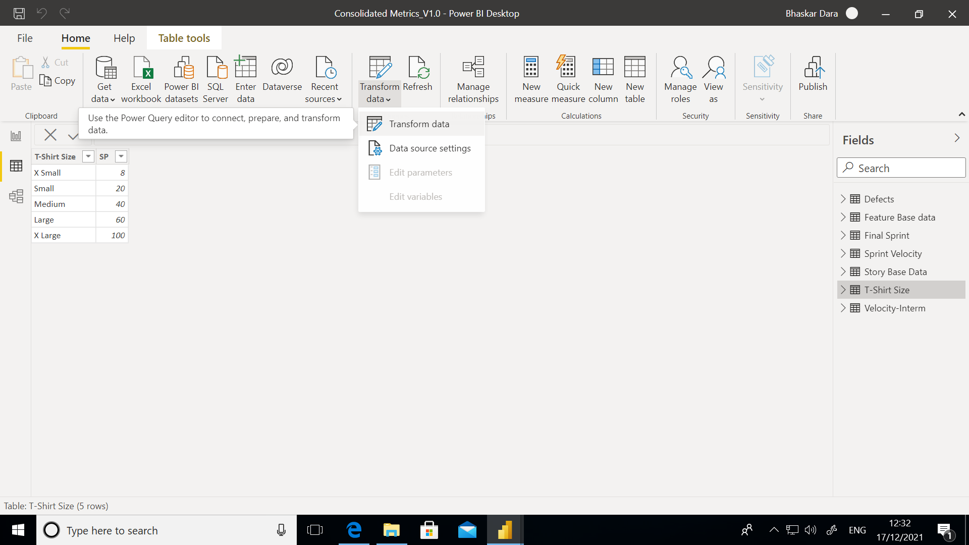

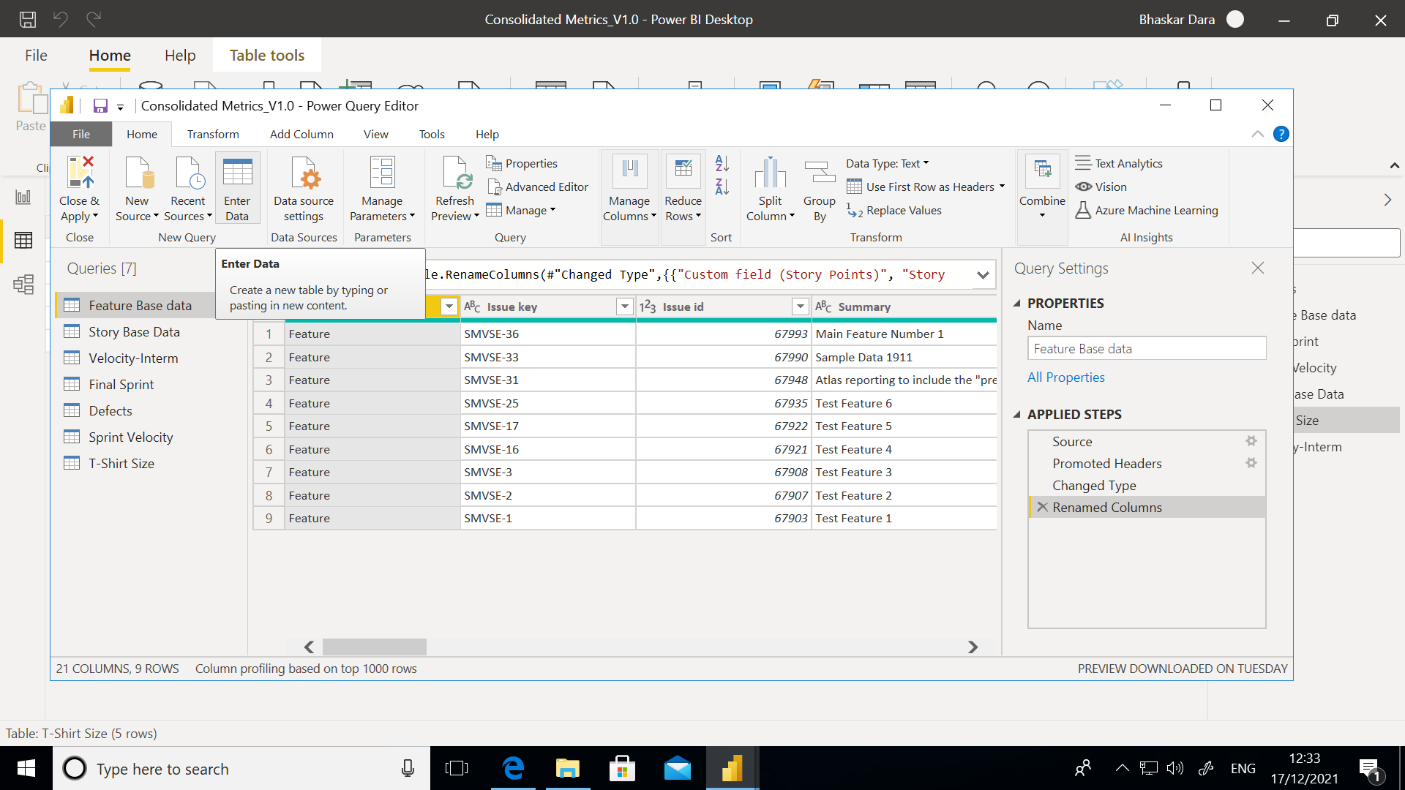

Add rows and column as per the T-Shirt Size data:

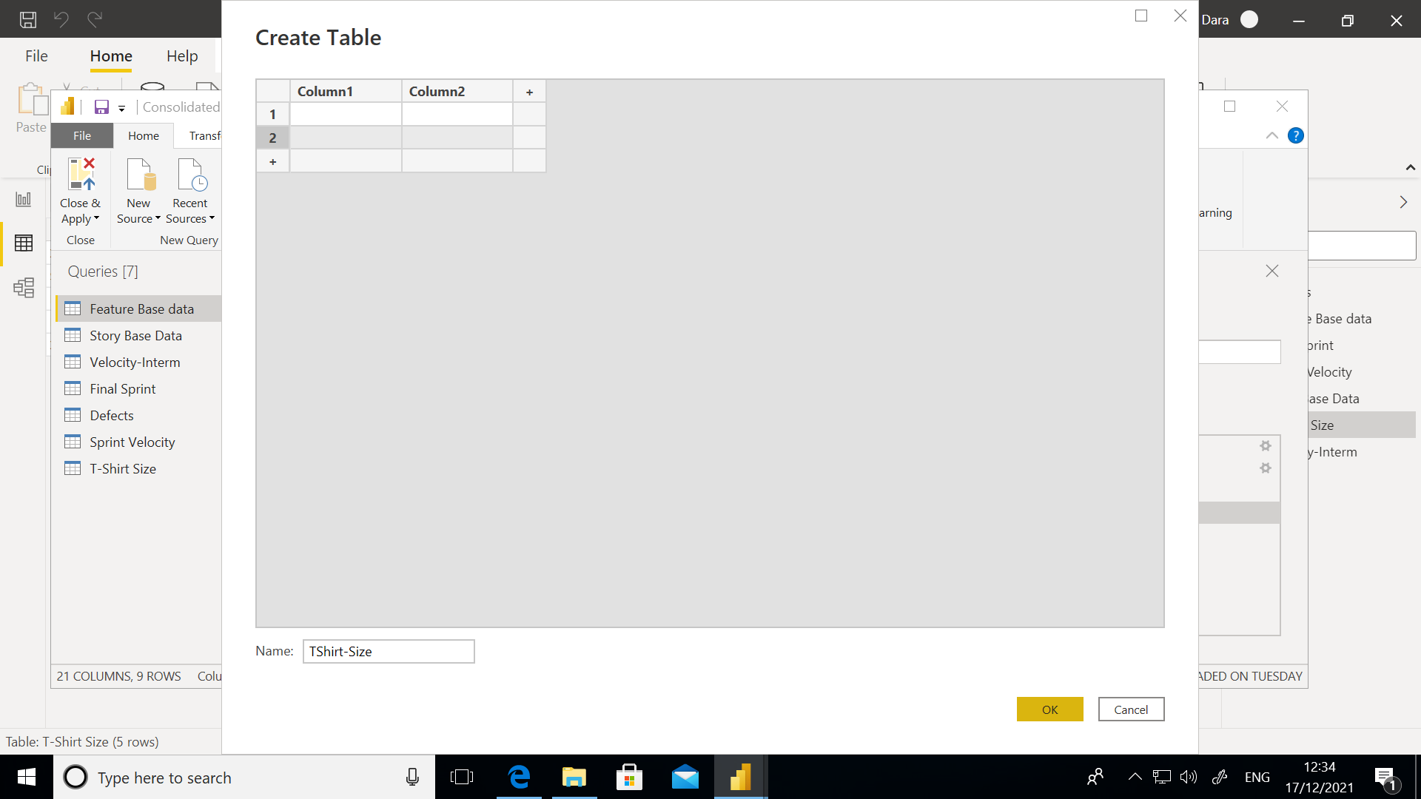

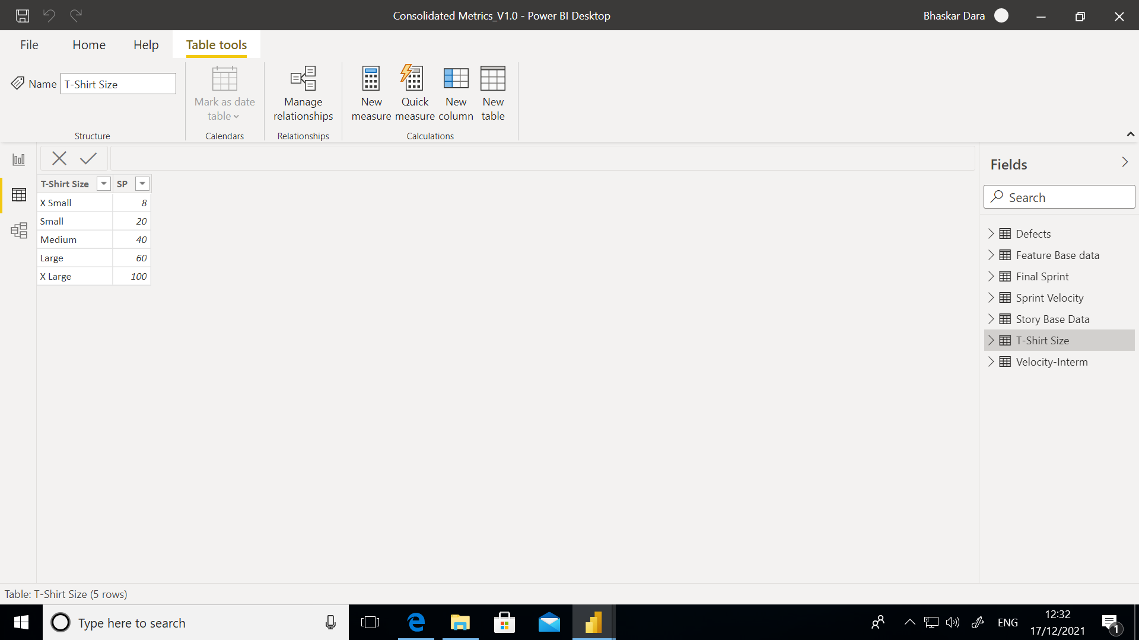

Adding New Columns as per the requirement for Metrics:

For Final Sprint sheet –

Add column 🡪 FinalSprint = LOOKUPVALUE('Final Sprint'[SprintName],'Final Sprint'[Count.sprint_id], 'Final Sprint'[Final Sprint id])

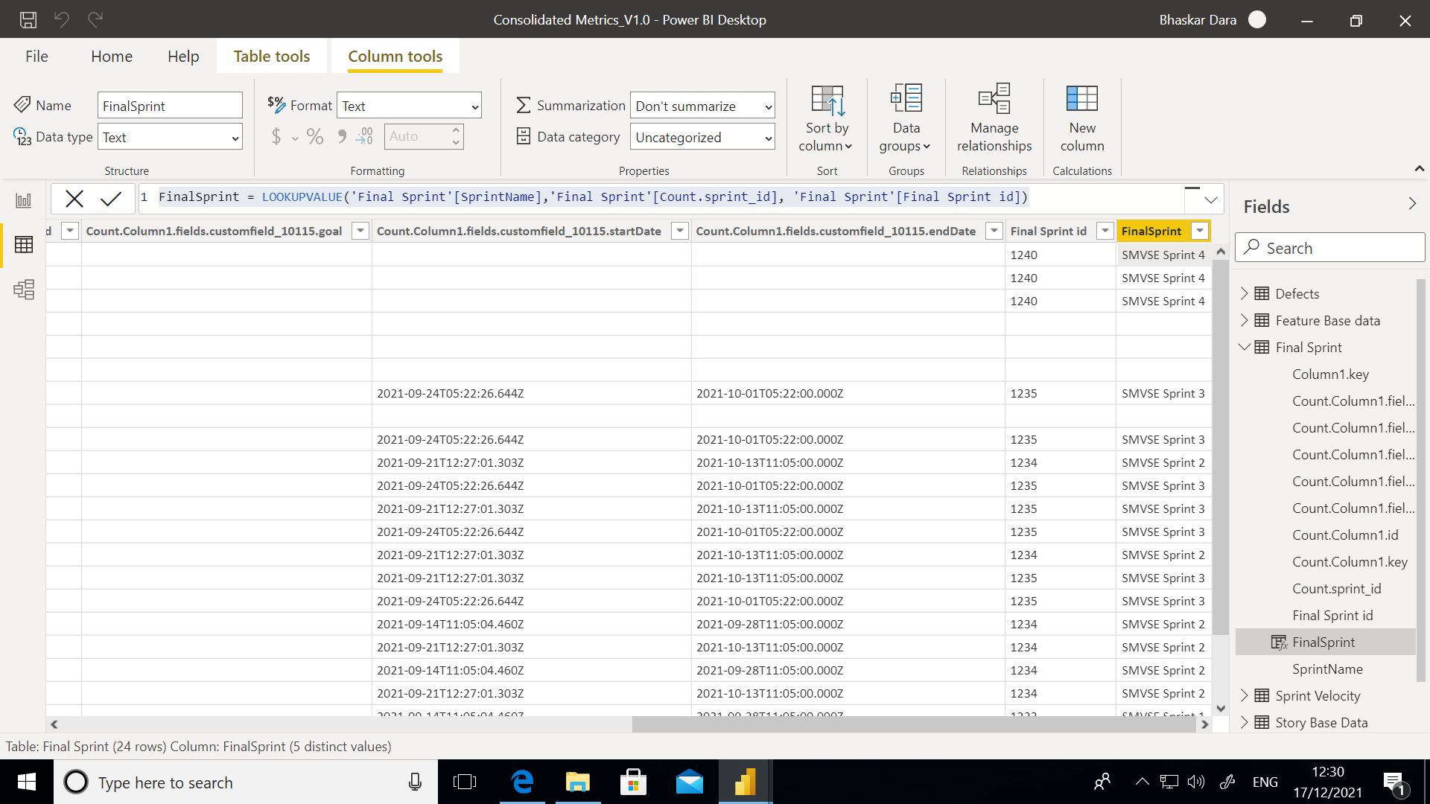

Story Base Data :

Add new columns as below:

FinalSprint = LOOKUPVALUE('Final Sprint'[FinalSprint],'Final Sprint'[Column1.key], 'Story Base Data'[Issue key])

L1 Estimate = CALCULATE( SUM('Story Base Data'[Story Points]), ALLEXCEPT('Story Base Data','Story Base Data'[Custom field (Epic Link)]))

L0 Forcast = IF(ISBLANK(LOOKUPVALUE( 'Feature Base data'[Custom field (L0 Forecast (T-Shirt Size))],'Feature Base data'[Issue key], 'Story Base Data'[Custom field (Feature Name)])),"NA",LOOKUPVALUE( 'Feature Base data'[Custom field (L0 Forecast (T-Shirt Size))],'Feature Base data'[Issue key], 'Story Base Data'[Custom field (Feature Name)]))

L0 Forcast SP = IF(ISBLANK(LOOKUPVALUE('T-Shirt Size'[SP],'T-Shirt Size'[T-Shirt Size], 'Story Base Data'[L0 Forcast])), 0,LOOKUPVALUE('T-Shirt Size'[SP],'T-Shirt Size'[T-Shirt Size], 'Story Base Data'[L0 Forcast]))

L0-L1 = IF(('Story Base Data'[L0 Forcast SP] - 'Story Base Data'[L1 Estimate])<0, 0, 'Story Base Data'[L0 Forcast SP] - 'Story Base Data'[L1 Estimate])

L0 vs L1 Variance = 'Story Base Data'[L0-L1]/'Story Base Data'[L0 Forcast SP]

SP vs L1 = 'Story Base Data'[Story Points] - 'Story Base Data'[Custom field (L1 Estimation (Story Points))]

Sp vs L1 Variance Variance = 'Story Base Data'[SP vs L1]/ 'Story Base Data'[Custom field (L1 Estimation (Story Points))]

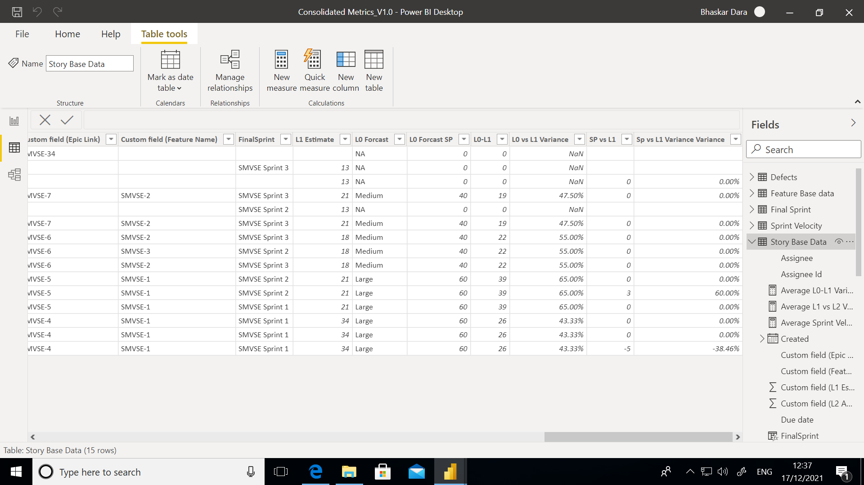

Once we have the base data ready, we can drag and drop the required chart format and add the fields accordingly:

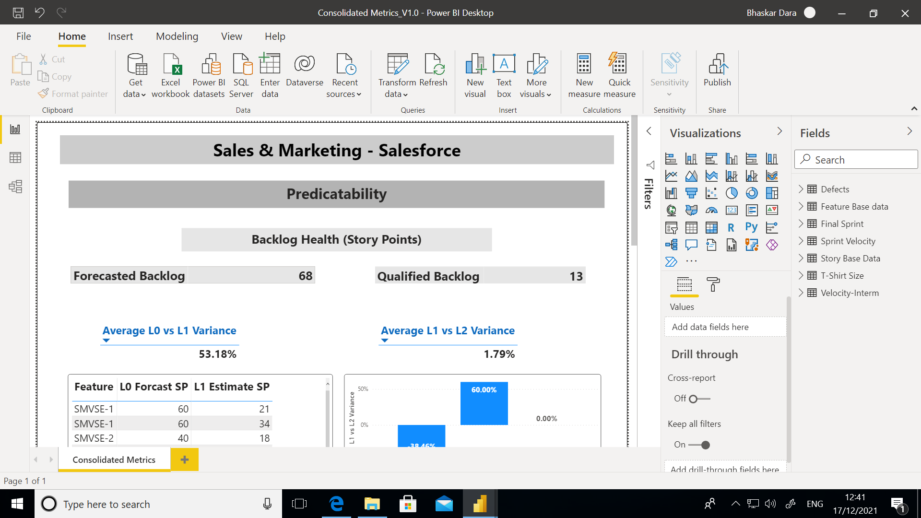

You can apply the filters for chart by using the Filters section:

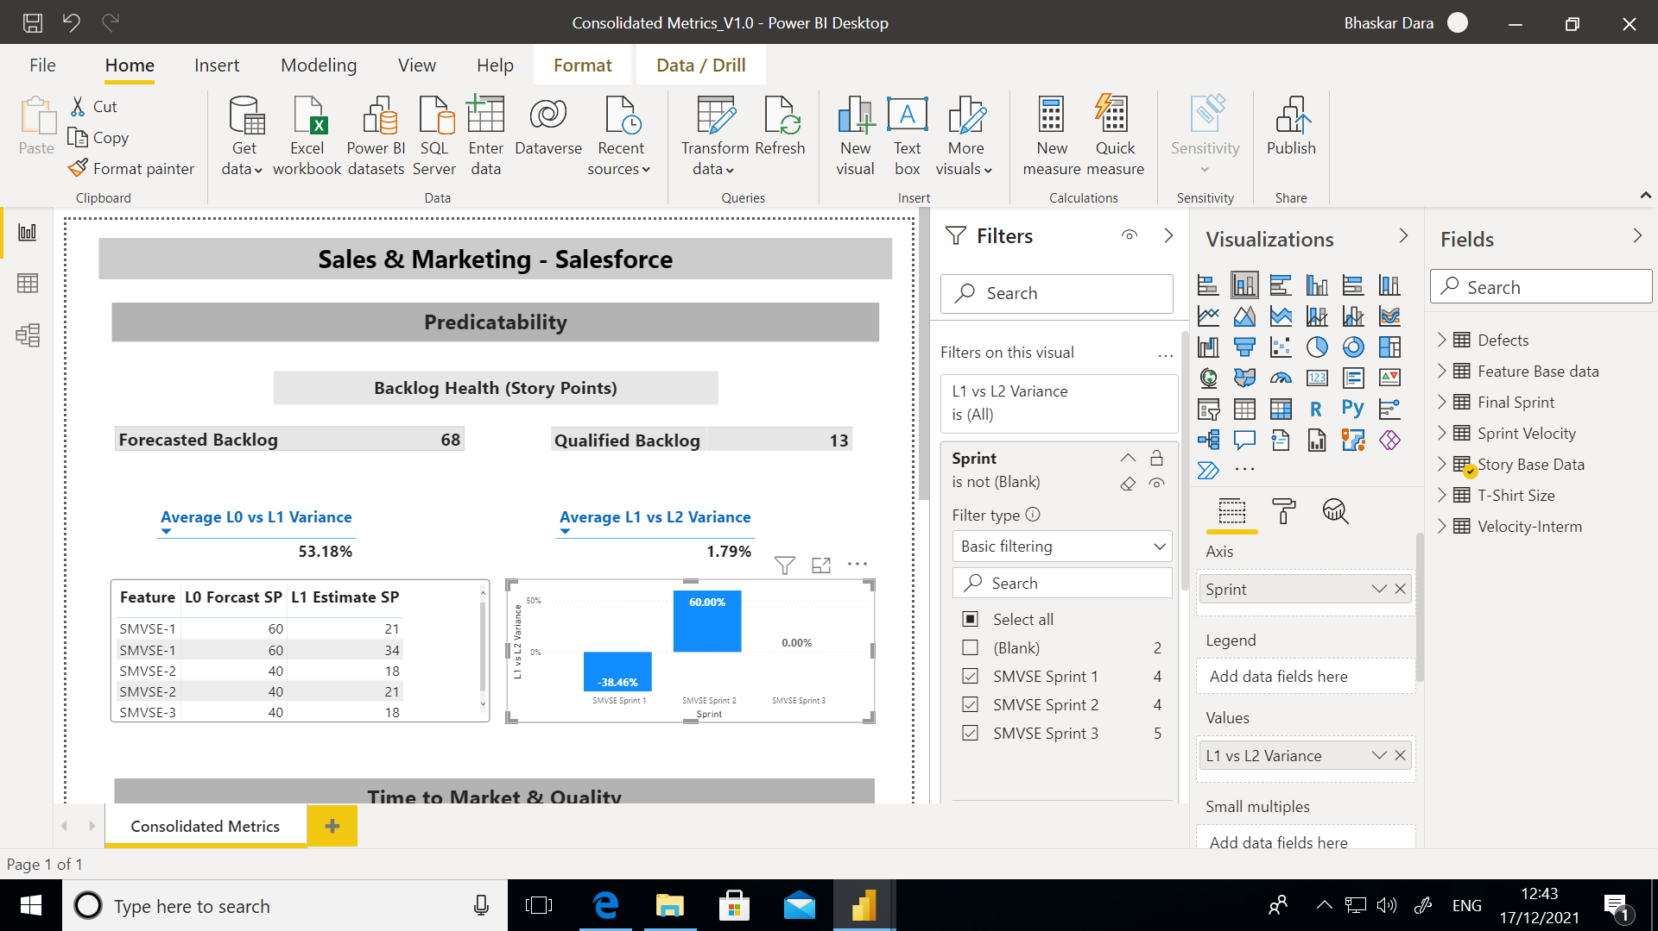

For any format changes click the specific chart and in right pane below the Visualizations you can see the format symbol and apply the changes accordingly:

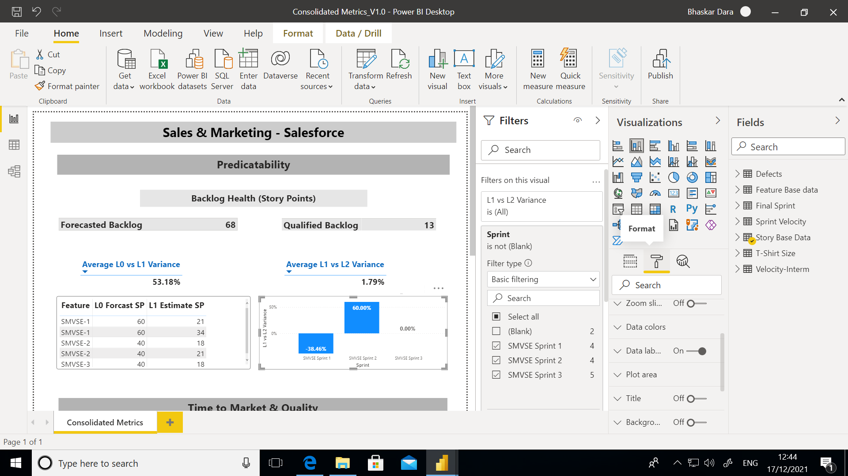

Relationship between tables:

Click the Relationship icon in left pane for linking any table for identifying the relations:

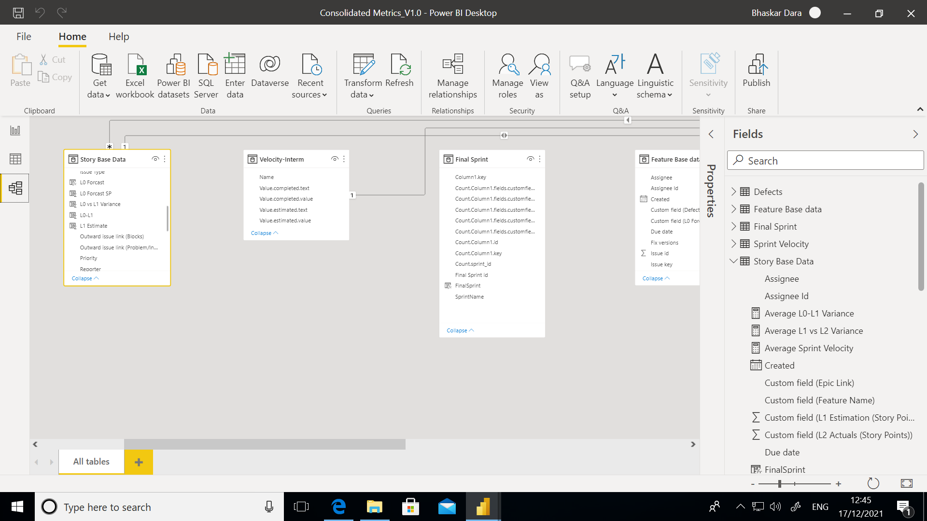

## PowerBI Dashboard Refresh and Publish:

## Manual Refresh:

Click on Refresh button to get the latest data from JIRA instance:

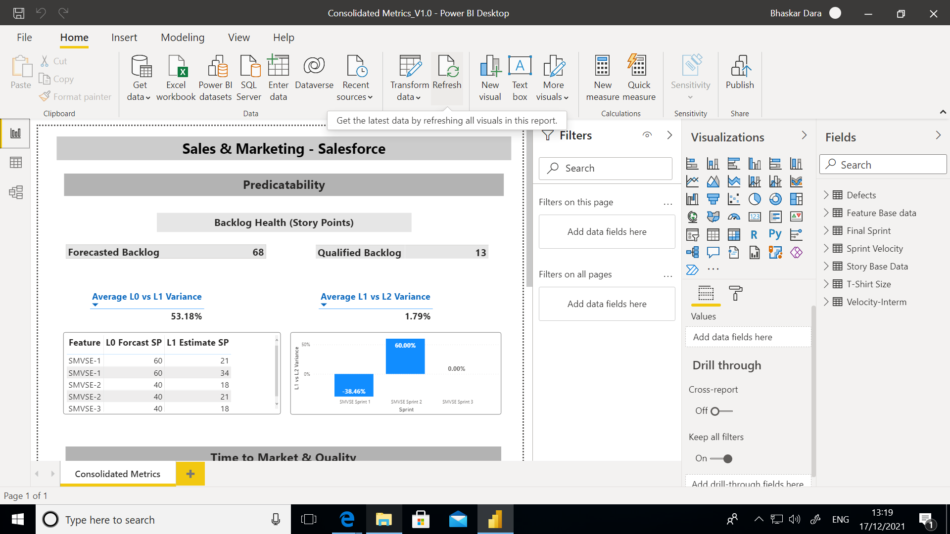

The data will be updated automatically from JIRA and you can see the number of rows loaded:

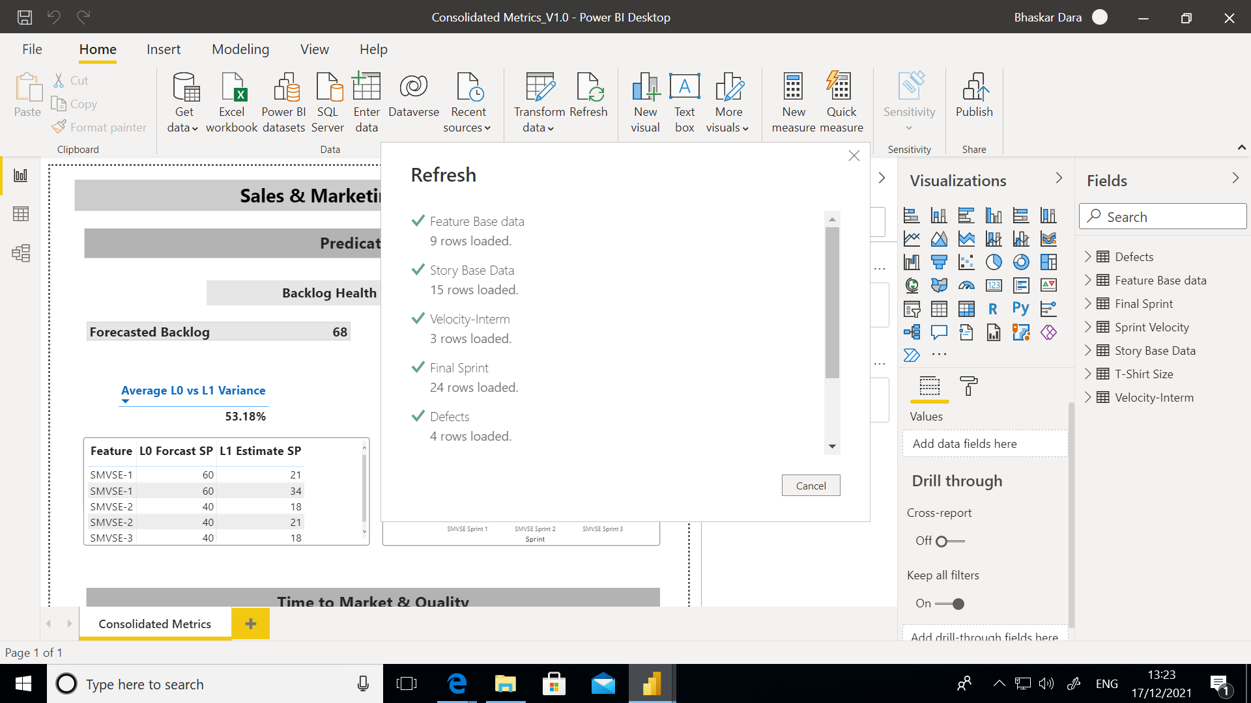

Publish the dashboard as a service:

Create the workspace in PowerBI app Service 🡪

Open 🡪 <https://app.powerbi.com/home>

Signin with your organization email id

Click on the Workspace from left pane 🡪 Create Workspace:

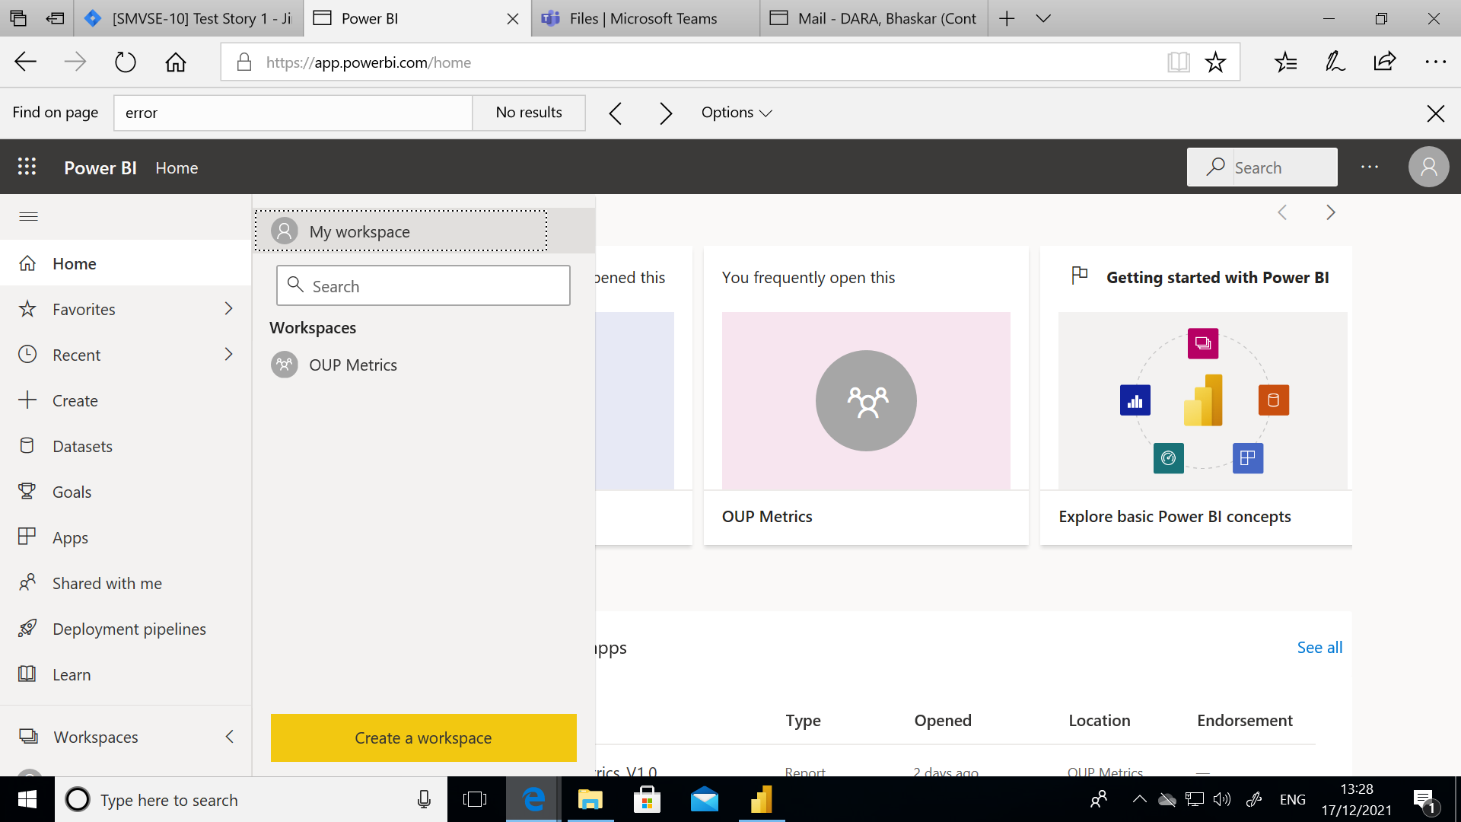

Give Workspace Name and save:

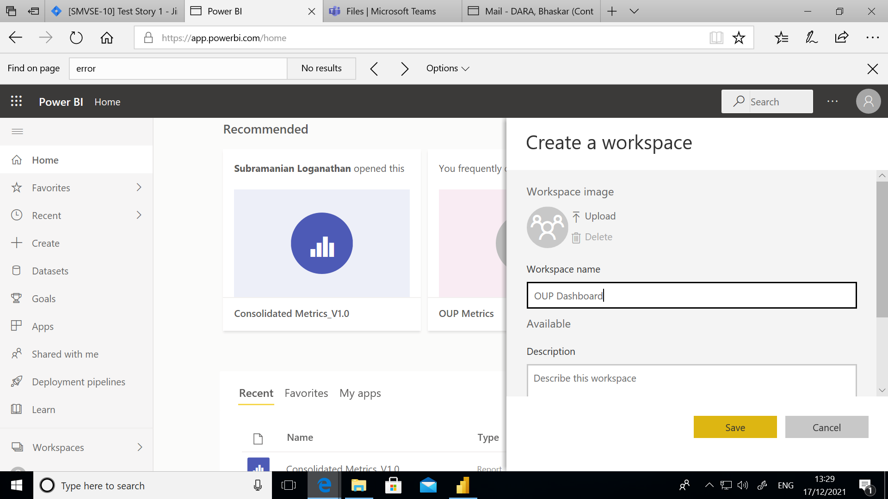

In PowerBI Desktop app click on Publish icon from Home menu:

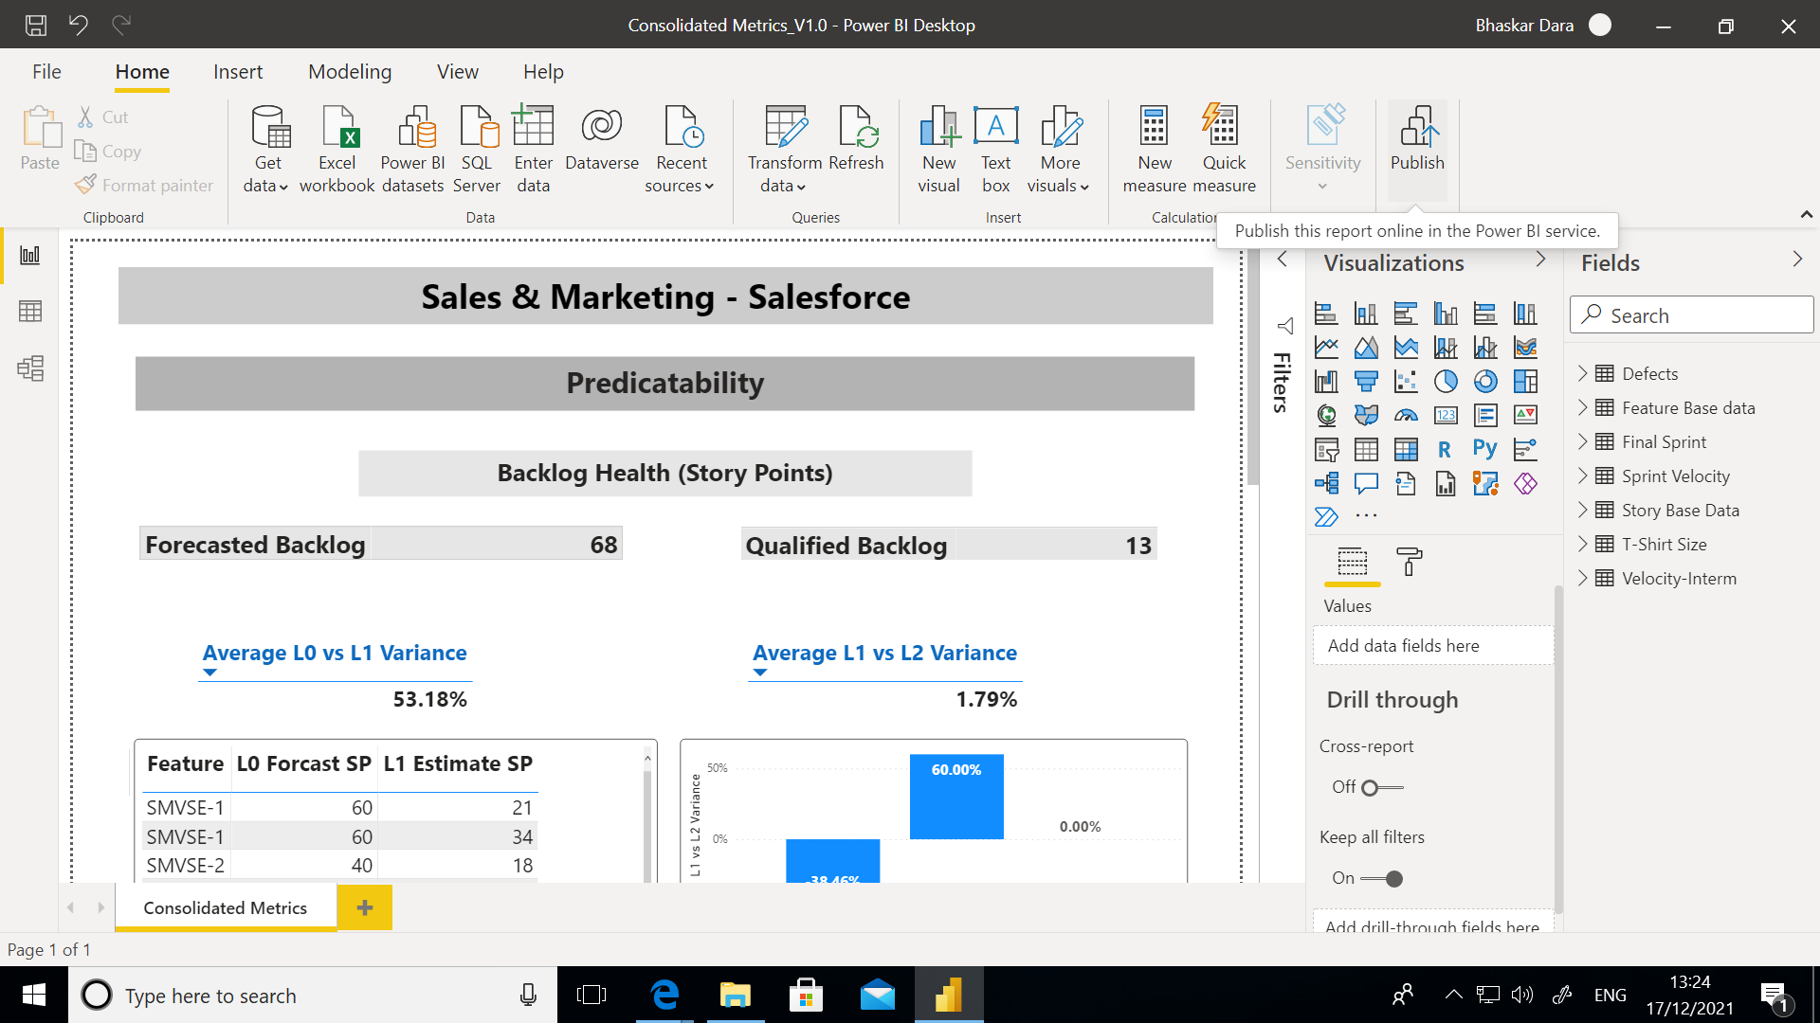

Select the workspace to which you want to publish the report, by default it will save it to My workspace:

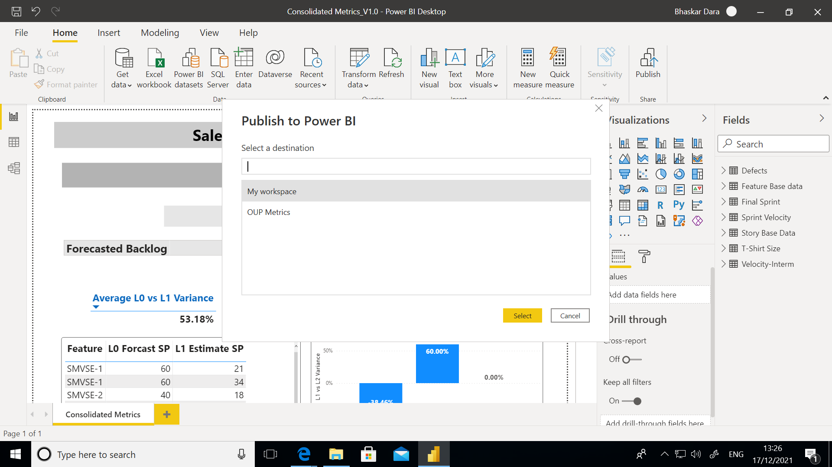

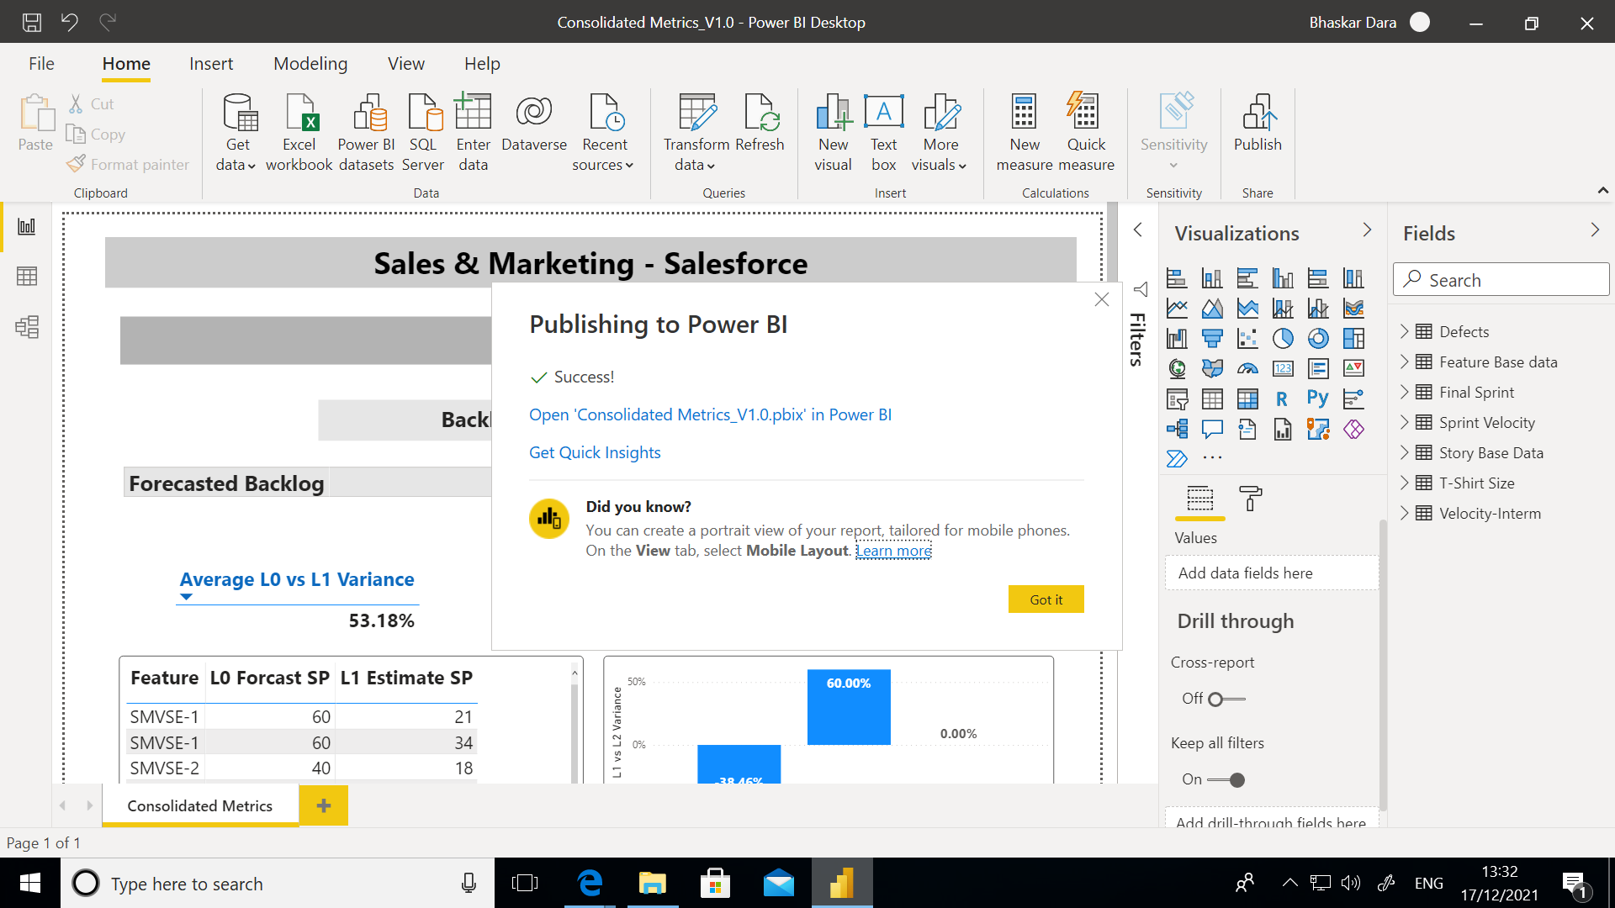

Open PowerBI app service to check the dashboard:

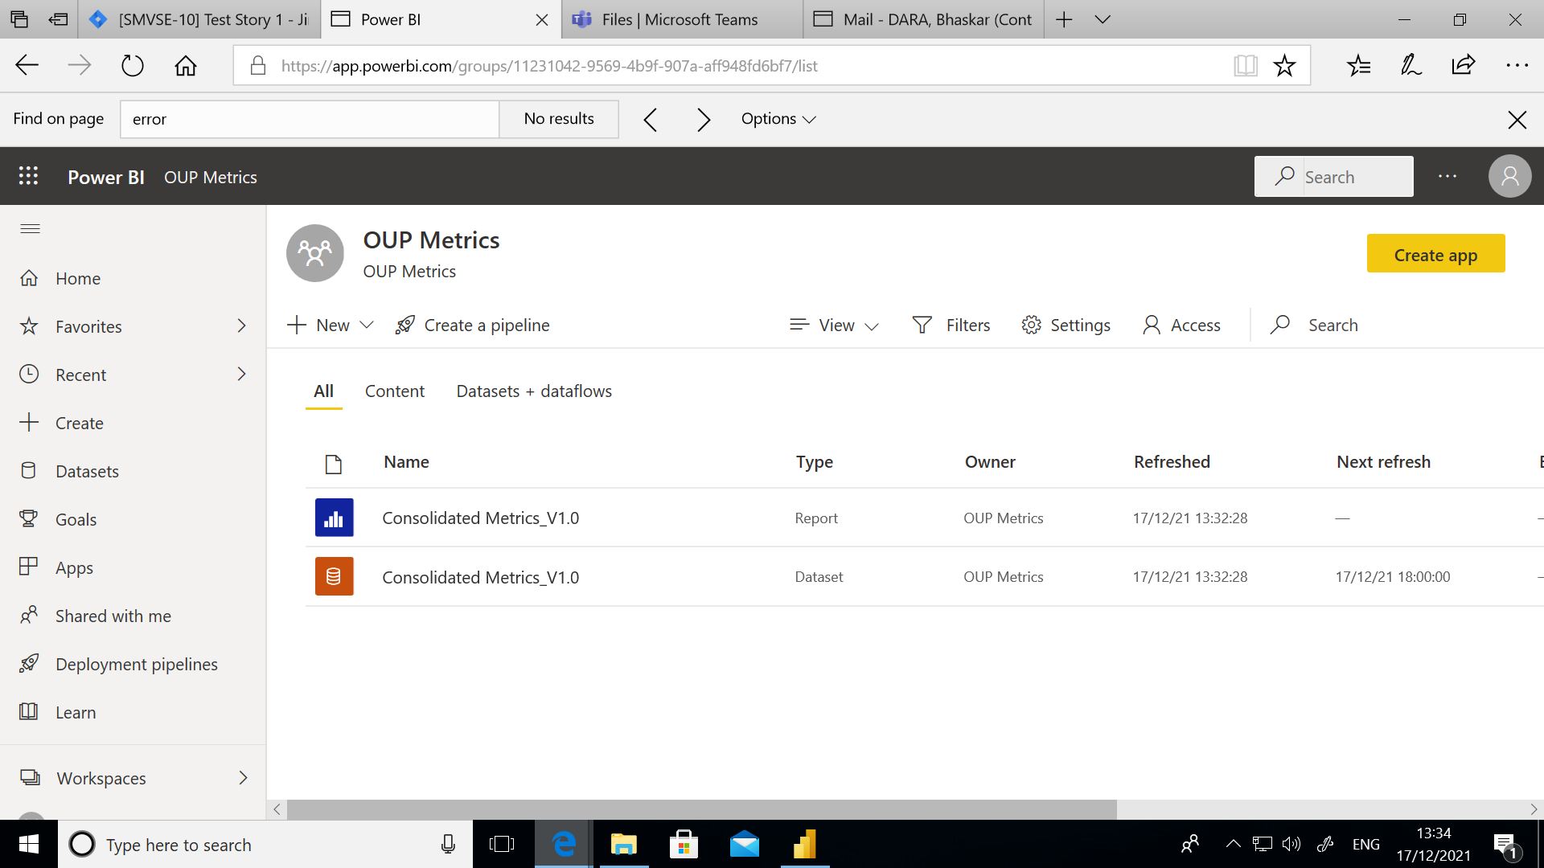

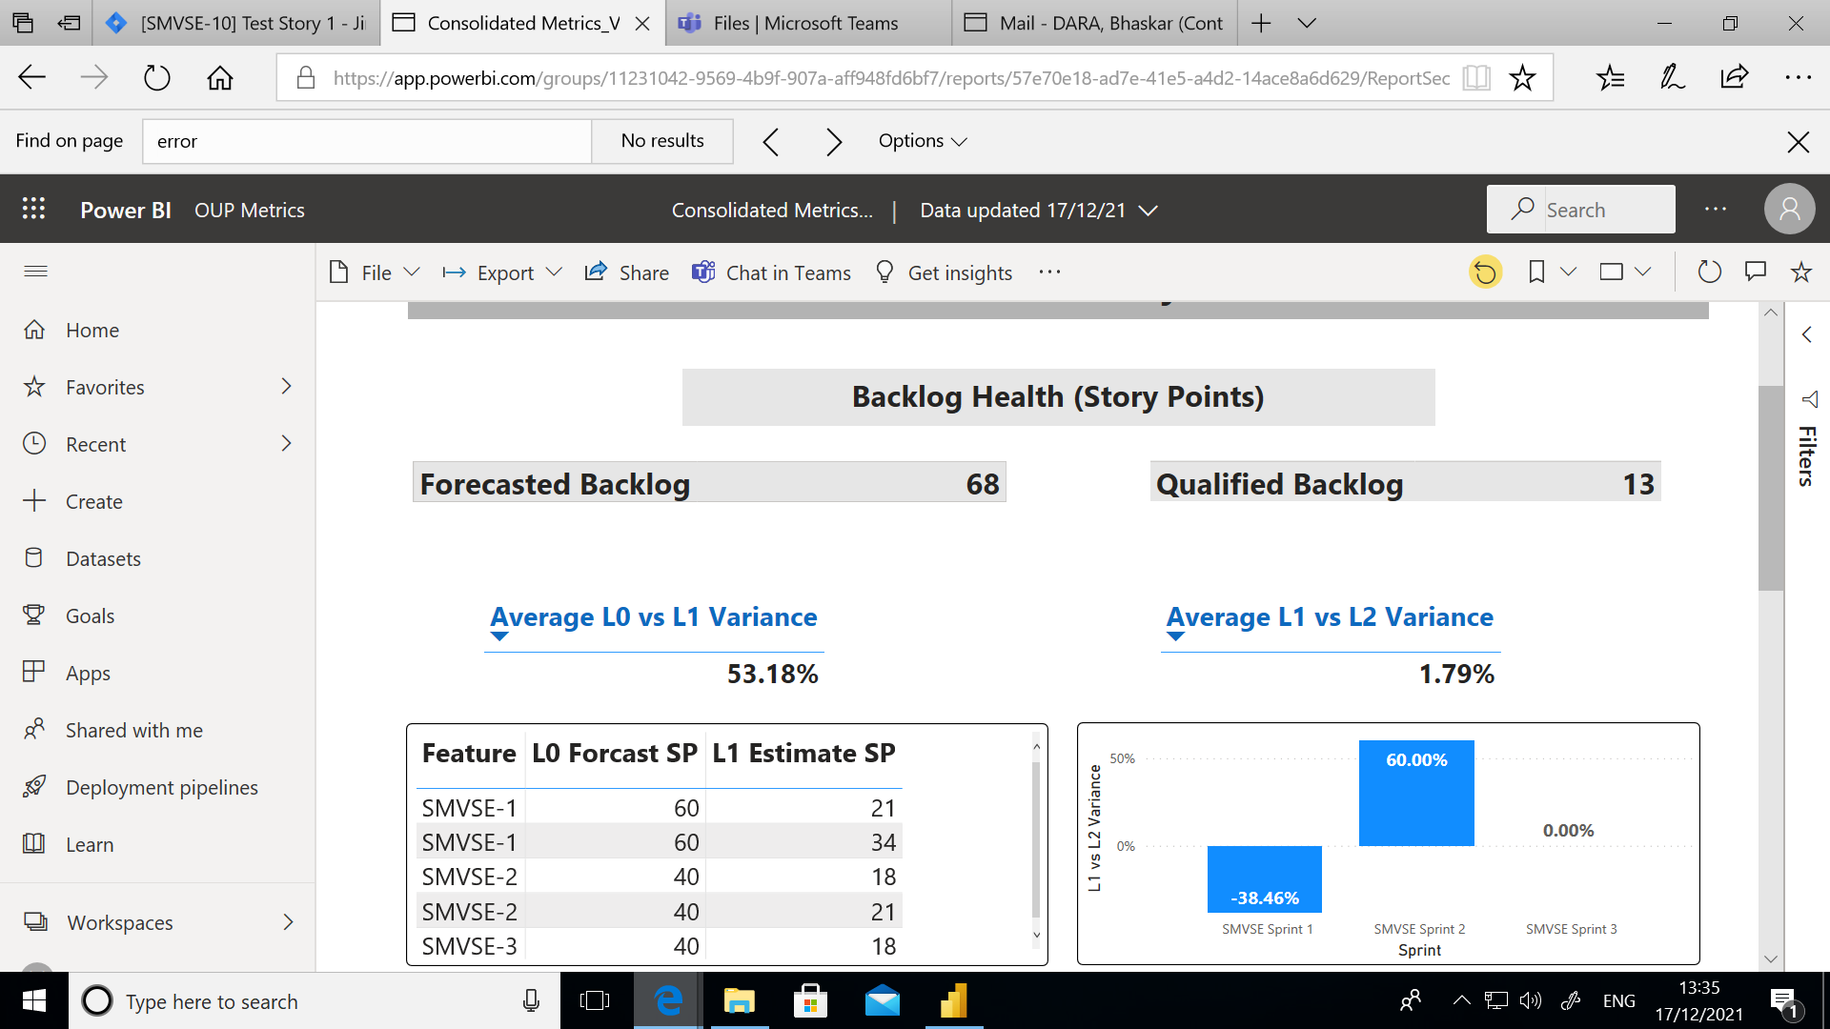

You can share the report with your teammates by clicking the Share icon on top of the screen.

## Schedule Refresh:

Click on the Schedule Refresh icon on Dataset:

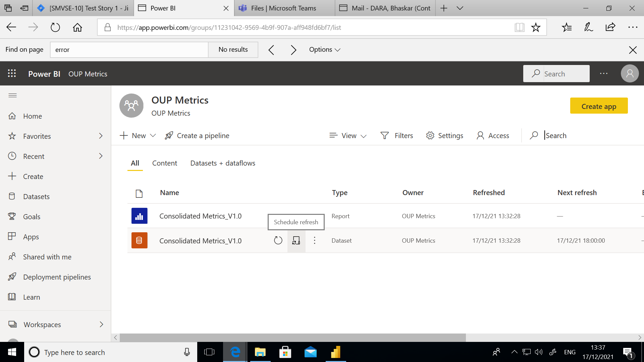

Under Data Source Credentials:

Edit the credentials for all the queries, give username as your email id and password as the API token which we generated in JIRA:

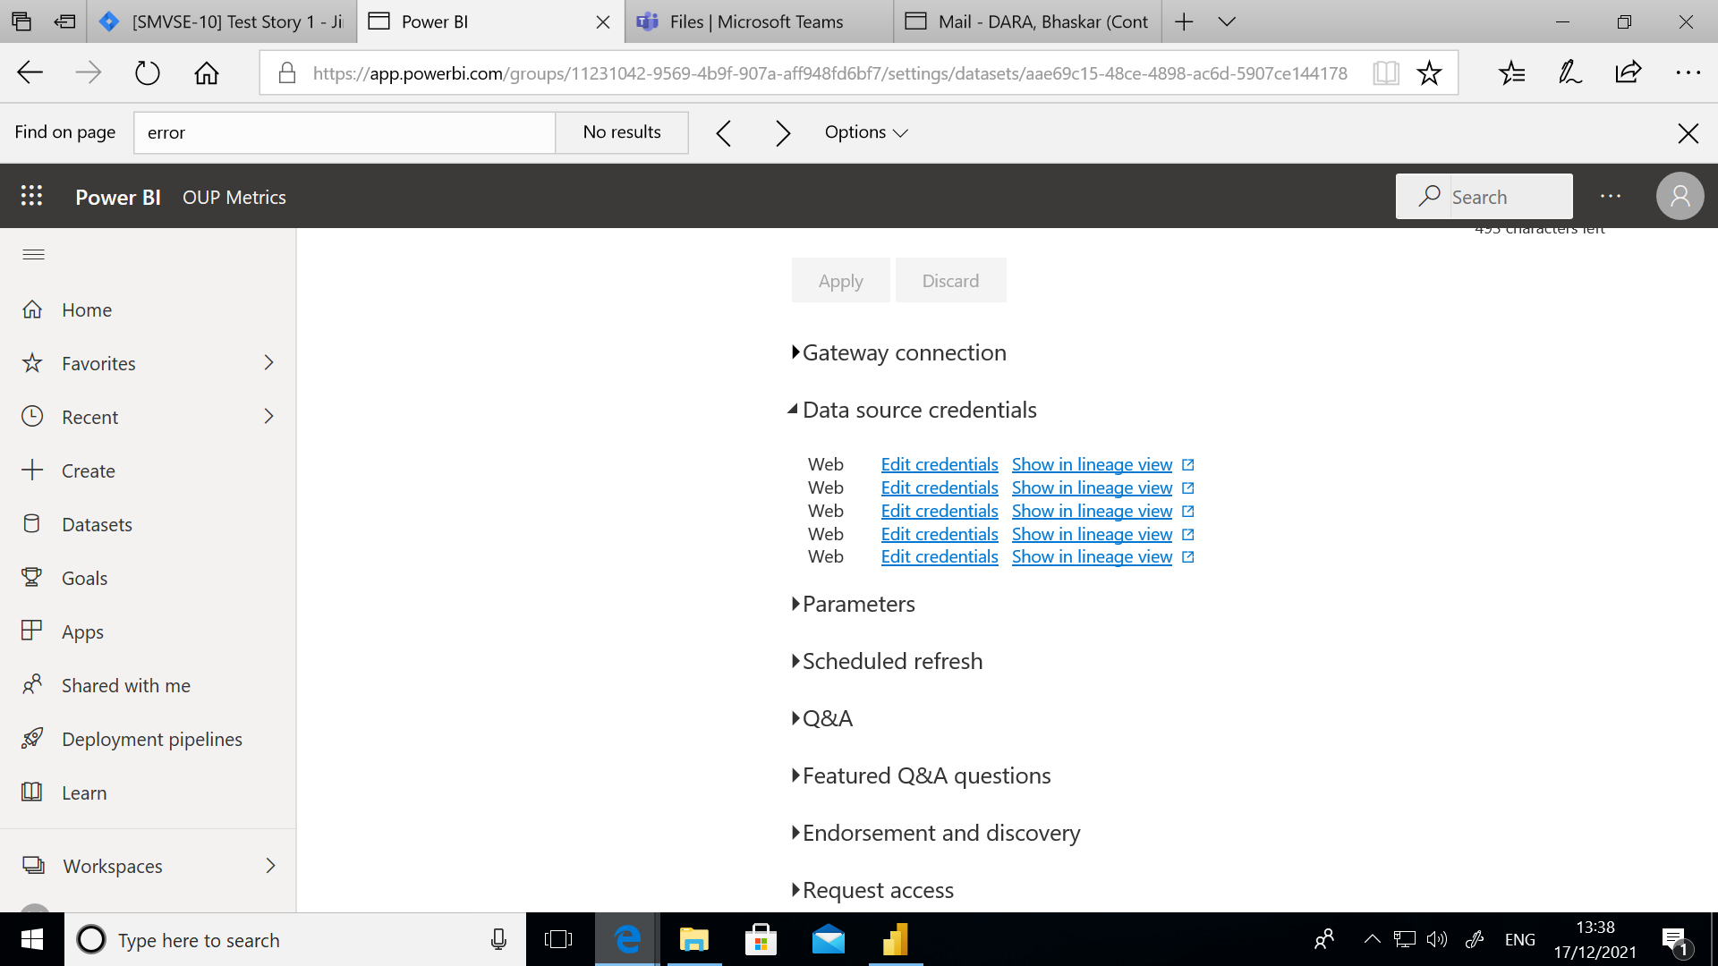

Under Schedule Refresh add the below details and Apply:

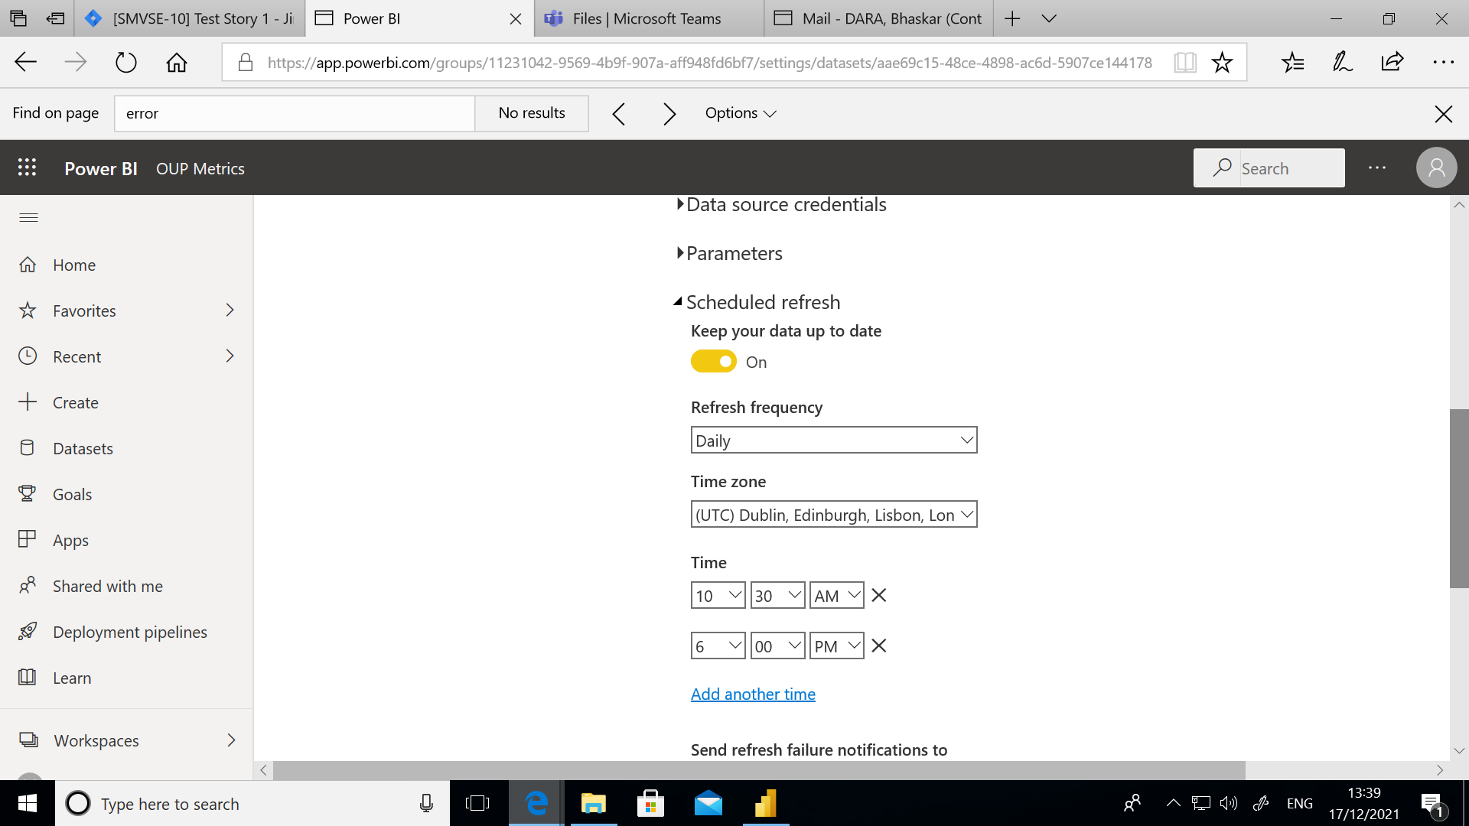

You can verify the status of Scheduled Refresh from the Dataset columns:

